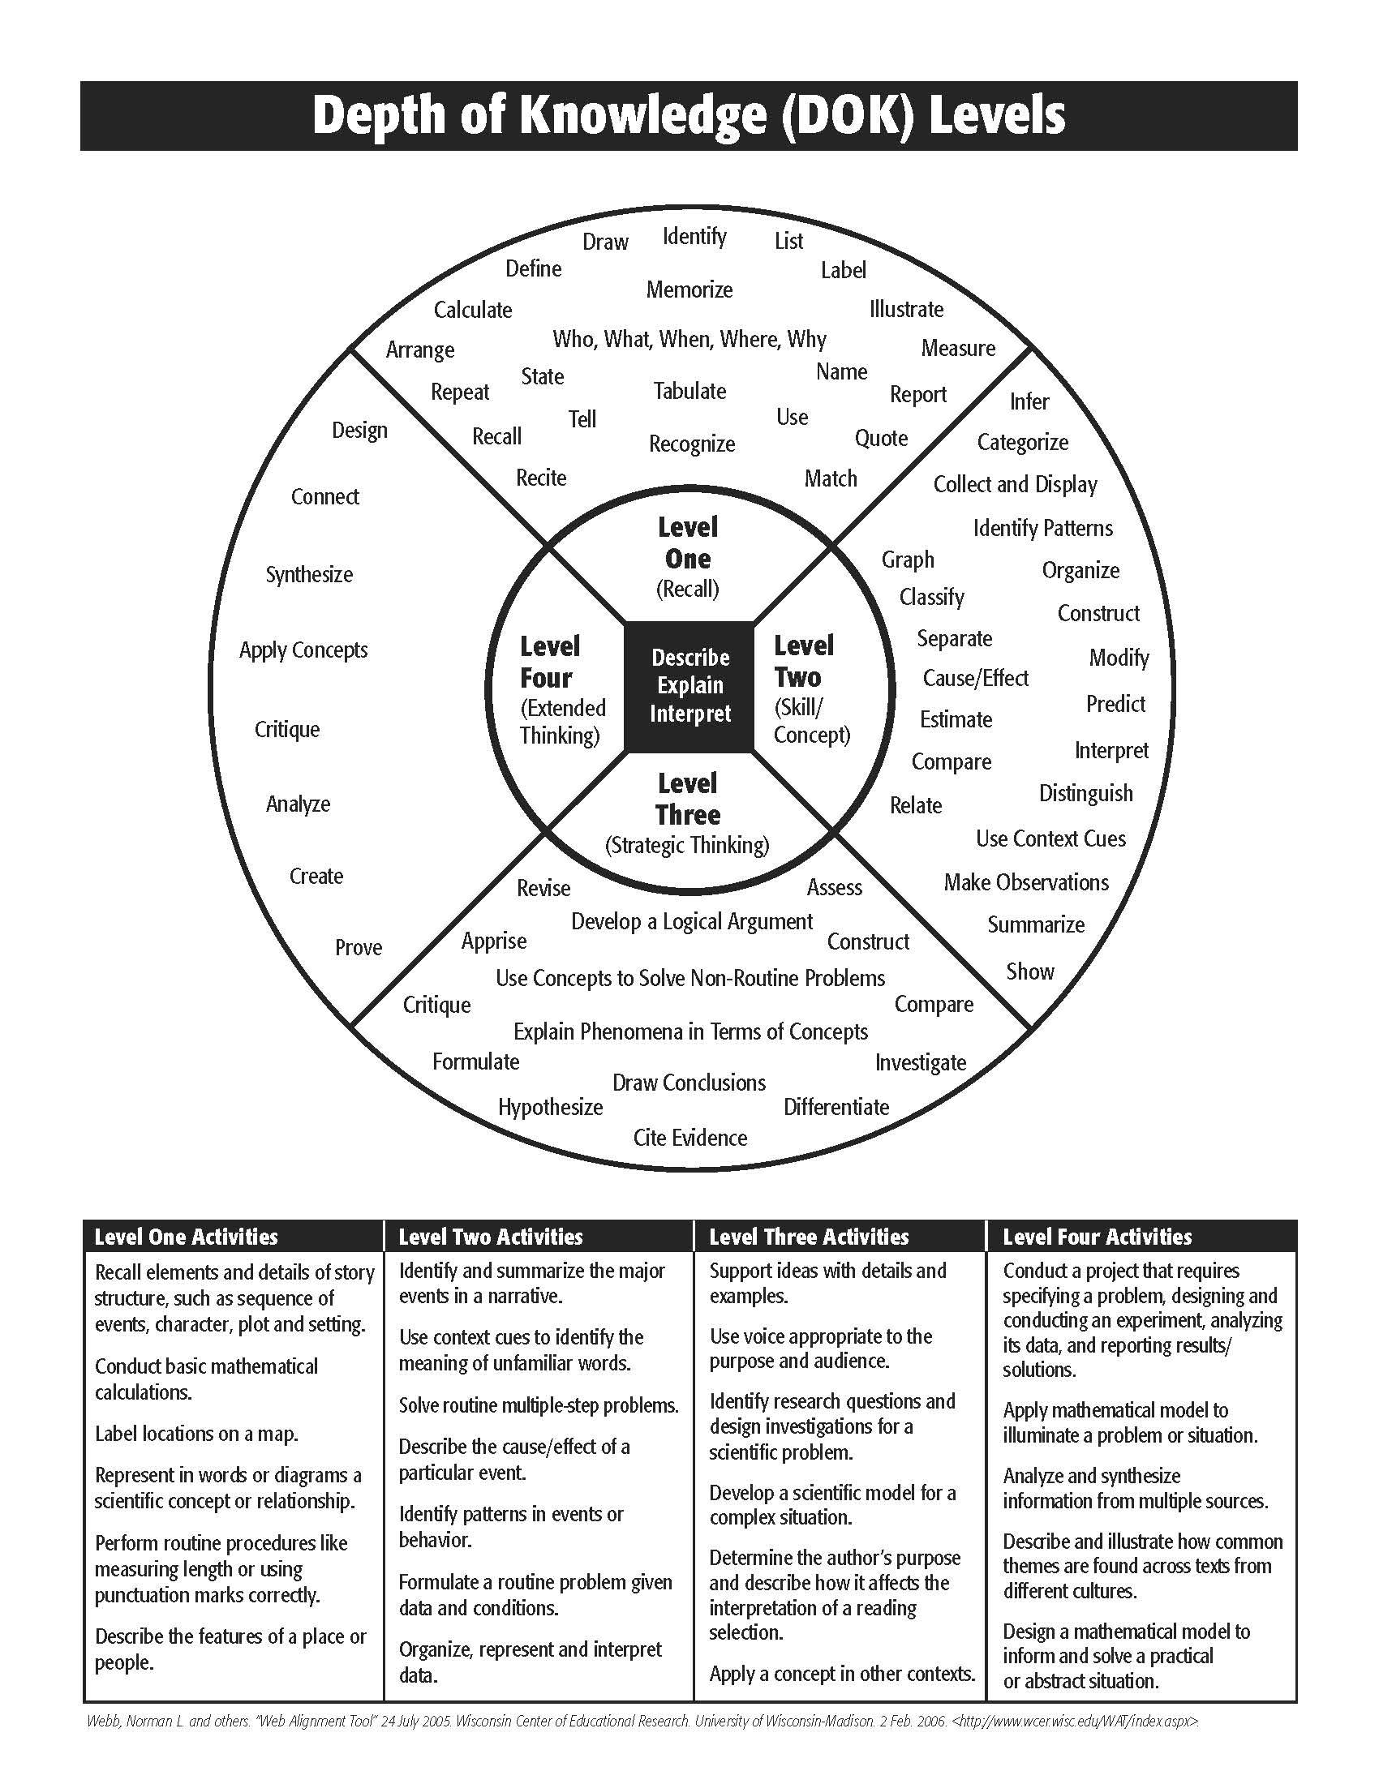

Depth of Knowledge/Rigor Chart and Checklist
Use the following chart to help create and categorize assessment items. The range of rigor of the assessment items should reflect the rigor of the course content and instruction.
Level | Learner Action | Key Actions | Sample Question Stems | Question Numbers/Portfolio Components
Level 1:  Recall | Requires simple recall of such information as a fact, definition, term, or simple procedure. | List, Tell, Define, Label, Identify, Name, State, Write, Locate, Find, Match, Measure, Repeat | How many...?  Label parts of the….  Which is true or false...?
Level 2:  Concept | Involves some mental skills, concepts, or processing beyond a habitual response; students must make some decisions about how to approach a problem or activity. | Estimate, Compare, Organize, Interpret, Modify, Predict, Cause/Effect, Summarize, Graph, Classify | Identify patterns in...  Use context clues to... Predict what will happen when...  What differences exist between...?  If x occurs, y will….
Level 3:  Strategic Thinking | Requires reasoning, planning, using evidence, and thinking at a higher level. | Critique, Formulate, Hypothesize, Construct, Revise, Investigate, Differentiate, Compare | Construct a defense of…. Can you illustrate the concept of…?  Apply the method used to determine...?  Use evidence to support….
Level 4:  Extended Thinking | Requires complex reasoning, planning, developing, and thinking, most likely over an extended time. Cognitive demands are high, and students are required to make connections both within and among subject domains. | Design, Connect, Synthesize, Apply, Critique, Analyze, Create, Prove, Support | Design x in order to…..  Develop a proposal to…. Create a model that….  Critique the notion that…

