The Big Picture and Calendar Integration Activities
To be used in conjunction with one another, these two activities are meant to take information to identify initiatives and high priority items. From there you can begin mapping out when they occur, find connections between them, and find areas where items can be moved or integrated with one another, ultimately aligning them with each teacher’s long-range student growth plan.

The Big Picture
The Big Picture is a four-step process to assist in developing a more integrated system in which school leaders and collaborative teams step back to view the “big picture” of their schools’ initiatives and mandates which require their time. The goals of this process are:
  - To help school leaders facilitate school-based conversations that acknowledge the tensions which might exist between instructional mandates or initiatives.
  - To identify commonalities that may exist across various initiatives or opportunities in the coordination of planning, aligning those opportunities around shared data.
In getting “the big picture” schools must consider the following items:
- What are the mandated items that we “Have-To-Do?”
- What are goal(s) that we “Want-To-Do” (and accomplish)?
- What are the other initiatives competing for our time and attention?
- How do we map out all the various tasks we are working on and efforts we are making to improve teaching and learning?

Each of the three steps in the Big Picture process give your school teams the chance to collaborate, examine, prioritize, reflect, and make connections. The following graphic outlines these steps that a school leadership team can follow to establish a “Big Picture” of their instructional mandates, core initiatives and priority activities.

The Calendar Integration Activity
Clarifying and prioritizing instructional requirements, initiatives, and work requires long range planning. Therefore, it is critical to look at the entire school year’s calendar and identify the key dates and times for all of the various initiatives and mandates your school is involved in. The Calendar Integration Activity is designed to assist you in this endeavor, serving as a visual tool that builds consensus and understanding of where there are commonalities, tensions or conflicts, and opportunities for alignment in the work being done in a school district during the year.

This process includes four exercises that districts and schools can follow to create an integrated calendar. Schools will map tasks and activities across a timeline in order to identify opportunities for consolidation and integration of instructional improvement activities. Each exercise references a corresponding step from The Big Picture process that should either precede the specific calendaring activity or be done at the same time.
Integrating the Activities
Ultimately, while the Big Picture is designed to facilitate and support critical conversations at the school level, the Calendar Integration Activity offers a way to plot the outcomes of these conversations visually and experiment with opportunities for alignment. The graphic below demonstrates the relationship between these two activities.

A Detailed Look at the Big Picture Process
New Jersey's Standards for Professional Learning remind us that student achievement is best realized through a comprehensive, sustained, intensive, and collaborative approach to improving teachers’ and principals’ effectiveness. This definition is guided by seven standards. The leadership standard states any effort to increase educator effectiveness and raise student achievement requires skillful leaders who develop capacity, advocate, and create support systems for professional learning.
A school leadership team (such as the School Improvement Panel), as well as educators from grade-level and/or content-related teams should participate in this process. The following materials are needed to properly complete this activity.
- Copy of the Big Picture worksheet for each participant
- Chart Paper
- Colored note cards and tape, or Post-It notes
- Calendar Integration Activity (recommended)
Step 1: Identify Activities Making up the Big Picture

Use the companion Big Picture Worksheet to record your responses. (Participants should brainstorm alone for 5-10 minutes and fill in as much of the table as possible.)

Have To Dos: What instructional activities are mandated by the state or district for our school? Examples include:
  - SGOs
  - State assessments
  - AchieveNJ requirements (SGOs, etc.)
  - District curricula, lesson plans
  - District benchmark assessments

Note: The following chart shows an example of the Big Picture activity. The example follows through for each of the steps.
HAVE-TO-DO’S (REQUIRED BY STATE OR DISTRICT)
What?  What is the name of the initiative? | Type?  Assessment; Instructional Support; Meeting; PD; curriculum implementation; other | Why?  What’s the purpose of the initiative or activity? | Outputs?  What are the types of data, other insights or decisions produced by this initiative? | How?  What steps, preparation work, or follow-up work is required? | When?  What are the specific dates and/or frequency for key activities i.e. testing window, 6-week cycles of reading instruction, 2-week units of math topics, etc.?
Student Growth Objectives | Mandated measure of teacher and principal effectiveness | To measure student growth, while measuring a teacher’s effectiveness | Growth scores for students | Follow the five steps of the SGO process | From beginning of school year until spring
Math Model Curriculum assessments | Assessment | To measure student growth on standards, preparing students for PARCC | Benchmark data to display how well students are progressing | Administering the benchmark; data analysis and preparing lessons based upon results of the data | Depending on the unit, roughly 8 weeks of instruction in the cycle

Step 1: Identify Activities Making up the Big Picture (Cont)

Want-To-Dos: What instructional activities are we taking on as a school which are not mandated by the state or district? Examples include:
  - School improvement plan activities
  - Faculty initiated strategies (i.e. formative assessments for non-core subjects)
  - Instructional intervention/support programs (i.e. Balanced Literacy)
  - Professional development, Data initiatives
  - School structures (i.e. 4x4 schedule, end of course exams)

Note: The following chart shows an example of the Big Picture activity. The example follows through for each of the steps.

WANT-TO-DO’S
What?  What is the name of the initiative? | Type?  Assessment; Instructional Support; Meeting; PD; other | Why?  What’s the purpose of the initiative or activity? | Outputs?  What are the types of data, other insights or decisions produced by this initiative? | How?  What steps, preparation work, or follow-up work is required? | When?  What are the specific dates and/or frequency for key activities i.e. testing window, 6-week cycles of reading instruction, 2-week units of math topics, etc.?
New math program pilot | Curriculum and instruction | To deliver standards aligned-math material | Assessing students to see how they are progressing with the new materials | PD time for teachers to get to know the resources used during the pilot; Team meeting time to discuss how teachers are progressing with resources | Ongoing throughout the year

Step 1: Identify Activities Making up the Big Picture (Cont)

Participants come back together as a team and discuss what they wrote down.
- One or two people can take charge of transferring “Have-To-Do” and “Want-To-Do” tasks onto note cards or post-its that reflect group consensus.
- Paste them onto the chart paper in two separate columns. (Allow 15-20 minutes for this part of the process.)

Step 2: Clarifying and Prioritizing

- Use the grid on the Big Picture Worksheet to categorize the “Have-To-Do” initiatives and “Want-To-Do” initiatives as high and low priorities. (Allow 5 minutes for individual participants to jot down notes on their worksheet.)
- Engage in a group discussion to categorize the initiatives from the first list. The most critical element of this exercise is to try to reach consensus about what are the high priority items – what are you, as a school, committed to investing in this year? (Allow 15 – 20 minutes for group discussion.)
Initiative/Activity | Low Priority | High Priority
Have to Do |  | Student Growth Objectives  Administering model curriculum assessments
Want to Do |  | New math program pilot
Step 3: Making Connections

- Look for possible connections between your High Priority “Want-To-Do” list and your High and Low Priority “Have-To-Do” lists. Discuss:
  - Are there any possible areas of overlap?
  - Are there conflicts or tension points between any of the planned initiatives?
  - What are the ways of integrating “Have To Do’s and “Want To Do’s?”
  - How do these initiatives integrate with SGOs in your school?
- SGOs are a High Priority “Have-To-Do.” They are also a long range growth plan for students, based on the most critical standards taught during a school year. Consider ways in which your SGOs can integrate with and provide support for all of the other work you are doing.
- Identify possible commonalties, tensions, connections or opportunities to build connections.
- Use the Big Picture Worksheet to record your answers. This part of the exercise focuses on columns 1-4 in the chart below. (Allow 10 minutes for individual brainstorm and 20-30 minutes for group discussion.)

1 | 2 | 3 | 4 | 5
Activities  (2 or more) | Commonalities or Duplication | Tensions or Conflicts | Leverage Opportunities | Alignment Actions
SGOs | Measures growth on standards | Timelines | Can measure long range growth on standards taught throughout the year | Develop the SGO summative assessment based on standards measured during the model curriculum assessments.
Model Curriculum Assessments | Measures growth on standards | Timelines | Can serve as benchmarks toward growth on overall SGO. Can also be used to evaluate the new math program and resources being used | Use Model Curriculum Assessment data to assist in determining student starting points as well as map growth on teacher’s overall SGO, as well as evaluating the new math program that is being piloted.
New math program pilot | Resources for teaching growth on math standards | Time factor it takes to incorporate new programs | Can be used to assess student progress as well as the effectiveness of the new program | Use the resources to teach the material which will be measured in common benchmarks. Student data can reveal how well students are progressing as well as in evaluating the resources we are piloting. It does this in exposing the gaps in the resources we are using or the way they are being utilized.

Step 3: Making Connections (Cont)

5. As a group, discuss the 5th column (from the chart above) together. Use the questions below to help guide the discussion. (Allow 20 minutes for this part of the process.)

Meetings:
- Can any high priority “Want-To-Do” planning be consolidated with “Have-To-Do” meetings?
- Do or could any meetings address the same discussions or involve the same staff members and could be combined to reduce total number of meetings?
- Are data meetings scheduled after the release of test data to maximize content for discussion?
- Can data meetings be used to support implementation and evaluation of high priority “Want-To-Do” activities?

Reporting and Planning:
- Can “Want-To-Do’s” satisfy planning requirements set by the district or state?
- Can the data collected and analyzed for upcoming meetings be coordinated with required reporting of the same data?
- Could data collected for any mandate (state or district) support teacher level work?
- Do summative assessments used for SGOs reflect alignment to recent revisions to curriculum?

SGO Integration:
- SGOs are long-term academic goals for groups of students. These goals include data collection on student growth. How can the identified mandates and initiatives be supported by data associated with SGOs?
- How do SGOs integrate with the other instructional work of your school?
- As you monitor and adjust instruction throughout the year, how can the data you collect from other mandates and initiatives inform student growth?

Professional Development Days:
- Can professional development days be used for high priority “Want-To-Do” activities?
- Can scheduled trainings be used to accomplish anything else (i.e. combine purposes)?

Note: If you have been using visual representations, like note cards, or different colored markers on a white board, participants should be allowed to physically re-order the priorities and connect possible opportunities for alignment/integration.

A Detailed Look at the Calendar Integration Activity
One of the greatest challenges of working effectively in schools is managing time. As you make connections between your “Have-To-Dos” and High Priority “Want-To-Dos” lists, it can be useful to map out relevant dates for each activity on a calendar. This will help with integration. If you have school leadership in the room, and have the time, an important next step in this process is to work together to map out the full-year calendar. This activity can be done at a later date, but during Step 3 is when the Calendar Integration activity makes the most sense.
Materials needed:
- Butcher block or chart paper
- A set of large, light-colored post-it notes,
- Colored markers.
- Completed or partially completed Big Picture Worksheet.
Note: Another option for completing these activities would be to use an online calendar (like a Google calendar) and to project the calendar onto a screen during the meeting and color-code calendar entries. This approach has pros and cons. While it is easier to set up and use as a real, ongoing calendar for the school, it is also (potentially) a less engaging activity for the group if they do not participate in the creation/development of the calendar. Sitting together and seeing activities and potential conflicts/overlap can trigger discussion. A school should choose the approach that makes the most sense.
Step 1: Map all initiatives and activities identified from Step 1 on a monthly calendar and categorize activities by “type”.
- Pre-Work: draw out a monthly calendar on a piece of butcher block or chart paper. Use one paper for each month giving yourself plenty of room to write.
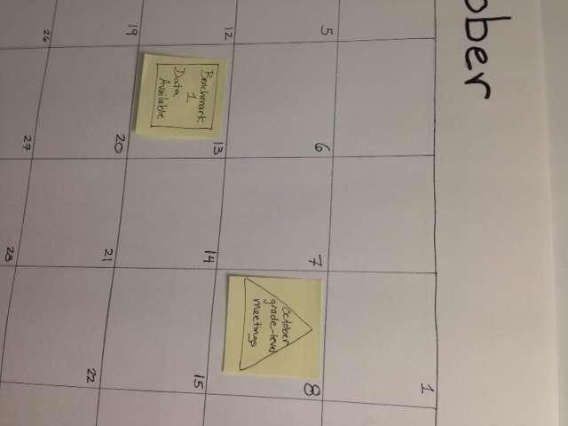
- Review work resulting from Step 1 of the “Big Picture” worksheet.
- Write down on a post-it note each initiative or activity you identified on the Big Picture worksheet.
- For initiatives or activities with known dates or timeframes, place the post-its onto the calendar accordingly.
- See the picture.
- For initiatives or activities without known dates or timeframes (i.e. activities that are ongoing), place them to the side for now.
- Draw a shape around the text that corresponds to the type of activity or initiative you’ve written down (e.g., all meetings are written within a triangle, all data availability/reporting deadlines are written within a square, etc.). See the picture below:

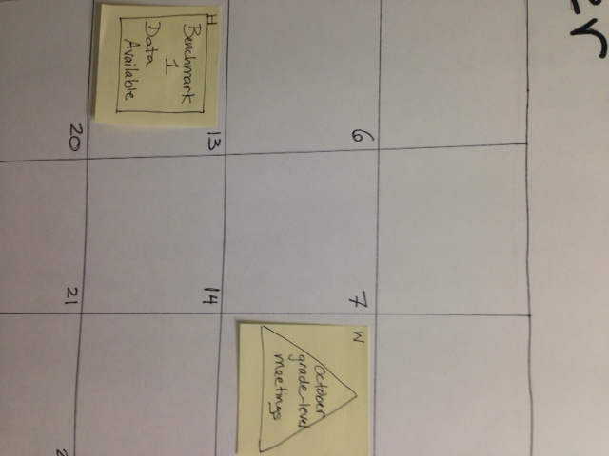
- Mark at the top left corner of each post-it as “Have-To Do” versus “Want-To-Do” using an “H” or a “W” as shown below:

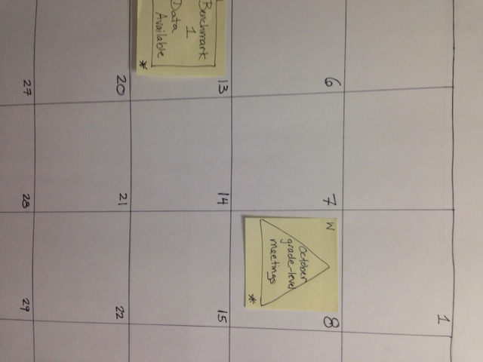
Step 2: Highlight items that were deemed as “High Priority” from Step 2 of the “Big Picture” worksheet.
- Mark at the lower right hand corner a star/asterisk next to high priority initiatives.

Step 3: Move/shift items that can be consolidated, re-ordered, or re-prioritized, based on the “Alignment Actions” discussion that took place in Step 3 of the “Big Picture” worksheet.
- If you see opportunities to consolidate tasks that involve similar or related work in instructional planning, collection or reporting of data, or progress monitoring, move the post-it notes.
- If you see opportunities to combine a “Want-To-Do” activity with a “Have-To-Do” initiative, move the post-it notes accordingly.
- If you see opportunities to re-order initiatives or activities to facilitate more timely availability of a wider range of data, move the post-it notes accordingly.
- Examples
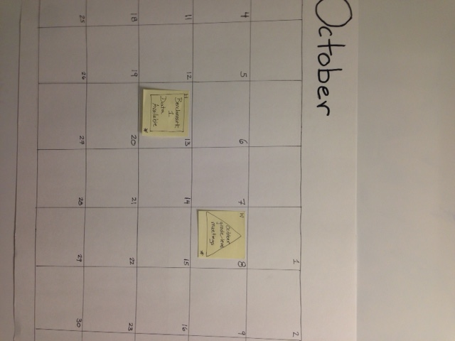
  - Current Calendar: The school is scheduled to receive its first benchmark assessment data in mid-October. The school has monthly grade-level team meetings, at which they often look at whatever data are available. The October meeting is scheduled directly before the benchmark assessment data will be arriving. Normally the school prefers to keep its grade-level team meetings at the same time each month, but doing so in this case would prevent the teachers from discussing the benchmark result analysis. At a more advanced stage, the school realizes that the next SGO check-in does not occur until late December, so this benchmark data will not be used to inform SGOs for another two months.
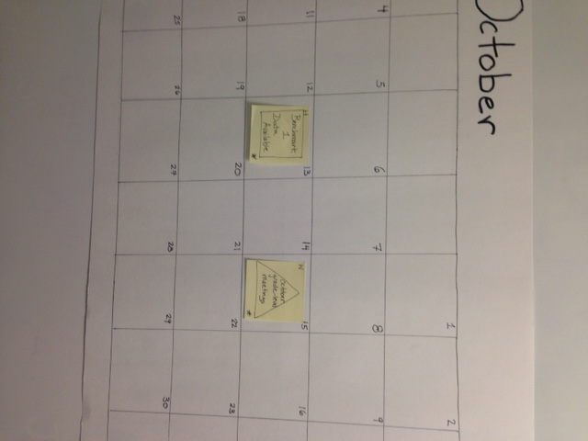
Improved Calendar: Instead, the school decides to align its meetings with the date on which data will become available. The grade-level meeting is rescheduled to take place after the benchmark assessment data delivery to optimize the timing and knowledge from those data. At a more advanced level, the school also goes another step, by deciding to incorporate SGO data into these meetings. By doing this, by the time there is a mid-year check-in on SGOs, the improvement strategies decided upon in mid-October are well underway. This means teachers will have had more structured support from their peers, and will have a better chance at meeting their mid-year targets for SGOs.

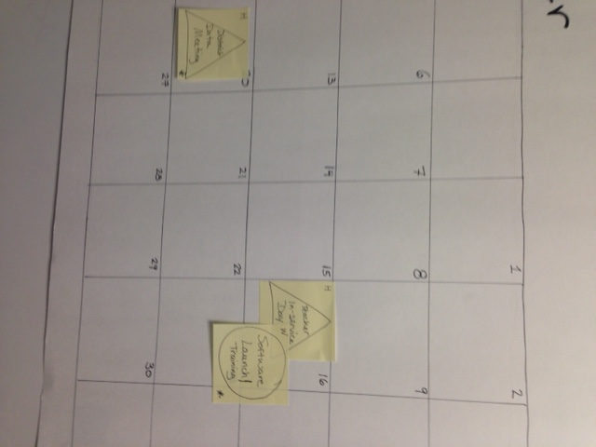
  - Current Calendar: The school is launching a new individualized learning software program in its tiered intervention program. Originally, the school decided to time the launch around an early fall teacher in-service day so that they could use that time to train teachers on the new software. After putting together its calendar, the school notices that its quarterly district data meeting, where the school must present its progress on instructional initiatives, is shortly after that launch.

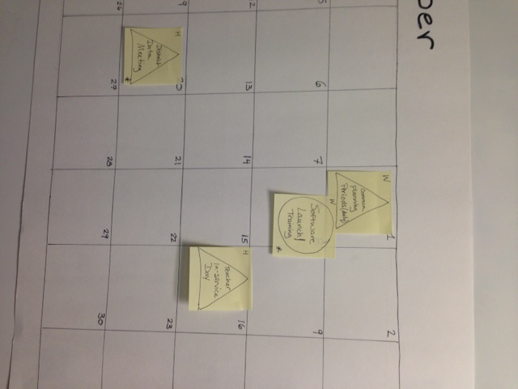
Improved Calendar: After a discussion between the school leadership team and several teachers, the team decides that the training of teachers on the new software could take place during common planning periods without adversely affecting the integrity of the training. The school therefore decides to move up the launch of the new software by two weeks and shift the training into common planning periods, so that during their district data meeting, the school can demonstrate clear progress on launching a key intervention (met timelines, implemented with quality/fidelity, is starting to generate data from the software system, etc.), and potentially could have early data on use and effectiveness of the system.

Step 4: Color code items that connect with the SGO process, based on discussions that took place in Step 3 of “The Big Picture” worksheet.
- Review your completed worksheet from Step 3 of the Big Picture process. Assign colors (using 3 different colored markers you have) to each of the three SGO steps you filled in, describing other instructional initiatives and activities that either support teachers in answering one or more of those core SGO questions. For example, everything related to Assessment of Learning will be green and everything related to Evidence of Learning will be red.
  - Establishing learning goals and targets
  - Assessment of learning
  - Evidence of learning

Establishing Learning Goals/Targets | Assessment of Learning | Evidence of Learning
- Monthly grade-level meetings centered around SGOs | - Quarterly benchmarks | - Analysis of benchmark data

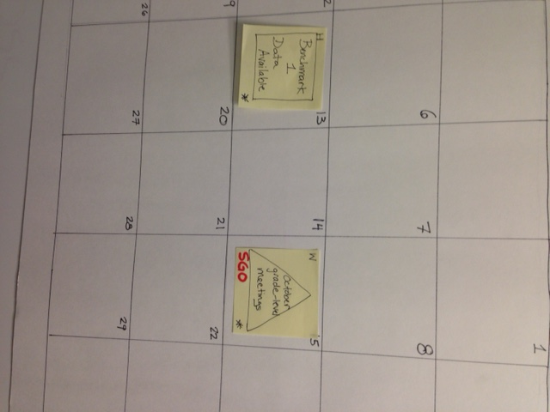
- On your calendar, find the post-it notes with those corresponding activities.
- Write “SGO” on the bottom left-hand corner of each selected post-it, using the same color that you assigned to a particular SGO category in the first step of this activity i.e. green for Assessment of Learning.

- Post-it notes do not stick forever. Capture the new, consolidated calendar electronically. A monthly calendar template is provided in the Big Picture Activity Worksheet where you should document your improved calendars.

The Big Picture Worksheet
Step 1: Brainstorming the Big Picture
Use the tables below to record ideas individually and then as a group about what your school “has to do” and “wants to do” instructionally in the upcoming school year. Provide as much detail as possible.
HAVE-TO-DO’S (REQUIRED BY STATE OR DISTRICT)
What?  What is the name of the initiative? | Type of Initiative?  Assessment; Instructional Support; Meeting; PD; curriculum implementation; other | Why?  What’s the purpose of the initiative or activity? | Outputs?  What are the types of data, other insights or decisions produced by this initiative? | How?  What steps, preparation work, or follow-up work is required? | When?  What are the specific dates and/or frequency for key activities related to this initiative i.e. testing window, 6 week cycles of reading instruction, two week units of math topics, etc.?

WANT-TO-DO’S
What?  What is the name of the initiative? | Type of Initiative?  Assessment; Instructional Support; Meeting; PD; other | Why?  What’s the purpose of the initiative or activity? | Outputs?  What are the types of data, other insights or decisions produced by this initiative? | How?  What steps, preparation work, or follow-up work is required? | When?  What are the specific dates and/or frequency for key activities related to this initiative i.e. testing window, 6 week cycles of reading instruction, two week units of math topics, etc.?

Step 2: Clarify and Prioritize
As a group, use the lists generated in Step I of this process to fill in the chart below and prioritize mandates and desired instructional initiatives. (Keep in mind the most critical element of this exercise is to try to reach consensus about what are the high priority items – what are you, as a school, committed to investing in this year?)
Initiative/Activity | Low Priority | High Priority
Have to Do
Want to Do

Step 3: Making Connections (Identifying Commonalities, Tensions, Leverage Opportunities)
- Column #1: Identify an initiative/activity that may have something either: 1) in common with; 2) in tension with or; 3) potential to support another initiative/activity. Start with higher-priority initiatives and then move to lower-priority initiatives.
- Columns #2-4: Describe where you see these initiatives/activities having something in common, some potential tension/conflict, or potential for one initiative/activity to support the success of another.
- Column #5: Write down possible action steps your school can take to better align these initiatives/activities, based on your analysis of commonalities, tensions, and opportunities for connections.
1 | 2 | 3 | 4 | 5
Activities (2 or more) | Commonalities or Duplication | Tensions or Conflicts | Connection Opportunities | Alignment Actions

