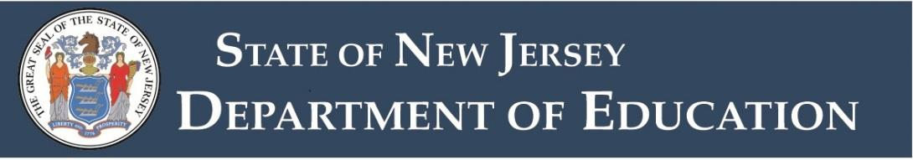

# Middle School with Subject-Matter Specialization in Humanities Grades 5–8 Standard Certificate

Endorsement: 1108

**Note**: Requirements, passing test scores, and fees are subject to change without notice.

This endorsement authorizes the holder to teach English language arts, social studies and related literature, and social and civic engagement courses in grades five through eight in all public schools.

The standard certificate is a permanent certificate issued to an individual who has completed the Provisional Teacher Process, holds a previously issued New Jersey standard instructional certificate, or meets [reciprocity requirements](http://highpoint.state.nj.us/education/certification/reciprocity/index.shtml) for standard certification.

## Certificate Requirement

Hold a middle school with subject-matter specialization endorsement in English language arts or social studies.

## Praxis II Test Requirement

Pass the Praxis II test in the additional content area (Middle School with Subject Matter Specialization: English Language Arts or Middle School with Subject Matter Specialization: Social Studies).

[Test Requirements for Certification in New Jersey](https://www.nj.gov/education/certification/testing/req/index.shtml)



# Middle School with Subject-Matter Specialization in Humanities Grades 5–8 Certificate of Eligibility with Advanced Standing

Endorsement: 1108

**Note**: Requirements, passing test scores, and fees are subject to change without notice.

This endorsement authorizes the holder to teach English language arts, social studies and related literature, and social and civic engagement courses in grades five through eight in all public schools.

The Certificate of Eligibility with Advanced Standing (CEAS) is issued to an individual who has completed a teacher preparation program and met requirements for certification, including academic study and applicable test requirements.

## Certificate Requirement

Hold a middle school with subject-matter specialization endorsement in English language arts or social studies.

## Praxis II Test Requirement

Pass the Praxis II test in the additional content area (Middle School with Subject Matter Specialization: English Language Arts or Middle School with Subject Matter Specialization: Social Studies).

[Test Requirements for Certification in New Jersey](https://www.nj.gov/education/certification/testing/req/index.shtml)



# Middle School with Subject-Matter Specialization in Humanities Grades 5–8 Standard Certificate

Endorsement: 1108

**Note**: Requirements, passing test scores, and fees are subject to change without notice.

This endorsement authorizes the holder to teach English language arts, social studies and related literature, and social and civic engagement courses in grades five through eight in all public schools.

The standard certificate is a permanent certificate issued to an individual who has completed the Provisional Teacher Process, holds a previously issued New Jersey standard instructional certificate, or meets [reciprocity requirements](http://highpoint.state.nj.us/education/certification/reciprocity/index.shtml) for standard certification.

## Certificate Requirement

Hold a middle school with subject-matter specialization endorsement in English language arts or social studies.

## Praxis II Test Requirement

Pass the Praxis II test in the additional content area (Middle School with Subject Matter Specialization: English Language Arts or Middle School with Subject Matter Specialization: Social Studies).

[Test Requirements for Certification in New Jersey](https://www.nj.gov/education/certification/testing/req/index.shtml)