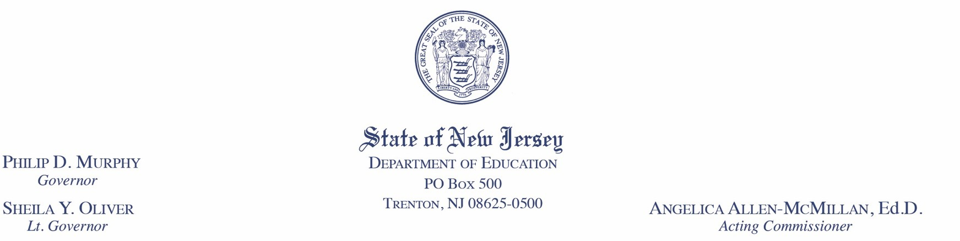

**Date:**  December 14, 2022

**To:** State-Funded Preschool Chief School Administrators

**From:** Cary A. Booker, Assistant Commissioner **CAB**  Division of Early Childhood Services

# **Subject:** Provider Payment Guidance for January - June of the 2022-2023 School Year

In our continued efforts to preserve New Jersey’s preschool ecosystem during this post-pandemic period and its aftermath on enrollment, we are providing this guidance to support the immediate needs of Head Start and contracted providers to ensure the continued mixed delivery partnership. This communication will clarify payment instructions for January 2023 – June 2023. **School districts are advised to continue paying their contracted Head Start and providers for their *contracted* enrollment through June 2023**. **Districts can reduce monthly payments for salaries for classrooms where teachers have not been hired.**

Your commitment to supporting your contracted providers is greatly appreciated. As you review contracted providers’ quarterly expenditure reports, please continue to offer flexibility to move unspent portions of their budgets to cover unexpected costs they incur in response to the demands of the current circumstances.

**The below list is a sample of what unspent funds identified during quarterly reviews should be used for:**

* Recruitment of students to increase enrollment;
* Recruitment of staff;
* Ensuring provider’s teachers are paid parity; and
* Ensuring families have technology (both devices and internet access).

If you have any questions, please do not hesitate to contact your district preschool office liaison. Thank you for your support and attention to this matter.

CAB/TDC/KF

c: Angelica Allen-McMillan, Ed.D., Acting Commissioner

Scott Henry

Kimberly Friddell

Executive County Superintendents

School Business AdministratorsFooter: www.nj.gov/education
New Jersey Is An Equal Opportunity Employer - Printed on Recycled and Recyclable Paper.