Partnerships Advancing Student Success
Division of Teaching and Learning New Jersey Department of Education
Mathematics Instruction

Mathematics Instruction and Parent and Family Engagement in Student Learning

Mathematics – Supporting 1st Grade Students
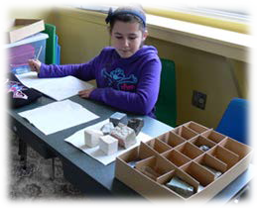

What Students Learn In 1st Grade Mathematics
In grade one, students will work with whole numbers and place value—including grouping numbers into tens and ones as they learn to add and subtract up through 20. Students will also use charts, tables, and diagrams to solve problems.

Activities in these areas will include:
- Quickly and accurately adding numbers together that total up to 10 or less and subtracting from numbers up through 10
- Understanding the rules of addition and subtraction (for example, 5+2=2+5)
- Solving word problems that involve adding or subtracting numbers up through 20
- Understanding what the different digits mean in two-digit numbers (place value)
- Comparing two-digit numbers using the symbols > (more than), = (equal to), and < (less than)
- Understanding the meaning of the equal sign (=) and determining if statements involving addition and subtraction are true or false (for example, which of the following statements are true? 3+3=6, 4+1=5+2)
- Adding one- and two-digit numbers together
- Measuring the lengths of objects using a shorter object as a unit of length
- Putting objects in order from longest to shortest or shortest to longest
- Organizing objects into categories and comparing the number of objects in different categories
- Dividing circles and rectangles into halves and quarters

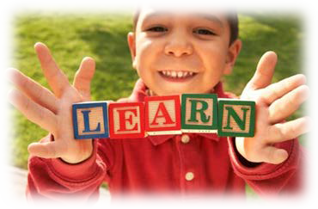
Students will use pictures and diagrams to show addition and subtraction and to compare amounts.
Julie

Ely
Julie has three more apples than Ely. Ely has
three fewer apples than Julie.
3
9
12

Here are just a few examples of the skills and strategies students will develop as they solve word problems in grade one.
Built on knowledge and skills from  prior grade level | Performing on Grade Level | Preparing for next grade level
Kindergarten Mathematics  - Represent addition and subtraction with objects, fingers, mental images, drawings, sounds (such as claps), acting out situations, verbal explanations, expressions, or equations  - Solve word problems by adding or subtracting numbers up through 10 using objects and drawings | Grade One Mathematics  - Solve word problems by adding or subtracting numbers up through 20  - Solve addition and subtraction problems for different unknown numbers (20-?=15, 9+4=?) | Grade Two Mathematics  - Solve one- and two-step word problems by adding or subtracting numbers up through 100
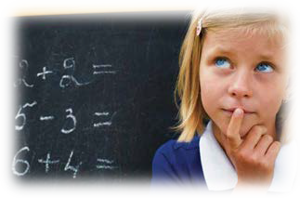
14 Bunnies
-5 Bunnies
9 Bunnies
+
Addition
6 bunnies
+
14 bunnies
=
20
Six bunnies sat
on the grass. More bunnies hopped over. Then there were 14 bunnies.
How many bunnies hopped over?
EXAMPLES OF GRADE ONE WORD PROBLEMS

-  Subtraction | 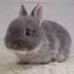
14 bunnies were sitting on the grass. Some bunnies
hopped away. Then there were 5 bunnies. How many bunnies hopped away?

Here are a few examples of how students will develop and use their understanding of place value in grade one.
Built on knowledge and skills  from prior grade level | Performing on Grade Level | Preparing for next grade level
Kindergarten Mathematics  - Count to 100 by ones and tens  - Understand that numbers from 11 to 19 contain a ten and some leftover ones (for example, 14=10+4) | Grade One Mathematics  - Understand that 10 can be thought of as a bundle of ten ones—called a “ten”  - Understand that the two digits of a two-digit number represent amounts of tens and ones (place value)  - Add and subtract numbers through 100 using what students have learned about place value | Grade Two Mathematics  - Understand that 100 can be thought of as a bundle of ten tens—called a “hundred”  - Understand that the three digits of a three-digit number represent amounts of hundreds, tens, and ones (place value)  - Add and subtract numbers through 1000 using what students have
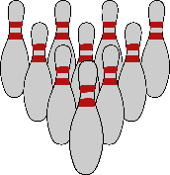
EXAMPLES OF HOW 1ST GRADE STUDENTS USE MODELS AND PICTURES TO SHOW THAT THERE ARE SEVERAL WAYS TO FIND THE CORRECT ANSWER.
47
40 + 7

4 groups of 10 bowling pins and 1 group of 7 bowling pins = 74 pins

Students apply an | 4 | + | 7 | + | 2 = | 49 40 + 7 + 2 = 49
understanding of | Tens |  | Ones |  | Ones
place value to ad
one- and two-digit  numbers together. | 47 | + | 20 | = | 67 | 47 + 20 = 67

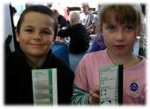
Ely has 12 apples Julie has 9 apples
Students use models and pictures to show that 47 is the same as 47 ones, or 4 tens + 7 ones, and to better understand the relative size of the units.
Compare to begin math problems | Ely has 12 apples. Julie has 9 apples. How many more apples does Ely have than Julie?

Encourage your child to read and write numbers in different ways. For example, what are some ways that your child can make the number 15? 15 can be 10+5, 7+8, 20-5, or 5+5+5.

Ask your child’s teacher for more great ideas!

