Partnerships Advancing Student Success
Division of Teaching and Learning New Jersey Department of Education
Mathematics – Supporting 2nd Grade Students
Mathematics Instruction and Family Engagement in Student Learning
Mathematics Instruction

What Students Learn In 2nd Grade Mathematics

In grade two, students will extend their understanding of place value to the hundreds place. They will use this place value understanding to solve word problems, including those involving length and other units of measure. Students will continue to work on their addition and subtraction skills, quickly and accurately adding and subtracting numbers up through 20 and also working with numbers up through 100. They will also build a foundation for understanding fractions by working with shapes and geometry.

Activities in these areas will include:
- Quickly and accurately adding numbers together that total up to 20 or less or subtracting from numbers through 20
- Solving one- or two-step word problems by adding or subtracting numbers up through 100
- Understanding what the different digits mean in a three-digit number
- Adding and subtracting three digit numbers
- Measuring lengths of objects in standard units such as inches and centimeters
- Solving addition and subtraction word problems involving length
- Solving problems involving money
- Breaking up a rectangle into same-size squares
- Dividing circles and rectangles into halves, thirds, or fourths
- Solving addition, subtraction, and comparison word problems using information presented in a bar graph
- Writing equations to represent addition of equal numbers. In 2nd grade an equation is a mathematical statement that uses numbers and symbols, such as 3 + 3 = 6.

Here are just a few examples of the skills and strategies students will develop as they solve word problems in grade two.
Built on knowledge and skills from  prior grade level | Performing on Grade Level | Preparing for next grade level
Grade One Mathematics  Solve word problems by adding or subtracting numbers up through 20 | Grade Two Mathematics  Solve one- and two-step word problems by adding or subtracting numbers up through 100 | Grade Three Mathematics  Solve two-step word problems by adding, subtracting, multiplying, or dividing numbers up through 100

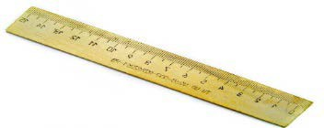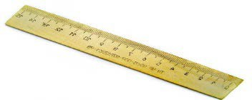

Students learn that 250
= 2 hundreds and 5
tens, 25 tens, or 250
250
2
5
0

2 | 5 | 0 | + | 2 | 5 | 3 | = | 5 | 0 | 3
Hundreds | Tens | Ones |  | Hundreds | Tens | Ones |  | Hundreds | Tens | Ones

Here is an example of how students will develop and use their understanding of place value in grade two.
Built on knowledge and skills  from prior grade level | Performing on Grade Level | Preparing for next grade level
Grade One Mathematics  - Understand that 10 can be thought of as a bundle of ten ones—called a “ten”  - Understand that the two digits of a two-digit number represent amounts of tens and ones (place value)  - Add and subtract numbers through 100 using what students have learned about place value | Grade Two Mathematics  - Understand that 100 can be thought of as a bundle of ten tens—called a “hundred”  - Understand that the three digits of a three-digit number represent amounts of hundreds, tens, and ones (place value)  - Add and subtract numbers through 1000 using what students have learned about place value | Grade Three Mathematics  - Use place value understanding to round whole numbers to the nearest 10 or 100  - Quickly and accurately add and subtract numbers through 1000 using knowledge of place value  - Use place value understanding to multiply and divide numbers up through 100  - Multiply one-digit whole numbers by multiples of 10 between 10 and 90. For  example, 9×80 or 5×60
SECOND GRADE SAMPLE PROBLEM USING DIAGRAMS

Students in 2nd grade will use
Julie has 35 books. Julie has 10 more books than Ely. Question #1: How many books does Ely have? Question #2: How many books do they have together?
diagrams such as

this one to think through and solve one-and two-step word problems.
Step 1: If Ely has 10 less books than Julie, students first need to figure out what 10 less than 35 is.
35 book – 10 books = 25 books

Julie
35

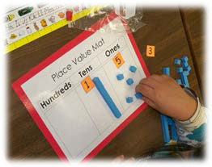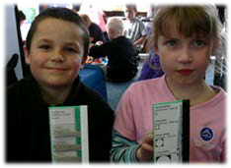How many books does Ely have? 25
=
+
+
Hundreds Tens Ones
Students apply their
understanding that 5 tens + 5 tens = 10 tens, or 1 hundred, that can then be added to the hundreds place.
Ely
Step 2: Students then have to add the number of books Julie has to the number of books Ely has.
35 book + 25 books = 60 books
10
?

How many books do they have together? 60
35 |  | 25

