Partnerships Advancing Student Success
Division of Teaching and Learning New Jersey Department of Education
Mathematics – Supporting 3rd Grade Students
Mathematics Instruction and Parent and Family Engagement in Student Learning
Mathematics Instruction

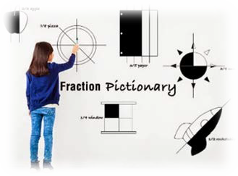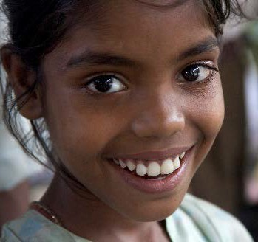What Students Learn In 3rd Grade Mathematics
In grade three, students will continue to build their concept of numbers, developing an understanding of fractions as numbers. They will learn the concepts behind multiplication and division and apply problem-solving skills and strategies for multiplying and dividing numbers up through 100 to solve word problems. Students will also make connections between the concept of the area of a rectangle and multiplication and addition of whole numbers.

Activities in these areas will include:
- Understanding and explaining what it means to multiply or divide numbers
- Multiplying all one-digit numbers from memory (knowing their times table)
- Multiplying one-digit numbers by multiples of 10 (such as 20, 30, 40)
- Solving two-step word problems using addition, subtraction, multiplication, and division
- Understanding the concept of area
- Relating the measurement of area to multiplication and division
- Understanding fractions as numbers
- Understanding and identifying a fraction as a number on a number line
- Comparing the size of two fractions
- Expressing whole numbers as fractions and identifying fractions that are equal to whole numbers (for example, recognizing that 3⁄1 and 3 are the same number)
- Measuring weights and volumes and solving word problems involving these measurements
- Representing and interpreting data

x = 5 groups of 3 tens = 15 tens
5
30
Students understand that 15 tens =
5 tens + 10 tens
(or 1 hundreds).
Students use their understanding of place value as a strategy for multiplying one- digit numbers by multiples of ten. This will prepare them to multiply two multi-digit numbers in grade four.

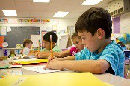=
1
15
5
0

Tens Hundreds Tens Ones

Here are a few examples of how students will develop and use their understanding of place value in grade 3.
Built on knowledge and skills from  prior grade level | Performing on Grade Level | Preparing for next grade level
Grade Two Mathematics  - Understand that 100 can be thought of as a bundle of ten tens—called a “hundred”  - Understand that the three digits of a three-digit number represent amounts of hundreds, tens, and ones (place value)  - Add and subtract numbers through 1000 using what students have learned about place value | Grade Three Mathematics  - Use place value understanding to round whole numbers to the nearest 10 or 100  - Quickly and accurately add and subtract numbers through 1000 using knowledge of place value  - Use place value understanding to multiply and divide numbers up through 100  - Multiply one-digit whole numbers by multiples of 10 between 10 and 90.  For example, 9×80 or 5×60 | Grade Four Mathematics  - Use place value understanding to round multi-digit whole numbers to any place  - Use place value understanding to find the product of two multi-digit numbers  - Recognize that in a multi-digit whole number, a digit in one place represents ten times what it represents in the place to its right  - Compare two multi-digit numbers based on the meanings of the digits in each place, using the symbols > (more than), = (equal to), and < (less than)
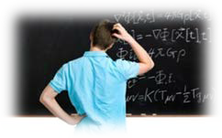
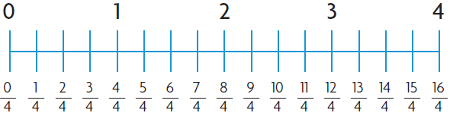
SAMPLE PROBLEM USING A NUMBER LINE
Using a number line helps students think of a fraction as a number.
Third grade students begin to understand that fractions are sometimes the same quantity as a whole number (8/4 = 2) and whole numbers can be expressed as fractions (3 = 12/4).

Built on knowledge and skills  from prior grade level | Performing on Grade Level | Preparing for next grade level
Grade Two Mathematics  - Break circles and rectangles into two, three, or four equal parts  - Describe parts of a whole using the words halves, thirds, half of, a third of, etc.  - Describe a whole as two halves, three thirds, four fourths  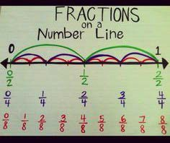 | Grade Three Mathematics  - Determine a fraction’s place on a number line by defining the length from 0 to 1 as the whole and “cutting it” into equal parts  - Understand two fractions as equal if they are the same size or at the same point on a number line  - Compare the size of two different fractions of the same size object. For example, which is bigger, 1⁄8 of a pizza or 1⁄6 of that same pizza? | Grade Four Mathematics  - Break down a fraction into smaller fractions with the same denominator, or bottom number, in more than one way(3⁄8 = 1⁄8+1⁄8+1⁄8 = 2⁄8+ 1⁄8)  - Explain why a fraction is equal to another fraction  - Add and subtract mixed numbers (whole numbers mixed with fractions, such as 1 1⁄5) with the same denominators  - Multiply a fraction by a whole number

