Partnerships Advancing Student Success
Division of Teaching and Learning New Jersey Department of Education
Mathematics Instruction

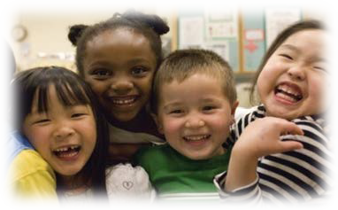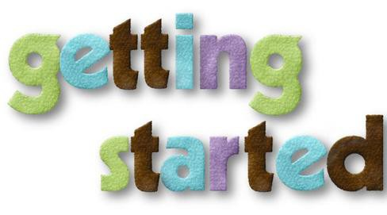
Mathematic Instruction and Parent and Family Engagement in Student Learning
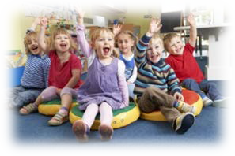
Mathematics – Supporting Kindergarten Students

What Students Learn in Kindergarten Mathematics

In kindergarten, students focus primarily on two important areas. The first is learning numbers and what numbers represent. The second is addition and subtraction. Students will also learn to identify and work with shapes.

Activities in these areas include:
- Counting how many objects are in a group and comparing the quantities of two groups of objects
- Comparing two numbers to identify which is greater or less than the other
- Understanding addition as putting together and subtraction as taking away from
- Adding and subtracting very small numbers quickly and accurately
- Breaking up numbers less than or equal to 10 in more than one way for example, 9=6+3, 9=5+4)
- For any number from 1 to 9, finding the missing quantity that is needed to reach 10
- Representing addition and subtraction word problems using objects or by drawing pictures
- Solving addition and subtraction word problems involving numbers that add up to 10 or less or by subtracting from a number 10 or less
Parents are very important to helping their child begin his or her learning at home and at school. They are the number one teacher in their child’s life. Educators should provide parents with advantages and opportunities to learn about student
experiences in the classroom. With that information, parents can also be a learning support system for the classroom, outside of school and through their child’s future.
Many parents of Kindergarten students want to be involved and participate in their child’s school activities. As students begin school, educators should take the lead to build academic partnerships so that parents will feel free to ask specific questions about learning such as:
- What types of early math activities should my child and I do together?
- Do you know of games or toys that build early math skills at home?
- Are manipulatives, workbooks or computer programs available to borrow from the school?
- What types of everyday items can be used to support math skills at home
- What types of technology could benefit my child’s learning? Do you have suggestions for computer activities or programs at home?

MATH WORD PROBLEMS
Here are a few examples of the skills and strategies students will develop as they solve word problems in kindergarten math.

Performing on Grade Level | Preparing for the next grade level | Preparing for the following grade level
Kindergarten Mathematics  - Represent addition and subtraction with objects, fingers, mental images, drawings, sounds (such as claps), acting out situations, verbal explanations, expressions, and equations  - Solve word problems by adding or subtracting numbers up through 10 using objects and drawings | Grade One Mathematics  - Solve word problems by adding or subtracting numbers up through 20  - Solve addition and subtraction problems for different unknown numbers (20-?=15, 9+4=?) | Grade Two Mathematics  - Solve one- and two-step word problems by adding or subtracting numbers up through 100

SAMPLE PROBLEM KINDERGARTEN WORD PROBLEMS

Addition | Three red apples and three green apples are on the table. How many apples are on the table?
Subtraction | Mom as ten apples. She gives one to Timothy. How many apples are left?

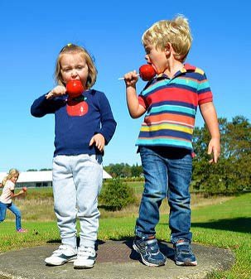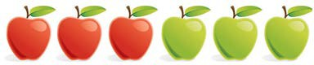

In kindergarten students use a variety of pictures and models to understand and solve
addition and subtraction problems.

PLACE VALUES
Here are a few examples of how students will work with numbers and learn to think of ten as a unit – important

Performing on Grade Level | Preparing for the next grade level | Preparing for the following grade level
Kindergarten Mathematics  - Count to 100 by ones and tens  - Understand that numbers from 11 to 19 contain a ten and some leftover ones (for example, 14=10+4) | Grade One Mathematics  - Understand that 10 can be thought of as a bundle of ten ones—called a “ten”  - Understand that the two digits of a two-digit number represent amounts of tens and ones (place value)  - Add and subtract numbers through 100 using what students have learned about place value | Grade Two Mathematics  - Understand that 100 can be thought of as a bundle of ten tens—called a “hundred”  - Understand that the three digits of a three-digit number represent amounts of hundreds, tens, and ones (place value)  - Add and subtract numbers through 1000 using what students have learned about place value

Students learn to find the “partners” that make ten for any number. This drawing shows that if you have 8, it takes 2 more to make 10.

14

10 +

From there, students learn to think of ten as a unit and to break all the ten numbers down to a ten and
4 some leftover ones.

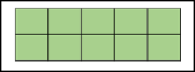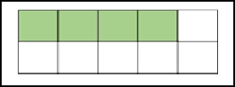

SAMPLE PROBLEM UNITS OF TEN
The NJ DOE uses the term "parent" to refer to any adult who plays the primary role in a child's family life.
Throughout the PASS model the terms parent and family are used broadly to include adults who have a significant responsibility in a child’s life. The model recognizes and respects that other individuals may also have opportunities to support the parenting, education and well-being of children and youth. Such individuals might include grandparents, relatives, stepparents, adult siblings, guardians, foster parents, etc.

The PASS model utilizes the term "parent" to refer to any adult who plays the primary role in a child's family life.

