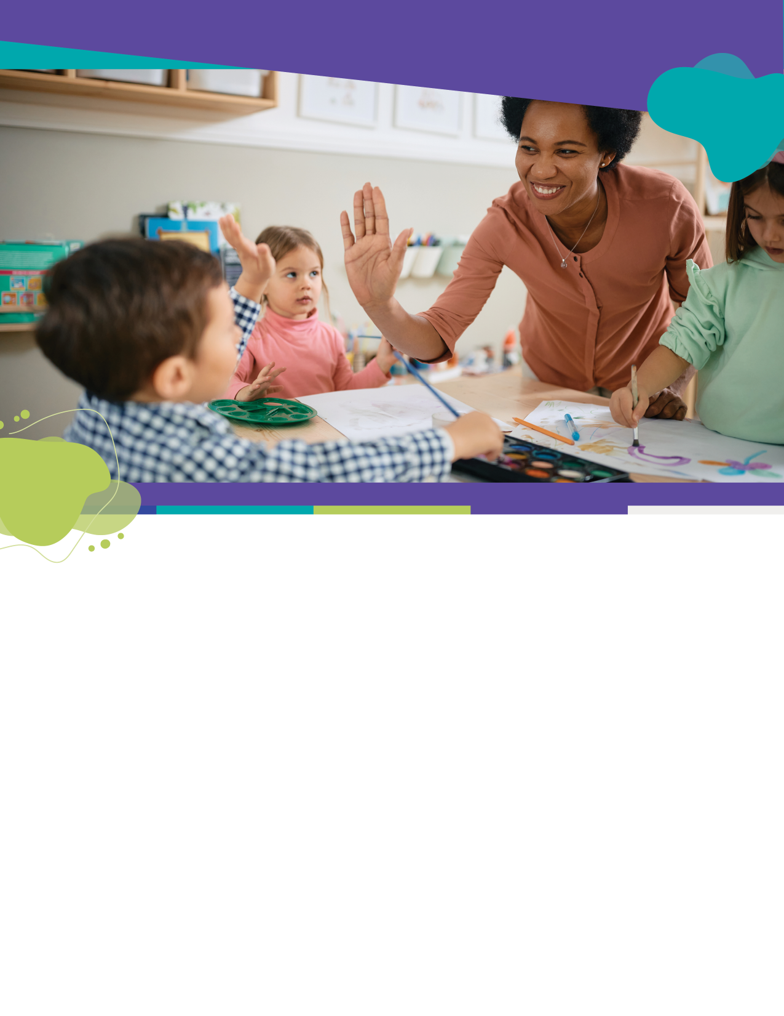Approaches to Learning: How Young Children Learn

Principles For Use Across New Jersey's  
Preschool Through Third Grade (P–3)  
Teaching and Learning Continuum

Overview for Teachers, Administrators and Families

New Jersey Department of Education [Division of Early Childhood Services](https://www.nj.gov/education/earlychildhood/p3alignment/)

***Approaches to Learning: How Young Children Learn*** *presents eight principles for use across NJ’s P–3 teaching and learning continuum*and summarizes a set of developmental concepts based on decades of research into how young children learn. Consistent with nationally recognized frameworks, these principles were developed to ensure that children in preschool to third grade are provided with *opportunities to learn* that align with *how they learn*. Teachers can use these principles to inform their instruction.

New Jersey's P–3 Learning Principles are at the center of early education.   
(Text version of diagram)

## 1. Children’s brains develop rapidly and in ways that help them organize and understand their worlds.

Children are naturally curious about the objects and people around them. Their brains work in ways that help them organize their experiences. Using all their senses, children seek new stimulation over old stimulation; classrooms should be structured to balance the level of stimuli competing for children’s attention. Over time, they get better at controlling impulses and focusing their attention. They begin to understand the concept of cause and effect, and they see that their actions can impact other people and their environment. Having structures that are predictable wherever possible helps children build this understanding and their executive functioning skills.

## **2. Children’s thinking is imaginative and can be fostered***.*

While children are learning, they often propose unusual solutions because they have not learned the “right” answer. This is normal and should be encouraged! Allow them to exercise their creativity (the sky does not always have to be colored blue). Understand that children may make connections differently from adults (e.g., they may think a zebra makes a sound like a horse). Supporting creativity can ultimately help them learn better even if they do not have the perfect answer right away.

## **3. Children’s learning and development are multidimensional***.*

Like adults, children have strengths and weaknesses. One child might be great at building with blocks while another is better at drawing. One child may show considerable empathy for others while another child may be athletically inclined. It is important to look at the whole child and not to focus only on children’s strengths. An area of strength can be used to build up an area of weakness. For example, a child might learn counting more easily if they are bouncing a ball, but another child might learn better by looking at pictures or hearing a story. Try not to see children as innately “good” or “bad” at something, but instead recognize that learning happens across domains and young children need to be nurtured mentally, physically, *and* emotionally.

## 4. Children’s learning tends to follow a predictable, progressive learning sequence.

For most children, learning happens in relatively predictable sequences. For example, most children learn to make sounds, then speak words, then recognize letters, then write words. Some children move through these stages faster than others. Some children move slower, but the general path follows similar milestones. It can be reassuring to know that all children develop at slightly different rates, but it can also be a sign to investigate any issues if a child is significantly off the “predictable” sequence.

## **5. Children’s learning fluctuates***.*

Like adults, children need to have many chances to practice new skills as they are learning. But sometimes they may seem to be going backwards. Especially when they have a lot of new information to try and make sense of, children may appear to lose some newly found skill or forget new knowledge. This “regression” is not necessarily a bad thing. As children have more time to use new skills and knowledge, they become more consistent and are better prepared to move on and add additional information.

## **6. Children’s emotional security and regulation skills are essential to successful learning.**

When children feel emotionally secure at home and at school, they can learn better. They can focus more on learning and are more likely to try challenging tasks. They are often better behaved and tend to have more positive self-esteem and self-confidence. Building strong relationships with family members, teachers, and peers can help reduce stress and positively impact learning. Helping children understand and name their emotions can lead to better-developed emotional regulation skills, which in turn help students learn.

## 7. Children learn better with a well-developed sense of self-agency

When children are allowed to make choices about what they are learning, they are more likely to enjoy the process and feel more engaged and motivated. To whatever extent possible, adults working with children should give them options and some control over *how* they learn. Give children a range of materials to choose from (different color pencils, or the choice to listen to an audio book instead of reading it), chances to work with peers (the choice to work as partners or alone), or the opportunity to experiment (what happens when different colors are combined, or how many equal groups can be made from 20 blocks).

## 8. Joyful play supports children’s learning and development.

Young children are usually active and looking for new adventures and stimulation. Use this inclination to help them learn through play! Take advantage of children’s natural tendencies to play to support their learning. As children get older, and learning becomes more structured and formalized, playful learning can be even more important in helping children learn. Build in opportunities to learn through play as much as possible.

More information about the research evidence supporting these ideas can be found on the NJDOE Early Childhood Education’s [P–3 Alignment](https://www.nj.gov/education/earlychildhood/p3alignment/) webpage. See related resources on the [NJDOE Division of Early Childhood Services](https://www.nj.gov/education/earlychildhood/index.shtml) website.

## Text Version: New Jersey's P–3 Learning Principles Diagram

1. Organize and understand
2. Foster imagination
3. Multi-dimensional
4. Sequence
5. Fluctuates
6. Security and Regulation
7. Self-Agency
8. Joyful play and learning

Back to place in document: 1. Children’s brains develop rapidly