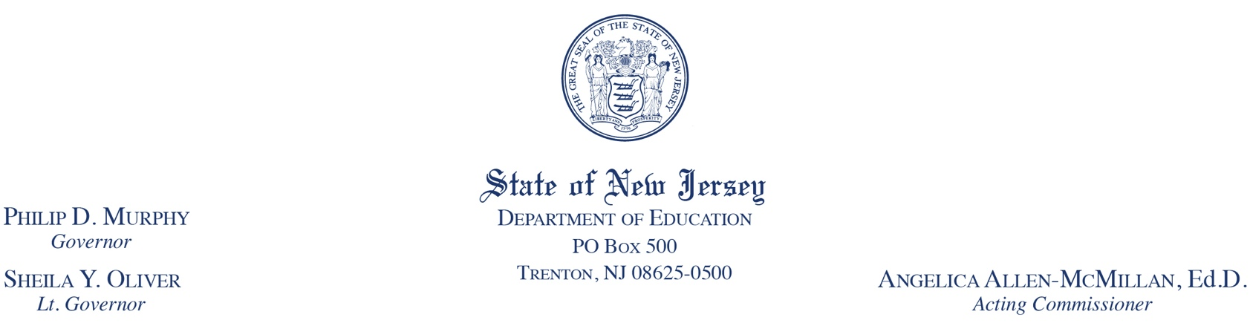

To: Public school districts required to use state-approved contracts for
Private Providers and Head Start Programs
Date: May 2, 2022
From: Tonya D. Coston, Executive Director
Division of Early Childhood Services
Subject: 2022-2023 Preschool Education Program Contracts
School districts that are required to use a preschool education program contract when contracting with Department of Children and Families-licensed Head Start Programs or private providers for the 2022-2023 school year must use the standard, state-approved Preschool Education Program Contract templates provided by the Department of Education (DOE).
Attached are the updated, standard, state-approved Preschool Education Program Contract templates for 2022-2023. The contract templates will also be posted to the NJDOE’s website for providers and for Head Start programs. Please note that districts must submit all contracts electronically, via Homeroom. The Division of Early Childhood Services (DECS) will no longer accept paper copies of revised or fully executed contracts.
To upload contracts, visit NJDOE’s website for Homeroom, https://homeroom.state.nj.us/ and upload documents to the “Early Childhood” hyperlink listed in the “Homeroom Administration” column. Please remember that you will need your District ID, Username and Password to upload documents. Districts without an account for this application must contact their district's Homeroom Administrator to establish an account.
For both private provider and Head Start contracts, please remember to include the number of students that the district is serving. Also, take note that a “Subrecipient” section is a new addition to the contract and the “Financial Management” section has additional language regarding audits.
Also, please be aware that a Child Abuse Record Information (CARI) and a Criminal History Record Information (CHRI) is required of anyone entering the private providers’ and Head Start Grantees’ classrooms. Head Start Grantees and Private providers will provide an affidavit to the districts verifying
that all procedures were properly followed. Individual copies of CARI and CHRI background check information will no longer be accepted. According to the Child Care Center Licensing Law (N.J.S.A. 30:5B1-1to 15, supplemented by P.L. 1992, c.95.) and the Manual of Requirements for Child Care Centers (N.J.A.C. 3A:52). The CARI and CHRI background information is governed by confidentiality and dissemination statutes that prohibit this information from being shared with unauthorized persons.
Additionally, please review the “Definitions” section of both the provider and Head Start contracts, which provides clarification of the term “homeless children and youths,” in accordance with the McKinney-Vento Homeless Assistance Act.
Finally, please note the addition of the Pre-Employment Resources Statute, P.L. 2018, c. 5, in the contract templates which mandates that all school districts, charter schools, nonpublic schools and contracted service providers make certain inquiries regarding child abuse and sexual misconduct of prospective employees who will have regular contact with students.
Please note the following Head Start-specific additions to the state-approved Preschool Education Program contract template:
Head Start Program Performance Standards requirements addressing chronic absenteeism are referenced.
Coaching and classroom support on the chosen curriculum and ECERS-3 will be provided jointly by Master Teachers and Head Start Education Supervisors/Coordinators.
Head Start Grantees and districts will coordinate professional development activities.
The section on suspension and expulsion includes information from the Head Start Program Performance Standards and state policies, along with the use of the Pyramid Model for Supporting Social and Emotional Competencies to reduce challenging behaviors.
For school districts using the standard state-approved Preschool Education Program Contract template without modifications:
All fully executed contracts must be received by the department within 60 days of the school district’s receipt of this memo.
For school districts requesting modifications to the standard state-approved Preschool Education Program Contract template:
Districts must seek and receive approval from the DOE prior to executing the contract.
The DOE will not accept modifications that repeat language or citation contained in N.J.A.C.6A:13A.
Modifications to the standard state-approved preschool education program contract template must be submitted to the Division of Early Childhood Services by July 30, 2022 for approval. Requests for modifications submitted after this date will not be considered.
All contract modification requests will be reviewed and approved as they are received. The DOE must approve all modified state-approved preschool education program contracts prior to discussion and/or dissemination to Head Start Grantees or providers.
Modification requests must be submitted on the standard contract template. Additions must be indicated by underlining and highlighting. Deletions must be indicated with a strike through.
Fully executed contracts must be received by the department within 60 days of the school district’s receipt of contract modification approval.
If you have any questions, please contact Erika Kelley, Division of Early Childhood Services or Suzanne Burnette, Director, Head Start Collaboration Office at 609-376-9077.

