

New Jersey Department of Education Division of Early Childhood Services

Preschool Budget and Operational Plan (PBOP)

Contact Sheet Guidance

Purpose of this Guide
The purpose of this guide is to provide district staff with step-by-step instructions for creating, completing, reviewing, and acknowledging the District Contact Sheet in the PBOP System. By following this guide, districts can ensure that all required contact information, board resolution details, and staffing information are entered accurately and completely, supporting timely communication and successful completion of PBOP requirements.

Accessing the District Contact Sheet
Log in to the PBOP System. From the home screen, select the link to open a ‘New Contact Sheet’.
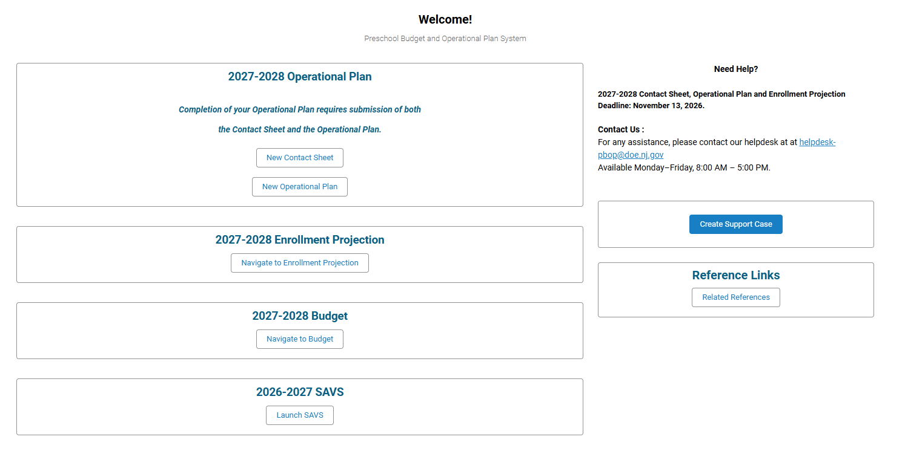
On the next screen, you will see brief ‘Contact Sheet Directions’. Click ‘Next’ or if you need to continue at a later time, click ‘Save for later’.
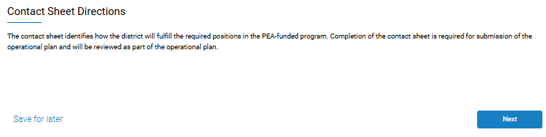
On the next screen, your current district information is displayed. The district information should be reviewed carefully to ensure all information is accurate and complete. If there are any errors on this screen, please contact the PBOP helpdesk at helpdesk-pbop@doe.nj.gov. After reviewing the existing information, click ‘Next’ to continue. See an example below:
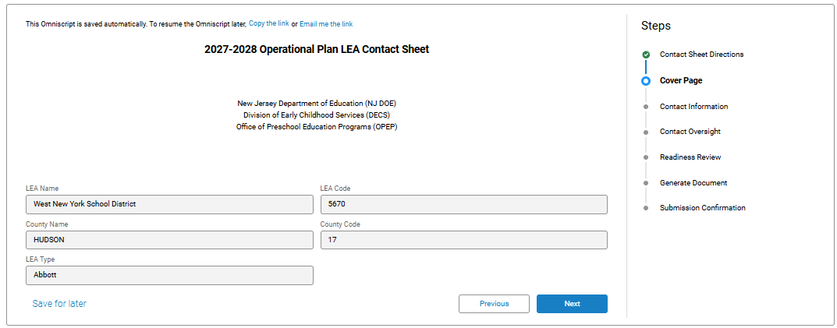

Completing the District Contact Information

Entering the Superintendent, Primary Early Childhood Contact, and Business Administrator:
After selecting ‘Next’, the District Contact Information screen will open. All required fields must be completed, including salutations, name, telephone numbers, extensions, and email addresses. These fields may already have been auto populated based on the information that was entered in the past. You may need to edit the title and/or add the salutation. To do this click on the drop down arrow and choose ‘Edit’.
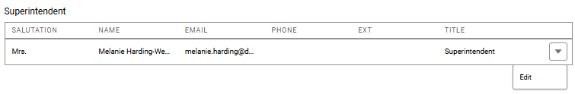
No other fields can be edited. If there are any other errors, contact the helpdesk-pbop@doe.nj.gov.
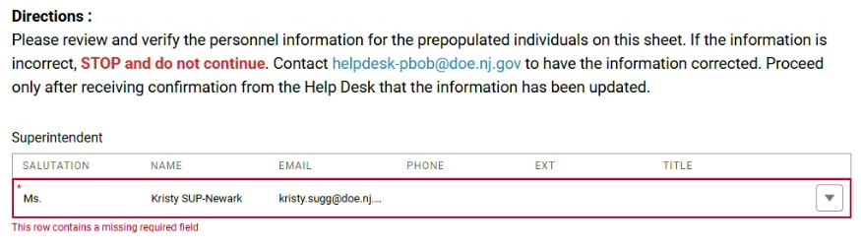
After choosing to ‘Edit’ a position, the position details will appear. Review all fields. If the salutation needs to be added or edited, or the Title needs to be edited, this can be done by clicking on the ‘Update Contact Data’ box. Click the box and make the allowable changes.
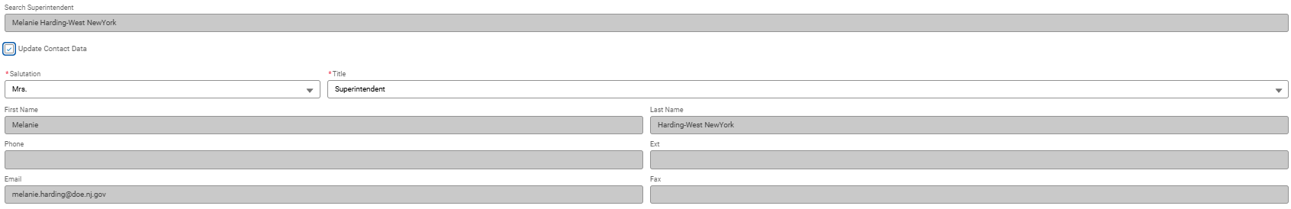
Repeat this process for all other required positions within your program. Please keep in mind that it is not necessary to complete contact information for all positions. See below for guidance:
- Primary Early Childhood Contact: This is a mandatory position and must be entered. This person is an in-district administrator who oversees the preschool program. For school districts with fewer than 750 enrolled preschool children, this position may be combined with another in-district school administrator position with the same certification and qualifications (e.g. the superintendent may also serve as the Early Childhood Contact).
- Business Administrator: This is a mandatory position and must be entered.
- Secondary Early Childhood Contact: When adding a secondary contact, understand that this person will have full access to all documents, including the plan, budget, and SAVS. This is not a mandatory position and can be left blank.
- Fiscal Contact or Fiscal Specialist: Only if applicable. This is not a mandatory position and can be left blank. If there is no fiscal contact for the district, the BA will automatically be entered here.
- Early Childhood Supervisor: LEAs only need to provide the Early Childhood Supervisor for LEAs with 750 students or more. This is not a mandatory position if the LEA has less than 750 preschool students and can be left blank.
If there is missing information, an alert message will show that there is missing information. If this is seen, click on the drop down arrow and click on edit. See below for an example where the salutation is missing and needs to be added:
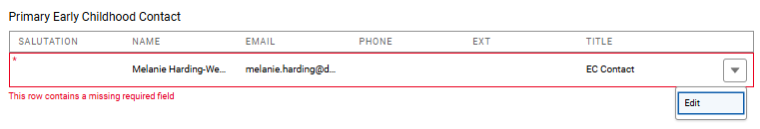
When all information is entered, click "Next".

Staffing Questions and Administrative Oversight
The next section of the District Contact Sheet captures the district's staffing plan for required Preschool Education Aid positions.

Contact Oversight
Respond to each staffing question by selecting ‘Yes’ or ‘No’, as appropriate, then click ‘Next’.
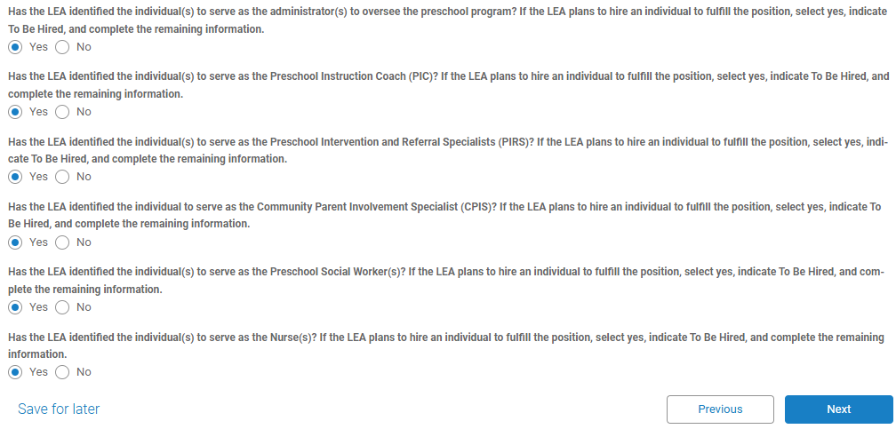

Administrative Oversight and Required Preschool Roles
To input the Early Childhood Administrator (Early Childhood Contact), click ‘Add Admin’ and complete all required fields. Click ‘Save’.
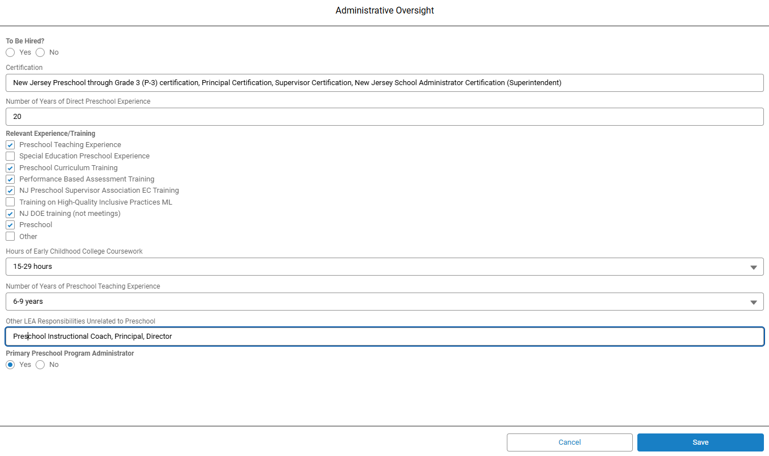
In addition to the Administrative Oversight, the District Contact Sheet includes staffing information for the following required positions:
- Preschool Instructional Coach
- Preschool Intervention and Referral Specialist
- Community Parent Involvement Specialist
- Preschool Social Worker
- Preschool Nurse
Continue to fill in the rest of the requested information. For each required preschool role, districts must provide staffing information. When adding a position, you can search for a previously entered staff member.
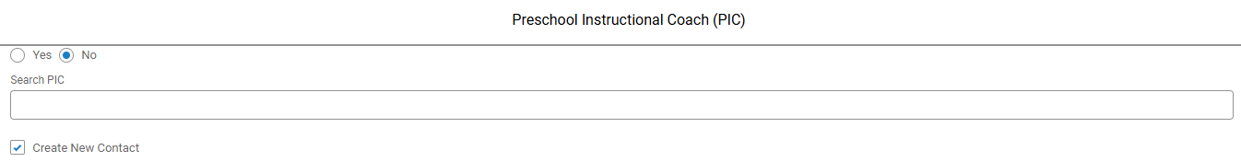
See below for an example of an entry for a Preschool Instructional Coach:
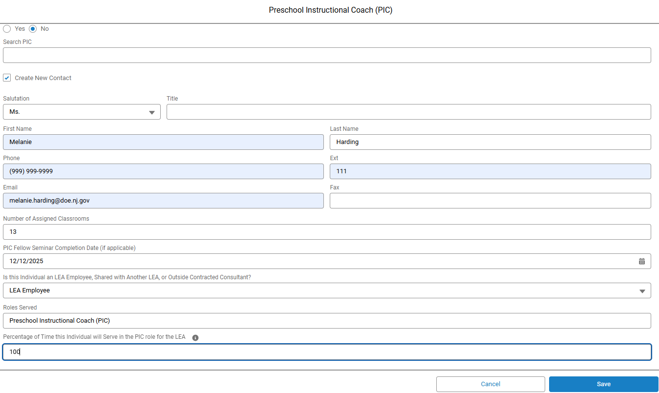
After entering and saving all required staffing information, click ‘Next’.

Reviewing and Acknowledging the District Contact Sheet
- Once all information has been entered, districts should carefully review the Contact Sheet before acknowledging completion. Confirm that all required contacts and staffing positions have been entered. After a careful review of your entries, check the box to acknowledge that the contact sheet is complete and then select ‘Ready for Acknowledgement’ or ‘Save for Later’ to continue at a later time.
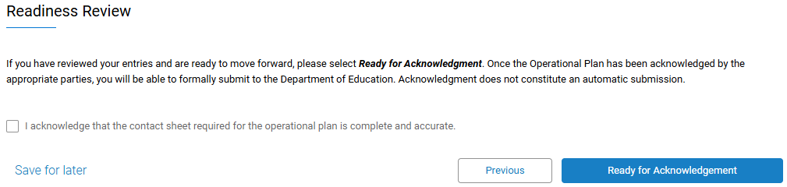
When you select ‘Ready for Acknowledgement’, the system will generate a PDF version of the District Contact Sheet containing all information entered by the district. Districts will then be able to download the PDF, review all entered information, and verify accuracy before final acknowledgment.
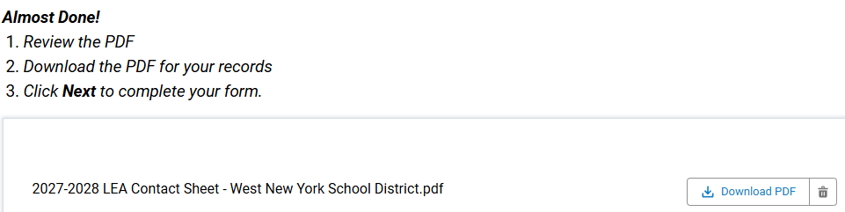
If corrections are required:
- Click ‘Previous’ to return to earlier sections and make revisions; or
- Select ‘Save for Later’ to continue at a later time
If no changes are required:
- Scroll to the bottom and click ‘Next’.
At this stage, the District Contact Sheet has been completed but has not yet been submitted as part of the district's overall PBOP submission process. To continue, select ‘Navigate to the Home Page’, ‘Operational Plan Details’. Click the Home button to return to the PBOP main menu. Proceed with completion of the Operational Plan.
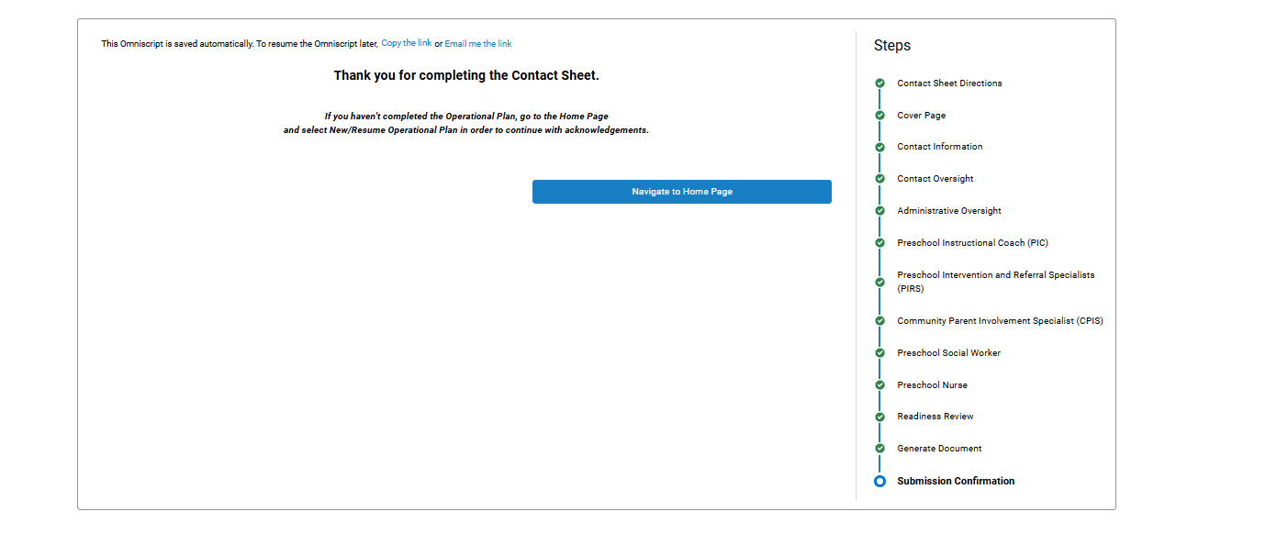
Note: Final submission occurs during the Operational Plan submission process. Completing the District Contact Sheet is a required prerequisite for submitting the district's Operational Plan documentation for final approval to the DOE. The district can update the contact sheet prior to submitting the Operational Plan at anytime. After the Operational Plan is complete, the Contact Sheet is able to be submitted along with the Operational Plan.
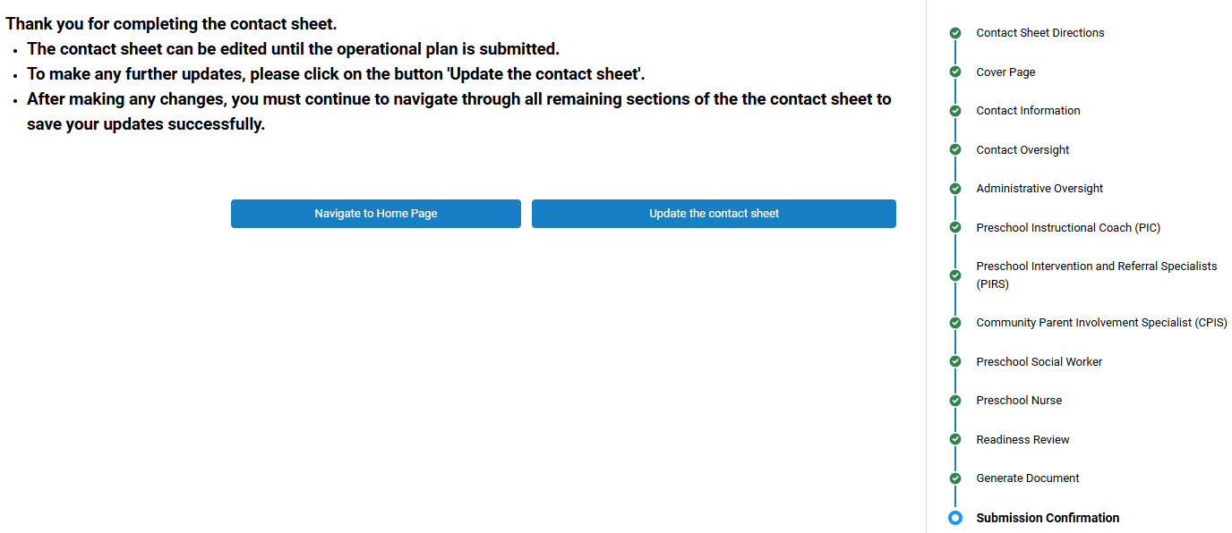

Entering Board Resolution Information
The District Contact Sheet and Operational Plan requires districts to provide the date of the Board of Education resolution associated with preschool program submissions. First, if the board resolution date has already occurred, select the ‘Date of Board Resolution’ to enter the applicable Board Resolution date. Once the date is entered you will be prompted to upload the board resolution document as well as click on which submission(s) the board resolution supports (see below).
If the board resolution date is in the future, the district may continue working in PBOP and upload the board resolution document at a later date once it has been approved. After entering the board resolution information, click ‘Next’.

