

New Jersey Department of Education Division of Early Childhood Services

2026-2027 Preschool Budget and Operational Plan (PBOP)

Enrollment Projections User Guide

Purpose of this Guide
This guide provides step-by-step instructions for completing and submitting Annual Enrollment Projections in the Preschool Budget and Operational Plan (PBOP).

Access the Enrollment Projections
- Log in to the PBOP System and navigate to the Home Screen at the top left of the screen.
- From the Home screen, select ‘New Enrollment Projection’.
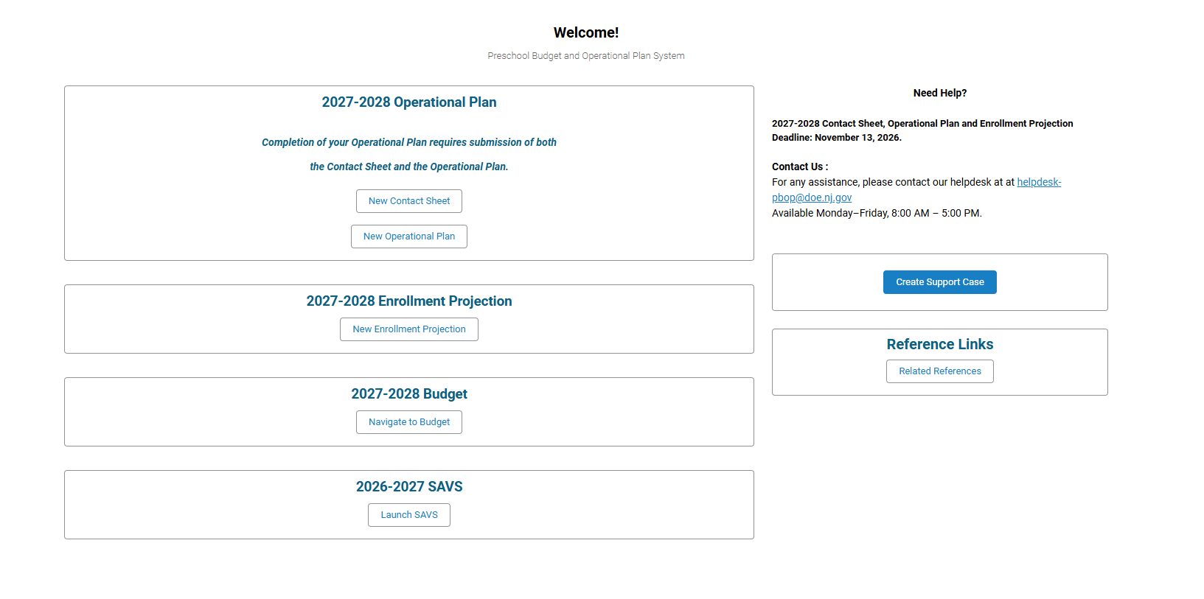

Complete the ‘Preschool Classroom Updates and Eligibility’ Information

On the Preschool Classroom Updates and Eligibility screen:
- Select the Board Meeting Date that approved the enrollment projection submission. Click on the calendar icon to add a date.
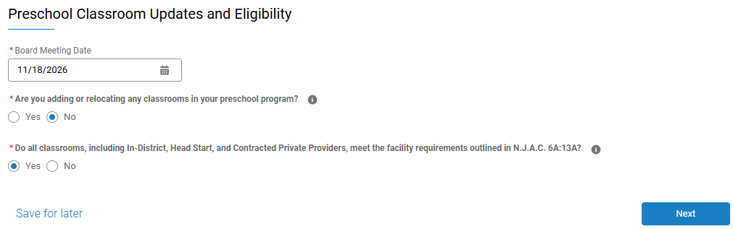
- Next, answer the question, “Are you adding or relocating any classroom in your preschool program”. As a reminder, this is referring to the 2027-28 school year. If the answer is no you will click on ‘No’ and go to the next question.
- If the answer is yes, the question will expand for more information (see below). Also, if the answer is yes, floor plans will need to be uploaded.
- At this point click, “Add Facility”:
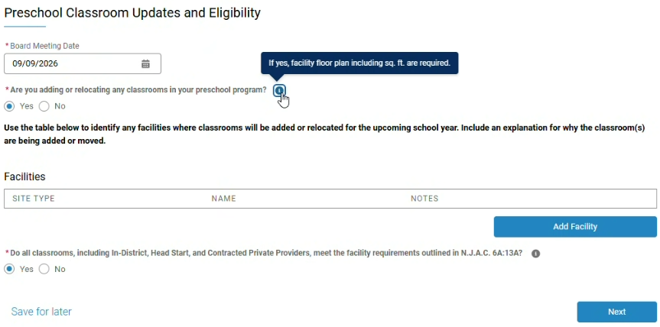
- On the next screen, click on the drop down box to indicate whether the district is adding or relocating a classroom to one of the following site types. Click on the site type:
  - In-District Regular/Inclusion Site
  - Contracted Enhanced Head Start Site
  - Contracted Other Private Provider Regular/Inclusion Site
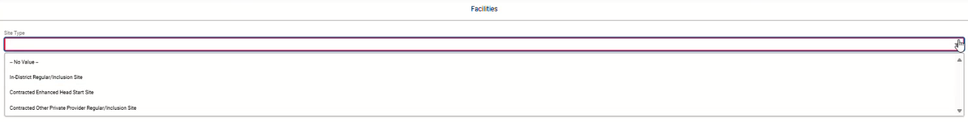
- At this point, you will be required to choose the site type, input the name of the site, and enter any notes explaining why this classroom is being added or relocated.
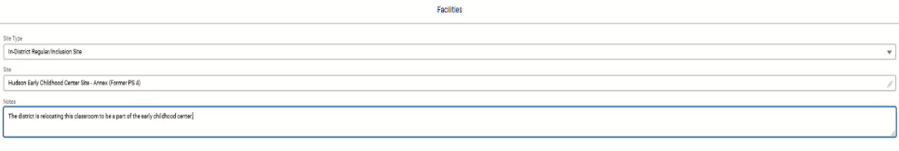
- After the information about the site is inputted, click ‘Save’.
- Next, complete the additional facility-related question “Do all classrooms meet the facility requirements?”. Click Next to continue.
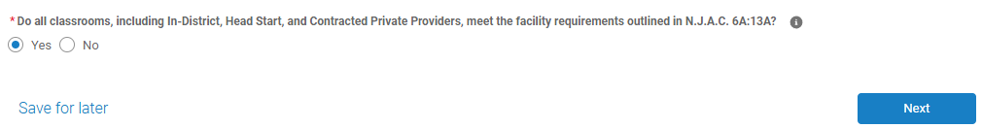

Complete the Annual Enrollment Projections Chart

In-District Programs

General Education Children (row 1)
Enter projected enrollment for:
- 3- and 4-year-old general education children in general education classrooms (row 1)
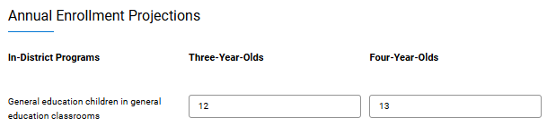
Example of Row 1

Special Education Children in General Education Classrooms (row 2)
Enter projected enrollment for:
- 3- and 4-year-old children classified as special education and placed full-time in general education classrooms (row 2)
Example of Row 2

General Education Children from other Local Education Agencies (LEAs) paying tuition (row 3)
If applicable, enter projected enrollment for:
- 3- and 4-year-old tuition-paying general education children from other LEAs (row 3)
Example of row 3

Self-Contained Special Education Classrooms (row 4)
Enter projected enrollment for:
- 3- and 4-year-old classified special education children. Please keep in mind that these self-contained classrooms are not funded through Preschool Education Aid (PEA).
Example of row 4

PEA Eligible In-District Classrooms
Insert projected number of In-District PEA Classrooms. Do not include self-contained special education classrooms.
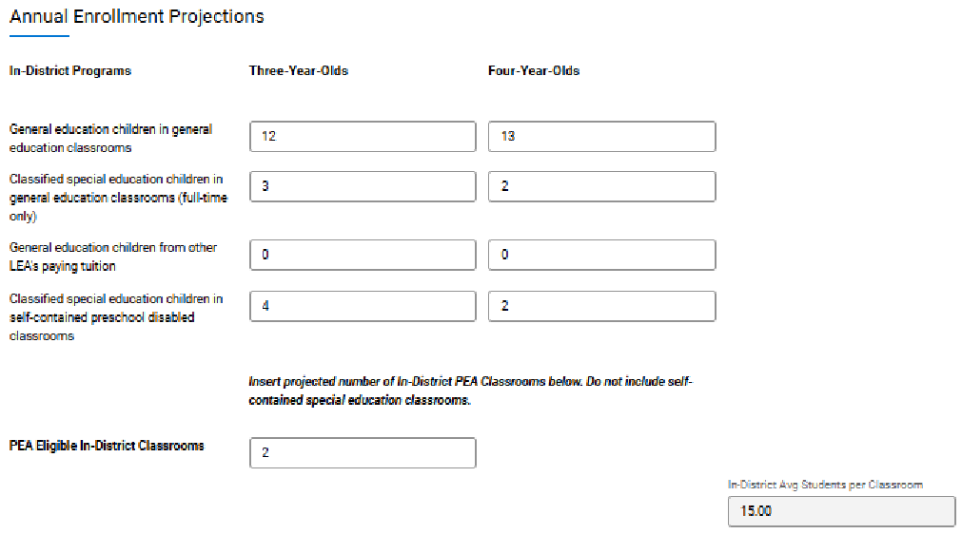
Important Note: If the number of children that are entered into the general education classrooms exceeds 15 children, an error will appear (see below). If this error appears, simply add up the children you entered in the section and divide by the amount of classrooms you indicated that you would have. In the example below there are 31 children entered, which is one child too many. Revise the projection so no more than 15 are in a classroom.
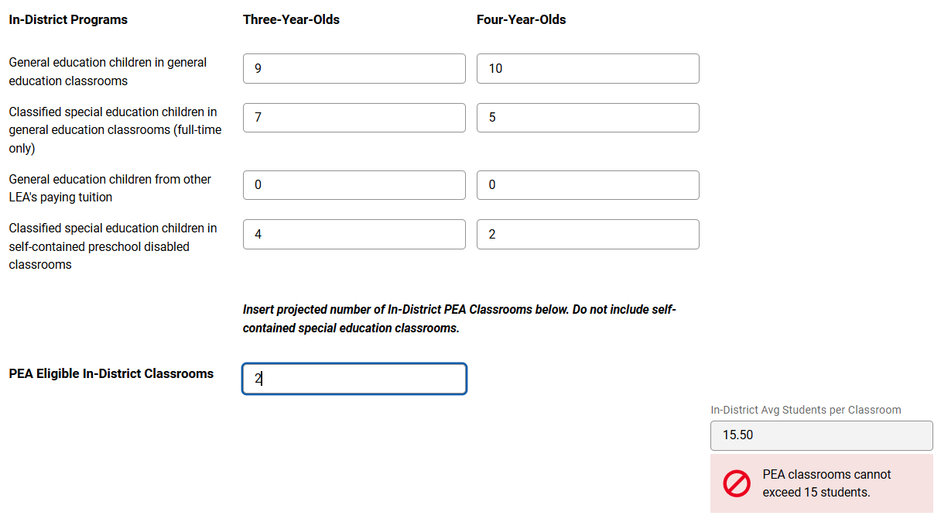

Complete Charter School Enrollment Projections (if applicable)
Before entering charter school enrollment data, confirm projected enrollment numbers with your DOE District Liaison.
Enter the total projected enrollment for:
- 3- and 4-year-old general education children in general education classrooms. (row 1)
- 3- and 4-year old classified special education children in general education classrooms (full-time only). (row 2)
- 3- and 4- year-old general education children from other LEA’s paying tuition. (row 3)
- 3- and 4-year-old classified special education children in self-contained preschool disabled classrooms. (row 4)
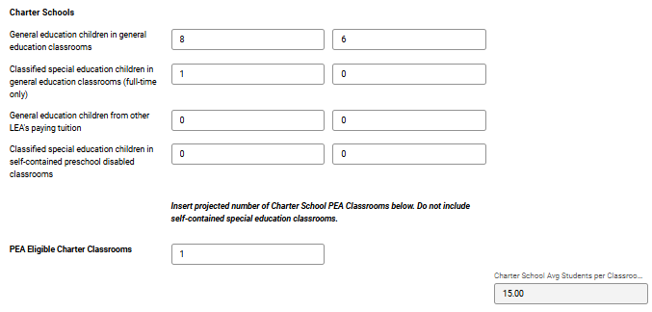

Complete Head Start Programs Enrollment Projections (if applicable)
Enter the total projected enrollment for:
- 3- and 4-year-old general education children in general education classrooms. (row 1)
- 3- and 4-year old classified special education children in general education classrooms (full-time only). (row 2)
- 3- and 4- year-old general education children from other LEA’s paying tuition. (row 3)
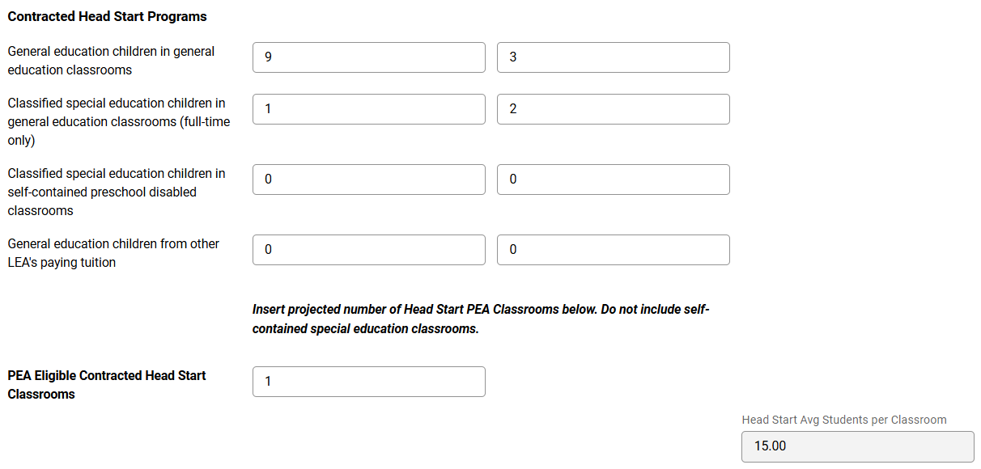
- 3- and 4-year-old classified special education children in self-contained preschool disabled classrooms. (row 4)

Complete Other Contracted Provider Enrollment Projections (if applicable)
Enter the total projected enrollment for:
- 3- and 4-year-old general education children in general education classrooms (row 1)
- 3- and 4-year old classified special education children in general education classrooms (row 2)
- 3- and 4- year-old general education children from other LEA’s paying tuition. In the last box on line 3, be sure to enter the total PEA eligible classrooms (row 3)
- 3- and 4-year-old classified special education children in self-contained preschool disabled classrooms (row 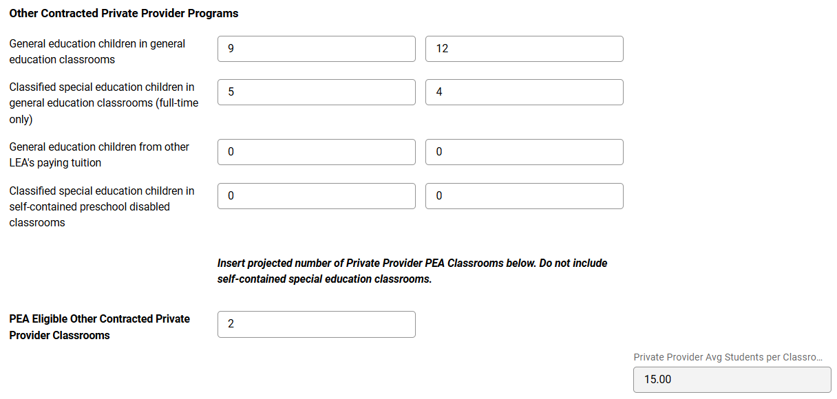

Review and Verify Information
After completing all enrollment sections, scroll down and review all information entered. Choose one of the following actions:
- Save for Later (to return later).
- Previous (to make corrections).
- Check the confirmation box indicating the information is correct. After checking the confirmation box indicating all information is correct and ready for submission, click ‘Ready for Acknowledgement’.

Download the Enrollment Projection PDF
Click ‘Download PDF’ and save the generated PDF for district records.
Scroll to the bottom of the screen and select one of the following:
- Save for Later
- Previous to make edits
- Next to proceed
Sample of page 1 of the PDF is below:
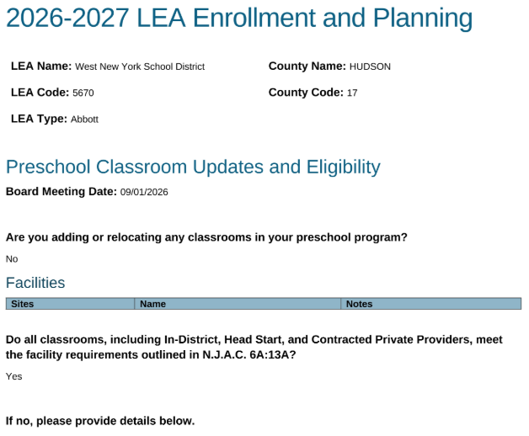

Sample of page 2 of the PDF is below:
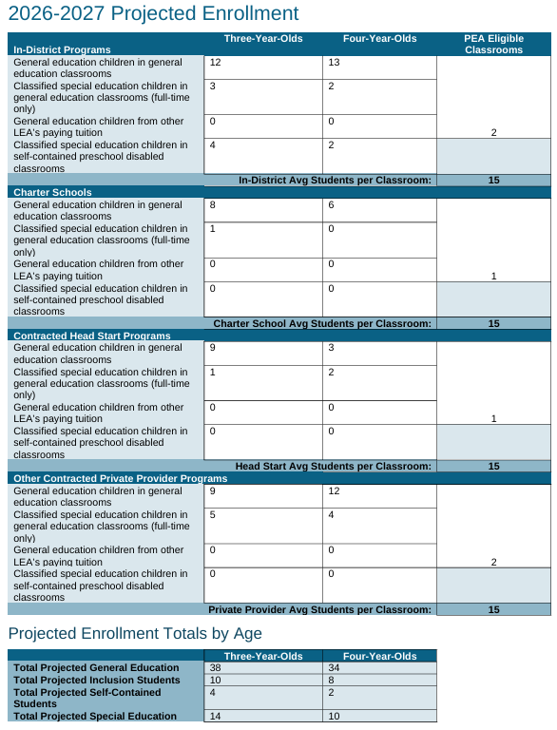

Acknowledgement Completion
After selecting ‘Next’, the system will display a message indicating that the Annual Enrollment Projection has been completed; however, the submission has not yet been submitted to the DOE. Click ‘Continue to Projection Details’.
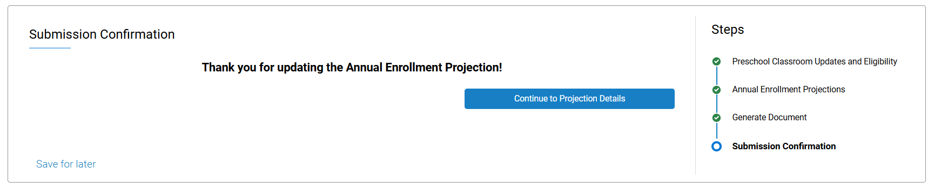

Certification and Approval Process

Business Administrator (BA) Certification
The Business Administrator must:
- Review and complete the Annual Enrollment Projection.
- Click ‘Sign Certification’.
- Read the certification and click on the orange pencil to sign and certify. Click ‘Next’.
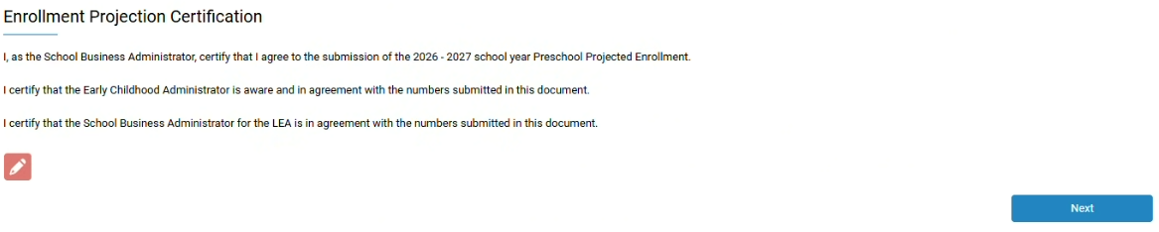
- Complete the Signature fields and click ‘Proceed’.
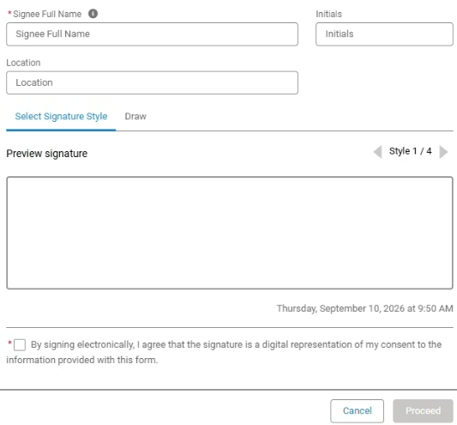
- The certification will appear on the screen. Click ‘Next’.
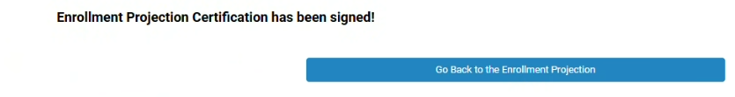

Superintendent Certification
- The Superintendent will receive a chatter post from the BA requesting their signature.
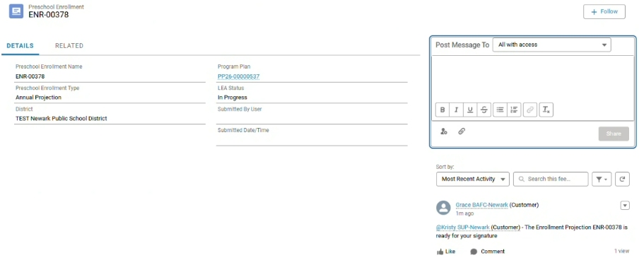
Chatter Post from BA to Sup.
- After receiving the chatter post, the Superintendent would click ‘Navigate to Enrollment Projection’.
- The Superintendent will click ‘Sign Certification’.
• Read the certification and click on the orange pencil to sign and certify.
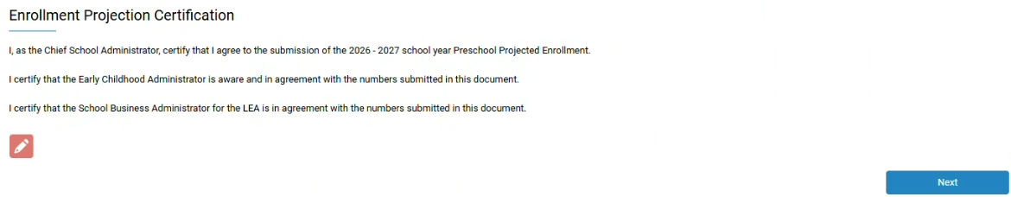
- Complete the Signature fields and click ‘Proceed’.
- Once the Superintendent has acknowledged and signed, click ‘Go Back to the Enrollment Projection.
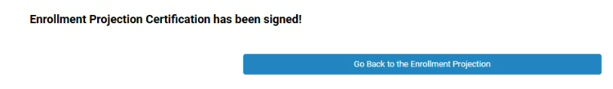
- The Superintendent or the Business Administrator can return to the Preschool Enrollment Projections and click ‘Submit for DOE Review’.
- After clicking ‘Submit for DOE Review’, a message will appear that the Enrollment Projection was successfully submitted. Click ‘Finish’.
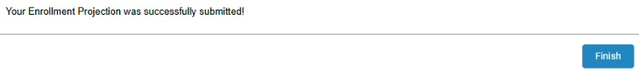
The enrollment projection is now officially submitted to the New Jersey Department of Education. The LEA status should now read ‘Submitted’.
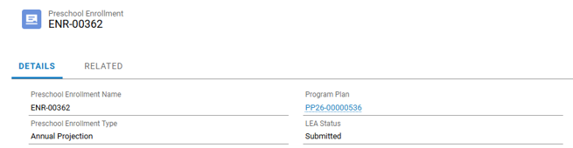

Upload Board Resolution
Click on ‘Upload Enrollment Projections Board Resolution’.
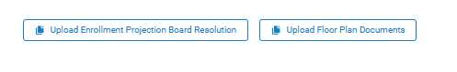
At any time throughout the process of completing the Enrollment Projections, the Board Resolution can be uploaded.
- Save the approved Board Resolution to your computer.
- From the PBOP Home page, navigate back to the ‘Enrollment Projections’.
- Select ‘Enrollment Projections Board Resolution’.
- Click Upload Files and browse to the saved Board Resolution file. Select the file and upload it.
- Enter the date of the Board Resolution meeting and confirm the resolution is associated with the Enrollment Projections.
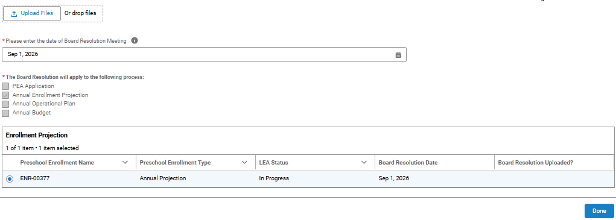

Upload Floor Plans
After completing the Enrollment Projections, the Floor Plans can be uploaded.
- Save the approved Floor Plans to your computer.
- From the PBOP Home page, navigate back to the ‘Enrollment Projections’ portal.
- Click on ‘Upload Floor Plan Documents’.
- Choose the facility to add a floor plan.
- Click ‘Upload Files’ and browse to the saved Floor Plan file. Select the file and upload it.
- Click ‘Done’, then ‘Submit’.
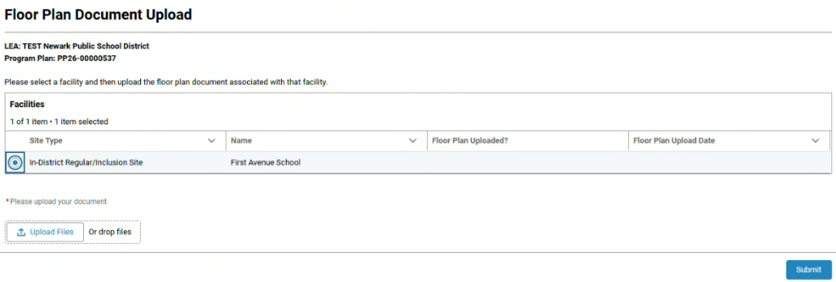
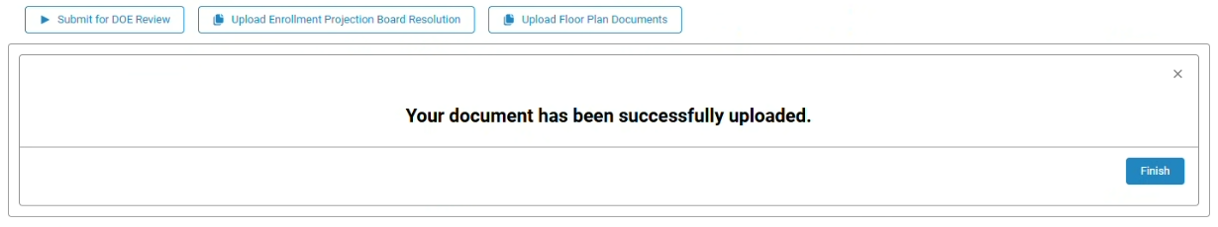

Additional Resources and Checklist
☐ Open New Enrollment Projections
☐ Complete Preschool Classroom Eligibility screen
☐ Enter In-District enrollment projections
☐ Enter Charter School projections
☐ Enter Contracted Head Start and Private Provider projections
☐ Verify information and select ‘Ready for Acknowledgement’
☐ Download and save PDF
☐ Click ‘Continue to Projected Details’
☐ BA signs and certifies
☐ Superintendent signs and certifies and submits for DOE review (the BA is also able to submit for the final DOE review).
☐ Upload Enrollment Projections Board Resolution.
☐ Upload floor plan documents (if applicable).
☐ Retain PDF for district records

