

New Jersey Department of Education Division of Early Childhood Services

Preschool Budget and Operational Plan (PBOP)

Operational Plan Guidance

Purpose of this Guide
This User Guide provides step-by-step guidance for completing the Operational Plan section of the PBOP portal and documenting how the district will implement and support a high-quality preschool program.

Accessing the Operational Plan
Log in to the PBOP System. From the home screen, select the link to open a New Operational Plan and navigate to ‘Cover Page’.
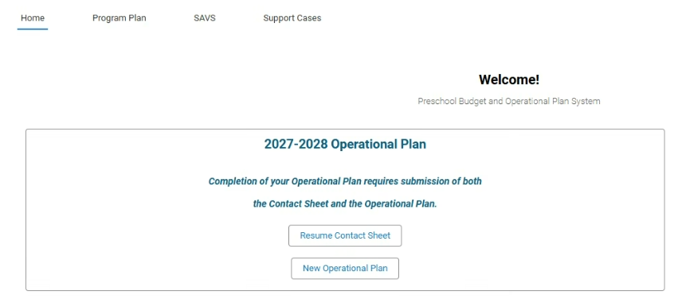
On the next screen, you will see the Operational Plan Cover Page with the due date. Click ‘Next’, or if you need to continue at a later time, click ‘Save for later’.
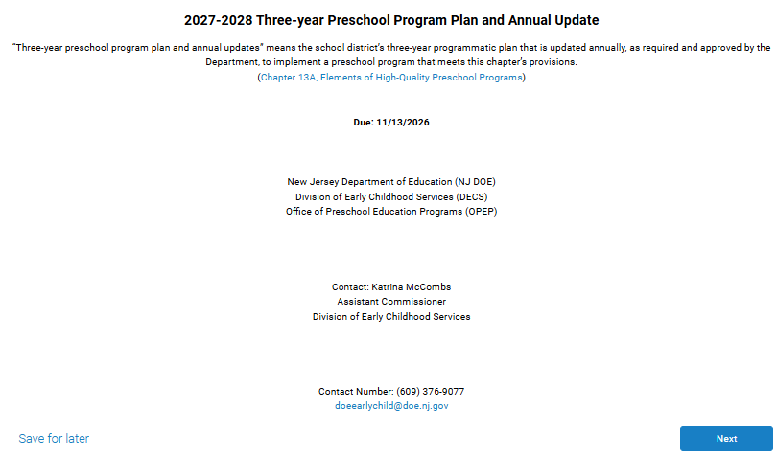
On the next screen, current district information is displayed. The district information should be reviewed carefully to ensure all information is accurate and complete. In addition, the Board Resolution Date must be entered. Click on the calendar icon and choose the date of your board resolution. If there are any errors on this screen, please contact the PBOP helpdesk at helpdesk-pbop@doe.nj.gov. After reviewing the existing information, click ‘Next’ to continue.
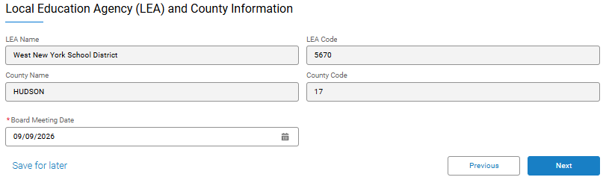

Enrollment
This section is used to document strategies to ensure that at least 90% of eligible preschool children are served as well as the LEA’s classroom configurations.
- Indicate whether the LEA has a plan to ensure that at least 90% of eligible preschool children are served. If ‘Yes’, describe the strategies the LEA will use to reach and maintain enrollment of at least 90% of eligible children.
- Indicate whether the LEA has a process to monitor enrollment throughout the school year and track progress toward the 90% enrollment goal.
- Select whether the LEA projects serving three-year-olds and/or four-year-olds during the upcoming school year.
- Complete the Preschool Planned Classroom Configuration table by entering the number of mixed-age, three-year-old-only, and four-year-old-only classrooms planned in each setting (In-District, Head Start, and Private Providers). Totals will calculate automatically.
- If mixed-age classrooms are planned, select all applicable reasons for using mixed-age groupings. If Other is selected, provide a brief explanation.
- Review all entries for accuracy and ensure classroom counts align with planned enrollment and program structure.
- Check the acknowledgment box to certify that the Enrollment section has been reviewed and is ready for submission.
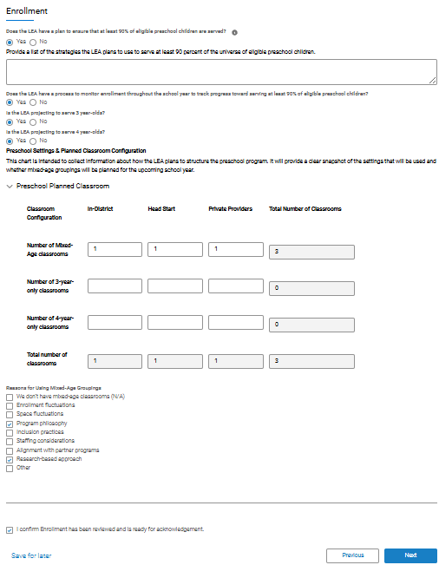

Outreach
This section is used to document the LEA's current contracted private providers and Head Start as well as due diligence efforts to identify and pursue partnerships with eligible licensed child care providers and Head Start programs for the upcoming school year.
Entering Outreach Information
The LEA is required to demonstrate due diligence by documenting:
- Licensed child care providers and Head Start programs operating within the LEA’s geographic area;
- Contact information for designated representatives at each provider or program regarding potential contracting opportunities; Is the site location located in a part of the community with limited or no contracted Head Start or private providers; and
- The outcome of each outreach effort.
Districts can enter data in one of two ways, either manually or through an upload of data using a file.

Adding Records Manually:
- Select ‘Add’ in the appropriate section (Head Start or Private Provider).
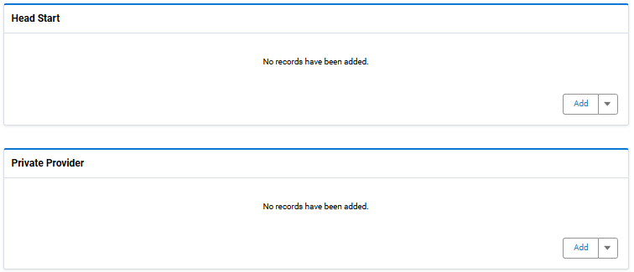
- Enter the required information for one site location. See an example below:
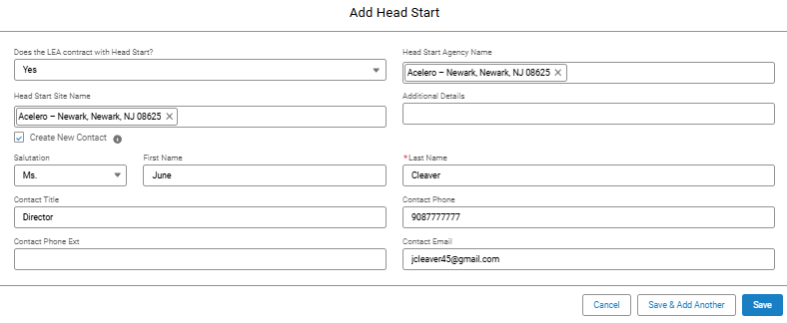
- Click ‘Save’
- Prior to moving forward, ensure that all information for each record has been added.
- Repeat for each Head Start program and private provider contacted.
- Verify that all required records have been entered before proceeding.

Upload Information Using a File
Click ‘Add’ to create a new entry. Enter information for each site type and each site location one record at a time OR after inputting the first entry, you can export the file and add the fields into the excel or csv file for upload. See below for instructions:
- Export Your Current Data: After inputting one new entry click ‘Save’. Next click the drop down arrow next to ‘Add’ and choose ‘Import’.
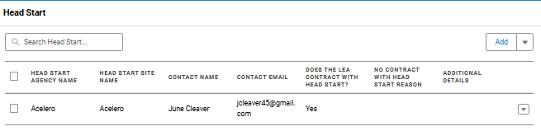
- On the next screen, click ‘Export Current Data’ and select CSV or Excel. The downloaded file will include all existing records and an ID column for each row. Data is exported in the same order in which it was entered into the table. The export will include only the data entered into the selected section.
- Update the Exported File: Use the exported data as a sample to add new records. Update existing records as needed and save files. Do not edit, retype, or delete values in the ID column. The ID is used to match your updates to existing records.
- Upload Your File: Click ‘Choose File’ and select your updated file (supported formats: .csv, .xlsx, .xls). The system will validate your file and display the number of valid rows.
- Import Data: Click ‘Import’ to proceed. Rows with an ID → will update existing records Rows without an ID → will create new records
- Edit any uploaded Data if necessary.
  - Navigate to record that needs edits.
  - Use arrow to right of record and select ‘edit’.
  - Record will open and user can make necessary changes.
- Tips for Success
  - Ensure each section of data, includes the relevant category being requested. (i.e. In-district Program, Head Start, Private Provider or Teacher, Relief Teacher, Teacher Assistants, Other Professional Staff on Budget, etc.).
  - Do not mix different categories in the exported spreadsheet when inputting new data. Each category will have its own export that should be updated by the district user.
  - Always start with an exported file to ensure correct formatting.
  - Keep column names and structure unchanged.
  - Double-check your file before uploading to avoid errors.

Outreach Questionnaire:
Use this section to describe how the LEA will identify, enroll, and support at-risk preschool children.
- Indicate whether the LEA has a plan to identify and prioritize the enrollment of at-risk preschool children.
- Select all recruitment and outreach strategies the LEA will use to connect with at-risk families and increase access to preschool programs.
- Select all strategies the LEA will use to reduce barriers to enrollment and participation for at-risk children and families.
- Select all ways the LEA will collaborate with community partners to identify, support, and enroll at-risk children.
- Indicate whether the LEA has a process to monitor enrollment data and ensure at-risk children are equitably represented across preschool settings.
- Review all responses for accuracy and completeness.
- Check the acknowledgment box to certify that the Outreach section has been reviewed and is ready for submission.
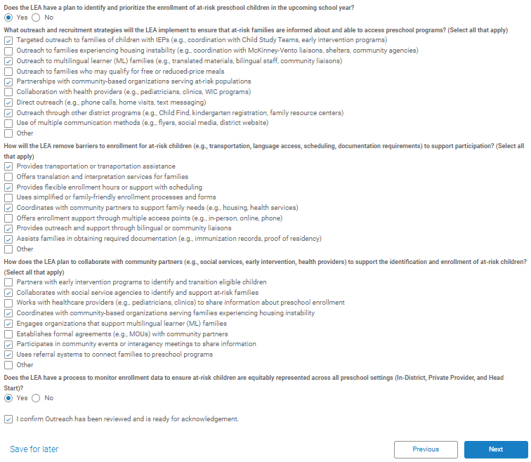

Facilities
This section is used for documenting preschool facility information, projected classroom additions or relocations, and compliance with N.J.A.C. 6A:13A facility requirements for all preschool settings.
- Indicate whether the LEA began receiving preschool funding prior to August 2017.
- Select whether any preschool classrooms are projected to be added or relocated for the upcoming school year.
- Indicate whether all preschool classrooms, including In-District, Head Start, and Contracted Private Provider classrooms, meet the facility requirements outlined in N.J.A.C. 6A:13A.
- Review all responses for accuracy and completeness.
- Check the acknowledgment box to certify that the Facilities section has been reviewed and is ready for submission.
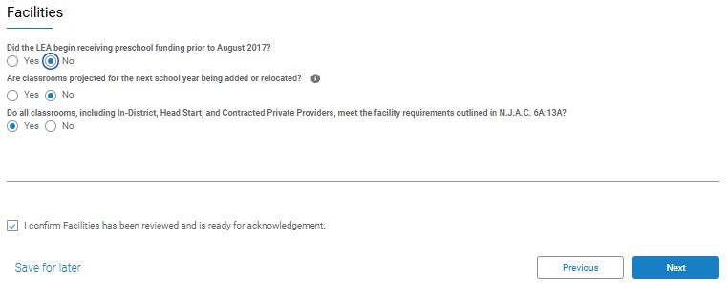

Self-Assessment Validation System (SAVS)/Grow NJ Kids (GNJK)
This section is used for reporting LEA participation in SAVS and/or Grow NJ Kids (GNJK) and related program information. The first question is automatically prefilled according to whether your district has been invited to participate in SAVS.
- If your district plans to engage in SAVS follow the directions below:
  - The first question is automatically prefilled.
  - Provide the date of the district’s last SAVS Self-Reporting submission.
  - Provide the date of the district's last SAVS Validation Visit.
  - After answering all remaining questions, check the box next to the statement ‘I confirm SAVS/GNJK has been reviewed and is ready for acknowledgement’, then click ‘Next’.
- If your district plans to engage in GNJK follow the directions below:
  - Using the space provided, answer the question “How does the LEA plan to track and obtain status updates on the progress of contracted providers and Head Start programs participating in GNJK during the upcoming school year?”.
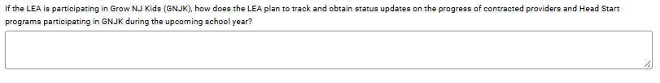
  - Next, click ‘add’ to input all sites participating in GNJK and provide the GNJK status for each location. Click ‘save’ after inputting each location.

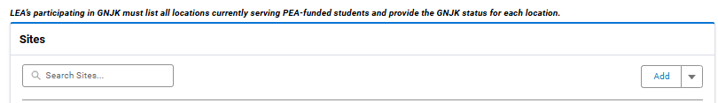
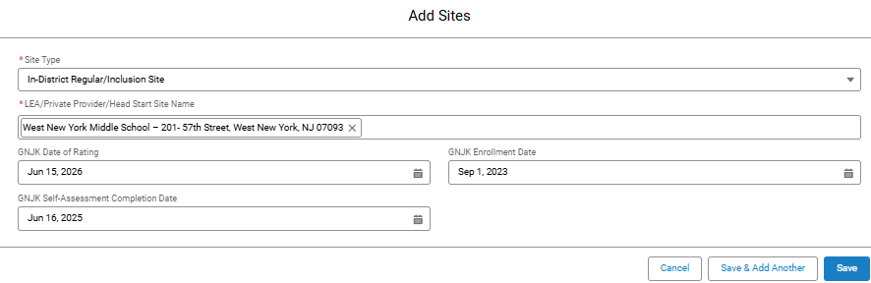

Review all responses and site information for accuracy and completeness.

Check the acknowledgment box to certify that the SAVS/GNJK section has been reviewed and is ready for submission. Click ‘Next’.

Health and Safety
This section is used for reporting projected timelines for required preschool health screenings at all program locations.
- Provide the projected completion timeline for all locations (inclusive of children enrolled at in-district, Head Start and private provider locations) for the following required screenings: vision, hearing, dental, height, and weight. To input the date, click on the calendar icon.
- Review all responses for accuracy and completeness.
- Check the acknowledgment box to certify that the Health and Safety section has been reviewed and is ready for submission. Click ‘Next’.
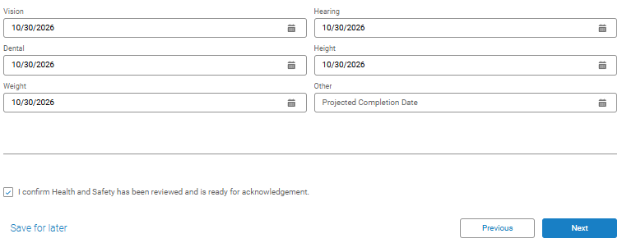

Community Collaboration
This section is used for reporting Early Childhood Advisory Council (ECAC) membership and community collaboration activities.
- Answer the two questions regarding the Early Childhood Advisory Council (ECAC). If the answers are ‘Yes’, the screen will expand to enter ECAC members.
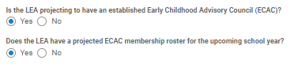
- Add all ECAC members
  - Click on ‘Add ECAC Member’ and a new screen will appear.
  - Search for the ECAC member by name. If the individual is already in the system, their information will appear in the search results and can be selected. If the individual is not found, you will need to manually enter all required fields to add the ECAC member to the system.
  - After all fields have been entered, click ‘Save’.
- Answer the final question, “Does the ECAC meet quarterly?”
- After all fields have been entered, check the acknowledgment box to confirm the Community Collaboration section has been reviewed and is ready for submission, then click ‘Next’.
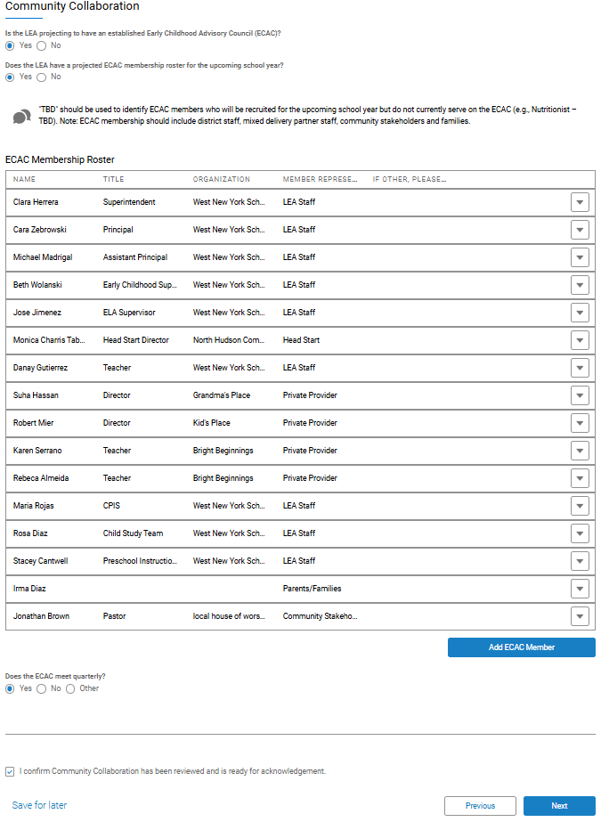

Transitions
This section is used for reporting planned transition activities and Kindergarten Entry Assessment (KEA) information.
- For each category (i.e. From preschool; LEA-operated, child care, and Head Start, to kindergarten) list projected transition activities for each category. Click on the drop down arrow and choose ‘Edit’ to add the transition activities for each category. See a sample below:
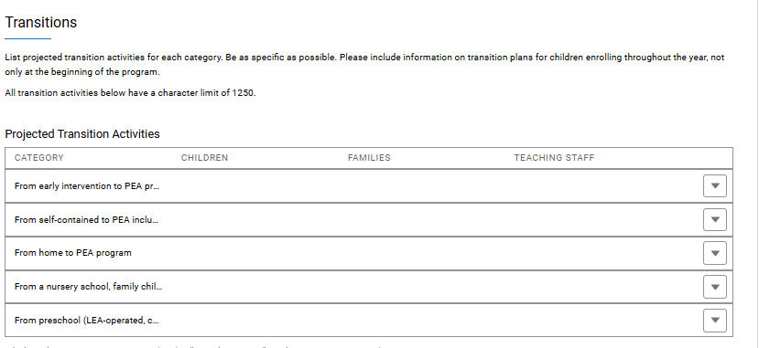
- All of the narratives for the transition activities have a character limit of 1250. See an example below (do not copy this sample):
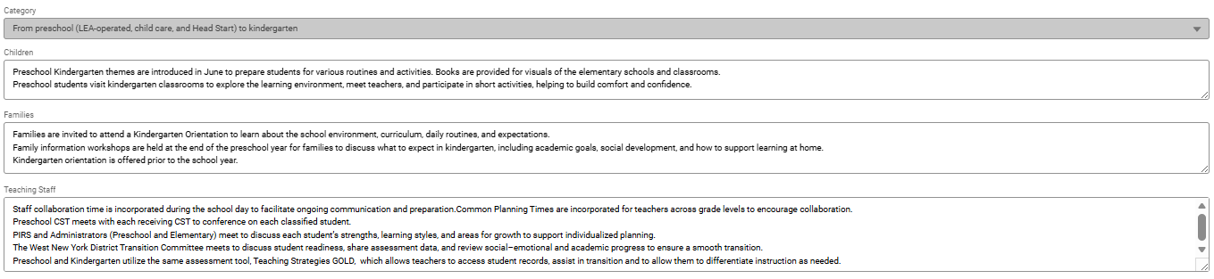
- After all activities have been inputted for each transition category, answer the questions regarding the district’s Kindergarten Entry Assessment (KEA).
- After all fields have been entered, check the acknowledgment box to confirm the Transitions section has been reviewed and is ready for submission, then click ‘Next’.
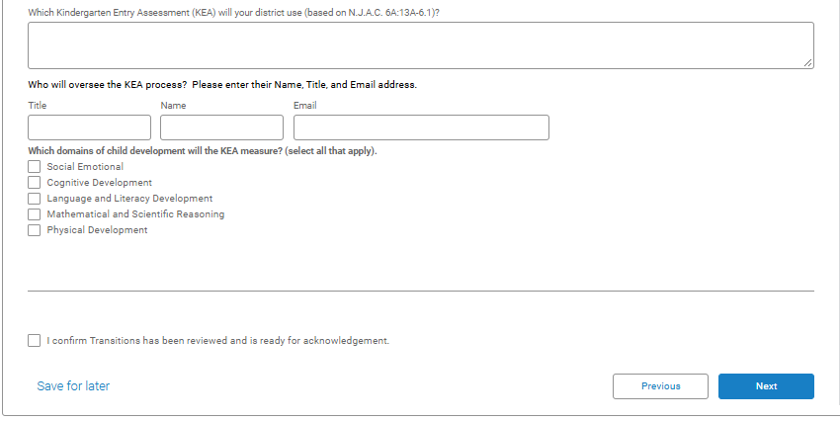

Family Engagement
This section is used for reporting family engagement activities, parent education topics, and access to family support resources and services.
- Select all observation tools the LEA uses to assess classroom quality, collect data, and inform professional development and program planning.
- Select all methods the LEA uses to deliver professional development to PEA staff.
- If "Other" is selected for either question, provide a brief explanation in the text box.
- In the narrative box, describe how the district develops its professional development plan for all PEA staff, including staff in district-operated, private provider, and Head Start programs.
- Select the option that best describes how the LEA will provide professional development to support multilingual learners during the upcoming school year.
- Review all responses for accuracy and completeness.
- Check the acknowledgment box to confirm the Family Engagement section has been reviewed and is ready for submission.
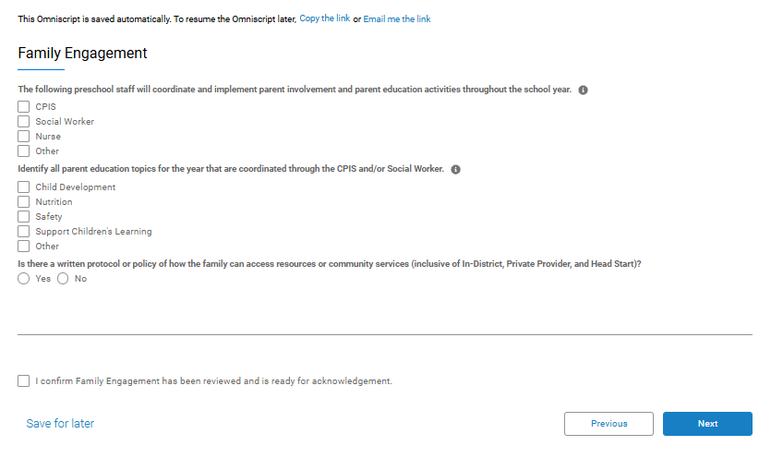

Professional Development
This section is used for reporting professional development plans, quality observation tools, and supports for preschool staff, including multilingual learner instruction.
- Select all structured observation tools used to assess classroom quality, collect data, and inform professional development and program planning. Multiple choices can be made.
- Select all methods used to provide professional development to PEA staff. Multiple choices can be made.
- If "Other" is selected, provide a brief explanation in the text box.
- Describe how the district develops its professional development plan for all PEA staff, including staff in district-operated, private provider, and Head Start programs.
- Select the option that best describes the LEA's professional development plan for supporting multilingual learners during the upcoming school year.
- Review all information for accuracy and completeness.
- Check the acknowledgment box to certify that the Professional Development section has been reviewed and is ready for submission. 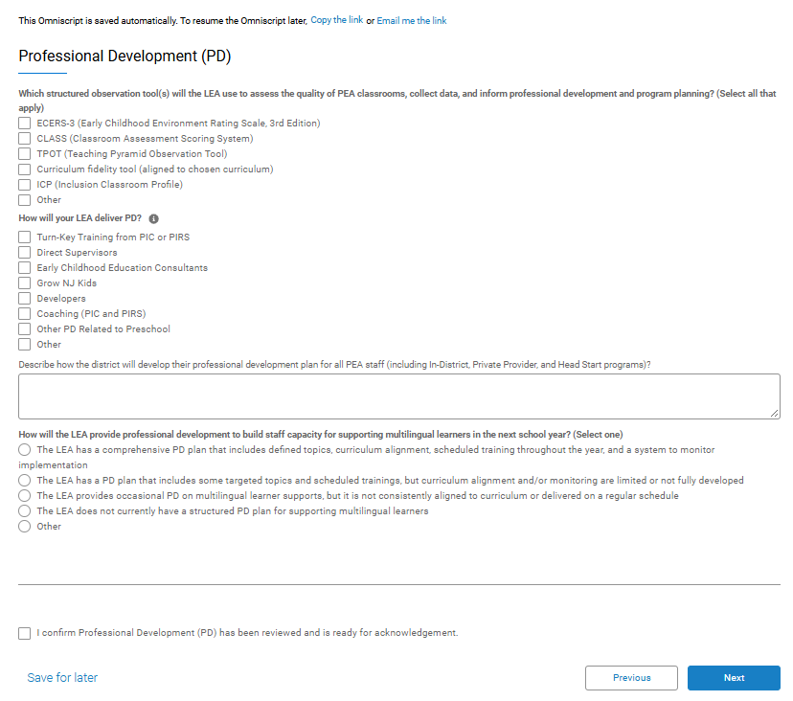

Curriculum Implementation and Child Assessment
This section is used for reporting preschool curriculum, assessment practices, and supports for multilingual learners and child development.
- Select the comprehensive curriculum that will be used during the current school year.
- Indicate whether the LEA uses a curriculum enhancement and, if so, please explain and provide the DOE approval date.
- Select the Performance-Based Assessment (PBA) that will be used during the current school year.
- Select all strategies the LEA will use to support multilingual learners through curriculum implementation and instruction.
- Choose the option that best describes the LEA's plan for supporting multilingual learners in preschool classrooms.
- Describe how the LEA will support preschool instructional staff in collecting and using child assessment data to monitor developmental progress, inform instruction, and support individual learning needs.
- Review all responses for accuracy and completeness.
- Check the acknowledgment box to certify that the Curriculum Implementation and Child Assessment section has been reviewed and is ready for submission. See below for a screenshot:
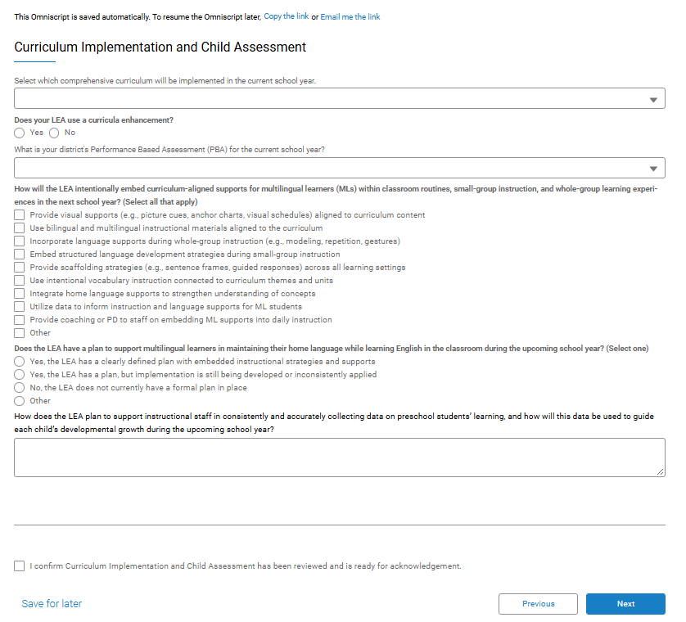

Screening and Intervention
This section is used for reporting developmental screening tools, screening timelines, and intervention planning for preschool students.
- Select the developmental screening tool that will be used for preschool children during the upcoming school year.
- Enter the anticipated date by which all initial developmental screenings will be completed.
- Indicate whether this is the LEA's first full year receiving Preschool Expansion Aid (PEA) funding.
- If this is not the LEA's first full year of PEA funding, enter the required referral counts from the previous school year:
  - Referrals to the Preschool Intervention and Referral Specialist (PIRS) generated from developmental screenings
  - Referrals for Assistance (RFA) submitted to PIRS
  - Referrals to the Child Study Team (CST) following PIRS RFA support
  - Direct referrals to the CST without prior PIRS intervention
- Review all entries for accuracy and completeness.
- Check the acknowledgment box to certify that the Screening and Intervention section has been reviewed and is ready for submission.
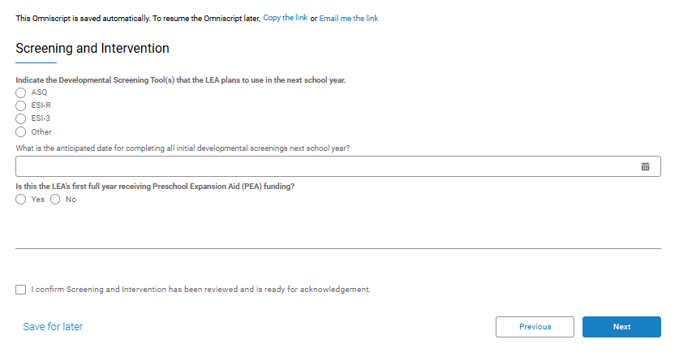

Inclusion and Individualized Education Program (IEP)
This section is used for reporting plans for the inclusion of preschool students with IEPs in general education classrooms and the supports in place to ensure meaningful participation.
- Indicate whether the LEA projects including children with IEPs in general education Preschool Expansion Aid (PEA) classrooms.
- If Yes, describe how the LEA will support meaningful inclusion by providing students with IEPs access to general education preschool settings, appropriate supports and services, and opportunities to participate in classroom learning and activities.
- Select the percentage of PEA classrooms projected to include children with IEPs.
- Review all responses for accuracy and completeness.
- Check the acknowledgment box to certify that the Inclusion and Individualized Education Program (IEP) section has been reviewed and is ready for submission.
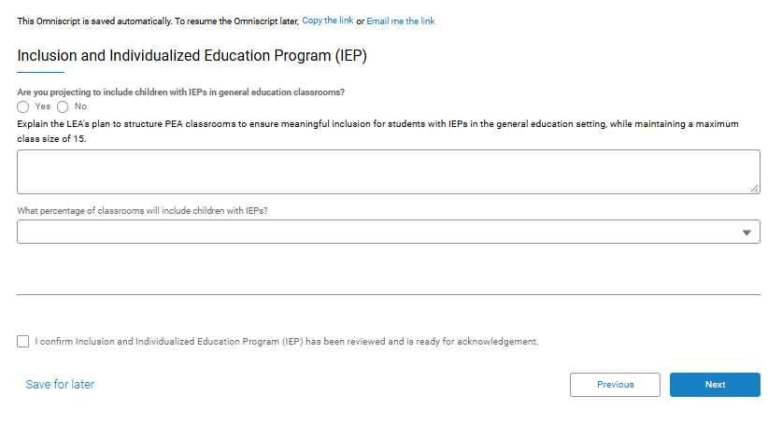

Title 1
This section is used for reporting whether the LEA receives Title I funding.
- Indicate whether the LEA receives Title I funds.
- Select whether preschool is included in the LEA's Title I needs assessment.
- Indicate whether the LEA plans to use the Title I needs assessment to identify professional development needs for preschool staff.
- Select whether the LEA plans to use Title I funds to support transition activities from preschool to kindergarten and from kindergarten to first grade.
- Review all responses for accuracy and completeness.
- Check the acknowledgment box to certify that the Title I section has been reviewed and is ready for submission and click ‘Next’.
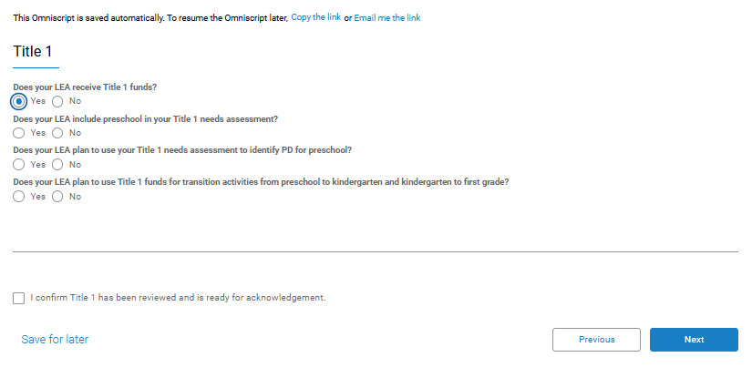

Readiness Review
After reviewing all entries, select “Ready for Acknowledgment” to begin the approval process. Please note that selecting “Ready for Acknowledgment” does not automatically submit the plan.
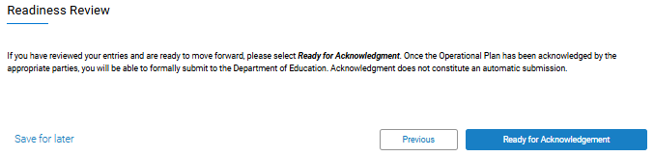
The next screen to appear will allow you to generate a pdf of the Operational Plan for your records.
- Review the PDF and download the PDF for your records.
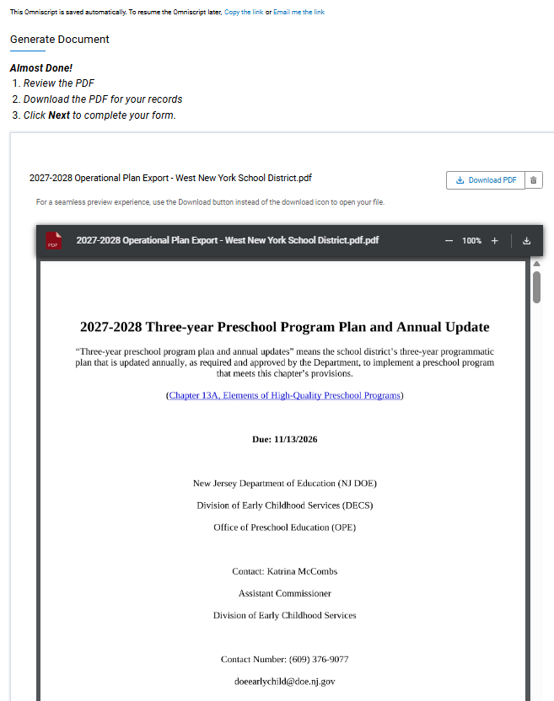
- Scroll to the bottom and click ‘Next’ to navigate back to the home screen. The following message will appear:
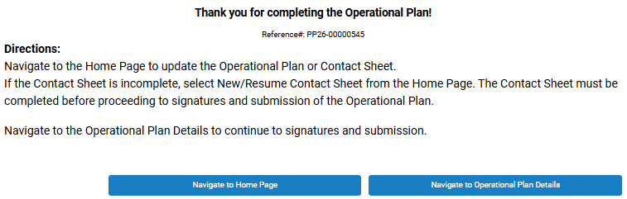
- At this point, there are two choices:
  - ‘Navigate to the Home Page’ will allow the user to update the Operational Plan or Contact Sheet. If the Contact Sheet is incomplete, select New/Resume Contact Sheet from the Home Page. The Contact Sheet must be completed before proceeding to signatures and submission of the Operational Plan.
  - If the Contact Sheet is complete and there are no updates needed to the Operational Plan, click ‘Navigate to the Operational Plan Details’ to continue to signatures and submission.

Business Administrator (BA) Statement of Assurance
- The BA will receive a chatter post alerting them that the Operational Plan is ready for your signature. The BA will then, click on sign the ‘Statement of Assurance’.

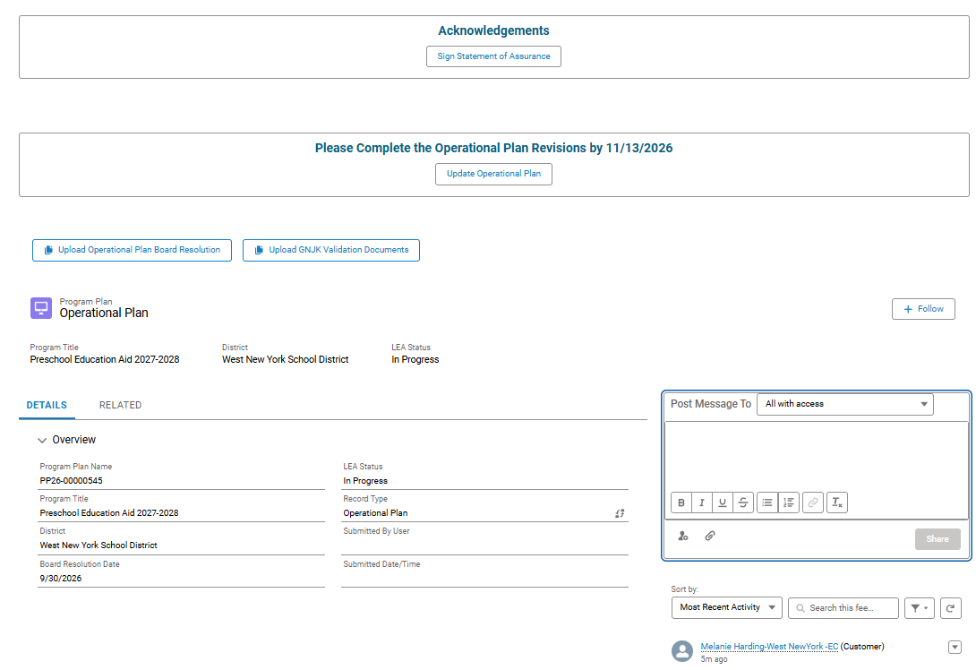
Chatter Post
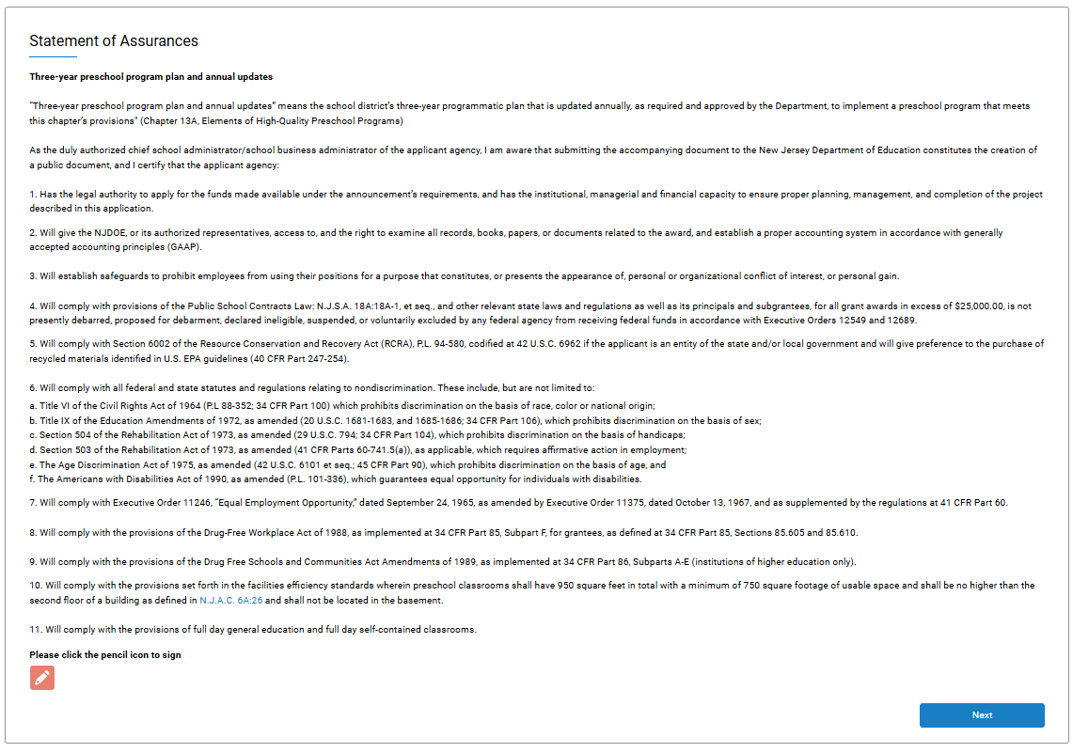
- Read the certification and click on the orange pencil to sign and certify. Click ‘Next’.
- The following message will appear:
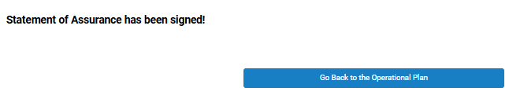

Final Submission
- The superintendent will receive a chatter post alerting them that the Operational Plan is ready for their signature. The superintendent will then, click on ‘Submit for DOE Review’.

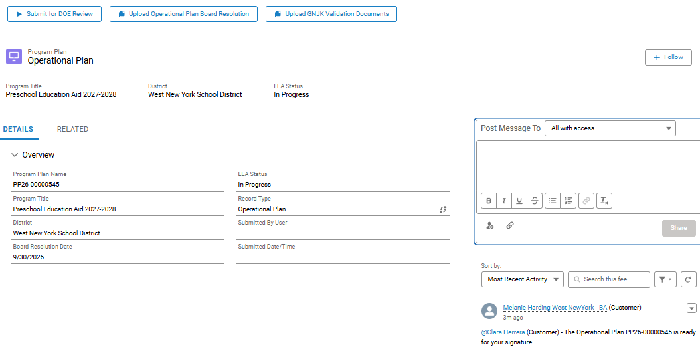
Complete the Statement of Assurance Signature fields and click ‘Proceed’.
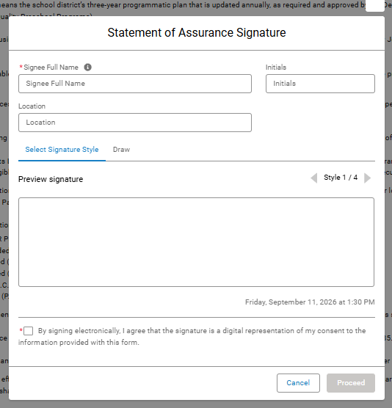
- The certification will appear on the screen. Click ‘Next’.
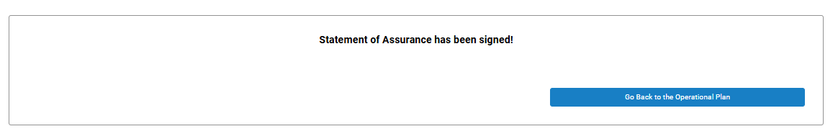

Superintendent Approval and Final Submission
- The superintendent will receive a chatter post alerting them to review, sign, and submit the Operational Plan.
- The superintendent must first review the Operational Plan (if it was completed by the Early Childhood Contact). To review, click on ‘Update Operational Plan’ .
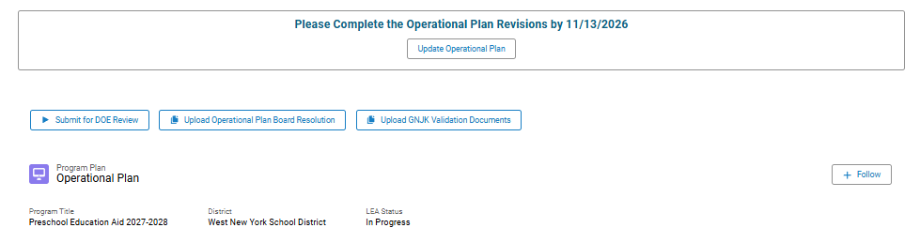
- Next, click ‘Sign Statement of Assurance’.

- Read the certification and click on the orange pencil to sign and certify.
- Complete the Statement of Assurance Signature fields and click ‘Proceed’. Then click ‘Next’.
- The superintendent will then sign the Operational Plan certification.
- The following message will appear:
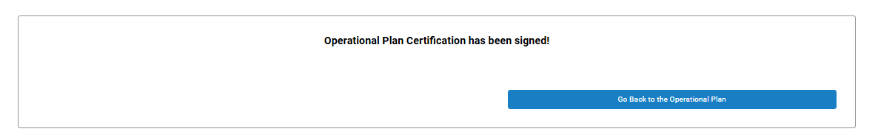
- Click ‘Go Back to Operational Plan’.
- Click ‘Submit for ‘DOE Review’ (Either the EC Contact or the superintendent are able to submit at this time).
- The LEA status will now read ‘Submitted’.
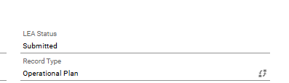
- Once all required parties have acknowledged the Operational Plan, the LEA will be able to formally submit it to the Department of Education.

Board Resolution File Upload for annual Operational Plan
At any time throughout the process of completing the Enrollment Projections or Operational Plan, the Board Resolution can be uploaded.
- Save the approved Board Resolution to your computer.
- From the PBOP Home page, select Upload Operational Plan Board Resolution.
- Click Upload Files and browse to the saved Board Resolution file. Select the file and upload it.
- Enter the date of the Board Resolution meeting and confirm the resolution is associated with the Annual Operational Plan.
