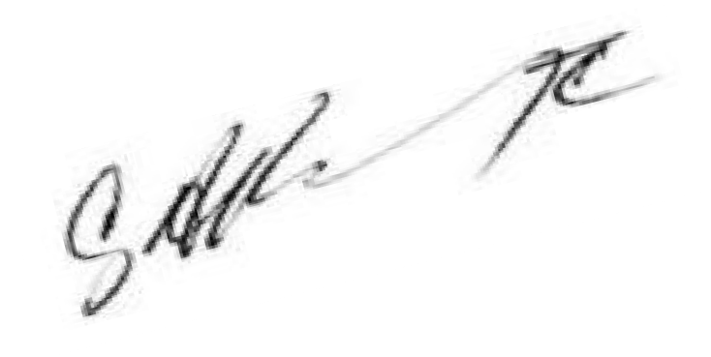**TO:** Chief School Administrator, Preschool Education Aid Districts

**FROM:** Cary A. Booker, Assistant Commissioner Division of Early Childhood Services

**DATE:** January 8, 2025

**SUBJECT:** Parental Choice in Preschool

New Jersey’s State funded preschool model is based on a mixed delivery approach where families are provided options to high quality learning through classrooms located within school buildings, as well as licensed child care providers and Head Start programs.

The value of a mixed delivery system is the provision of options for families, providing them the flexibility to choose where they would prefer to enroll their child. As districts implement state-funded preschool programs, the registration and enrollment process allow families in your community to be given a choice to enroll their child in the diverse preschool environments available within the community. Limiting or not allowing choice can be a barrier to enrollment of students in the program.

Each family requires different support. Considerations should include:

* Does the family want a smaller, more intimate setting?
* Does the family have a sibling infant/toddler who attends a provider location and needs the preschooler at the same location?
* Does the family have an older sibling and prefer the preschooler to be in the same building as their other child?
* Does the provider offer before and after care that the in-district program doesn’t offer?
* Do the district’s before and after care programs not accept subsidies and parents can’t afford the

payment?

Additionally, the contracted programs should not be seen as secondary placement after district seats are filled. The ability to select licensed child care providers and Head Start classrooms should be options presented equally to families.

If you have any further questions, please contact your district liaison. CAB

c: Kevin Dehmer, Acting Commissioner Mickey Ronan-Grosshtern

Kimberly Friddell

Early Childhood Contacts