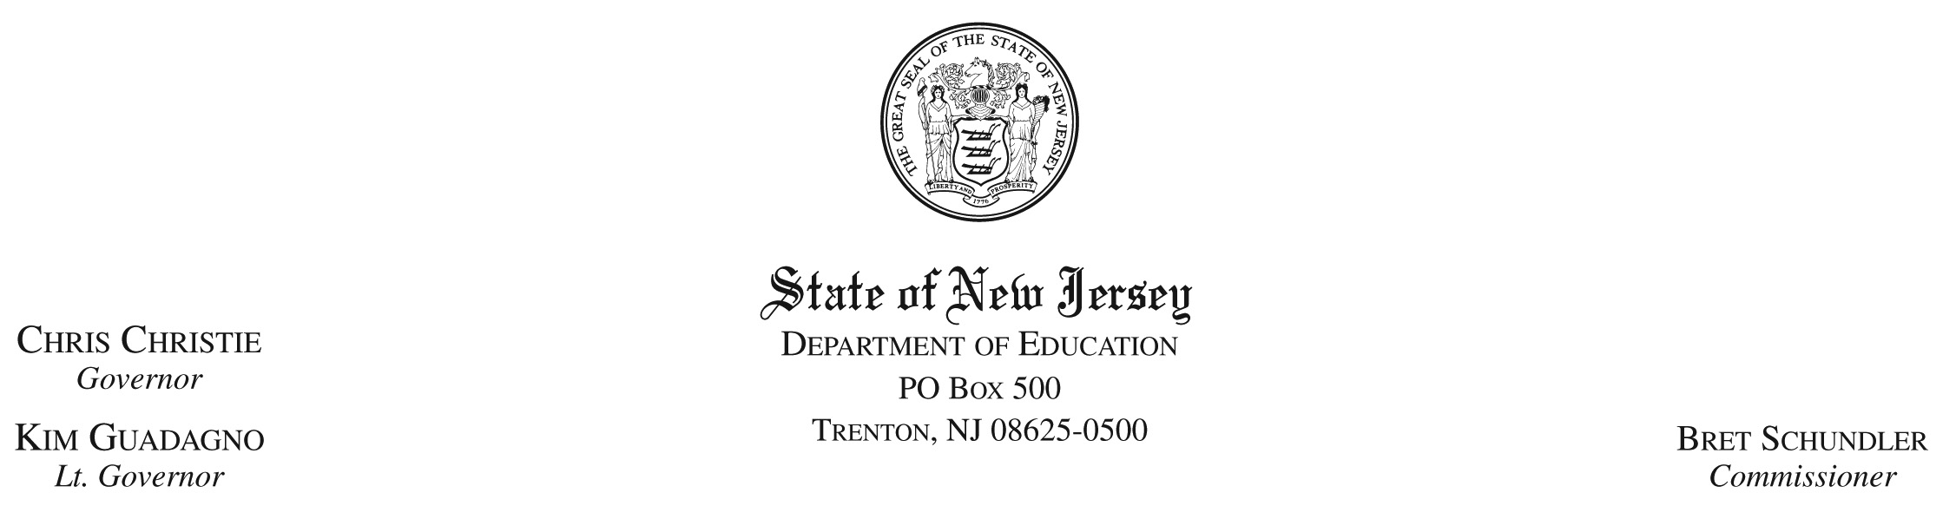

June 21, 2010

TO: Directors, Private Schools for Students with Disabilities

FROM: Jim Verner, Section Supervisor
Office of Fiscal Policy and Planning

SUBJECT: 2010-2011 Tentative Tuition Rates to be Charged (Other Information)

Please complete the attached form (Page 2), which is a request for your school’s 2010-2011 tentative tuition rates to be charged and if applicable, update various administrative information. Items #2 through #10 should only be completed if there are any changes/updates from the information filed in the 2009-2010 Annual Fiscal and Program Information.

Please follow these directions for the “2010-2011 Tentative Tuition Rates to be Charged” Insert into column (A) the full-day tentative per diem rate to be charged for the ten month and extended school years (one amount); insert in column (B) the number of possible enrolled days in the ten month school year; insert into column (C) the total ten month school year tentative tuition rate to be charged which must equal column (A) multiplied by column (B); insert into column (D) the number of possible enrolled days in the extended school year; insert into column (E) the total extended school year tentative tuition rate to be charged which must equal column (A) multiplied by column (D); and insert into column (F) the total school year tentative tuition rate to be charged for the 12 month school year which must be the total of columns (C) and (E). Please complete a separate page 2 for each approved private school for students with disabilities.

EXAMPLES

School Name | (A)  Full Day  Per Diem  Rate | Ten Month |  | Extended |  | (F)  Total  School Year  Tuition Rate
School Name | (A)  Full Day  Per Diem  Rate | (B)  Enrolled  Days | (C)  Total  Rate | (D)  Enrolled  Days | (E)  Total  Rate | (F)  Total  School Year  Tuition Rate
ABC Private School | 241.00 | 180 | 43,380 | 19 | 4,579 | 47,959
XYZ Private School | 90.00 | 180 | 16,200 | N/A | N/A | 16,200

Please forward the attached to the below address by August 13, 2010 or fax it to Toula Aris at (609) 292-6794 or emailed to her at toula.aris@doe.state.nj.us by the same date. If you have any questions concerning this memo, please call Elise Sadler-Williams at (609) 777-4483.
Toula Aris
New Jersey State Department of Education
Division of Finance
Office of Fiscal Policy and Planning
P.O. Box 500
Trenton, NJ 08625-0500
Toula Aris, Division of Finance
(609) 292-6794

1.____________________________________________________________________________

Name of School

----only complete lines 2 through 10 if this information has changed from the 2009-2010Annual Fiscal and Program Information----

2. County:___________________________________________________________________
3. Street Address1:_____________________________________________________________
4. Street Address2:_____________________________________________________________
5. City:_______________________________________________________________________
6. Zip Code:___________________________________________________________________
7. Telephone Number___________________________________________________________
8. Director’s (or contact person’s) Name:___________________________________________
9. Director’s (or contact person’s) Fax Number:_____________________________________
10. Director’s (or contact person’s) Email Address:__________________________________
2010-2011 TENTATIVE TUITION RATES TO BE CHARGED

JV:esw:/tmp/in/input.doc

