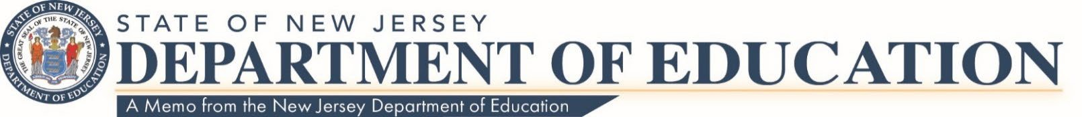

Date: August 9, 2023
To: Local Educational Agency Leads
Route To: School Business Administrators/Board Secretaries
From: Robert Amon, Director
Office of Budget and Accounting

Federal Programs: Pension and Social Security Reimbursement to State of New Jersey for Contributions Paid by the State
The New Jersey Department of Education’s (NJDOE) Office of Budget and Accounting has been notified by the Division of Pensions and Benefits that the State payment to the Teacher’s Pension and Annuity Fund for Fiscal Year 2022-23 will be 45.28%.
The NJDOE’s website, Office of School Finance, nj.gov/education/finance/ will provide the reporting form for Federal programs under the section titled “Reimbursement of TPAF and Social Security - School Year 2022-23 - Report Form”. The form will show the 2022-23 final pension rate and Social Security rate for calendar year 2022 of 7.65% of the first $147,000 and 1.45% for gross wages in excess of $147,000. For calendar year 2023, the rate is 7.65% of the first $160,200 and 1.45% for gross wages in excess of $160,200.
In accordance with NJSA 18A:66-90, the above rates must be used when budgeting for Federal Programs for FY 23. Your school district will be notified by the Public Employees’ Retirement System (PERS) if a payment is due for its members.
Please note that the NJDOE will accept payments to the State by either electronic payment (ACH) or via paper checks.
Contact information
Should you have any questions, please contact the Office of Budget and Accounting at TPAF@doe.nj.gov.
c: Members, State Board of Education
Angelica Allen-McMillan, Ed.D., Acting Commissioner NJDOE Staff
Statewide Parent Advocacy Network Garden State Coalition of Schools
NJ LEE Group

