|  |
| --- |
| Logo: State of New Jersey, Department of Education. The Great Seal of the State of New Jersey. |
| Building Responsive Instruction  through Data-Guided Evaluation (BRIDGE)  25-TL01-G03  Program Term Date: June 1, 2025-May 31, 2026  Application Due Date: May 30, 2025 no later than 4:00 P.M. |
| **Kevin Dehmer**  Commissioner of Education  **Jorden Schiff**  Assistant Commissioner  **Natalie Franzi Dougherty**  Director  Office of Learning Equity and Academic Recovery  **FY 2025**  25-100-034-5063-371  **New Jersey Department of Education**  **P.O. Box 500 ● Trenton, NJ 08625-0500**  Updated 11/22/2024 |

The following are requirements and instructions for a Notice of Grant Opportunity (NGO) from the New Jersey Department of Education (NJDOE). Instructions on how to gain access to the application and how to complete the application in the Electronic Web-Enabled Grant (EWEG) system are available in [the Discretionary Grants Manual](https://www.nj.gov/education/grants/discretionary/apps/).

When responding to this NGO, applicants must use [the EWEG online application system](https://njdoe.mtwgms.org/NJDOEGmsWeb/logon.aspx) on the NJDOE’s [Homeroom](http://homeroom.state.nj.us/) webpage. In the EWEG GMS page scroll down to view “Available” grants to initiate the application. If the application is not available, contact [EWEG help](mailto:grants.vendors@doe.nj.gov) to gain access to the application. The responsibility for a timely submission resides with the applicant. The Application Control Center (ACC) must receive the completed application through the online EWEG system through the NJDOE Homeroom webpage by no later than 4:00 P.M. on the due date of the application. Without exception, the ACC will not accept, and the Office of Grants Management (OGM) cannot evaluate an application submitted after this deadline for funding consideration.

**Table of Contents**

I. Grant Program Information 4

I.1. Purpose of the NGO 4

I.2. Federal Compliance Requirements - Unique Entity Identifier (UEI) Registrations 4

I.3. Award Management SAM Application 5

I.4. Dissemination of This Notice 5

I.5. Access to the EWEG Application 5

I.6. Application Submission 6

I.7. Application Review Criteria 6

I.8. Grantee Award Notifications 7

I.9. Open Public Records 7

II. Completing the Application 8

II.1. General Instructions for Applying 8

II.2. Application Technical Assistance Session 8

II.3. Grant Deliverables 8

II.4. Project Design Considerations 8

II.5. Application Component Required Uploads 11

II.6. Allowable Uses and Eligible Activities 12

II.7. Sub-granting Funds 12

II.8. Nonpublic Participation 12

II.9. Apportionment of Grant Funds 12

II.10. Eligible Costs 12

II.11. Ineligible Costs 13

III. Grant Agreement and Program Requirements 15

III.1. Mandatory Orientation and Training 15

III.2. Reporting Requirements 15

III.3. Interim Activity Reports 15

III.4. Fiscal Reimbursement and Fiscal Interim Report Requirements 15

III.5. Reporting Periods 16

III.6. Monitoring 16

III.7. Acceptable Documentation for Grant Monitoring 17

III.8. Grant Amendments 17

III.9. Suspension/Cancellation of Grant/Loan Agreement and/or Reduction in Funding 18

III.10. Grant Close Out 18

III.11. Federal Requirements 18

IV. Appendices 19

|  |  |
| --- | --- |
| **State Board of Education** | |
| Kathy A. Goldenberg – President | Burlington |
| Nedd James Johnson – Vice President | Salem |
| Arcelio Aponte | Middlesex |
| Mary G. Bennett | Essex |
| Mary Beth Berry | Hunterdon |
| Elaine Bobrove | Camden |
| Ronald K. Butcher | Gloucester |
| Jack Fornaro | Warren |
| Dr. Claudine Keenan | Atlantic |
| Jeanette Pena | Hudson |
| Ahmed Shehata | Union |
| Joseph Ricca, Jr | Morris |
|  |  |
| Kevin Dehmer, Commissioner  Secretary, State Board of Education | |
| It is a policy of the New Jersey State Board of Education and the State Department of Education that no person, on the basis of race, color, creed, national origin, age, sex, handicap or marital status, shall be subjected to discrimination in employment or be excluded from or denied benefits of any activity, program or service for which the department has responsibility. The department will comply with all state and federal laws and regulations concerning nondiscrimination. | |

# Grant Program Information

## Purpose of the NGO

The New Jersey Department of Education (the Department) established the Office of Learning Equity and Academic Recovery in accordance with [P.L. 2024, c.53.](https://pub.njleg.state.nj.us/Bills/2024/PL24/53_.PDF) This office is tasked to promote student literacy and advance learning equity through academic recovery practices, improve the Department’s capacity to make data-driven decisions, coordinate resources within the Department to promote implementation of effective literacy instruction, provide research best practices to support the creation of effective literacy practices and support local education agencies (LEAs) in developing and implementing best practices. The office also steers work related to learning equity, learning acceleration practices and related professional development opportunities.

Pursuant to P.L.2024, c.52, starting with the 2025-26 school year all LEAs must use universal screeners to gauge students’ achievement of key literacy skills in alignment with New Jersey Student Learning Standards-English Language Arts (NJSLS-ELA). More information pertaining to this legislation, including Department guidance, can be accessed through a Broadcast from the Department.

The FY2025 Appropriations Act includes $5.25 million to assist schools in adopting and utilizing universal screening tools. The Building Responsive Instruction through Data-Guided Evaluation (BRIDGE) grant, one of two grants supported by that appropriation, intends to provide eighteen (18) LEAs the opportunity to implement evidence-based data protocols to inform tier one literacy instruction in grades kindergarten through grade three (K-3), in alignment with State law. For schools to be eligible to apply for this competitive grant they must have at least 40 percent of their students receiving free or reduced lunch and 80 percent or more students who did not meet expectations on the 2023-2024 New Jersey Student Learning Assessment (NJSLA)- ELA Grade 3.

**Application Type: Open Competitive**

**Target Audience:** Local Education Agency (LEA), that meets eligibility criteria described above: as listed in appendix A  
 Community-Based Nonprofit Organization (CBO), or   
 Institutes of Higher Education (IHE)  
Other*

## Federal Compliance Requirements - Unique Entity Identifier (UEI) Registrations

In accordance with the Federal Fiscal Accountability Transparency Act (FFATA), all grant recipients must have a valid Unique Entity Identifier (UEI). As part of the government-wide initiative, the NJDOE will join other Federal agencies and transition from the use of the Dun and Bradstreet Data Universal Numbering System (DUNS) to the new UEI for all grant recipients and applicant organizations. UEIs are the primary means of entity identification for Federal awards and are required in accordance with 2 CFR Part 25. The UEI number is administered by the Federal Government in the System for Award Management (SAM) through theSAM.gov website

FFATA Executive Compensation Disclosure Criteria:

In the preceding fiscal year if an applicant:

* Received at least $25,000,000 in annual gross revenues from federal awards; and
* If at least eighty (80) percent of the applicant’s annual gross revenues came from federal awards, the applicant is required to disclose the name and total compensation of the five (5) most highly compensated officers of the applicant as part of the grant application.

This information is to be entered into the Award Management SAM Application in EWEG and updated on a yearly basis.

## Award Management SAM Application

Prior to applying for a grant application, a Local Education Agency (LEA), Community-Based Nonprofit Organization (CBO), or Institute of Higher Education (IHE) must provide the requisite information in the SAM section in the NJDOE’s EWEG system. The entity will need its valid UEI to complete this step.

Key steps/actions:

* + - 1. Create and submit the AWARD Management SAM application in EWEG if your entity has applied for or has received other grants from the NJDOE.
      2. When completing the AWARD Management SAM application, entities must enter an active SAM UEI and upload a copy of its SAM Entity Overview page. Applicants must ensure their address has the correct hyphenated nine-digit zip code in their address. Information provided in the LEA Central Contacts must match information from SAM.gov to be compliant with FFATA reporting.
      3. To renew an existing SAM UEI or to apply for a SAM UEI, entities must go through [www.sam.gov](http://www.sam.gov/).

Failure to complete or update the AWARD Management SAM application in EWEG will prevent the applicant from viewing, creating, and submitting applications in the EWEG system.

**No award will be made to an applicant not in compliance with FFATA.**

## Dissemination of This Notice

The Office of Learning Equity and Academic Recovery will make this notice available to eligible applicants listed in section I.1. based upon the eligibility statement, to the Office of Comprehensive Support Team Leaders, and to the county superintendents of the counties in which the eligible agencies are located.

Additional copies of the NGO are also available on the NJDOE’s [Grant Opportunities](https://www.nj.gov/education/grants/opportunities/index.shtml) website or by contacting the Office of Learning Equity and Academic Recovery at the New Jersey Department of Education, 100 River View Plaza, Route 29, P.O. Box 500, Trenton, NJ 08625-0500; Email Contact – LEAR@doe.nj.gov

## Access to the EWEG Application

To initiate the application, the applicant must have EWEG system logon credentials. Once you logon, go to the GMS Access Select page and scroll down to view “Available” applications. If an application is not visible in the EWEG system, contact your district’s Web (Homeroom) Administrator to request access to the application via EWEG help. LEA applicants without log on credentials must contact their district’s Web (Homeroom) Administrator to request access to the EWEG system. Non-LEA applicants must request access by sending an email to: eweghelp@doe.nj.gov. Please allow up to 48 hours for the registration to be completed in the EWEG system.

The NJDOE advises applicants to plan appropriately and to allow for time to address any technical challenges that may occur. Additionally, applicants should run a consistency check at least 48 hours before the due date to determine any errors that might prevent the submission of the application. Applicants are advised not to wait until the due date to submit the application online as the EWEG system may be slower than normal due to increased usage. Running the consistency check does not submit the application. When the consistency check runs successfully, a “Submit” button will appear. Once the application is complete and has passed the consistency check with no error messages, the applicant may submit the application by clicking the “Submit” button. The applicant should wait for a message from the EWEG system indicating the application was submitted. The application status will update in the Grants Management System (GMS) on the GMS Select page as “Submitted for Review” along with the date the application was submitted.

**IMPORTANT:** Once the application has been submitted via EWEG, the application will not be returned to the applicant for editing, nor can additional information or missing documentation be submitted to the department for application review consideration. **Please Note: The submit button in the EWEG system will disappear as of 4:00 PM on the due date**. Please refer to the [Discretionary Grants Manual](https://www.nj.gov/education/grants/discretionary/apps/) for instructions on how to work in EWEG.

## Application Submission

The Office of Grants Management’s Application Control Center (ACC) must receive the completed application through the EWEG system accessible through the NJDOE’s [Homeroom](http://homeroom.state.nj.us) webpage **no later than 4:00 P.M. on Friday, May 30, 2025** Without exception, the ACC will not accept nor evaluate an application after this deadline for funding consideration.

The NJDOE administers discretionary grant programs in strict conformance with procedures designed to ensure accountability and integrity in the use of public funds and, therefore, will not accept late applications. The responsibility for a timely submission resides with the applicant.

Completed applications are those that include all elements listed in Section II.5., Application Component Required Uploads checklist. Applications received by the due date and specified time will be screened to determine whether they are, in fact, eligible for consideration. The NJDOE reserves the right to reject any application not in conformance with the requirements of this NGO.

**Paper copies of the grant application will not be accepted in lieu of the EWEG application. Applications submitted via FAX will not be accepted under any circumstances.**

## Application Review Criteria

To be considered for funding, all grant applications complete a two-tiered review. First, the application will be reviewed and scored by a panel of three evaluators. The evaluators will only use the information provided in the EWEG grant application under the Narrative Tabs which include the Need, Project Description, Project Activity Plan, Goals/Objectives – Indicators and Activity Plan, Commitment and Capacity, the Budget Tabs, and all required documentation uploaded as noted in Section II.5. In addition to how well the content addresses Section II.4., the evaluators will also review the NGO application for completeness and accuracy.

The second review is done by the Program Office responsible for administering the program. The Program office reviews the application as noted in Section I.1 (Purpose of the NGO) and Section II.4. (Project Design Components). The NJDOE reserves the right to reject any application that is not in conformance with the requirements and intent of this NGO. The total point value for the NGO is 100 points. If noted in the NGO, bonus points will only be added if the grant application scores 70 points or greater and meets the intent of the Notice of Grant Opportunity (NGO).

Once scored, applications will be awarded based on rank order from highest to lowest score until grant allocated funds are exhausted.

## Grantee Award Notifications

The EWEG system notifies applicants of awards through emails to individuals listed in the Contacts Tab. A list will also be posted on the NJDOE’s website under the Office of Grants Management> YYYY NGOs> Grant Title> Awardee List.

In addition to the notifications mentioned above, the status in EWEG will change on the GMS page from “Submitted for Review” to one of the following:

* Preliminary Approved – For applicants awarded the grant funds by scoring 70 points or greater and meeting the eligibility criteria, where funds are available. Approved Applications will be notified via EWEG with instructions on how to proceed with the Pre-Award process. In addition, instructions on how to initiate the Pre-Award process can be found in the [Discretionary Grants Manual](https://www.nj.gov/education/grants/discretionary/apps/).
* No Award – No award is made for applicants that fall into one of two categories: applicants who do not meet the 70-point score and/or the intent of the NGO listed in II.4 (Program Design Consideration); and applicants who score 70 points or greater and meet the eligibility criteria but funds are exhausted.

## Open Public Records

In accordance with the Open Public Records Act P.L. 2001, c. 404, applications, evaluation results, and other competitive grant information for discretionary grant funds received September 1, 2003 or later will become matters of public record and will be available to members of the public upon request at the completion of the evaluation process.

# Completing the Application

The intent of this section is to provide the framework within which the applicant will plan, design and develop its proposed project to meet the purpose of this NGO. Before preparing applications, potential applicants are advised to review Section I, Grant Program Information, of this NGO to ensure a full understanding of the State’s vision and purpose for offering the program. Additionally, the information contained in Section III, Grantee Agreement Requirements, will complete the applicant’s understanding of the specific considerations and requirements that are to be considered and/or addressed in the project.

## General Instructions for Applying

To apply for a grant under this NGO, applicants prepare and submit a complete application by the deadline. The following tabs in the EWEG application are required to be completed:

* Admin Tab — Contact, Board Approval, Assurances
* Narrative Tab — Abstract, Need, Project Description, Goals & Objectives, Project Activity Plan and Commitment -Capacity
* Budget Tab — All related subtabs
* Upload Tab — No upload required

The application must be a response to the State’s vision as articulated in Section I, Grant Program Information, of this NGO. It must be planned, designed and developed in accordance with the program framework articulated in Section II, Completing the Application. The applicant may wish to consult additional guidance found in the [Discretionary Grants Manual](https://www.nj.gov/education/grants/discretionary/apps/docs/PreAwardManual.pdf)..

## Application Technical Assistance Session

**Wednesday, May 14, 2025 at 11:00 AM EST and Wednesday, May 21, 2025 at 2:00 PM EST**

**Teams Virtual Meeting: Click here to register.**

Registrants requiring special accommodation for the Technical Assistance Workshop should identify their needs at the time of registration.

Please direct questions regarding the EWEG online application system to [eweghelp@doe.nj.gov](mailto:eweghelp@doe.nj.gov). Please direct programmatic questions to [LEAR@doe.nj.gov](mailto:LEAR@doe.nj.gov). All questions must be submitted electronically to one of the email addresses above.

## Grant Deliverables

The expected outcomes of the grant are to align with the intent of the NGO as described in Section I.1, Purpose of the NGO, and in Section II.4, Project Design Considerations. Grant recipients are required to adhere to the reporting schedule detailed in Section III, Grant Agreement, and Program Requirements. The goals and objectives listed in [Section II.4.](https://docs.google.com/document/d/1jAcAxowD1aBGamyKxsLWERgRra5m81b4/edit#heading=h.4i7ojhp) provide a detailed description of the required deliverables related to this grant.

## Project Design Considerations

Through this grant opportunity, LEAs are encouraged to seek innovative ways to use data protocols to inform literacy instruction at the tier one level. Although this primary focus for data is to inform decisions around literacy for all students, there are other considerations that factor into a successful program:

* Literacy instruction should be inclusive of all the components of sound and well-researched literacy instruction, including background, vocabulary, language structures, verbal reasoning, literacy knowledge, phonological awareness, decoding and sight recognition for these lead to increased comprehension and fluency.
* LEAs and schools should create a way to monitor progress toward literacy goals using assessment data, high quality instructional materials, curriculum, effective tier one instruction, and set goals that meet the needs of all students for these are all essential to the success of this grant.
* LEA leaders should identify and create a Leadership Team that includes administrators, teachers and others who have access to data to make informed decisions around effective literacy goals for tier one instruction. The team should learn to use data protocols to evaluate data, create innovative practices that foster growth and implement well-researched high quality instructional materials. The team should have structures in place to reflect on goals and to make improvements to meet the needs of students during tier one instruction.

#### **Evaluation of Applications**

The application has the following sections in the Narrative tab: Project Abstract, Need, Project Description, Goals & Objectives, Project Activity Plan, Commitment-Capacity and Budget. While the Project Abstract is not scored, all other sections are scored. The point value for each section is noted below. For information on how each section is evaluated, refer to the rubric in Appendix B.

**Need [20]**

In this section, the applicant describes the gaps in literacy instruction and the LEA’s current efforts to address gaps. The applicant should demonstrate the LEA’s specific need as it relates to universal screening data. This includes, but is not limited to, providing the following information in a clear narrative:

1. Describe the current efforts when evaluating universal screening data. Provide evidence of gaps through data. Data may include, but need not be limited to, demographics, test data, descriptions of target population(s), student data, research and any additional evidence of literacy challenges within the LEA.
2. Connect the LEA’s need to the spirit and intent of the grant.

**Project Description [30]**

In this section, the applicant describes the scope of work for the project. The applicant organizes the description through narratives around two section topics: Overview and Leadership Team.

1. Overview - Explain how the LEA intends to support the leadership team to analyze data that informs tier one literacy instruction and results in increased student achievement. Include how the LEA project plan is specifically designed to:

* Utilize Universal Literacy Screener Data. LEA must utilize a Universal Screener that meets criteria outlined in NJDOE’s guidance [*The New Jersey Literacy Framework: A Guide to Evidence-Based Literacy Practices & Universal Screeners*](https://www.nj.gov/education/lear/)and reproduced for convenience in Appendix C of this NGO.
* Achieve the mandatory goals and objectives.
* Impact tier one instruction, staff and students.
* Involve Professional Learning Communities (PLCs) in the work.
* Leverage professional development to achieve the goals.
* Document promising practices and lessons learned.
* Sustain the promising practices and data protocols beyond the grant period.

1. Leadership Team – Describe the team including the anticipated members by position and the frequency of their meetings. Explain the specific logistics pertaining to their work including how their work with data is positioned to measure progress and impact tier one instruction. Describe intended outcomes of their work.

**Goals & Objectives [10]**

The applicant is to use the four mandatory goals provided by the Department. In the application, each goal has a separate tab. The Department’s goals have between one and five objectives. The Department’s objectives capture incremental measures of progress, or a benchmark point, towards achieving the goal. The applicant should list all corresponding objectives within each goal’s tab.

The applicant is only determining the indicators in this section of the application, and the indicators are based on the mandatory goals and objectives provided by the Department. An indicator identifies how the LEA determines that the objective has been achieved. Indicators establish an understanding of responsibility and a system of accountability for the project outcomes.

The Department’s mandatory goals and objectives for this grant program are for LEAs to:

1. Goal 1- Use data to inform literacy instruction at the tier one level, in each classroom as determined by the LEA.

* Objective 1.1- Form a diverse literacy team inclusive of administrators, teachers, teacher leaders, reading specialists, coaches and other key stakeholders within 30 days of receiving the grant.
* Objective 1.2- Provide professional development on collaborative literacy leadership and team-building strategies.
* Objective 1.3- Facilitate regular literacy team meetings (e.g., monthly) to review data, discuss progress and adjust implementation strategies as needed.

1. Goal 2- Establish leadership teams to evaluate data to inform literacy instruction.

* Objective 2.1- Form data teams to work with the literacy team at the school and district levels to evaluate the data generated by the universal screener and at least two additional data points (e.g., attendance, formative assessments).
* Objective 2.2- Train data teams to interpret data from the universal screener and other sources to make informed decisions about instructional practices.
* Objective 2.3- Develop clear, documented protocols for reviewing data and making recommendations to improve tier one instruction.
* Objective 2.4- Monitor progress by conducting bi-monthly data team meetings to analyze trends, monitor student progress and identify areas for improvement.

1. Goal 3- Monitor progress towards literacy goals.

* Objective 3.1- Develop a monitoring framework, including quarterly reviews, to track progress toward LEA literacy goals, focusing on high-quality instructional materials, curriculum and effective tier one instruction.
* Objective 3.2- Provide professional development about how to set measurable literacy goals and use data to monitor progress.
* Objective 3.3- Use PLCs to share data insights and promote collaboration among educators.
* Objective 3.4- Design and participate in professional development about differentiation and targeted instructional strategies that support diverse learners.
* Objective 3.5- Facilitate annual reflection sessions with the literacy team and data teams to evaluate the effectiveness of grant activities and plan for sustainability.

1. Goal 4- Share promising practices and lessons learned.

* Objective 4.1: Document and report promising practices, innovative strategies and key lessons learned through the BRIDGE grant opportunity. These reports will be shared with the broader education community to inform future literacy initiatives and improve statewide instructional practices.

**Project Activity Plan [10]**

In this section, the applicant is required to list significant activities or critical action steps to achieve the indicators and, in turn, the objectives for each goal. Use Project Activity Plan tabs 1-4 in the EWEG system. Tab 1 corresponds to Goal 1, Tab 2 corresponds to Goal 2 and so forth. List activities in chronological order. Use the numbering system to link activities to goals/objectives/indicators (e.g. - 1.1.A refers to Goal 1, Objective 1, Indicator A). Name the documentation that tracks progress such as agendas for meetings. In the report column, use multiple checkmarks for activities that are ongoing.

**Commitment and Capacity [20]**

Through narrative text, the applicant demonstrates the LEA’s capacity to support the project through:

1. Evidence of leadership commitment and stakeholder engagement.
2. Capacity of the LEA to implement and sustain the proposed initiative.
3. Identification of key personnel and their roles in executing the grant.
4. Explanation of existing resources and how each supports project implementation.

**Budget [10]**

In this section, the applicant is required to provide a budget up to $81,864 and a narrative justification, including a clear breakdown of how grant funds will be used. The budget should demonstrate a prudent use of resources. The applicant links each cost to goal(s), objectives and activities in the Project Activity Plan, providing additional details that justify and support each proposed cost as indicated. It is acceptable to identify the goal, objective and activity information by the numbering system used in the Goals and Objectives section (e.g.-1.1.A to identify Goal 1, Objective 1, Indicator A).

Guided by the project description, the budget lists costs that adhere to the parameters outlined in sections II.9, Eligible Costs, and II.10, Ineligible Costs. The Department reviews the budget to ensure that costs are allowable, reasonable and necessary for implementing the project as described.

## Application Component Required Uploads

No required uploads

## Allowable Uses and Eligible Activities

Grant funds may be used for the following:

* Leadership Team – supporting the team’s work through materials and/or resources, stipends for team members, and meeting facilitation
* Materials – supporting implementation of evidence-based literacy practices in Tier 1 instruction
* Professional development – providing team members and teachers with training related to the work

## Sub-granting Funds

Sub-granting is unallowable for this grant.

## **Nonpublic Participation**

Non-public participation is unallowable for this grant.

## Apportionment of Grant Funds

The applicant’s project must be designed and implemented in conformance with all applicable state and federal regulations. Final awards are subject to the availability offunds. Total funds available are $1,473,560. This is 100 percent funded from FY2025 appropriation act, line item “Literacy Initiatives” 25-100-034-5063-371. The project period is June 1, 2025 to May 31, 2026.

All grant funds are subject to a 60-day liquidation period at the end of the grant term. At this time, a final expenditure report will be due to close out the grant award.

Grant funds are to be used solely for the costs associated with implementing the grant program. Click on the links below to view the current rates:

[NJ Travel Reimbursement Rate](https://www.nj.gov/infobank/circular/cir23-02-OMB.pdf): $0.47 cents per mile

Please refer to Sections II.10 and II. 11 of the NGO for information regarding the allowability, inclusion, and/or restriction(s) of indirect costs in a grant budget.

Additional guidance for indirect costs can be found in the [glossary page of the Discretionary Grants Manual.](https://www.nj.gov/education/grants/discretionary/apps/)

The NJDOE will remove all ineligible costs and costs not supported by the Project Activity Plan from budget consideration. Through the pre-award revision process (PAR), the applicant will be given the opportunity to revise their budget. Providing opportunities for revisions or permitting the reallocation of the budgeted funds is at the discretion of the NJDOE. The final funding award will be contingent upon the applicant’s ability to justify its proposed budget.

## Eligible Costs

Use the [Quick Reference for Commonly Requested Costs](https://www.nj.gov/education/grants/discretionary/apps/docs/common_costs.pdf) or the [Uniform Minimum Chart of Accounts](http://www.nj.gov/education/finance/fp/af/coa/coa1718.pdf) to locate the appropriate budget cost codes.

Please note that the passage of N.J.A.C 6A:23A-7 places additional administrative requirements on the travel of school district personnel. The applicant is urged to be mindful of these requirements as they may impact the ability of school district personnel to participate in activities sponsored by the grant program.

The eligible costs are based on the allowable uses and eligible activities outlined in Section II.6.

Personnel costs include:

* Stipends for leadership team members (e.g., administrators, teachers, reading specialists, coaches) for work outside contractual hours.
* Hiring consultants or literacy specialists to support team building and data-driven instruction.
* Stipends for data team members working outside contractual hours.
* Data analysts or specialists to support data interpretation and implementation.

Professional development and training costs include:

* Workshops for collaborative literacy leadership and team-building strategies.
* Training in best practices in data-driven literacy instruction.
* Workshops for interpreting data from the universal screener and additional data points.
* Training in evidence-based literacy practices
* Training in evidence-based instructional decision-making using data.
* Training in setting measurable literacy goals and tracking student progress.
* PLC-focused training in data-driven collaboration.
* Workshops for differentiation and targeted instructional strategies.

Costs for materials and resources include:

* Purchase of literacy leadership books, instructional guides and research-based professional learning materials.
* Purchase of instructional materials to support implementation of evidence-based literacy practices
* Subscription to online literacy professional development platforms.

Costs for meeting and supporting collaboration include:

* Related costs for scheduled leadership team meetings (e.g., substitute coverage, facilitation costs).
* Access to digital collaboration tools for virtual literacy team meetings and resource sharing.
* Digital tools for data tracking and team collaboration.
* Funding for PLCs to discuss best practices and share insights.
* Annual reflection and sustainability planning meetings, including facilitator costs and resource development.

Technology and data tool costs include:

* Purchase of data analysis software or dashboards to support data-driven decision-making.
* Subscription to platforms that facilitate data collection, analysis and visualization.
* Development or purchase of a monitoring framework and tracking system for literacy progress.
* Investment in universal screening tools and additional formative assessment resources.

## Ineligible Costs

The NJDOE will not reimburse grantees or sub-grantees for ineligible costs. Ineligible costs include:

* Outside of grant term: Costs incurred outside of the grant term.
* Existing staff: Salaries and/or benefits for existing staff are not eligible unless they are assigned program responsibilities depicted in the staffing chart (see Section II.10.).
* Routine operating/admin costs: Costs for the routine operation of or administration of the organization are not eligible except when part of the approved budget (see section b of the grant/loan agreement).
* No benefit: Costs incurred for salaries, services, or media that do not benefit the end user of the grant program.
* Not reasonable or necessary: Costs that are not reasonable or necessary to carry out the grant.
* Poorly Documented/Undocumented: Costs that are not supported by adequate documentation.
* Off Message: Costs for media that are prohibited or off message.
* Curriculum Development or Expansion of Curriculum unless specified by the grant program as an eligible activity.
* Supplanting: Costs for salaries, services or media that are covered under other local, federal or state funding.

# Grant Agreement and Program Requirements

Once the application for funding is approved in the PAR process, the EWEG grant application will convert to a Grant Agreement between the applicant and the NJDOE ([OMB Circular 07-05-OMB](https://www.nj.gov/infobank/circular/cir0705b.pdf)). The grantee is expected to complete the goals and objectives laid out in the approved application and is expected to complete the activities established in its grant agreement and make satisfactory progress toward the completion of its approved action plan. Failure to do so may result in the withdrawal by NJDOE of the grantee’s eligibility for the continuation of grant funding. The NJDOE will remove ineligible, inappropriate, or undocumented costs from funding consideration. To view and download the complete grant agreement documents, including Attachments A and B of the grant agreement, click [here](https://www.nj.gov/education/grants/discretionary/management/docs/attacha_b.pdf). To locate the appropriate budget costs codes, go to the [Uniform Minimum Chart of Accounts](https://www.nj.gov/education/finance/fp/af/coa/) webpage.

## Mandatory Orientation and Training

The grantee will be required to attend a program orientation. The NJDOE staff will provide the grantee with general program information, requirements of the program (including grant management, mandated staffing, policies and procedures), and compliance with applicable state and federal program regulations.

## Reporting Requirements

Grantees will be required to submit reports on activities according to the program report schedule in Section III.5, Reporting Periods. The grantee will ensure that all reports are uploaded to EWEG by the due dates. Failure to deliver the reports by due dates may result in the Grantee achieving an unsatisfactory rating and may result in the stop of all NJDOE program payments.

## Interim Activity Reports

These reports are to be delivered to NJDOE electronically. Grantees are required to upload within the EWEG system. Reports submitted by other means will not be accepted. Reports will be considered late if not uploaded by the due date listed in Section III.5, Reporting Periods. This report tracks actual progress in meeting benchmarks and documenting measurable outcomes from the program activities listed in the application. Specific instructions for completing each report are found in this [link](https://www.nj.gov/education/grants/discretionary/management/docs/INSTRUCTIONS%20FOR%20SUBMITTING%20PERS-REPORTS.pdf).

## Fiscal Reimbursement and Fiscal Interim Report Requirements

Requests may begin once the contract has been fully approved and executed by the NJDOE. All programs are reimbursement-only programs. Grantees will be reimbursed based on the grantee’s actual expenditures.

**Reimbursement Request:** The grantee will complete a reimbursement request through the EWEG payment system by the 15th of every month. Reimbursement requests will be shut down 30 days before the end of the grant period. Any payments of remaining grant funds due to the grantee will be paid in the Final Expenditure Report. Specific instructions for completing this report are found at this [link](https://njdoe.mtwgms.org/NJDOEGmsWeb/HelpFiles/New_Reimbursement_Request_Instructions.pdf).

In making disbursements to any third party with whom the Grantee may contract to undertake the Project, the Grantee shall ensure that disbursements are made upon delivery of satisfactory work product and in accordance with the NJDOE’s program policies.

**Fiscal Interim Reports:** These reports are due as stated in [Section III.5, Reporting Periods](https://doe365-my.sharepoint.com/personal/lnietos_doe_nj_gov/Documents/Draft%20forms/Draft%20NGO%202023.docx#_Reporting_Periods), with the interim activity report. In this report, the grantee will report on actual expenditures incurred during the reporting period. The expenditures reported in the interim report should match what has been paid to the district during the reporting period.

**Final Expenditure Reports:** This report generates a final payment to the grantee upon selecting the “Final Report” button.

## **Reporting Periods**

Reimbursement requests are due by the 15th of every month.

**The reporting periods are as follow**

|  |  |  |
| --- | --- | --- |
| Report Number: | Reporting periods: | Dates Due: |
| Report 1 | June 1, 2025-September 30, 2025 | 10/31/2025 |
| Report 2 | June 1, 2025-December 31, 2025 | 1/31/2026 |
| Report 3 | June 1, 2025, March 30, 2026 | 4/30/2026 |
| Final Report* | June 1, 2025-May 31, 2026 | 7/31/2026 |
|  | *Includes 60-day liquidation period. |  |

In addition to, and separate from the above reporting periods, please note that Universal Screener Data will be gathered through mandatory reporting per P.L. 2024, c. 52. Required dates for those submissions will be forthcoming. LEAs will be responsible for submitting that data through NJ Homeroom with the following information:

* SID
* Composite Score
* Composite Score Level (Above, At, or Below grade level expectation)
* Subtest Raw Score and Score Level (Above, At, or Below grade level expectation)
  + Kindergarten
    - Letter Naming
    - Phonemic Awareness
    - Phonics & Decoding
  + Grade 1
    - Letter Naming
    - Phonemic Awareness
    - Phonics & Decoding
    - Oral Reading Fluency
  + Grade 2
    - Phonics & Decoding
    - Oral Reading Fluency
    - Comprehension
  + Grade 3: Oral Reading
    - Fluency
    - Comprehension

## Monitoring

The NJDOE Program Managers may schedule on-site monitoring visits with the Program Coordinator during the term of the Program contract to review program performance and fiscal documentation. These visits may be a comprehensive program assessment, or they may be oriented toward a review of performance in specific areas. In either case, Program staff shall cooperate with Program Managers and provide them with files and other information as requested.

## Acceptable Documentation for Grant Monitoring

Full and detailed documentation for grant expenditures shall be retained at the organization’s level for monitoring purposes. This shall include the expenditures of the grantee and all sub-grantees.

* + 1. **Activity Reports**

These reports consist of documentation and/or evidence of educational, outreach events, and program activities. This can be in the form of a properly completed programmatic Activity Report uploaded into EWEG or emailed to the program officer detailing events and activities. Sample documentation includes flyers, attendance sheets, and newspaper clippings. Documentation should be retained with the grantee for monitoring purposes unless otherwise specified by the program office.

* + 1. **Reimbursements**

**Staffing** – All timesheets and payroll records for any salaries paid using funds must be retained by the Grantee for both monitoring and reimbursement purposes. If staff is assigned part-time to the grant, a cost allocation sheet should accompany the reimbursement request.

**Travel** – Mileage records must include the date of travel, the point of origin and its designation (home/office), the sites visited, the purpose of the travel, and the ending location. Commutation, travel beyond one’s standard commute, must be subtracted from the mileage claimed. The travel reimbursement rate is $0.47 cents per mile. Receipts for parking and tolls must be retained.

**Mailings** – Receipts for postage and other materials and services associated with photocopying, printing, and distribution of materials. Cost allocation based upon agency budget may be acceptable. Please review with the NJDOE Program Manager.

**Training** – Receipts for payment of training providers, course materials, venue, proof of attendance, and copies of any certificates awarded.

**Other costs** – Receipts, invoices, and purchase orders with enough detail to determine that the expenditure is an eligible cost under the grant program.

## Grant Amendments

All requests for amendments must be submitted at a minimum of 90 days before the end date of the grant agreement via the EWEG system.

Amendment modification forms are available [here](https://www.nj.gov/education/grants/discretionary/management/). Amendment modifications are initiated and submitted through the EWEG system using the Upload Tab in the grant application. Instructions on how to initiate the amendment are available in [the Discretionary Grants Manual](https://www.nj.gov/education/grants/discretionary/apps/). Use the [Quick Reference for Commonly Requested Costs](http://www.nj.gov/education/grants/discretionary/apps/common_costs.pdf) or the [Uniform Minimum Chart of Accounts](https://www.nj.gov/education/finance/fp/af/coa/) to locate the appropriate budget costs codes.

Amendments are required if the following situations occur:

* Changes to the program activity and request for no-cost time extension;
* Budget transfers greater than ten percent of the total approved budget into a previously approved line item;
* Changes to 200-320 Purchased Professional Education Services (subgrantee costs) previously approved in the budget;
* Budget transfer to a line not previously approved in the budget;
* Equipment: Grantees are limited to the specific equipment items listed in the final approved grant application budget. To comply with federal requirements, all equipment purchases require prior NJDOE approval. Grantees can pay more or less than the approved amount, but the approved equipment item cannot be changed without permission (i.e., no additions, deletions, or substitutions to the approved equipment list);
* Changes to Indirect Costs.

**IMPORTANT NOTE**: If the grantee has a subgrantee, the subgrantee is subject to the same terms and conditions as the grantee. The subgrantee is responsible to the grantee for the agreed-upon scope of work (approved goals, objectives, and activities) and the expenditure of subgrant funds. Any changes (program or fiscal) requested by a subgrantee must be reviewed by the grantee. The NJDOE requires sub-grantee amendment approval for changes the grantee supports. Grantees are to forward the requested changes to the NJDOE Program Office for review. Grantees do not have the authority to approve any changes in their project activities or any budget variances without prior approval by the NJDOE.- Not Applicable

## Suspension/Cancellation of Grant/Loan Agreement and/or Reduction in Funding

The NJDOE reserves the right to suspend and/or cancel this Grant Agreement for nonperformance of any of the Grant/Loan Agreement provisions. Failure by the grantee to comply with agreement stipulations, standards, or conditions may give the NJDOE cause to suspend this agreement and withhold further payments, prohibit additional obligations, or project funds pending corrective action, and disallow all or part of the cost associated with the noncompliance, terminate this agreement, or take other remedies that may be legally available.

Formal written notice of suspension/cancellation of Grant Agreement and/or reduction in funding will be provided to the grantee in advance of the adverse action to be taken together with recommendations to correct deficiencies. Grantees that correct deficiencies in accordance with guidance provided in the written notice shall be reinstated.

## Grant Close Out

The grantee shall provide all documentation necessary to close out this agreement within 60 days of the grant agreement’s ending date. If performance is ahead of schedule, the documentation should be submitted within 60 days of the conclusion of grant activities. Documentation will include the Final Report referenced in paragraph III.5.

## Federal Requirements

Not applicable.

# Appendices

Appendix A – List of Eligible LEAs-For schools to be eligible to apply for the competitive grant they must have 40 percent of their students receiving free or reduced lunch and 80 percent or more students who did not meet expectations on the 2023-2024 NJSLA- ELA Grade 3.

|  |  |  |  |
| --- | --- | --- | --- |
| **County Code** | **County Name** | **District Code** | **District Name** |
| 25 | Monmouth | 0100 | Asbury Park School District |
| 11 | Cumberland | 0540 | Bridgeton City School District |
| 07 | Camden | 0680 | Camden City School District |
| 11 | Cumberland | 0950 | Commercial Township School District |
| 05 | Burlington | 1030 | Delanco Township School District |
| 27 | Morris | 1110 | Dover Public School District |
| 11 | Cumberland | 1120 | Downe Township School District |
| 17 | Hudson | 1200 | East Newark School District |
| 01 | Atlantic | 1300 | Egg Harbor City School District |
| 33 | Salem | 1350 | Elsinboro Township School District |
| 11 | Cumberland | 1460 | Fairfield Township School District |
| 03 | Bergen | 1470 | Fairview Public School District |
| 15 | Gloucester | 1730 | Glassboro School District |
| 07 | Camden | 1799 | Kipp: Cooper Norcross, A New Jersey Nonprofit Corporation |
| 01 | Atlantic | 1940 | Hamilton Township School District |
| 25 | Monmouth | 2400 | Keansburg School District |
| 29 | Ocean | 2500 | Lakehurst School District |
| 07 | Camden | 2560 | Lawnside School District |
| 07 | Camden | 2670 | Lindenwold Public School District |
| 25 | Monmouth | 2770 | Long Branch Public School District |
| 11 | Cumberland | 3230 | Millville School District |
| 01 | Atlantic | 3480 | Mullica Township School District |
| 15 | Gloucester | 3490 | National Park Boro School District |
| 25 | Monmouth | 3500 | Neptune City School District |
| 31 | Passaic | 3970 | Passaic City School District |
| 31 | Passaic | 4010 | Paterson Public School District |
| 15 | Gloucester | 4020 | Paulsboro School District |
| 33 | Salem | 4070 | Penns Grove-Carneys Point Regional School District |
| 39 | Union | 4160 | Plainfield Public School District |
| 31 | Passaic | 4270 | Prospect Park Public School District |
| 33 | Salem | 4280 | Quinton Township School District |
| 05 | Burlington | 4450 | Riverside Township School District |
| 33 | Salem | 4630 | Salem City School District |
| 21 | Mercer | 5210 | Trenton Public School District |
| 11 | Cumberland | 5300 | Upper Deerfield Township School District |
| 15 | Gloucester | 5740 | Westville Boro Public School District |
| 09 | Cape May | 5790 | Wildwood City School District |
| 05 | Burlington | 5805 | Willingboro Public School District |
| 09 | Cape May | 5840 | Woodbine School District |
| 80 | Charters | 6060 | Atlantic Community Charter School |
| 80 | Charters | 6086 | Hope Community Charter School |
| 80 | Charters | 6104 | Principle Academy Charter School |
| 80 | Charters | 6106 | Philip'S Academy Charter School Of Paterson |
| 80 | Charters | 7109 | Leap Academy University Charter School |
| 80 | Charters | 7720 | Red Bank Charter School |
| 80 | Charters | 8010 | Union County Teams Charter School-High School/College La |

Appendix B – Scoring Rubric

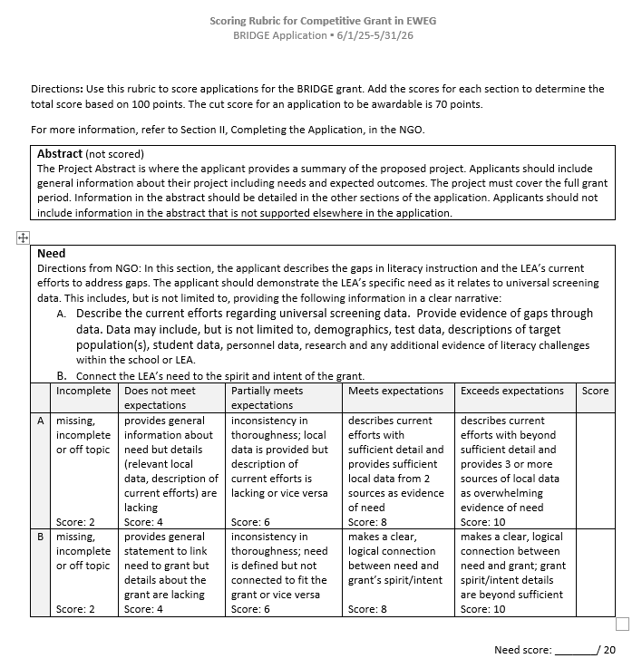

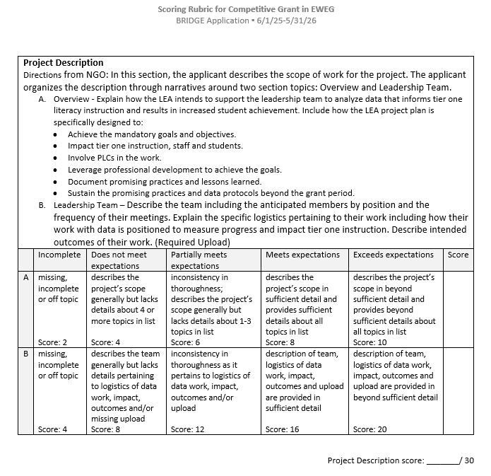

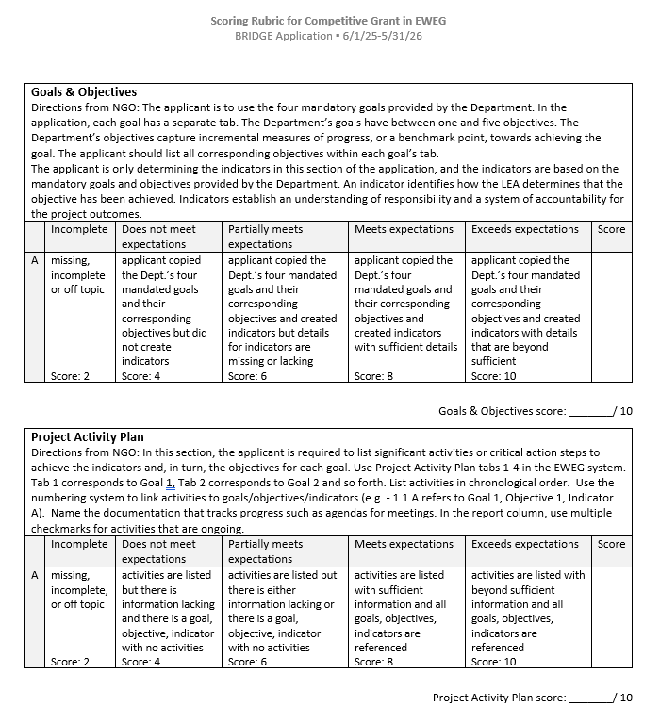

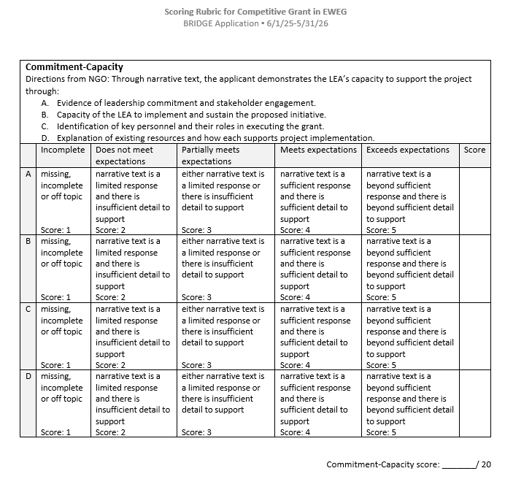

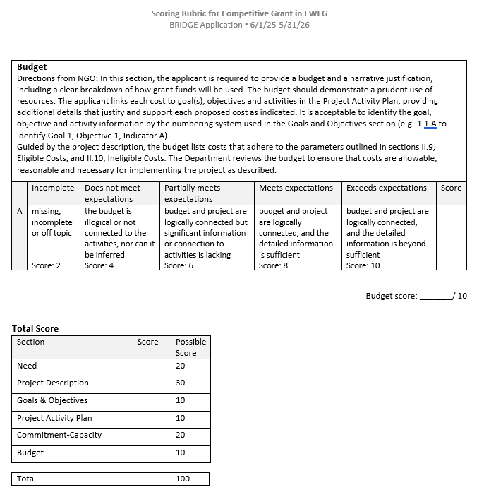

Appendix C- Universal Literacy Screening Criteria

**Universal Literacy Screener Evaluation Worksheet**

The criteria listed below outline the minimum requirements for Universal Literacy Screeners to meet New Jersey’s standards for an appropriate screener tool, in accordance with P.L. 2024 c. 52. Use the worksheet to evaluate whether the tool meets each criterion. Please refer to the technical manual provided by the screener vendor to confirm the information required for this evaluation.

**Criterion 1: Assessment of research-based indicators:** When evaluating a tool, it must assess the following skill areas at each grade level, as indicated by the check box. Place a mark in the box if the tool meets the criterion.

|  |  |  |  |  |  |
| --- | --- | --- | --- | --- | --- |
|  | **Letter** **Naming** | **Phonemic Awareness** | **Phonics &**  **Decoding** | **Oral Reading Fluency** | **Comprehension** |
| **Kindergarten** | 𝩋 | 𝩋 | 𝩋 |  |  |
| **Grade 1** | 𝩋 | 𝩋 | 𝩋 | 𝩋 |  |
| **Grade 2** |  |  | 𝩋 | 𝩋 | 𝩋 |
| **Grade 3** |  |  | 𝩋 | 𝩋 | 𝩋 |
| **Grades 4+** |  |  |  | 𝩋 | 𝩋 |

Review the following criteria, indicate yes or no and provide evidence for each criterion.

|  |  |  |
| --- | --- | --- |
| **Criterion** | **Yes/No** | **Findings/Decisions** |
| **Criterion 2:** Time efficient (less than 10 minutes per student) |  |  |
| **Criterion 3:** Sufficiency of items for assessing each skill |  |  |
| **Criterion 4:** Requires student oral production responses for letter/sound, word reading, and reading connected text |  |  |
| **Criterion 5:** Ease of administration and scoring |  |  |
| **Criterion 6:** Use of standardized scoring rules |  |  |
| **Criterion 7:** Use of common skills criteria for benchmark attainment |  |  |
| **Criterion 8:** Availability of companion progress monitoring tools |  |  |
| **Criterion 9:** Evidence of reliability and validity |  |  |
| **Criterion 10:** Evidence of Accuracy in predicting reading proficiency |  |  |
| **Consideration for Diverse Learners:** Available in other languages, in addition to English. |  |  |

Some screening tools also assess oral language skills, which can provide valuable insights into students’ language comprehension and other potential risk factors. For universal screening systems without measures of oral language skills, a brief rating scale can be used by teachers as an efficient means of screening for potential oral language concerns (e.g., Developmental Language Disorder). Additional oral language assessments can be administered to students for which educators suspect potential oral language weaknesses.

This criterion was developed and adapted through the **New Jersey Tiered System of Supports – Early Reading (NJTSS-ER) Project** that aligns with evidence-based literacy assessment practices. It reflects research, expert input, and stakeholder feedback from the Working Group on Student Literacy to support effective instruction and intervention for a full range of learners.