

LEARning About Literacy:
Families Series
Session 6 Series Introduction Facilitator Guide
This facilitation guide provides a structured approach to lead Session 1 Series Introduction. The session aims to help educators understand phonological awareness, its significance in early literacy, and how to effectively teach it. The facilitator is tasked with preparing materials, engaging participants, and ensuring active participation throughout the session.

Step-by-Step Facilitation Process
- Send Pre-Work Email to Community Members: Send the pre-drafted email with the pre-work assignment attached (e.g., reading or video) and session details (date, time, location/platform).
- Review Pre-Work and Session Presentation Materials: Session slides, and facilitator notes to ensure familiarity with content.
- Prepare and Update Session Presentation Materials: Update slides with relevant contextual information for the group, prepare all handouts and supplementary resources needed, and check on the room set up, and technology to ensure a smooth session. Test any video links in the presentation to confirm they are working properly.
- Deliver the Session: Present the pre-drafted session presentation, engage participants with discussions and activities, and answer questions to ensure understanding.
- Invite Community Members to Next Session: Thank participants, share details of the next session, and encourage ongoing engagement with additional resources.

Draft Email
Dear Families,
We are excited to share that we are continuing our Evidence-Based Literacy Instruction learning series as part of our Learning Equity & Academic Recovery efforts. This series is designed to strengthen reading instruction and support every child in becoming a confident, successful reader.
Session 6: Sentence Comprehension
Date: [Insert Date]
Time: [Insert Time]
Location: [Insert Location/Platform Link]
In this session, we will focus on sentence comprehension — how children understand the meaning of sentences as they read and listen. Strong sentence comprehension helps students connect words and ideas within a sentence, recognize how sentences are structured, and understand the message the author is communicating. When students can accurately interpret sentences, they are better able to make sense of paragraphs and fully understand what they read.
During the session, we will share practical strategies and activities that support sentence comprehension and can be reinforced at home. Families will learn how reading together, talking about sentence meaning, noticing key words, and asking questions about what a sentence is saying can help children strengthen their understanding. We will also discuss ways we can work together to support students as they build stronger comprehension skills.
We look forward to partnering with you to strengthen your child’s sentence comprehension and overall literacy development!
Best regards,
[Your Name]
[Your Title]
[School District Name]
[Your Contact Information]

PLC Session 6: Sentence Comprehension Presentation Facilitation Notes

Slide 1: Title Slide
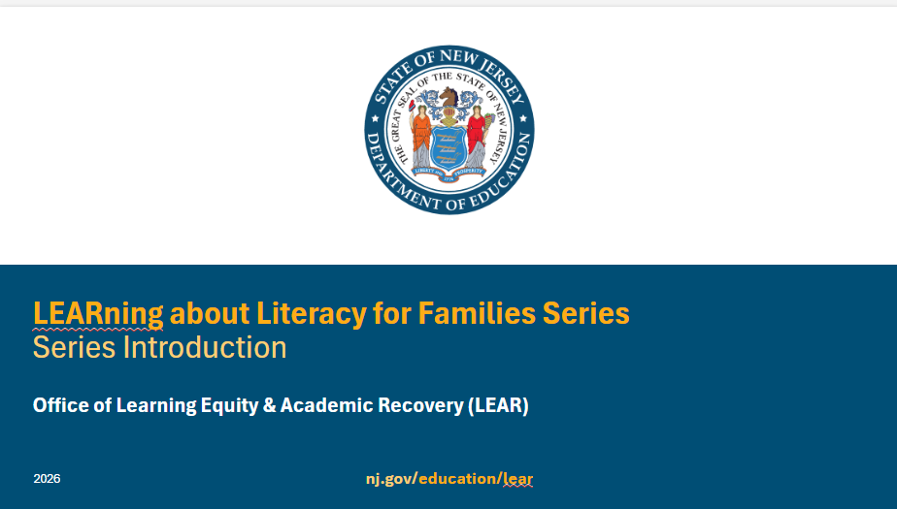
**Facilitator Notes: If you are using the presentation as a standalone or starting with a presentation other than the first one, you may want to unhide this slide to provide some context for participants.
Facilitator Narration:
Welcome to the LEARning about Literacy for Families series from the New Jersey Department of Education’s Office of Learning Equity and Academy Recovery, or LEAR. LEAR was established in August 2024 to transform New Jersey’s approach to literacy instruction and advance academic recovery.
Along with the LEAR office, a Working Group on Student Literacy was created to make recommendations on best practices and evidence-based strategies to help all children learn. Through the group’s research, it was determined that states that mirrored the language and formats used with teachers successfully communicated information about early literacy learning to families. As a result, one of the group's recommendations was to develop clear, accessible information for families to support aligned language around early literacy development. In response to this recommendation, the LEAR office created this series for parents, families, and caregivers, providing research and information on early literacy, along with practical applications and activities they can do with their children at home.
For more information about LEAR and the New Jersey Department of Education, visit the link on the screen.
Facilitator Note: Hide this slide if this is not the first session you are facilitating with this group.

Slide 2: Title Slide
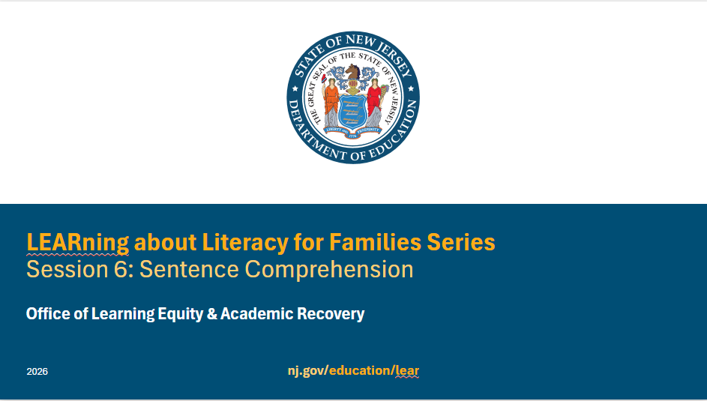

Facilitator Narration
Welcome! We’re excited to have you join us for this sixth session in the LEARning about Literacy for Families series created for New Jersey families supporting their children’s literacy journey at home. We will focus on sentence comprehension.

Slide 3: Session 6: Language Structures
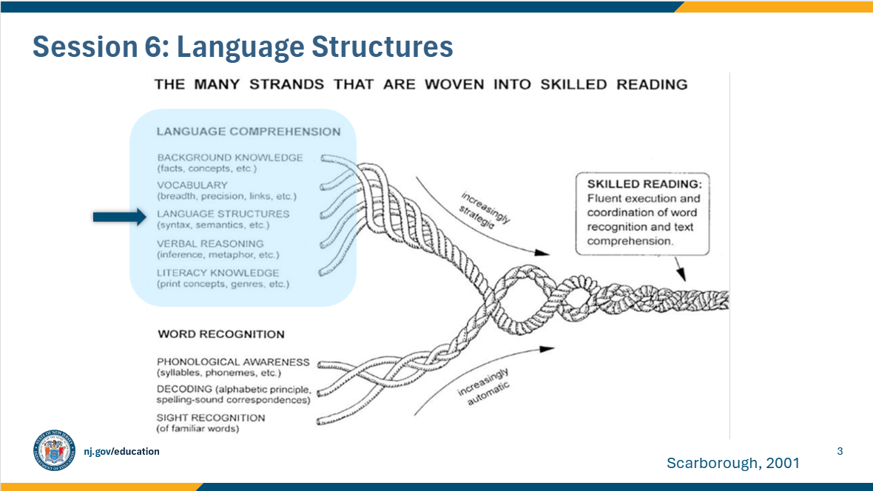

Facilitator Narration
Always starting with our conceptual framework for skilled reading, Scarborough’s Reading Rope, in this session, we will discuss language structures and the semantic and syntactic knowledge needed for sentence-level comprehension. Semantic knowledge is the understanding of all the different meanings a word can have, depending on the context it is used in. For example, a reader would need the context of a sentence or story to know which meaning of the word bank is being used: a financial institution or the side of a river. Syntactic knowledge helps readers understand how sentences work, including word order, structure, and punctuation. Semantics, along with syntactic knowledge, can help students understand increasingly complex texts.

Slide 4: Text Version of Scarborough’s Reading Rope
The text version is provided for people who cannot access the content in the image (e.g., someone who is blind or has low vision).

Slide 5: The Importance of Syntax
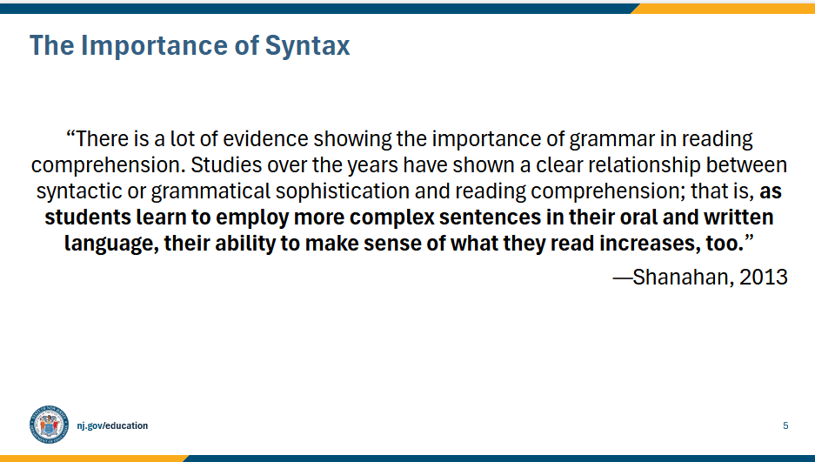

Facilitator Narration
Understanding sentences is an important part of reading. This means knowing how words go together to make sense—what we call syntax—and understanding the rules of grammar that guide how sentences are formed.
Both grammar and syntax are important because they help children understand the meaning of what they read. Research shows that students who can write and understand more complex sentences are also better at making sense of stories and information in their reading.
At home, you can support this by talking about how sentences are put together, helping your child expand their sentences when speaking or writing, and pointing out interesting sentence structures in the books you read together.

Slide 6: In the Classroom
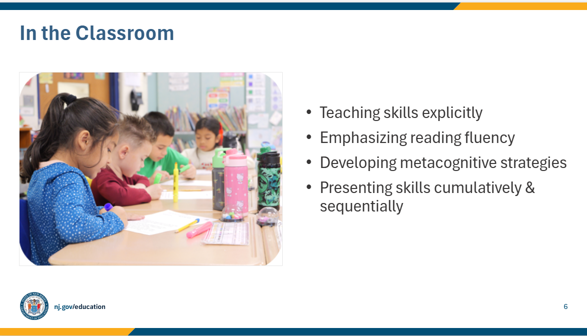

Facilitator Narration
In school, teachers use a variety of strategies to help children understand and use sentences, which is important for reading and writing. Some of the ways students experience this instruction include:
Teaching skills clearly and directly. Teachers make sentence rules and concepts concrete and visual so students can understand them.
Focusing on reading fluency. Students practice reading aloud, paying attention to phrasing and punctuation, which helps them better understand sentences. Students may also focus on prosody and using appropriate pitch, rhythm, and to express meaning. These also help children better understand what they read and are key components of reading fluency.
Learning strategies to think about sentences. Teachers help students notice how sentences are put together and apply these strategies when reading new texts.
Building skills step by step. Instruction is cumulative, starting with the basics and gradually introducing more complex sentence structures.
These classroom experiences help children become confident readers who can understand and enjoy the meaning of sentences in books and other texts.

Slide 7: Understanding Sentences by Breaking them Apart (1 of 2)
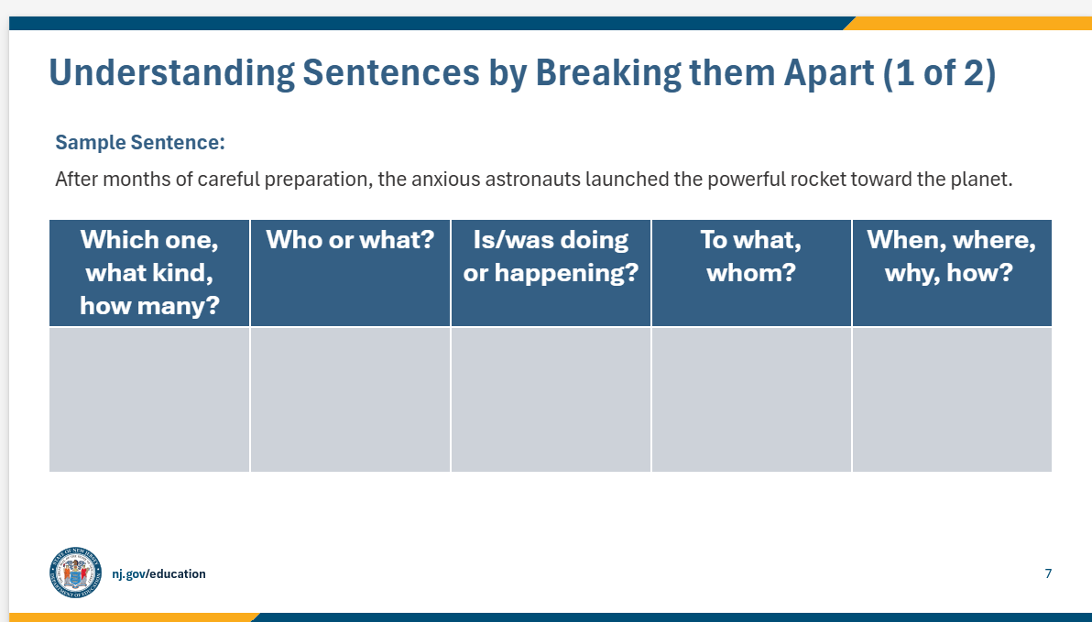

Facilitator Narration
Let’s try a fun sentence activity you can do at home with your child to explore how words work together in sentences. This helps children understand the function of words, phrases, and clauses, which is important for reading and writing.
- Step 1: Start with a sentence from a book, story, or one you create. Read the sentence together.
For example:
After months of careful preparation, the anxious astronauts launched the powerful rocket toward the planet.
- Step 2: Ask guiding questions.
Help your child answer these questions to break the sentence into parts:
  - Who is the sentence about? → astronauts
  - Which words describe them? → the anxious
  - What did they do? → launched
  - What did they launch? → the powerful rocket
  - When did this happen? → after months of careful preparation
  - Where did it happen? → toward the planet
Facilitator Note: See the results on the next slide.

Slide 8: Understanding Sentences by Breaking them Apart (2 of 2)
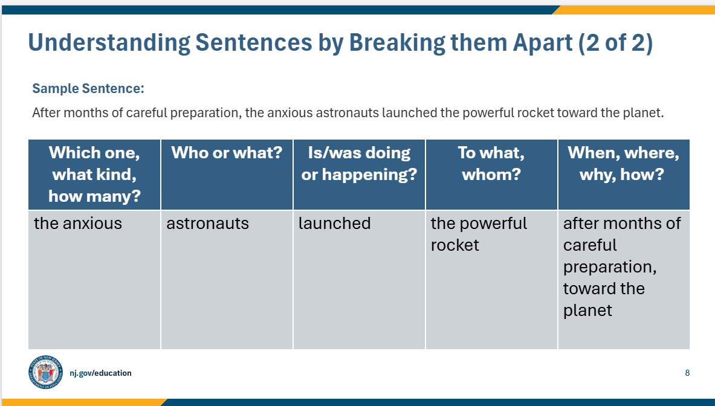

Facilitator Narration
Great! We can see how the different parts of the sentence are mapped out on the screen.
- Who is the sentence about? → astronauts
- Which words describe them? → the anxious
- What did they do? → launched
- What did they launch? → the powerful rocket
- When did this happen? → after months of careful preparation
- Where did it happen? → toward the planet
At home, continue the activity.
Try another sentence together. Choose a new sentence and have your child answer the same questions, helping them see how words and phrases work together.
Allow your child to practice sentence mapping independently. Encourage your child to try a few sentences on their own while you provide guidance and feedback.
By doing this, children learn to notice how sentences are built and how each word has a role. This supports reading comprehension and stronger writing skills.

Slide 9: Lesson on Sentence Combining
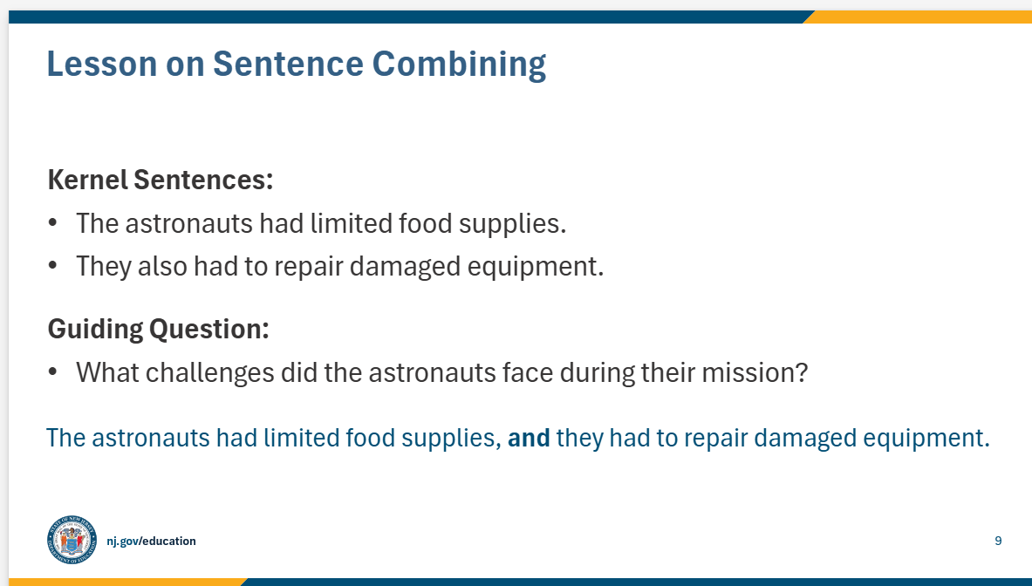

Facilitator Narration
Sentence combining is another fun way to help children build stronger sentences and better understand what they read. Here’s how you can try it at home:
- Step 1: Start with short sentences
Give your child two or more simple sentences, called kernel sentences. For example:
  - The astronauts had limited food supplies.
  - They also had to repair damaged equipment.
- Step 2: Ask a guiding question
Pose a question that connects to the sentences, like: What challenges did the astronauts face during their mission?
- Step 3: Combine the sentences together
Show your child how to join the sentences using words like and, but, or, so. For example:
  - The astronauts had limited food supplies, and they had to repair damaged equipment.
  - Talk about punctuation and how the sentences fit together.
- Step 4: Practice together
Give your child more short sentences from a story or one you make up and ask them to combine them into one sentence using conjunctions.
- Step 5: Try it independently
Encourage your child to pick sentences from books they are reading and combine them on their own. You can check together and discuss ways to make the sentence even stronger.
This activity helps children understand how words and ideas fit together, making reading comprehension and writing skills stronger at the same time.

Slide 10: Questions to Ask Your Child’s Teacher
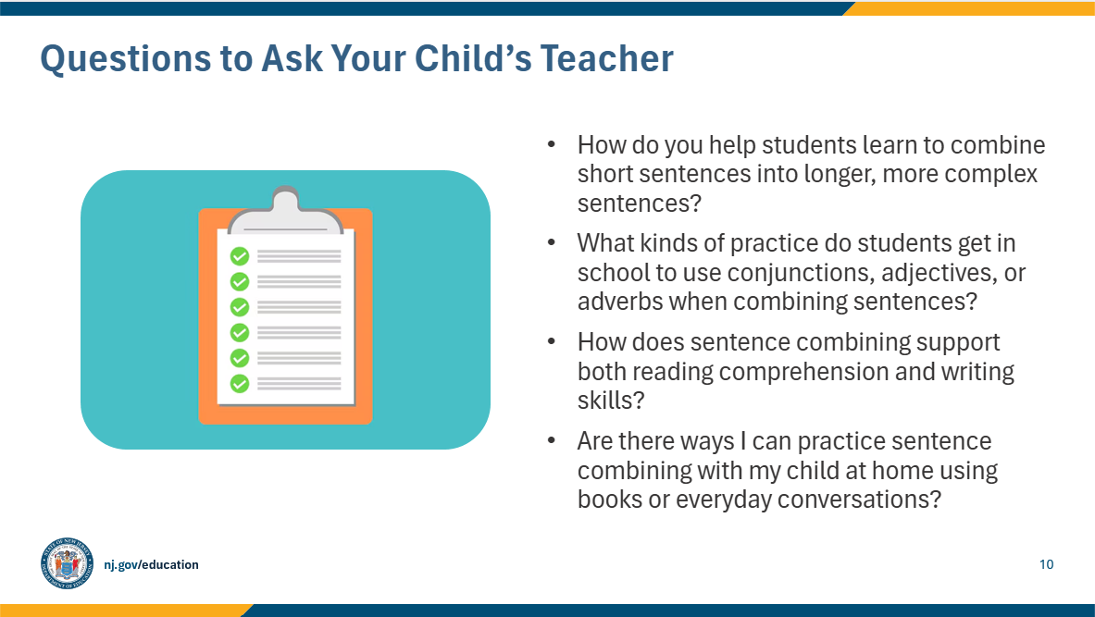

Facilitator Narration
As families, you can support your child’s growth in reading and writing by understanding how sentence combining is taught in school. Here are some questions you might ask your child’s teacher:
- How do you help students learn to combine short sentences into longer, more complex sentences?
- What kinds of practice do students get in school to use conjunctions, adjectives, or adverbs when combining sentences?
- How does sentence combining support both reading comprehension and writing skills?
- Are there ways I can practice sentence combining with my child at home using books or everyday conversations?
Asking these questions can give you ideas for ways to reinforce sentence skills at home and help your child become a stronger reader and writer.

Slide 11: How You Can Help Your Child at Home (1 of 2)
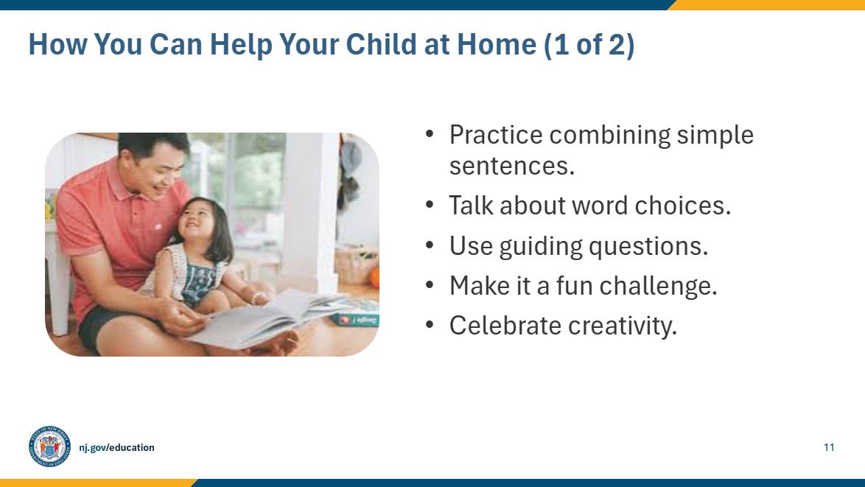

Facilitator Narration
You can help your child become a stronger reader and writer by practicing sentence combining at home. Here are some ways to do this:
- Practice combining simple sentences. Take two short sentences from a book or everyday life and help your child join them using words like and, but, or, and so.
- Talk about word choices. Encourage your child to add adjectives, adverbs, or descriptive phrases to make sentences more interesting.
- Use guiding questions. Ask questions like “Who is doing what?” or “How can we show when or where this happened?” to help your child think about sentence structure.
- Make it a fun challenge. Turn it into a game with sentences from stories or real-life events.
- Celebrate creativity. Praise your child’s efforts, even if they aren’t perfect, and explore ways to make sentences even stronger together.
Practicing this at home helps children see how words work together, which improves both their reading comprehension and writing skills

Slide 12: How You Can Help Your Child at Home (2 of 2)
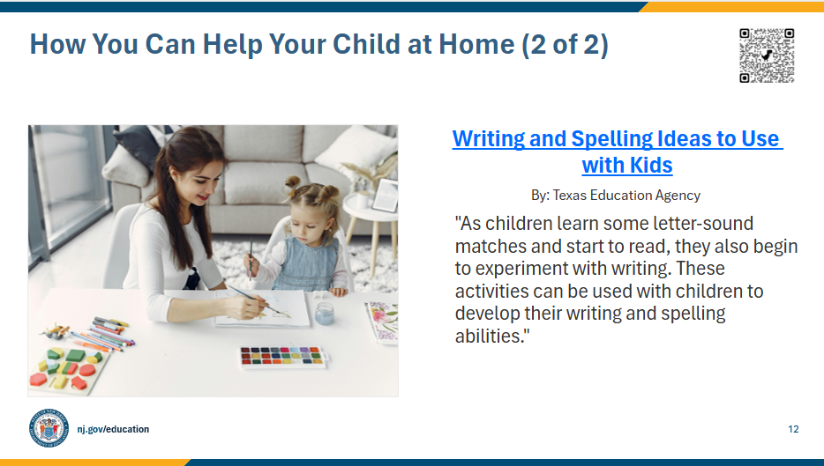

Facilitator Narration
A few additional activity ideas can be found on Reading Rockets website. The QR code is linked to the resource. As you work with your child, think about emphasizing some of the topics we discussed today, like sentence combining and word choice.
Facilitator Note: Link to resource: Writing and Spelling Ideas to Use with Kids

Slide 13: In Closing
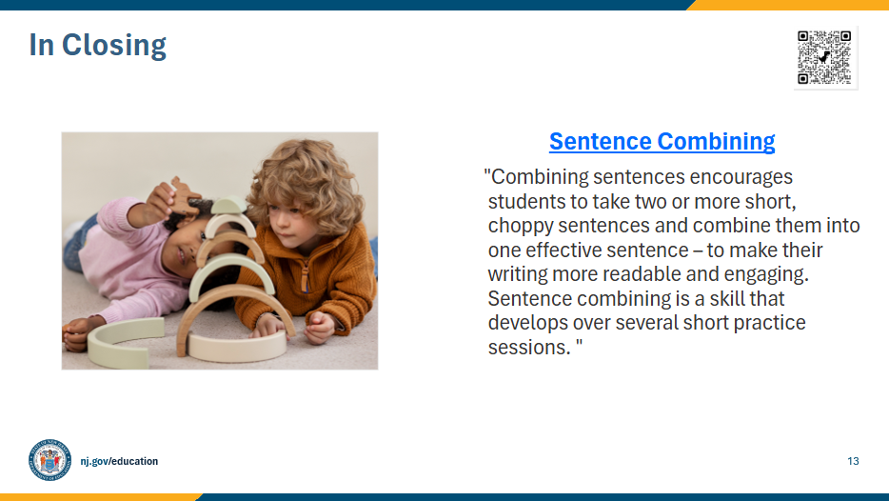

Facilitator Narration
In closing, we hope that you have enjoyed this session. To reinforce your learning, we recommend reviewing this article from Reading Rockets prior to our next session. The resource is linked to the QR code on the screen.
Facilitator Note: Link to resource: Sentence Combining

Slide 14: References
This slide lists references from the presentation.

Slide 15: Follow the New Jersey Department of Education
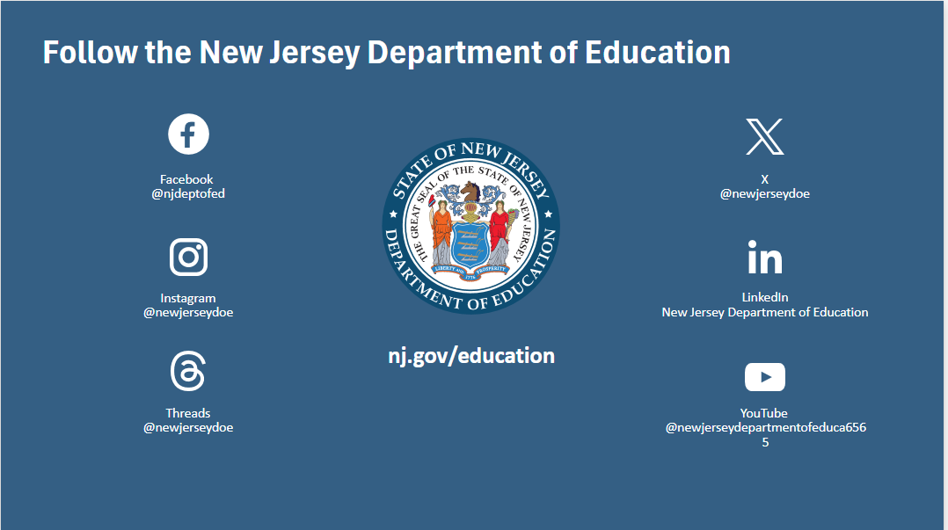

Session Materials Needed
Literacy Family Series Session 6 - Slide Presentation

