

LEARning About Literacy:
Families Series
Session 7 Series Introduction Facilitator Guide
This facilitation guide provides a structured approach to lead Session 1 Series Introduction. The session aims to help educators understand phonological awareness, its significance in early literacy, and how to effectively teach it. The facilitator is tasked with preparing materials, engaging participants, and ensuring active participation throughout the session.

Step-by-Step Facilitation Process
- Send Pre-Work Email to Community Members: Send the pre-drafted email with the pre-work assignment attached (e.g., reading or video) and session details (date, time, location/platform).
- Review Pre-Work and Session Presentation Materials: Session slides, and facilitator notes to ensure familiarity with content.
- Prepare and Update Session Presentation Materials: Update slides with relevant contextual information for the group, prepare all handouts and supplementary resources needed, and check on the room set up, and technology to ensure a smooth session. Test any video links in the presentation to confirm they are working properly.
- Deliver the Session: Present the pre-drafted session presentation, engage participants with discussions and activities, and answer questions to ensure understanding.
- Invite Community Members to Next Session: Thank participants, share details of the next session, and encourage ongoing engagement with additional resources.

Draft Email
Dear Families,
We are excited to share that we are continuing our Evidence-Based Literacy Instruction learning series as part of our Learning Equity & Academic Recovery efforts. This series is designed to strengthen reading instruction and support every child in becoming a confident, successful reader.
Session 7: Making Inferences
Date: [Insert Date]
Time: [Insert Time]
Location: [Insert Location/Platform Link]
In this session, we will focus on making inferences — how children use clues from the text along with their own background knowledge to understand ideas that are not directly stated. Strong inference skills help students read between the lines, think more deeply about what they read, and better understand characters, events, and messages within a text. When students can make inferences, they are better able to build meaning and strengthen their overall reading comprehension.
During the session, we will share practical strategies and activities that support inference skills and can be reinforced at home. Families will learn how asking thoughtful questions during reading, discussing clues in the text, and encouraging children to explain their thinking can help strengthen their ability to make inferences. We will also discuss ways we can work together to support students as they develop deeper comprehension skills.
We look forward to partnering with you to strengthen your child’s inference skills and overall literacy development!
Best regards,
[Your Name]
[Your Title]
[School District Name]
[Your Contact Information]

PLC Session 7: Making Inferences Presentation Facilitation Notes

Slide 1: Title Slide
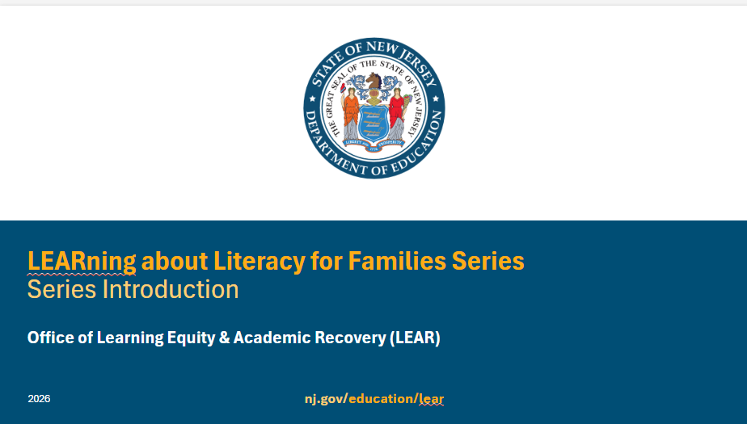
**Facilitator Notes: If you are using the presentation as a standalone or starting with a presentation other than the first one, you may want to unhide this slide to provide some context for participants.
Facilitator Narration:
Welcome to the LEARning about Literacy for Families series from the New Jersey Department of Education’s Office of Learning Equity and Academy Recovery, or LEAR. LEAR was established in August 2024 to transform New Jersey’s approach to literacy instruction and advance academic recovery.
Along with the LEAR office, a Working Group on Student Literacy was created to make recommendations on best practices and evidence-based strategies to help all children learn. Through the group’s research, it was determined that states that mirrored the language and formats used with teachers successfully communicated information about early literacy learning to families. As a result, one of the group's recommendations was to develop clear, accessible information for families to support aligned language around early literacy development. In response to this recommendation, the LEAR office created this series for parents, families, and caregivers, providing research and information on early literacy, along with practical applications and activities they can do with their children at home.
For more information about LEAR and the New Jersey Department of Education, visit the link on the screen.
Facilitator Note: Hide this slide if this is not the first session you are facilitating with this group.

Slide 2: Title Slide
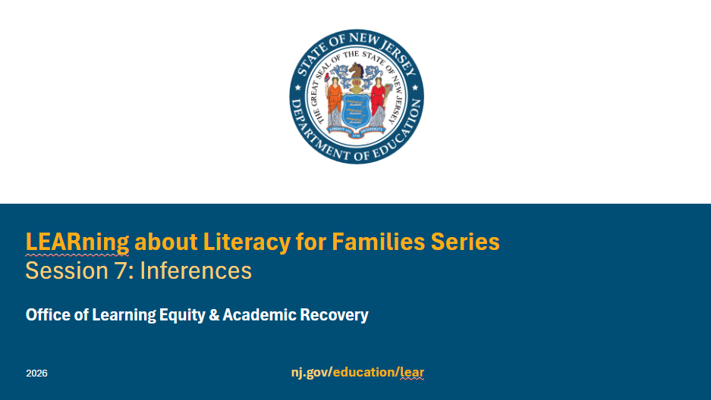

Facilitator Narration
Welcome! We’re excited to have you join us for this seventh session in the LEARning about Literacy for Families series created for New Jersey Families supporting their children’s literacy journey at home. We will focus on inferencing or making conclusions based on evidence and reasoning.

Slide 3: Session 7: Verbal Reasoning
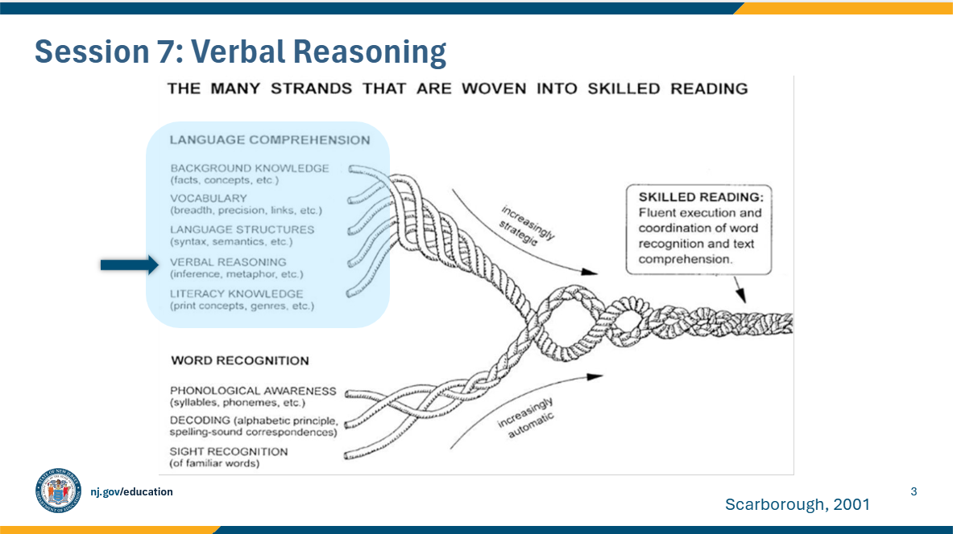

Facilitator Narration:
Always starting with our conceptual framework for skilled reading, Scarborough’s Reading Rope. This model shows us that reading is more than just recognizing words on a page—it’s about weaving together many different skills.
In session seven, we’ll focus on one strand of that rope: verbal reasoning, which is how words can be used literally and figuratively in text. Within verbal reasoning, we’ll look closely at inferencing. You may have heard of the saying, “Reading between the lines.” This expression means understanding the hidden meaning in a statement or situation. Inferencing is the skill of ‘reading between the lines’—using clues from the text along with what we already know to understand meaning that isn’t directly stated. This is a higher-level skill and an essential part of making sense of stories and information.
It’s important to know that inferencing doesn’t stand alone. Children need to pull together all of their language comprehension skills—like vocabulary, background knowledge, and understanding sentence structure—to make strong inferences while reading.
Helping students understand when information is implied rather than directly stated will improve their ability to draw conclusions. Inferential thinking is a complex skill that will develop over time and with experience.

Slide 4: Text Version of Scarborough’s Reading Rope
The text version is provided for people who cannot access the content in the image (e.g., someone who is blind or has low vision).

Slide 5: Set the Scene: What’s Going on Here?
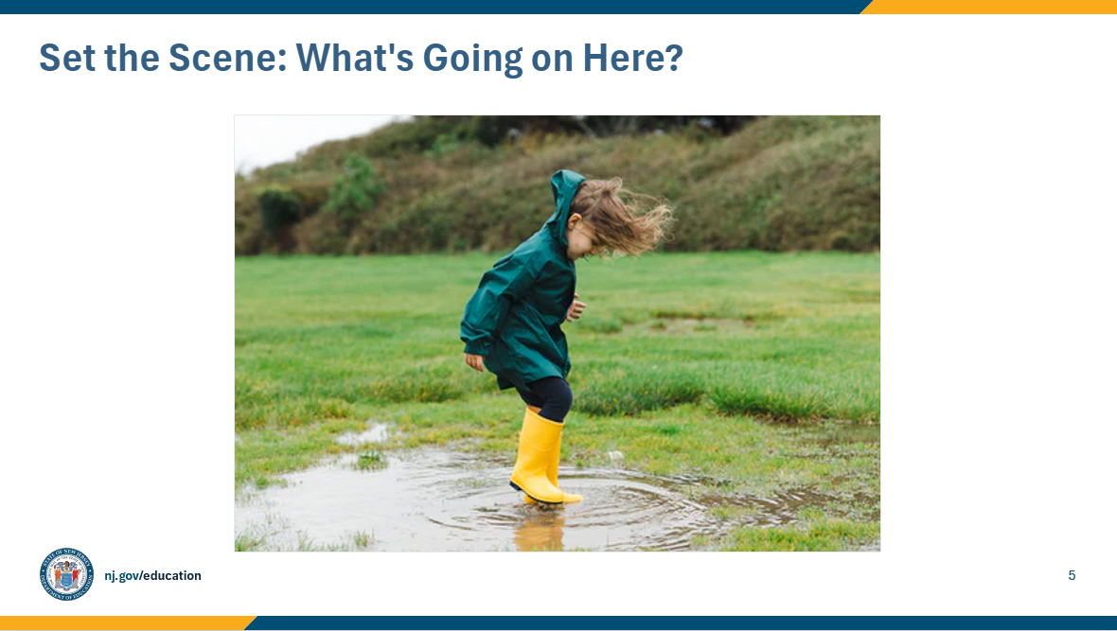

Facilitator Narration
We will now try a short activity to support your understanding in the skill of inferencing, what your child will experience in school, and how to support this skill at home.
Take a look at this picture. What do you think is happening? What clues help you make that guess?
Facilitator Note: Invite families to share what they notice, if possible, via the chat feature, or have them note this on their own.
Highlight their thinking or note on the following aloud:
- “You noticed the boots and jacket—great details!”
“Yes, splashing in the puddle tells us it probably rained just before this.”
Explain and share with the group: “You combined clues in the picture with what you already know about rain and puddles. That’s inferencing!”

Slide 6: Apply to Text
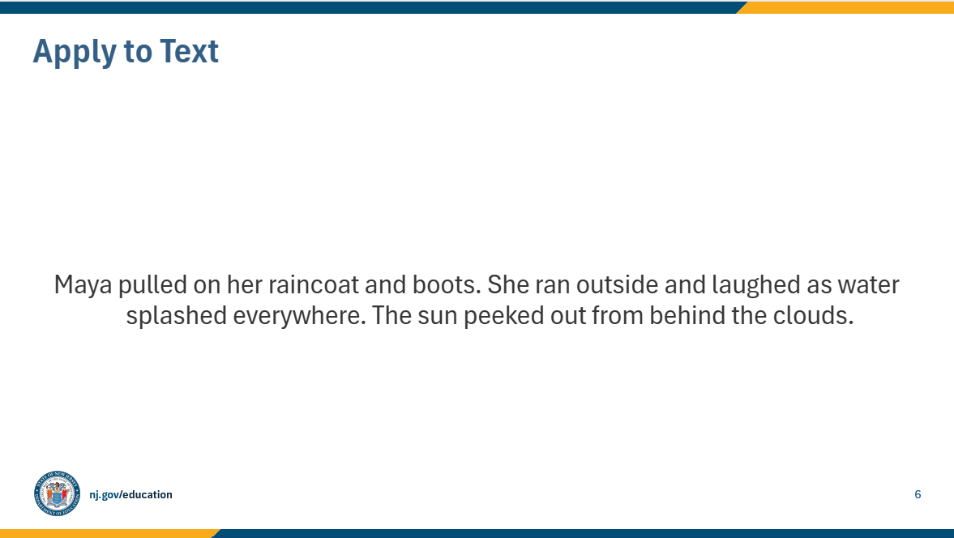

Facilitator Narration:
Now we’ll try to make some inferences based on text. Read the sentence on the screen: Maya pulled on her raincoat and boots. She ran outside and laughed as water splashed everywhere. The sun peeked out from behind the clouds.
Ask the group out loud: “What can we figure out that the author didn’t directly say?”
Then, share the possible inferences:
- It has just rained.
- Maya is jumping in a puddle.
- The rain has stopped.
Facilitator Note: Consider collecting additional inferences from participants using the chat feature or another method.

Slide 7: In the Classroom
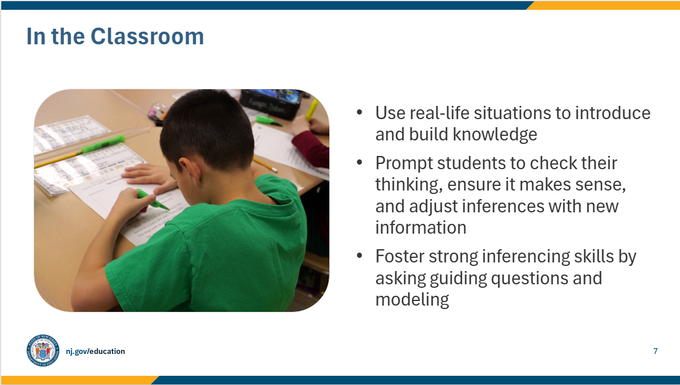

Facilitator Narration
The skills we practiced are the same ones your child uses in school—making smart guesses using clues and background knowledge.
In the classroom, teachers provide a variety of opportunities to help students use what they know and draw conclusions.
- Teachers often use real-life situations to introduce inferential thinking to students. This helps students recognize the inferences they make about their real-life experiences and their reading, check their thinking to make sure it makes sense, and adjust their inferences as they gain new information.
- Teachers foster strong inferencing skills when reading text by asking guiding questions about pictures and photos along with story elements in stories and using modeling to scaffold students’ understanding. Modeling includes the teacher “thinking aloud” to show students how they would use text and their own background knowledge to develop an inference.

Slide 8: Questions to Ask Your Child’s Teacher
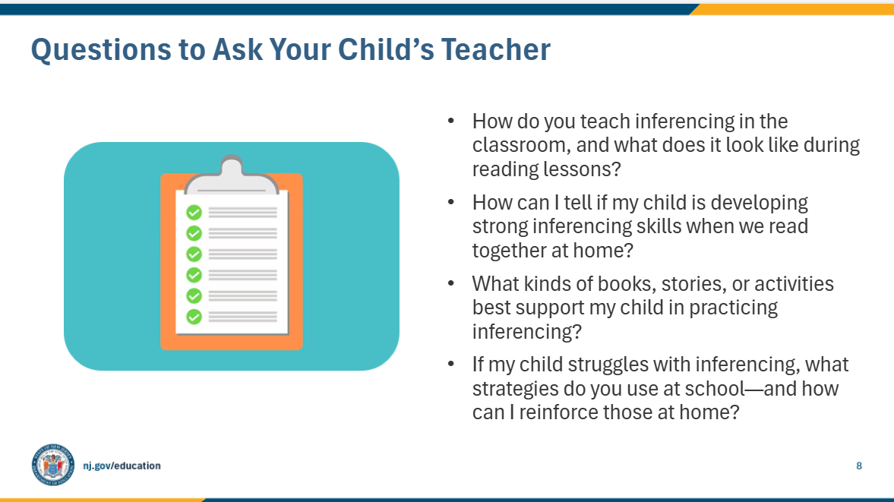

Facilitator Narration
Here are a few questions you can ask your child’s teacher to better understand how inferencing is taught and how you can support it at home.
You might ask:
- How do you teach inferencing in the classroom, and what does it look like during reading lessons? This helps you picture what your child is doing at school.
- How can I tell if my child is developing strong inferencing skills when we read together at home? This gives you some signs to look for as you listen to your child read.
- What kinds of books, stories, or activities best support my child in practicing inferencing? This way, you can choose materials that match what’s happening in school.
- If my child struggles with inferencing, what strategies do you use at school—and how can I reinforce those at home? This ensures you and the teacher are working as a team.
The goal is to open the conversation and get clear, practical ways to support your child’s reading growth.

Slide 9: How You Can Help Your Child at Home (1 of 2)
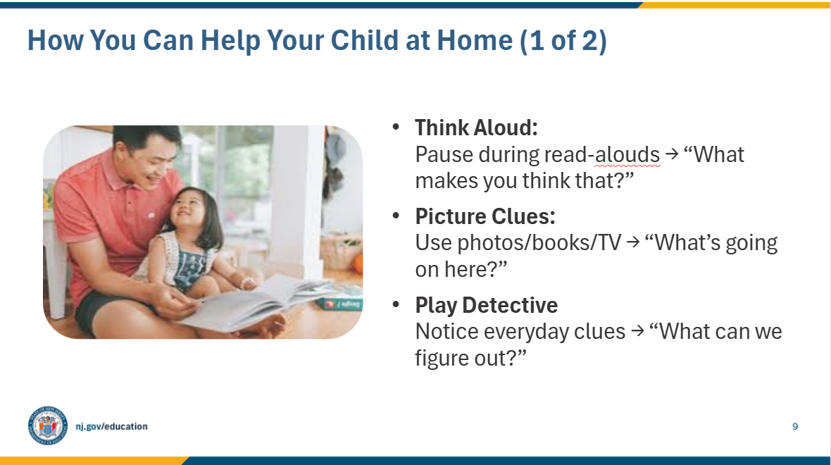

Facilitator Narration
When you’re at home, there are so many simple ways to help your child grow their inferencing skills.
- First, during read-alouds, pause and think out loud. Show your child how you make a smart guess from clues in the text by saying things like, ‘Her hair is wet… I think it must have rained. What makes me think that? The clue is her hair!’
- Second, use pictures—family photos, storybook illustrations, or even pausing a TV show. Ask, ‘What’s going on here? What clues helped you figure that out?’
- And third, play detective in everyday life. Notice things like muddy shoes, an empty plate, or a backpack left out, and ask, ‘What can we figure out from this?’
These small, playful moments help children see that inferencing is a skill they can use all the time—not just when reading.

Slide 10: How You Can Help Your Child at Home (1 of 2)
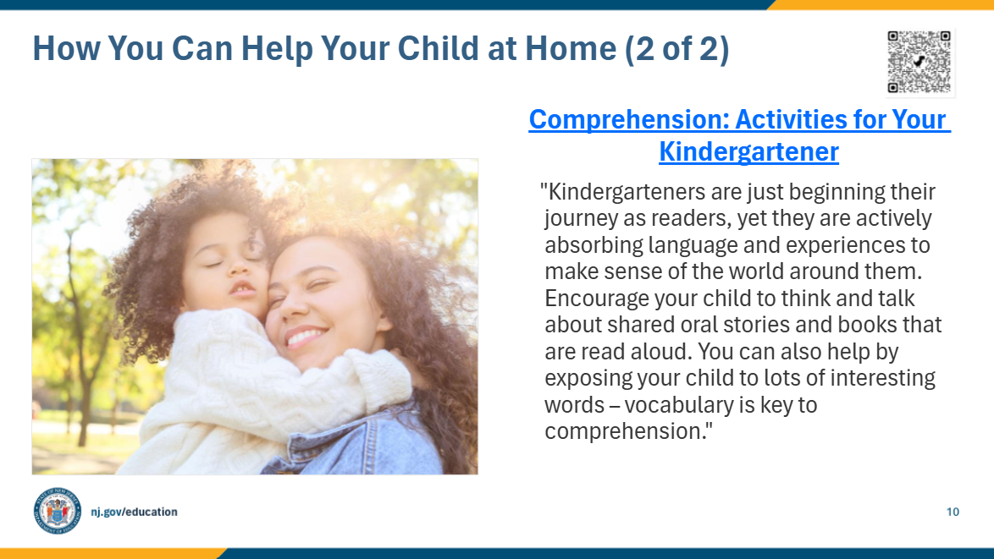

Facilitator Narration
Additional ideas, activities, directions, and examples can be found on Reading Rockets website. The QR code is linked to the Kindergarten page. Activities for other age and grade levels are accessible from the Reading 101: A Guide for Parents menu.
Facilitator Note: Link to Resource: Comprehension: Activities for Your Kindergartener

Slide 11: In Closing
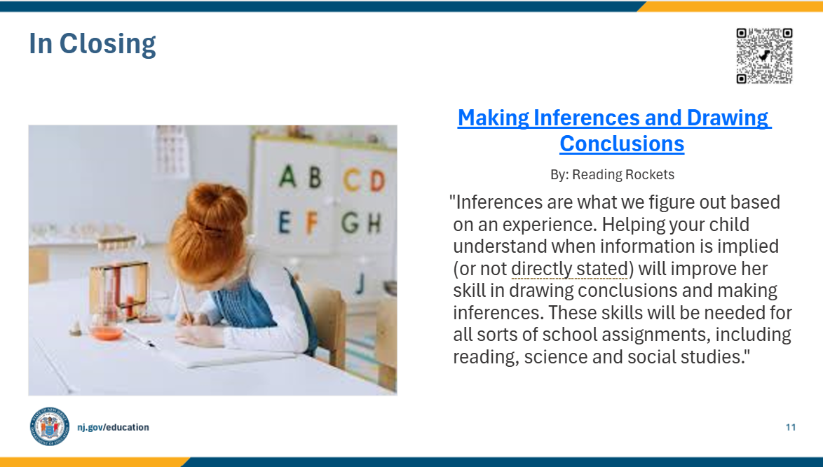

Facilitator Narration
In closing, we hope that you have enjoyed this session. To reinforce your learning, we recommend reviewing this article from Reading Rockets prior to our next session. The resource is linked to the QR code on the screen.
Facilitator Note: Link to resource: Making Inferences and Drawing Conclusions

Slide 14: References
This slide lists references from the presentation.

Slide 15: Follow the New Jersey Department of Education
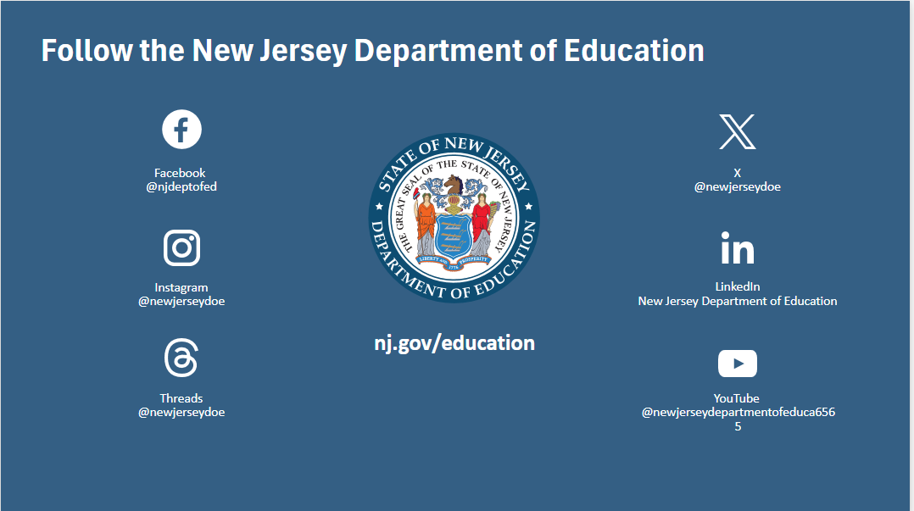

Session Materials Needed
Literacy Family Series Session 7 - Slide Presentation

