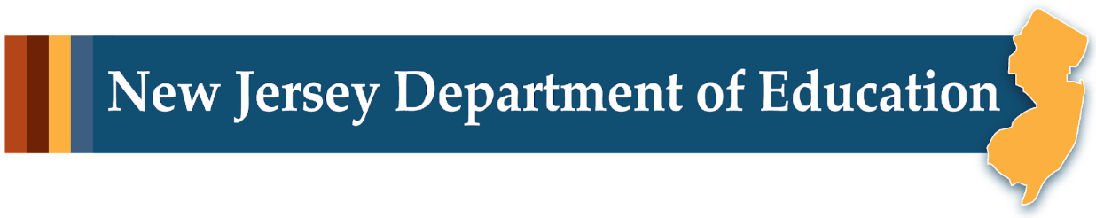

# LEARning About Literacy: Professional Learning Community (PLC) Series Introduction Facilitator Guide

## Step-by-Step Facilitation Process:

1. **Send Pre-Work Email to Community Members:** Send the pre-drafted email with the pre-work assignment attached (e.g., reading or video) and session details (date, time, location/platform).
2. **Review Pre-Work and Session Presentation Materials:** Review the pre-work assignment, session slides, and facilitator notes to ensure familiarity with content.
3. **Prepare and Update Session Presentation Materials:** Update slides with relevant contextual information for the group, prepare all handouts and supplementary resources needed, and check on the room set up, materials needed for activities, and technology to ensure a smooth session. Test any video links in the presentation to confirm they are working properly.
4. **Deliver the Session:** Present the pre-drafted session presentation, engage participants with discussions and activities, and answer questions to ensure understanding.
5. **Invite Community Members to Next Session:** Thank participants, share details of the next session, and encourage ongoing engagement with additional resources.

## Send an Introductory Email Inviting Community Members

Send the pre-drafted email with introductory video and session details (date, time, location or platform, and registration information).

## Draft Email

**Subject Line:** Enhance Your Literacy Instruction with the Office of Learning Equity & Academic Recovery’s (LEAR) Evidence-Based Literacy Instruction PLC Series

Dear [Staff Member],

We are excited to bring the **LEAR Evidence-Based Literacy Professional Learning Community (PLC) Series** to our district! This series offers a fantastic opportunity to deepen your understanding of effective literacy instruction, drawing on the latest research in reading and learning.

The PLC Series consists of 8 engaging, 40-minute sessions designed to foster collaboration and insight-sharing. Topics include Phonological Awareness, Phonics, Fluency, Vocabulary, Sentence Comprehension, Inference Skills, and more—essential components that will strengthen your teaching practice and support student success.

This professional development aligns with the state’s training requirements (N.J.S.A. 18A:6-131, N.J.S.A. 18A:6-149) for educators of students from preschool through grade six.

To get started, we encourage you to watch this brief video on Scarborough’s Reading Rope, which provides a powerful framework for understanding the key reading skills covered in this series:

[**Introduction to the Evidence-Based Literacy Professional Learning Community Series**](https://docs.google.com/presentation/d/1AZflK1pajT6ZZXB3EMpbsGV5_LH-cIwOighgAtoZiP8/edit?slide=id.p1#slide=id.p1)

[Add local details on meeting dates, times, location/platform, and registration]

We hope you take full advantage of this opportunity to enhance your skills and contribute to our ongoing efforts to improve literacy instruction across the district. If you have any questions or need further details, please feel free to reach out.

Best regards,

[Your Name]  
[Your Title]  
[School District Name]  
[Your Contact Information]