

# LEARning About Literacy: Professional Learning Community (PLC) Series Session 1 Phonological Awareness Facilitator Guide

This facilitation guide provides a structured approach to lead Session 1 Phonological Awareness. The session aims to help educators understand phonological awareness, its significance in early literacy, and how to effectively teach it. The facilitator is tasked with preparing materials, engaging participants, and ensuring active participation throughout the session.

## Step-by-Step Facilitation Process

1. **Send Pre-Work Email to Community Members:** Send the pre-drafted email with the pre-work assignment attached (e.g., reading or video) and session details (date, time, location/platform).
2. **Review Pre-Work and Session Presentation Materials:** Review the pre-work assignment, session slides, and facilitator notes to ensure familiarity with content.
3. **Prepare and Update Session Presentation Materials:** Update slides with relevant contextual information for the group, prepare all handouts and supplementary resources needed, and check on the room set up, materials needed for activities, and technology to ensure a smooth session. Test any video links in the presentation to confirm they are working properly.
4. **Deliver the Session:** Present the pre-drafted session presentation, engage participants with discussions and activities, and answer questions to ensure understanding.
5. **Invite Community Members to Next Session:** Thank participants, share details of the next session, and encourage ongoing engagement with additional resources.

## Draft Email

**Subject Line:** Session 1 is Here! Evidence-Based Literacy Instruction PLC Series

Dear [Staff Member],

This is a friendly reminder that our first session of the Learning Equity & Academic Recovery’s Evidence-Based Literacy Instruction Professional Learning Community (PLC) Series is fast approaching! We’re excited to begin this professional development journey with you.

### PLC Session 1: Phonological Awareness

Date: [Insert Date]  
Time: [Insert Time]  
Location: [Insert Location/Platform Link]

In this session, we will focus on the critical component of phonological awareness, with an emphasis on phonemic awareness and its essential role in developing strong reading and spelling skills. The session is designed to be interactive and collaborative, allowing you to engage with your colleagues and share ideas and best practices for supporting students’ literacy development.

Prior to our session together, please be sure to read **Building Phoneme Awareness: Know What Matters** [add link or attachment] to be prepared for our discussion and activities.

We look forward to seeing you there and working together to enhance our literacy instruction!

Best regards,

[Your Name]  
[Your Title]  
[School District Name]  
[Your Contact Information]

## PLC Session 1: Phonological Awareness Presentation Facilitation Notes

### Slide 1: Title Slide

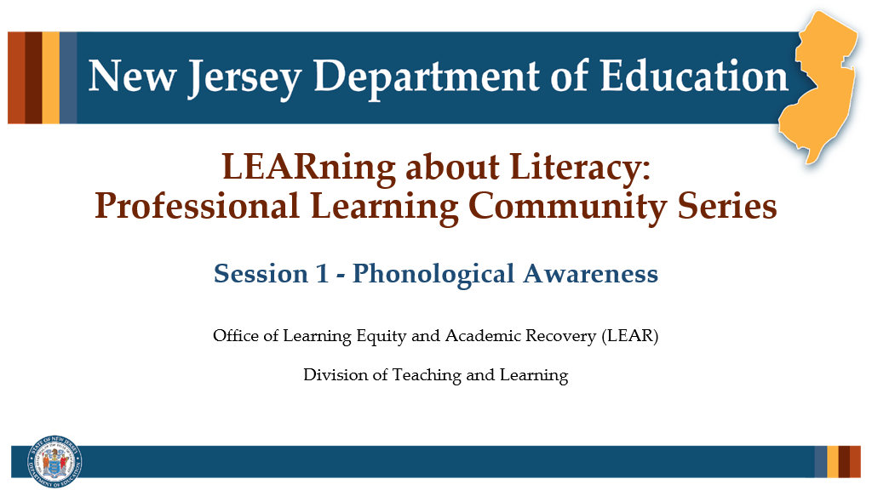

#### Facilitator Narration

Welcome! We’re excited to have you join us for this first session in our Professional Learning Community Series. Today, we’ll be looking to strengthen our instructional practices based on the latest research in phonological awareness.

**Note to Facilitator:** Turquoise highlights indicate a “click” is needed to advance the slide animation.

### Slide 2: Session 1 — Phonological Awareness

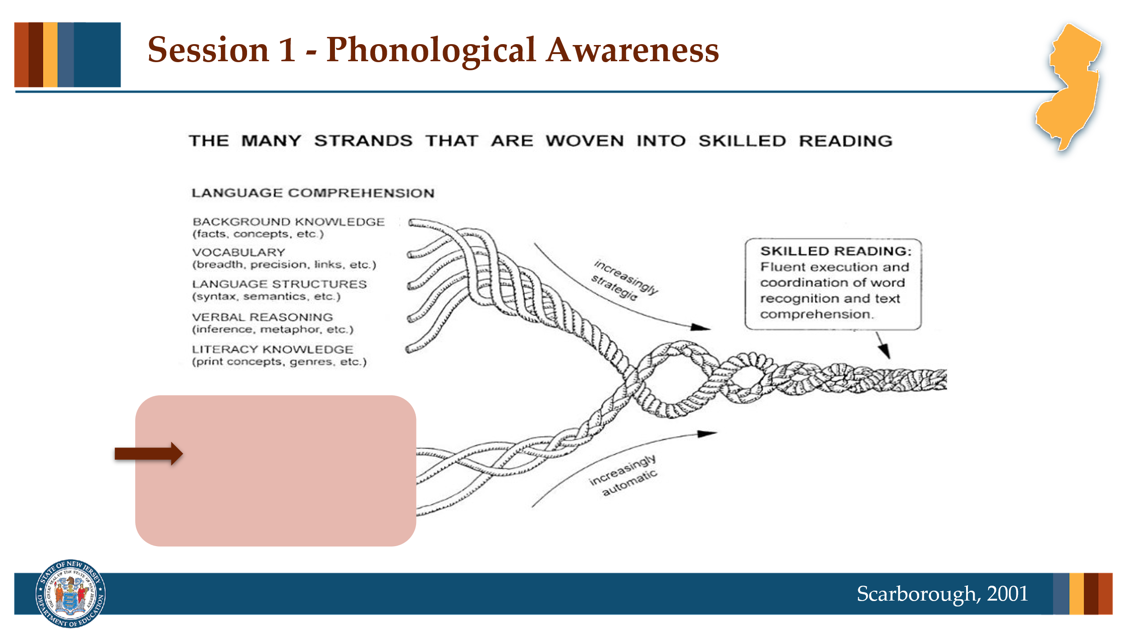

#### Facilitator Narration

If you took the opportunity to watch the brief video included in the introductory email, you are familiar with Scarborough’s Reading Rope image. In this session we will be exploring an important word recognition skill, Phonological Awareness.

**Note to Facilitator:** You might also consider watching the introductory video together before launching into the topic for this session.

### Slide 3: Text Version of Scarborough’s Reading Rope

The text version is provided for people who cannot access the content in the image (e.g., someone who is blind or has low vision).

### Slide 4: Building Phoneme Awareness

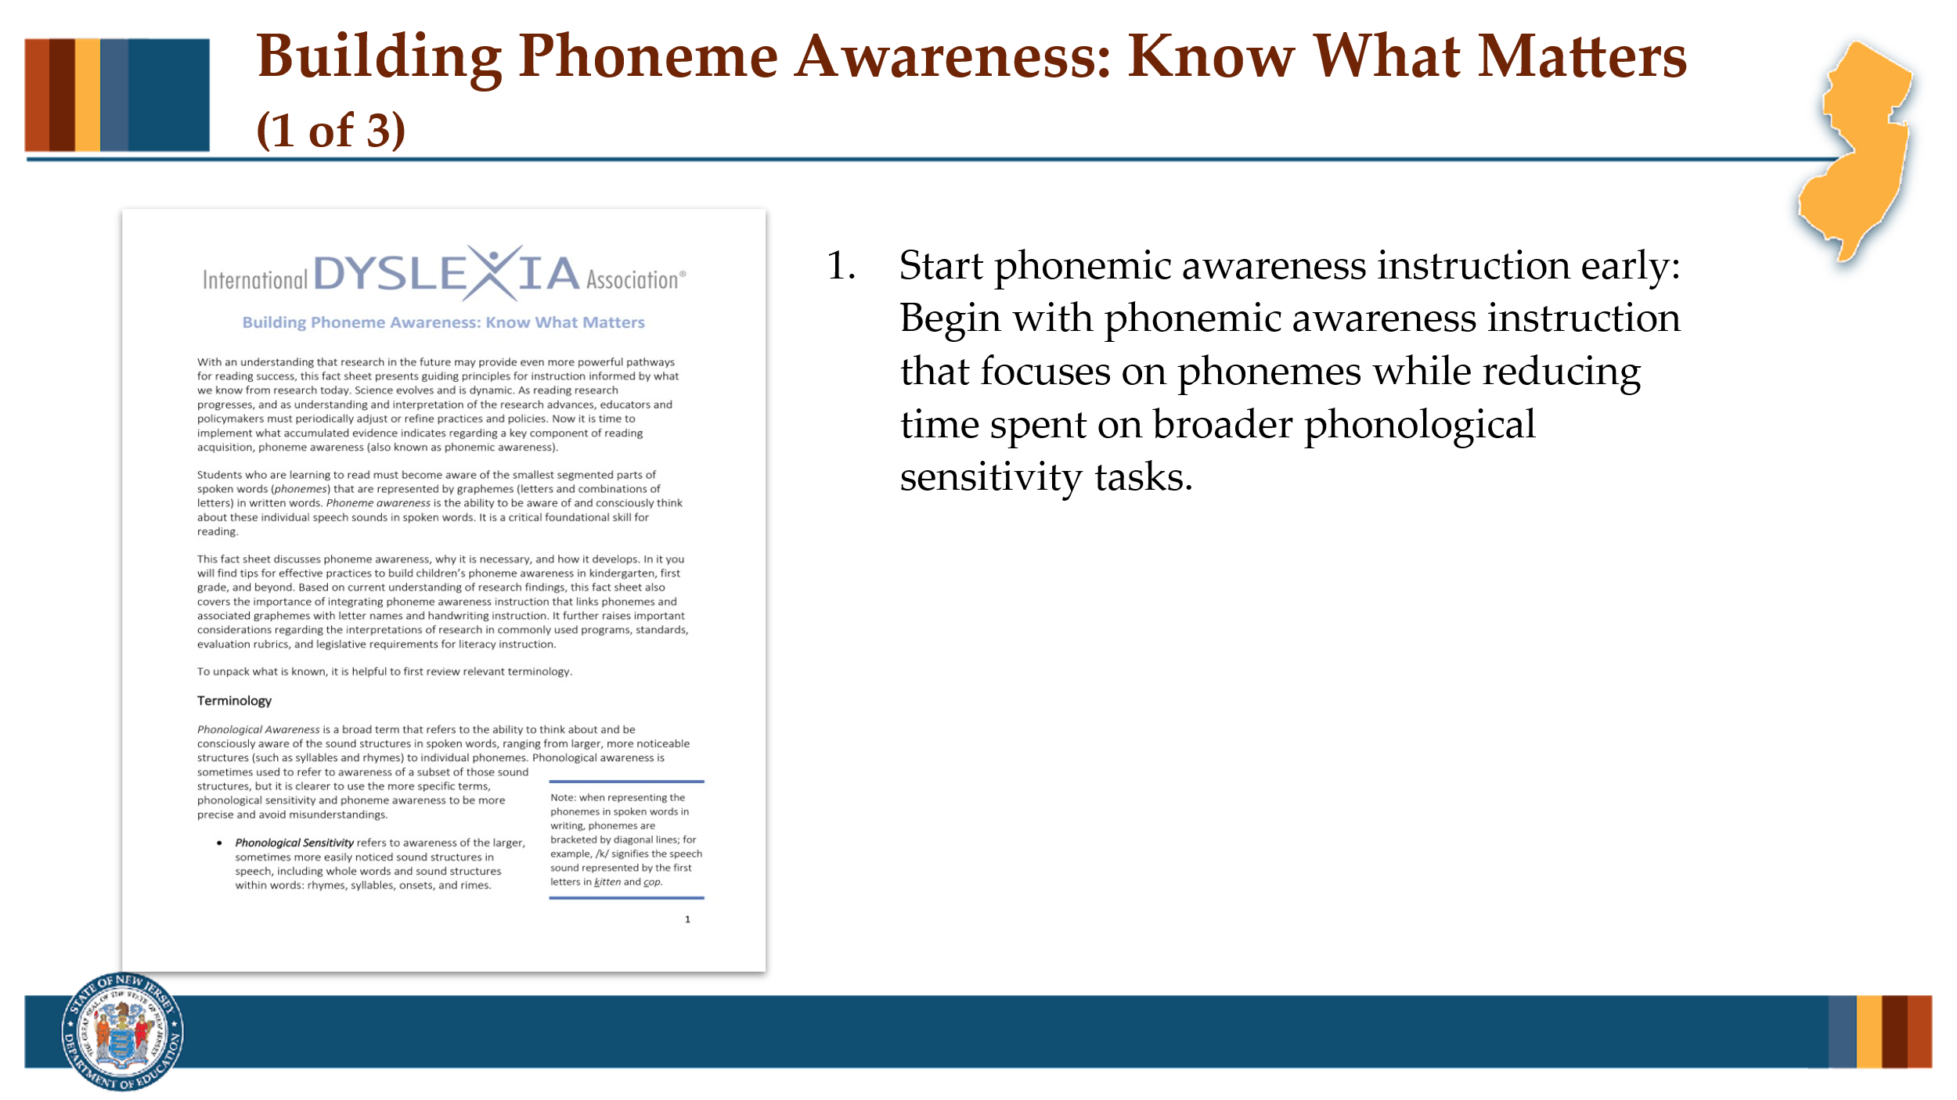

#### Facilitator Narration

As a pre-work activity for this session, we read the International Dyslexia Association’s brief *Building Phoneme Awareness: Know What Matters*. We are going to discuss the three key implications for instruction identified on page 10 of this brief. Can I get a volunteer to read bullet point #1?

#### Volunteer Reads

Educators should begin right away with phoneme awareness instruction in kindergarten (and when working with older students with phoneme awareness deficits). The best use of instructional time in kindergarten and beyond is to focus on phonemic awareness while greatly reducing time spent on phonological sensitivity elements. Educators do not need to follow a continuum that requires instruction in each element of phonological sensitivity (counting the words in a sentence, rhyme recognition and production, syllable counting, syllable segmenting/blending, and so on) prior to beginning instruction to develop phoneme awareness.

### Slide 5: Start Phonemic Awareness Instruction Early

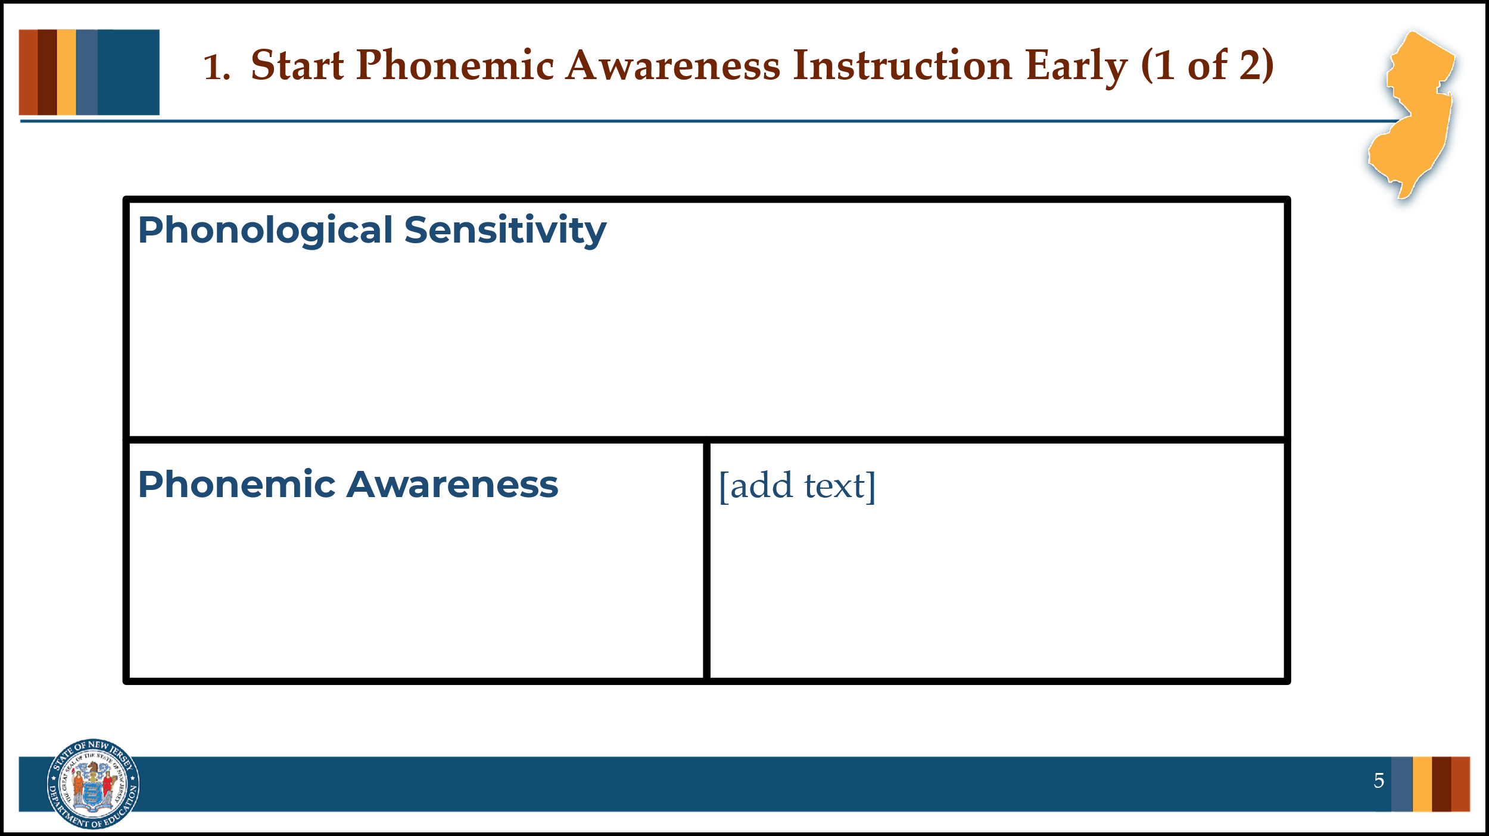

#### Facilitator Narration

Thank you. Let’s take a moment to discuss the components of phonological awareness described in this brief as phonological sensitivity and phonemic awareness.

#### Activity

(5–10 minutes)

Create a space to capture notes on the two components of phonological awareness (if virtual, using this slide and annotating tools; if in-person, using chart paper and markers). Facilitate the discussion to prompt community members for the following points:

##### Phonological Sensitivity

Phonological Sensitivity refers to awareness of the larger, sometimes more easily noticed sound structures in speech, including whole words and sound structures within words, such as rhymes, syllables, onsets, and rimes. Research indicates that phonological sensitivity instruction (with larger units such as rhyme, syllables, and onset-rime) is neither a prerequisite nor a causal factor in the development of phonemic awareness. An instructional continuum from phonological sensitivity to phoneme awareness is not necessary and should not delay explicit phonemic awareness instruction. There can be benefits to teaching students about syllable and rhyme structures, but mostly for reasons unrelated to phonemic awareness, such as syllable awareness during spelling or morphology instruction and rhyme structures during read-alouds and poetry writing.

##### Phonemic Awareness

Phonemic Awareness is the ability to be aware of and consciously think about individual speech sounds (phonemes) in spoken words. Phoneme awareness is a necessary component of early reading and spelling development. It goes beyond the hearing or perceiving of the speech sounds in spoken words. Phoneme awareness involves conscious awareness that allows a learner to notice and think about the phonemes in words they hear and pronounce. This skill develops gradually, almost always in the context of learning about phonemes and letters in written words.

### Slide 6: Start Phonemic Instruction Early

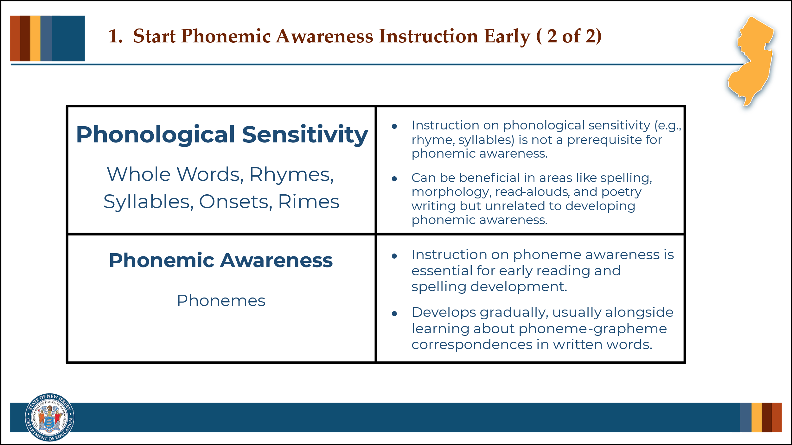

#### Facilitator Narration

Great discussion and distinctions noted! It is important to note that it is often common for students, especially young students or those struggling to learn to read, to lack both phonological sensitivity and phoneme awareness. However, research shows that even though phonological sensitivity can be taught, doing so can delay the type of instruction needed to build students’ phonemic awareness and corresponding letter knowledge—the skills that are really most relevant for developing proficient word recognition skills. There can be benefits to teaching students about syllable and rhyme structures, but mostly for reasons unrelated to phonemic awareness, such as syllable awareness during spelling or morphology instruction, rhyme structures during read-alouds and poetry writing, or even onsets.

### Slide 7: Building Phoneme Awareness

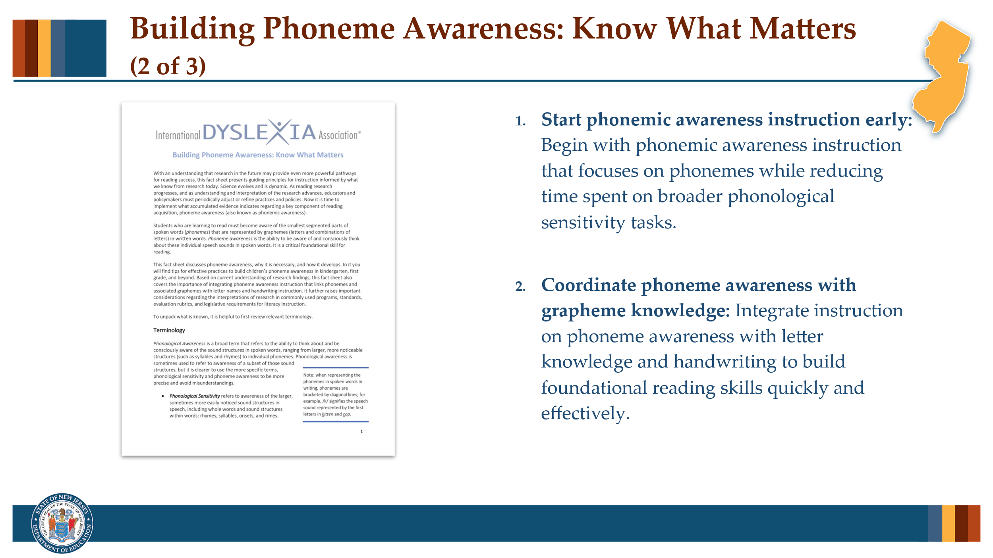

#### Facilitator Narration

Now let’s get into deeper discussion about instructional practices. Can I get a volunteer to read bullet point #2 from the International Dyslexia Association’s brief *Building Phoneme Awareness: Know What Matters* (page 10)?

#### Volunteer Reads

By focusing immediately on phoneme awareness instruction coordinated with letter/grapheme knowledge and handwriting, teachers can assess and teach the key skills connected to reading success and thus help students build foundational reading skills more effectively and quickly. These activities provide students with direct instruction and insights about how the writing system works, boosting motivation, confidence, and success.

### Slide 8: Coordinate Phoneme Awareness with Grapheme Knowledge

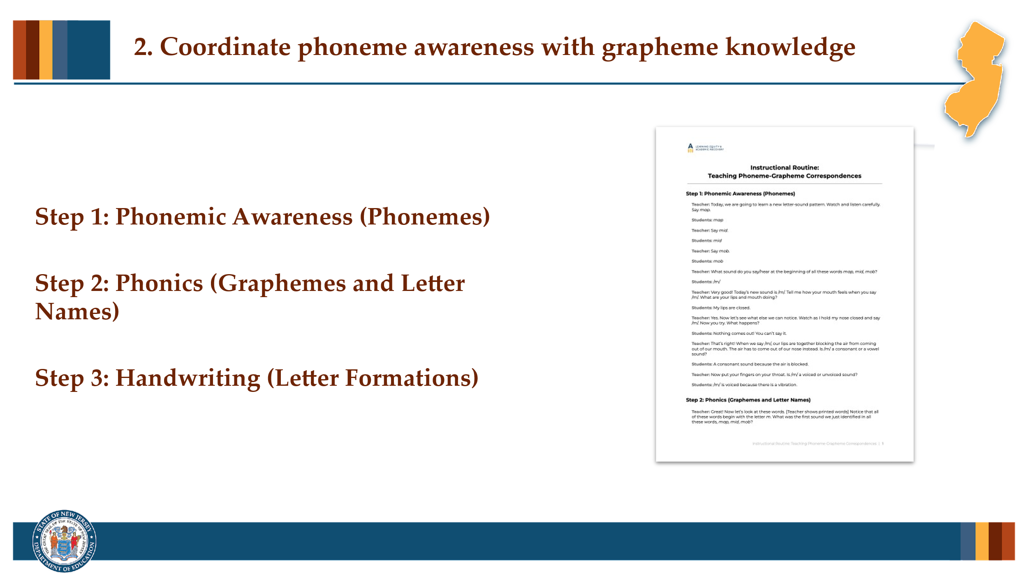

#### Facilitator Narration

Thank you. This coordination can be accomplished with a simple instructional routine that can be incorporated in our phonics instruction (or more advanced word study for older students). Let’s review the instructional routine with a partner and discuss how this can be implemented in our classrooms.

#### Activity

(5–10 minutes)

Distribute copies of the *Instructional Routine: Teaching Phoneme-Grapheme Correspondences* to all community members. Ask community members to pair off and review the routine. Community members may choose to role play the instructional routine or just review individually in preparation for discussion.

Prompt with questions as needed:

* What did you notice about the instructional routine?
* Does our current reading program have a similar routine for integrating letter sounds, letter names, and letter forms?
* How can this new routine be implemented to improve our current reading program or to help better coordinate existing programs already in use?

For older students, how could a similar type of instructional routine be used to integrate spoken words with their spellings, and meanings during advanced word study or vocabulary instruction?

### Slide 9: Building Phoneme Awareness

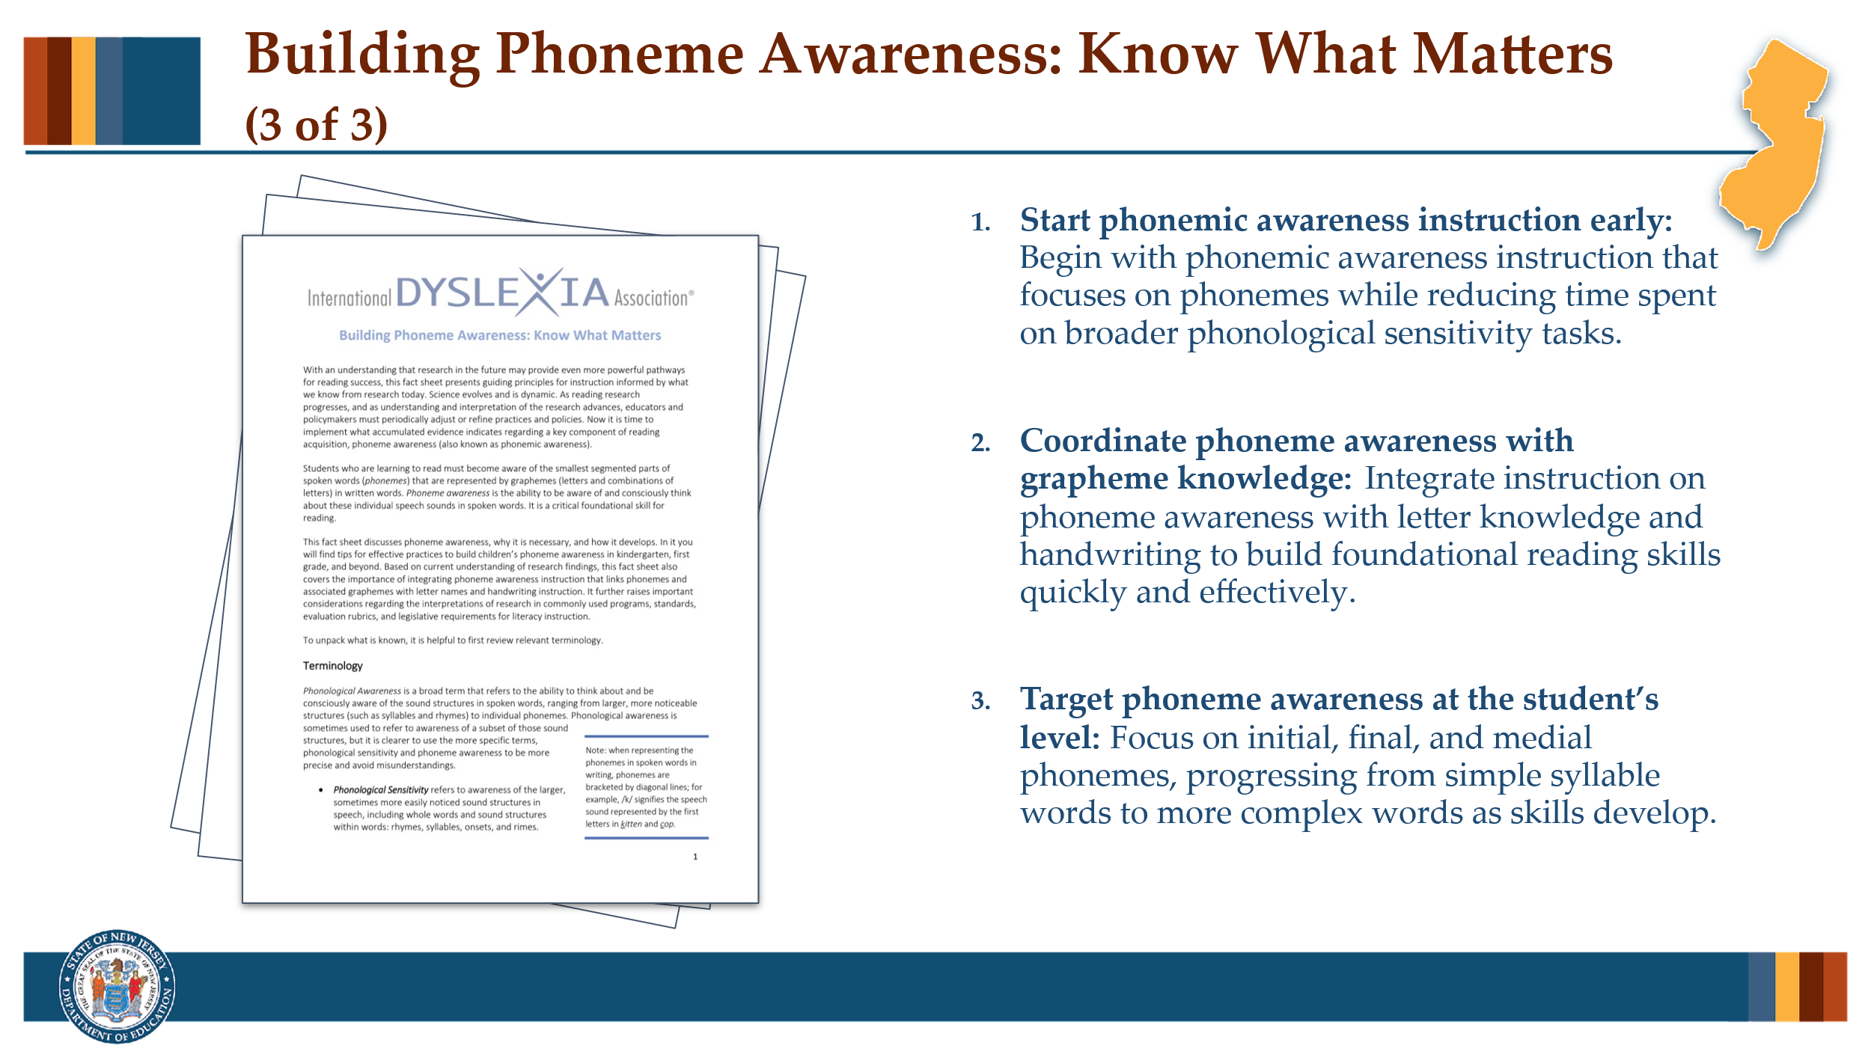

#### Facilitator Narration

Great discussion, now let’s discuss the last implication for instruction identified on page 10 of the brief. Can I get a volunteer to read bullet point #3?

#### Volunteer Reads

Whenever phoneme awareness instruction is needed, either for beginning readers or for older struggling readers, teachers should focus on phoneme awareness at the level appropriate for the student, keeping these recommendations in mind: Start with initial phonemes, then final phonemes, followed by medial vowel phonemes in words that are simple syllables; after these beginning levels of phoneme awareness are accomplished, next work on awareness of the internal consonants in complex, one-syllable words that include consonant blends.

### Slide 10: What is a Phoneme?

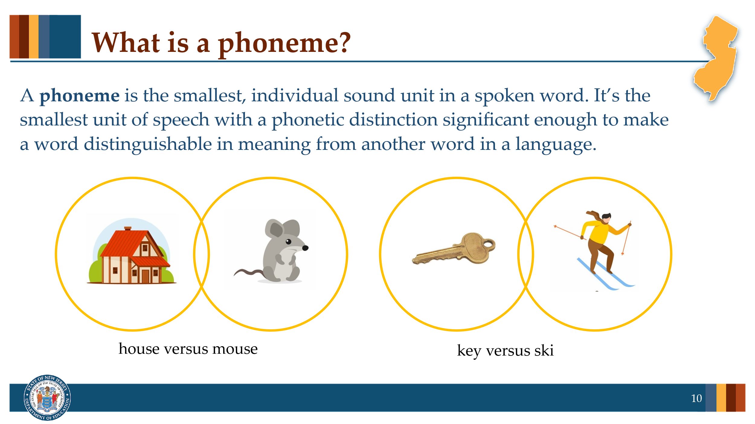

#### Facilitator Narration

It’s important to focus our phoneme awareness instruction at the level appropriate for the student. So, let’s warm up our own phoneme awareness before we discuss the simplicity or complexity of different tasks and the phonemic confusions that might arise for our students.

A phoneme is the smallest, individual sound unit in a spoken word. It’s the smallest unit of speech with a phonetic distinction significant enough to make a word distinguishable in meaning from another word in a language. For example, *house* versus *mouse* or *key* versus *ski*.

#### Optional Question

Can anyone think of another word pair that differs by one phoneme? Discuss the phonetic distinction in each word pair. Provide some examples if needed: *zoo/due* (distinct initial phonemes); *wise/ways* (distinct medial phonemes); *rake/raise* (distinct final phonemes); *queen/wean* (additional distinct initial phoneme); *plant/plan* (additional distinct final phoneme).

### Slide 11: How Many Phonemes Are in These Words?

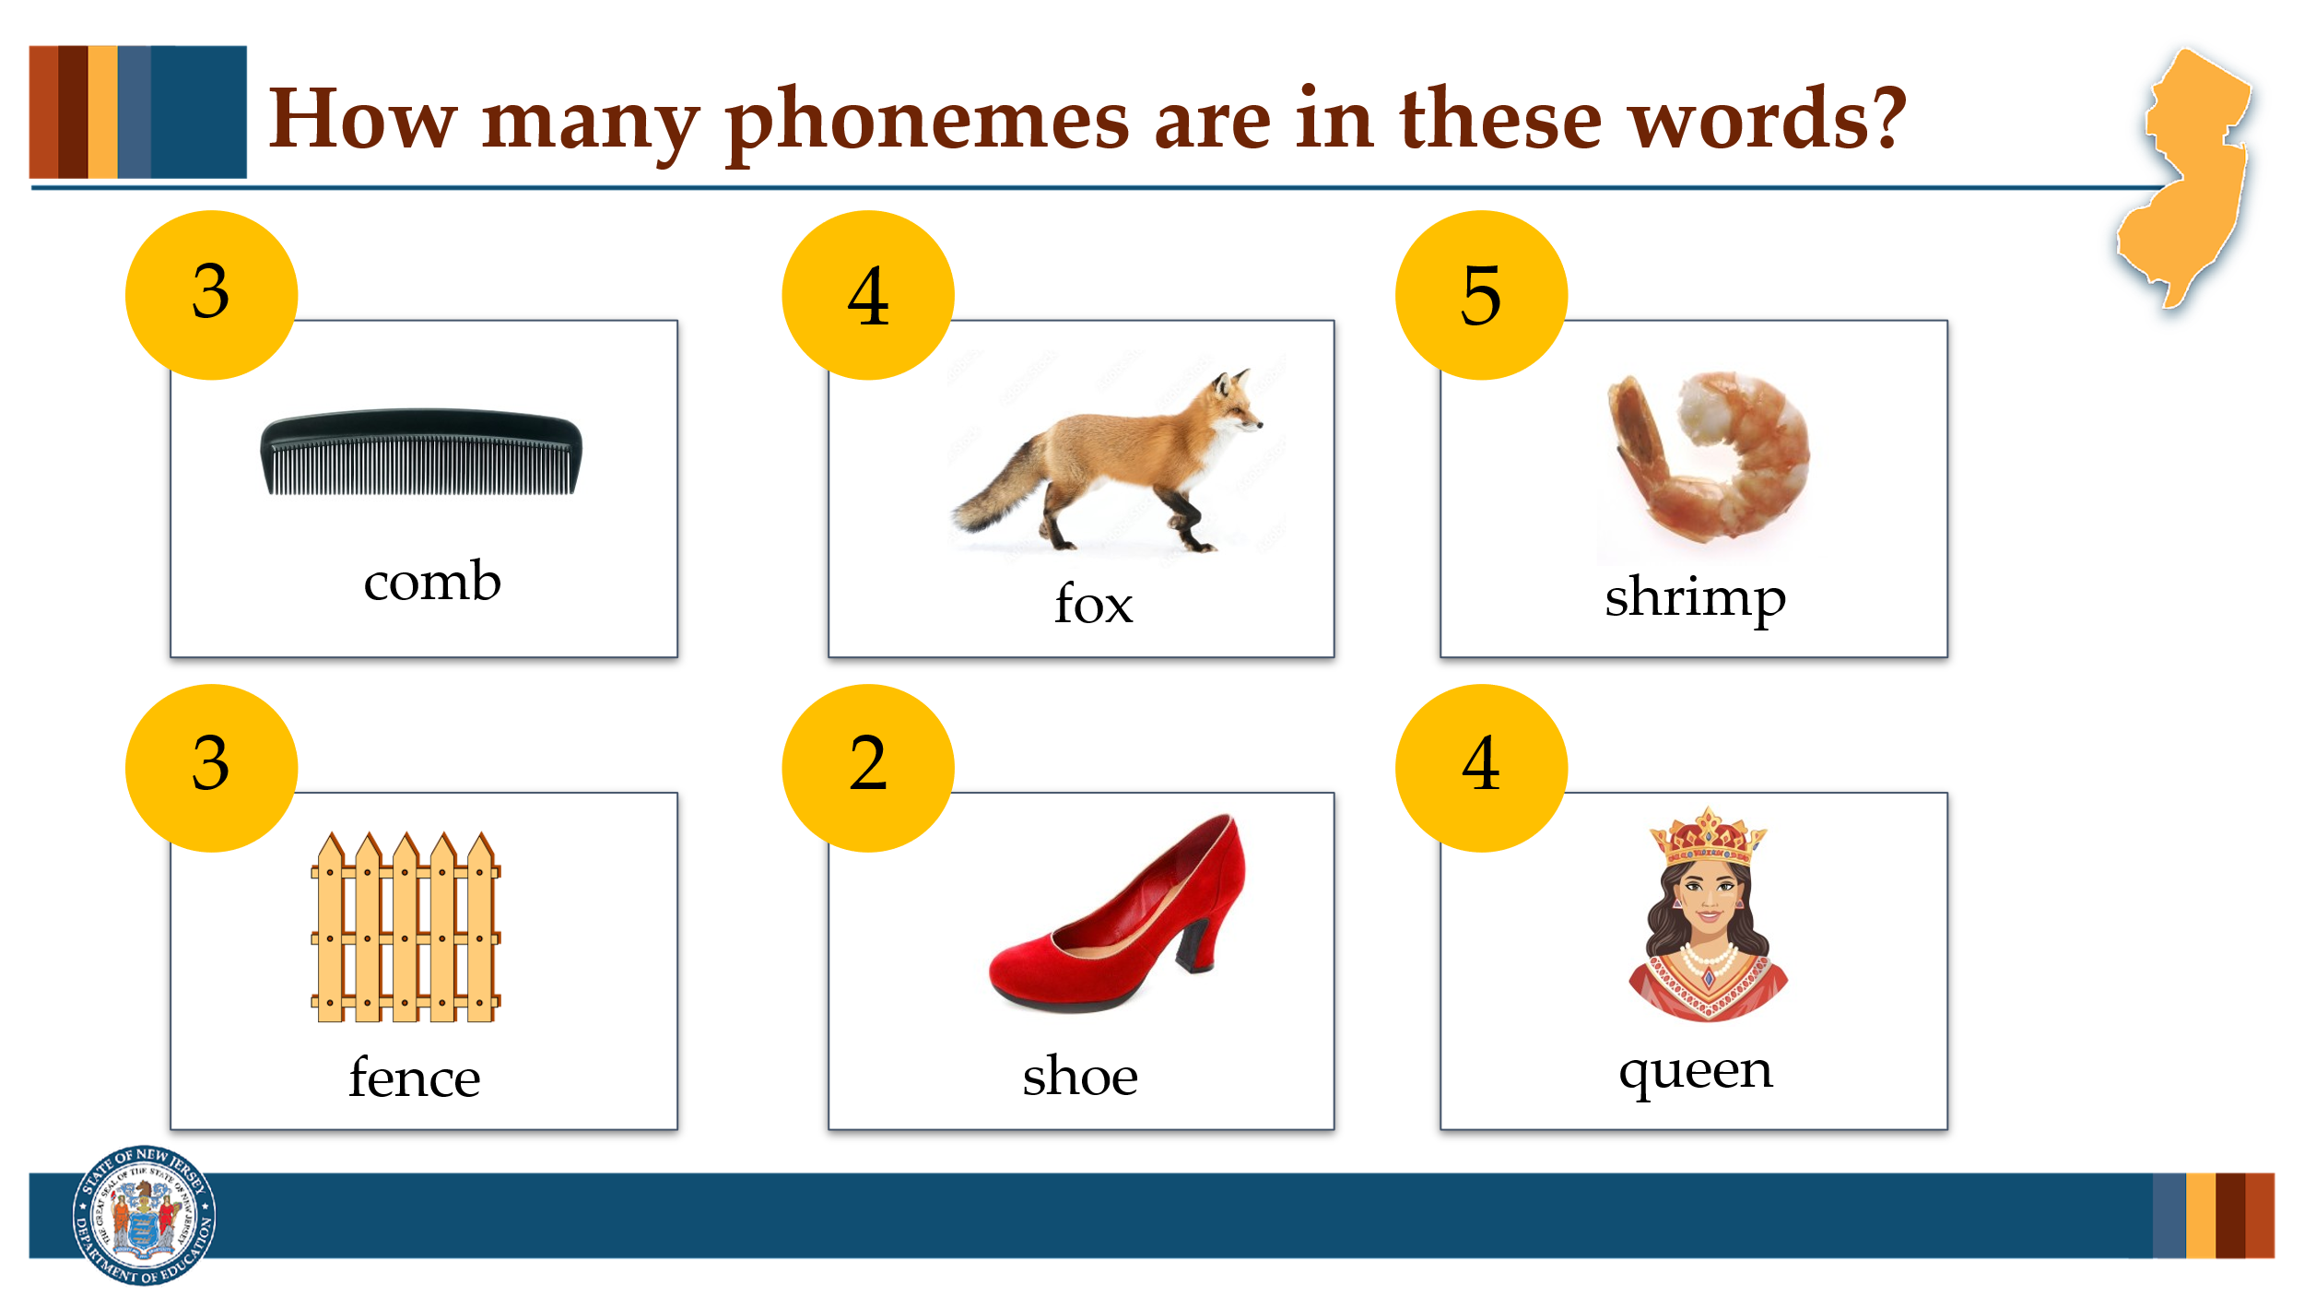

#### Facilitator Narration

Next, let’s count the number of phonemes in some words. Can I get a volunteer for the first word?

#### Activity

(5–10 minutes)

Ask volunteers to segment each word into its individual sounds and share how many phonemes are in the word. You might distribute and use the Elkonin boxes provided with manipulatives to demonstrate and practice a phoneme counting activity that could be used with students. Click to reveal each animated answer as you go.

*comb* = /k/ /ō/ /m/, 3 sounds (4 letters; graphemes c-o-mb)

*fox* = /f/ /ŏ/ /k/ /s/, 4 sounds (3 letters; graphemes f-o-x)

*shrimp* = /sh/ /r/ /ĭ/ /m/ /p/, 5 sounds (6 letters; graphemes sh-r-i-m-p)

*gate* = /g/ /ā/ /t/, 3 sounds (4 letters; graphemes g-a-t[e])

*shoe* = /sh/ /ü/, 2 sounds (4 letters; graphemes sh-oe)

*queen* = /k/ /w/ /ē/ /n/, 4 sounds (5 letters; graphemes q-u-ee-n)

#### Optional Activity Extension

To stress the importance of coordinating phoneme awareness instruction with letter/grapheme knowledge and handwriting, after counting phonemes in each word have all community members map each phoneme to its corresponding grapheme and notice how the number of phonemes does always match the number of letters in the word’s spelling. You might use a white board and dry erase markers.

**Note to Facilitator:** Notice if any community members are confusing sounds (phonemes) or letters/letter combinations (graphemes) and discuss how important it is to be clear with students about what is being asked for in any given instructional activity. For example, a teacher may need to clarify to a student, “You counted the letters. I am asking you to count the sounds.” or “You provided the letter name. I am asking for the sound.”

Also, this activity may spark a discussion on how specific phoneme-grapheme correspondences should be introduced to students and applied during phoneme-grapheme mapping activities. For example, the grapheme *x* represents two distinct phonemes /k/ and /s/ and the combined graphemes *qu* represent two distinct phonemes /k/ and /w/. You can hear/feel these phonetic distinctions by comparing the words *sax* (4 phonemes) to *sack* or *sass* (3 phonemes); and *quick* (4 phonemes) to *kick* and *wick* (3 phonemes). Published reading programs will differ in how they handle these unique correspondences. Some may introduce and apply them as *x* representing one combined sound /ks/ or *qu* represents /kw/. Either way, it is most critical that all materials treat the correspondences similarly and that all teachers across grades and classrooms are teaching the concepts in a consistent manner. From a corrective feedback perspective, it is important that teachers understand these phonetic distinctions so they can provide helpful support when needed. For example, if the district’s reading program introduces *x* representing one combined sound /ks/ and a student is having persistent confusion or difficulty spelling words such as *snacks* as *snax* and *box* as *bocks*, it may be helpful to explain the two distinct phonemes /k/ and /s/ while prompting the student to think about the target word’s grammatical number and part of speech.

### Slide 12: Target Phoneme Awareness at the Student’s Level

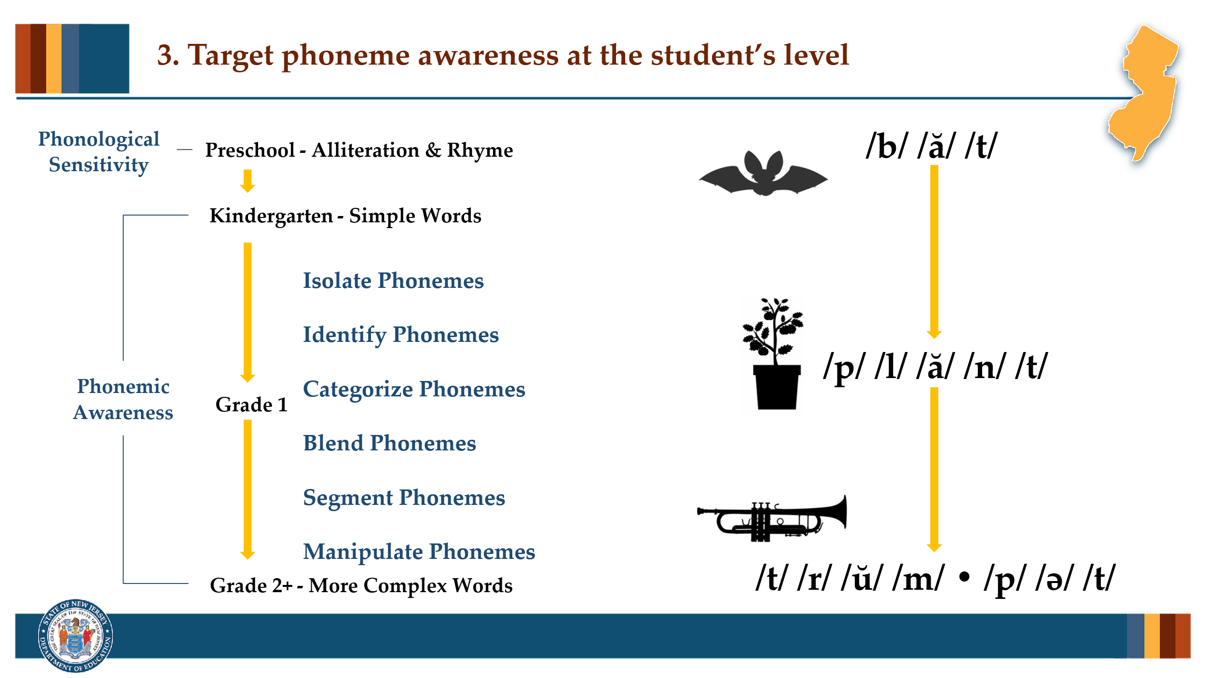

#### Facilitator Narration

Now that we’re warmed up, let’s discuss phonemic awareness instruction within a progression from simple to more complex word structures. Students will typically build awareness of initial phonemes in words **[point to /b/ in *bat*]**, before they gain awareness of final phonemes **[point to /t/ in *bat*]**. Medial vowel phonemes are a bit more challenging for students **[point to /ă/ in *bat*]**. While explicit phonemic awareness instruction will focus on tasks such as isolating or identifying phonemes, categorizing phonemes, or most importantly blending, segmenting and manipulating phonemes **[point down the list of phonemic awareness tasks from top to bottom]**, it is vitally important that we are using words in our instruction that match the students level of awareness.

Using simple syllable words will facilitate student’s mastery of beginning phoneme awareness **[point to *bat*]** and prepare them for explicit instruction using words that are complex syllables **[point to *plant*]** where becoming aware of initial or final external consonants **[point to /p/ and /t/ in *plant*]** is easier than becoming aware of the internal consonants in the consonant blends **[point to /l/ and /n/ in plant & /r/ in *trumpet*]**. So it is important to note that students may still be developing their automaticity with some of these more complex phonemic awareness skills beyond first grade, even though formal phonemic awareness instruction may have been discontinued in our reading programs.

#### Optional Question

For students in upper grades who may be struggling in the area of fluent word recognition, in what ways can we begin to target phonemic awareness instruction that meets their needs? Prompt the discussion to points related to first assessing the extent of phoneme awareness in struggling readers in any grade, and if weaknesses in phoneme awareness are evident, calibrating intervention to the student’s level of phoneme awareness development and integrating it with phonics or word analysis instruction/intervention.

### Slide 13: Text Version — Target Phoneme Awareness at the Student’s Level

This slide is the alternate version for people who are unable to access the content in slide 12. This is a text version of the content.

### Slide 14: Adapting to Student Needs

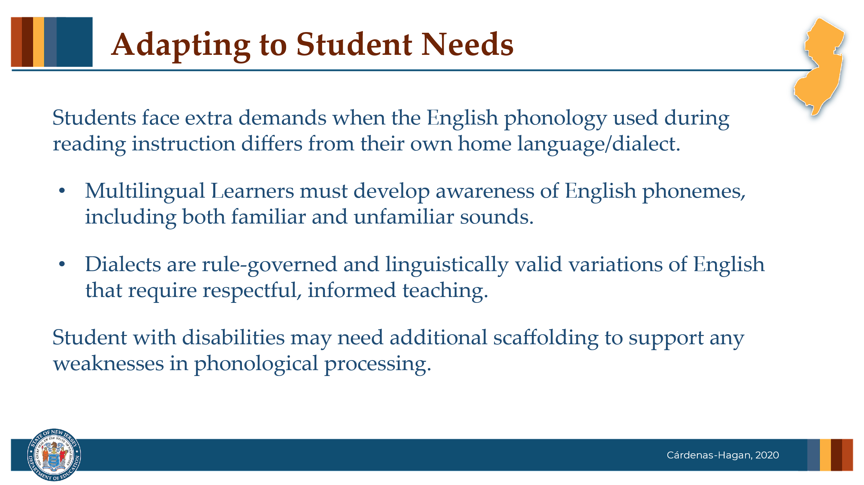

#### Facilitator Narration

As educators, it's important to recognize that when students come to school speaking a different language or dialect than the variation of American English used in the classroom, they face additional language and cognitive demands—especially during reading instruction, which relies heavily on a standardized version of English phonology.

Multilingual learners, for example, must become consciously aware of the sounds of English, including those that may not exist in their home language. This process takes time and explicit support.

Similarly, students who speak a different English dialect, may use rule-governed phonological patterns that differ from those used in reading instruction. These are not 'errors,' but features of a valid language variety.

Understanding and honoring these differences allows us to tailor instruction in a way that is respectful, effective, and inclusive.

Also, students with disabilities may need additional scaffolding to support any weaknesses in phonological processing.

#### Optional Question

How can we prepare ourselves to deliver instruction that supports students whose home language or dialect differs from the phonology of our school reading instruction?

*Note to Facilitator*: The brief provides a teaching tip about being well informed. One resource for becoming informed is the American Speech-Hearing Association’s [Phonemic Inventories and Cultural and Linguistic Information Across Languages](https://www.asha.org/practice/multicultural/phono/?srsltid=AfmBOor_WWHFnXjatq4qOCOkAh5UPqIjDEhVYDfxQzHtVXSua_WArWrZ).

### Slide 15: Thanks for Participating!

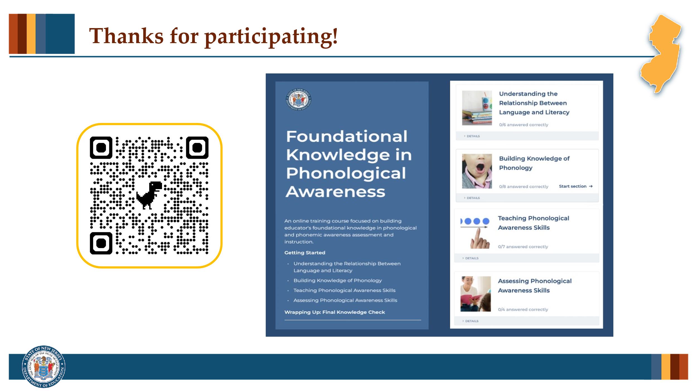

#### Facilitator Narration

This brings us to the end of our session today! If you are interested to learn more about phonological processing, phonological awareness and phonemic awareness instruction and assessment, you can enroll in the NJ Department of Education’s free SISEP online learning module titled Foundational Knowledge in Phonological Awareness.

### Slide 16: Next Session in the PLC Series

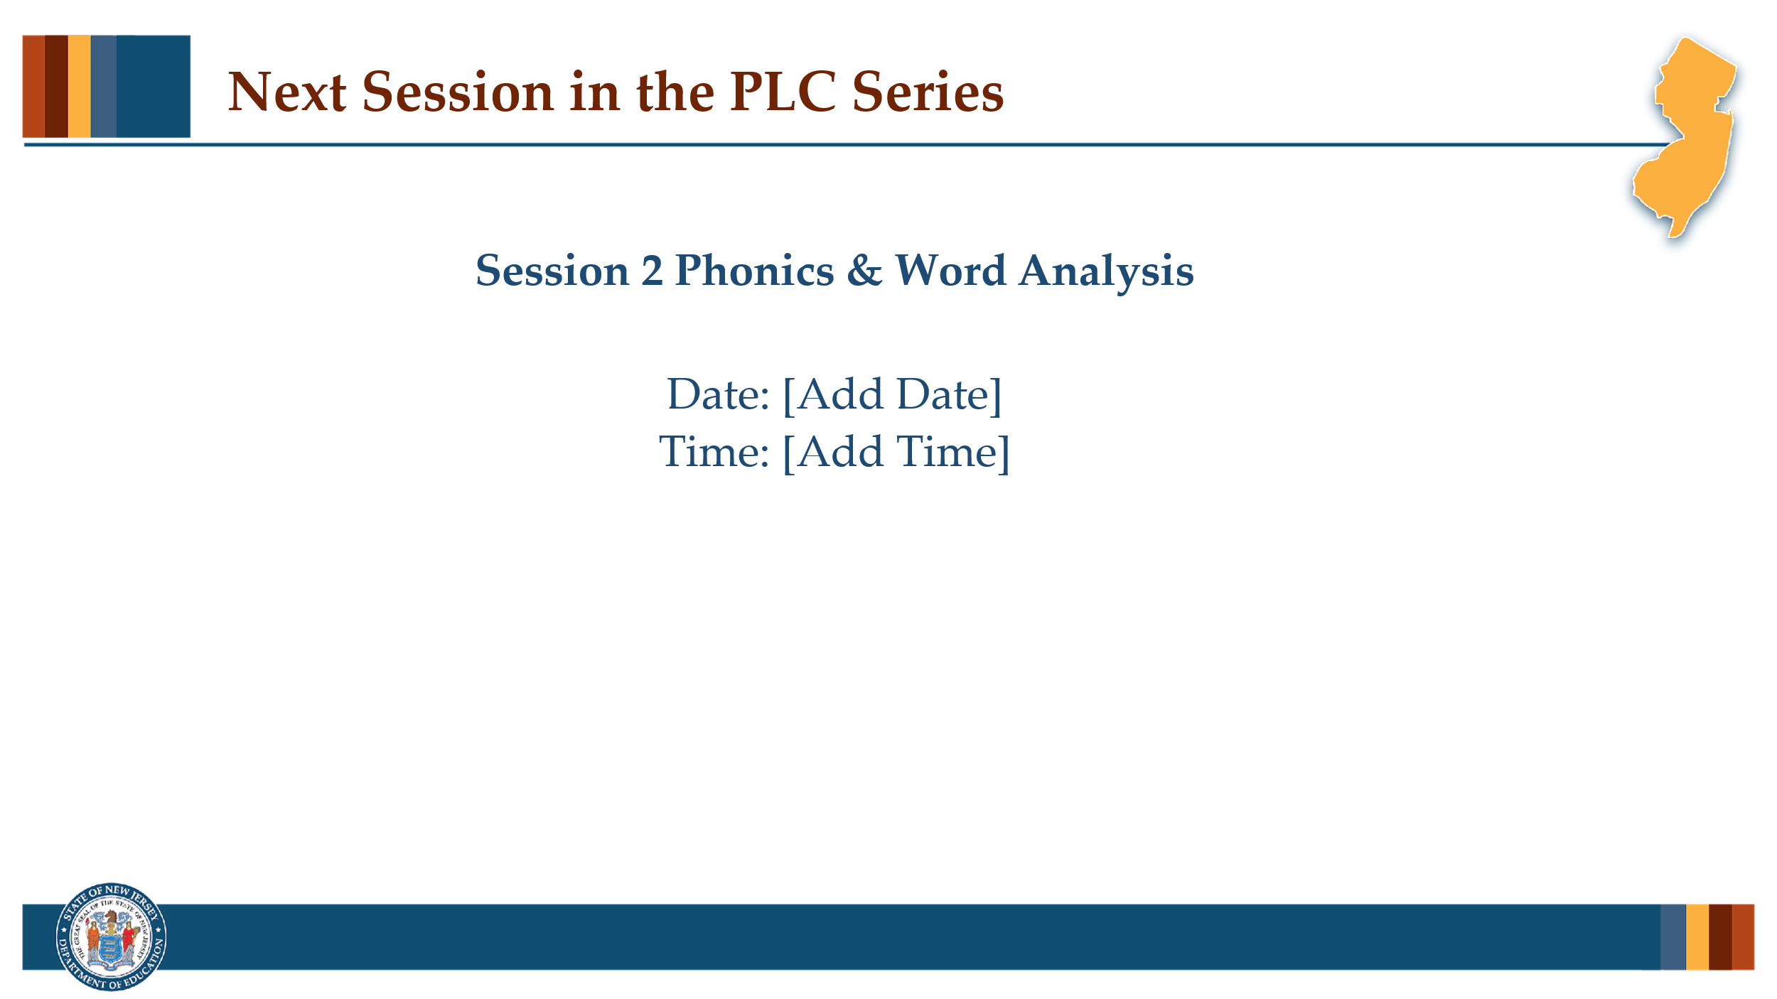

#### Facilitator Narration

Up next is Session 2 Phonics & Word Analysis. This PLC session will focus on best practices in decoding and encoding strategies for phonics and word analysis instruction. We will meet on [add date and time]. See you then!

### Slide 17: References

This slide lists references from the presentation.

### Session Materials Needed

* PLC Series Session 1 — Slide Presentation
* Copies of Supplementary Resources for Community Members:
  + IDA Building Phoneme Awareness: Know What Matters 2022 (If needed)
  + Instructional Routine for Coordinating Phoneme Awareness with Grapheme Knowledge
  + Elkonin Boxes
* Manipulative tokens or chips
* Chart paper/markers
* White boards/dry erase markers

If the session is being delivered virtually, use a virtual meeting space that includes slide annotation capabilities for activities and allows for meeting participants to engage via both audio and video.