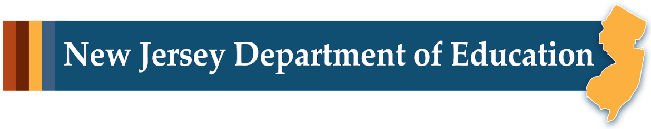

# LEARning about Literacy: Professional Learning Community (PLC) Series Session 2 Phonics & Word Analysis Facilitator Guide

This facilitation guide provides a structured approach to lead Session 2 Phonics & Word Analysis. The session aims to help educators understand English orthography, the instructional progression of phonics decoding and spelling skills, and how to effectively teach them. The facilitator is tasked with preparing materials, engaging participants, and ensuring active participation throughout the session.

## Step-by-Step Facilitation Process

1. **Send Pre-Work Email to Community Members:** Send the pre-drafted email with the pre-work assignment attached (e.g., reading or video) and session details (date, time, location/platform).
2. **Review Pre-Work and Session Presentation Materials:** Review the pre-work assignment, session slides, and facilitator notes to ensure familiarity with content.
3. **Prepare and Update Session Presentation Materials:** Update slides with relevant contextual information for the group, prepare all handouts and supplementary resources needed, and check on the room set up, materials needed for activities, and technology to ensure a smooth session. Test any video links in the presentation to confirm they are working properly.
4. **Deliver the Session:** Present the pre-drafted session presentation, engage participants with discussions and activities, and answer questions to ensure understanding.
5. **Invite Community Members to Next Session:** Thank participants, share details of the next session, and encourage ongoing engagement with additional resources.

## Draft Email

**Subject Line:** Join us for Session 2! Evidence-Based Literacy Instruction PLC Series

Dear [Staff Member],

This is a friendly reminder that the second session of the Learning Equity & Academic Recovery’s Evidence-Based Literacy Instruction Professional Learning Community (PLC) Series is coming soon!

### PLC Session 2: Phonics & Word Analysis

Date: [Insert Date]  
Time: [Insert Time]  
Location: [Insert Location/Platform Link]

In this session, we will focus on the critical component of phonics and word analysis, with an emphasis on English orthography and developing students’ decoding and spelling skills. The session is designed to be interactive and collaborative, allowing you to engage with your colleagues and share ideas and best practices for supporting students’ literacy development.

Prior to our session together, please be sure to watch the brief video **Decoding & Encoding: Reciprocal Skills** [add link] to be prepared for our discussion and activities.

We look forward to seeing you there and working together to enhance our literacy instruction!

Best regards,

[Your Name]  
[Your Title]  
[School District Name]  
[Your Contact Information]

## Session Presentation Facilitation Notes

### Slide 1: Title Slide

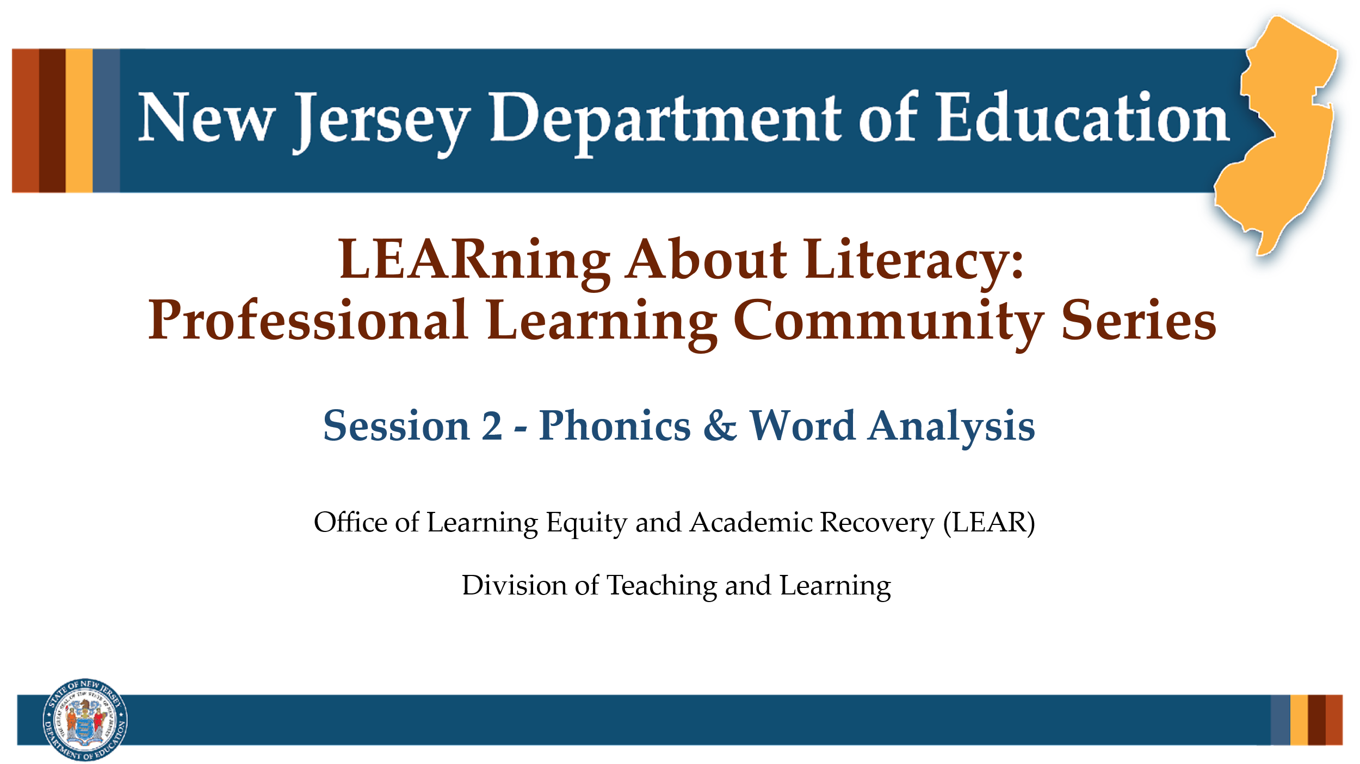

#### Facilitator Narration

Welcome! We’re excited to have you join us for this second session in our Professional Learning Community Series. Today, we’ll be looking to strengthen our instructional practices based on the latest research in phonics and word analysis instruction.

### Slide 2: Decoding Skill Simulation

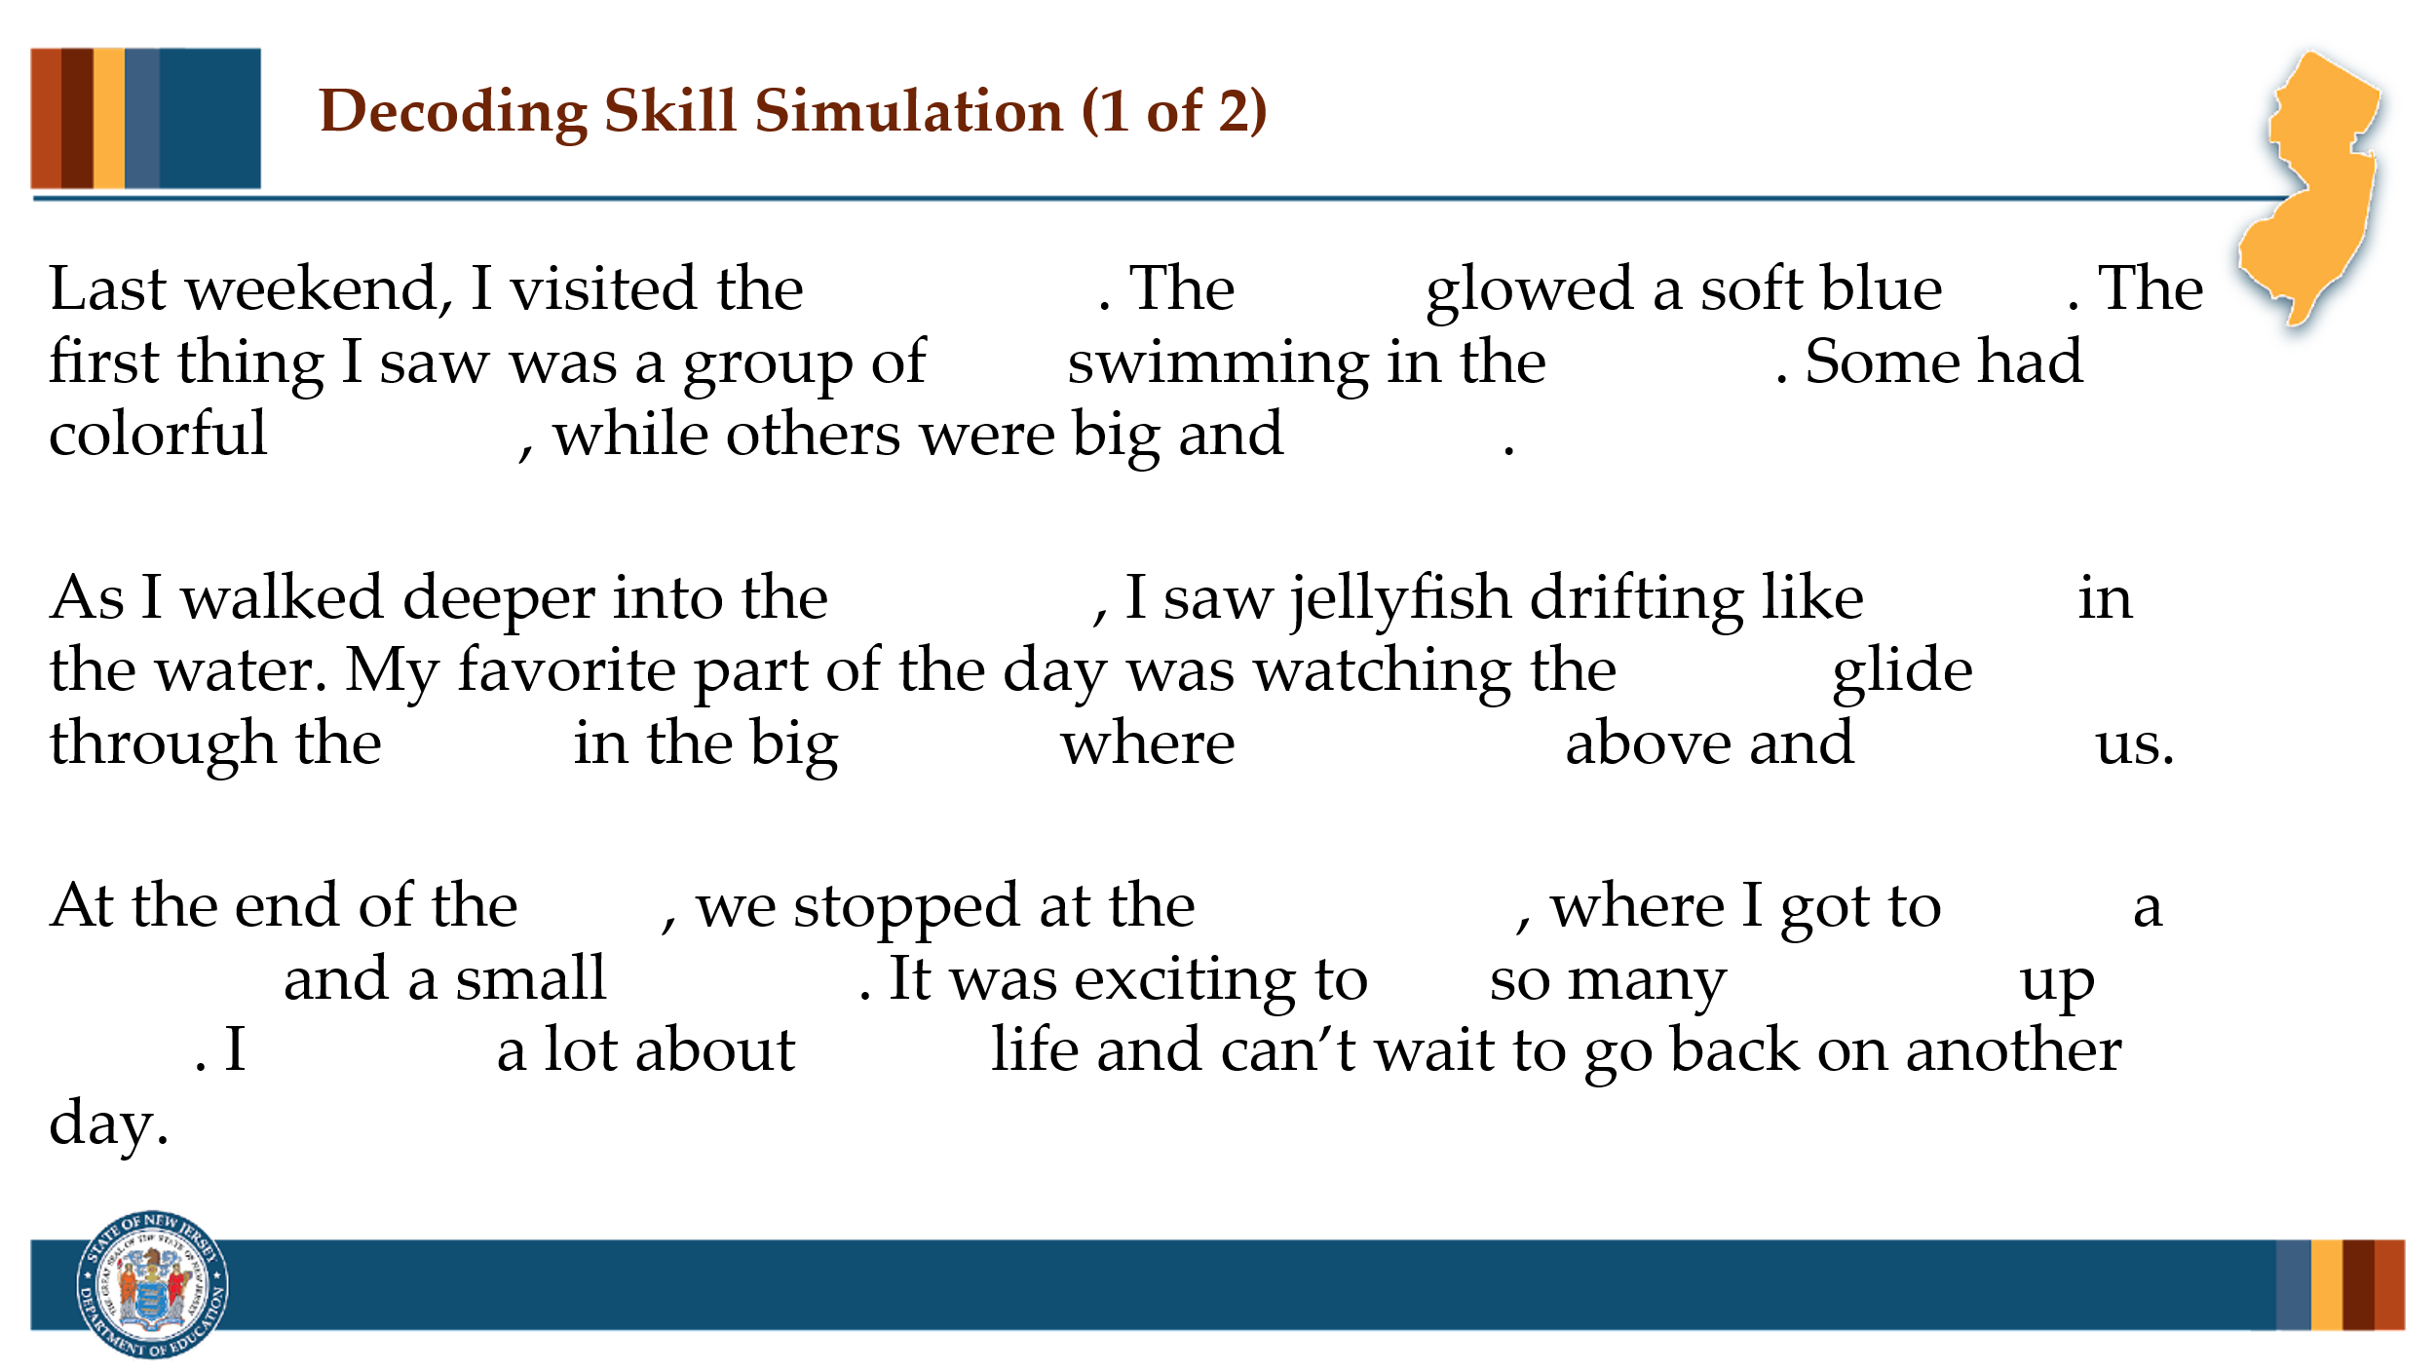

#### Facilitator Narration

Before we get started, let’s take a moment to immerse ourselves into the experience of making meaning from text. Here you will see a short passage that has been manipulated to simulate what it might be like for a student attempting to read a passage that is only approximately 80% decodable to them. This is not a perfect simulation but let’s give it a try. Read the passage to yourself and then let’s discuss what it’s about.

#### Activity

(5 –10 minutes)

Community members read the passage and discuss it.

**Note to Facilitator:** Prompt the discussion to focus on the strategies members need to rely on when decoding isn’t a stable option. Ask how much cognitive energy they are spending to try to make sense of the passage. Prompt for the types of behaviors that may arise in students when the cognitive load is too much with certain types of passages or begin a discussion about the types of texts that are given to students of varying decoding abilities.

### Slide 3: Phonological Awareness

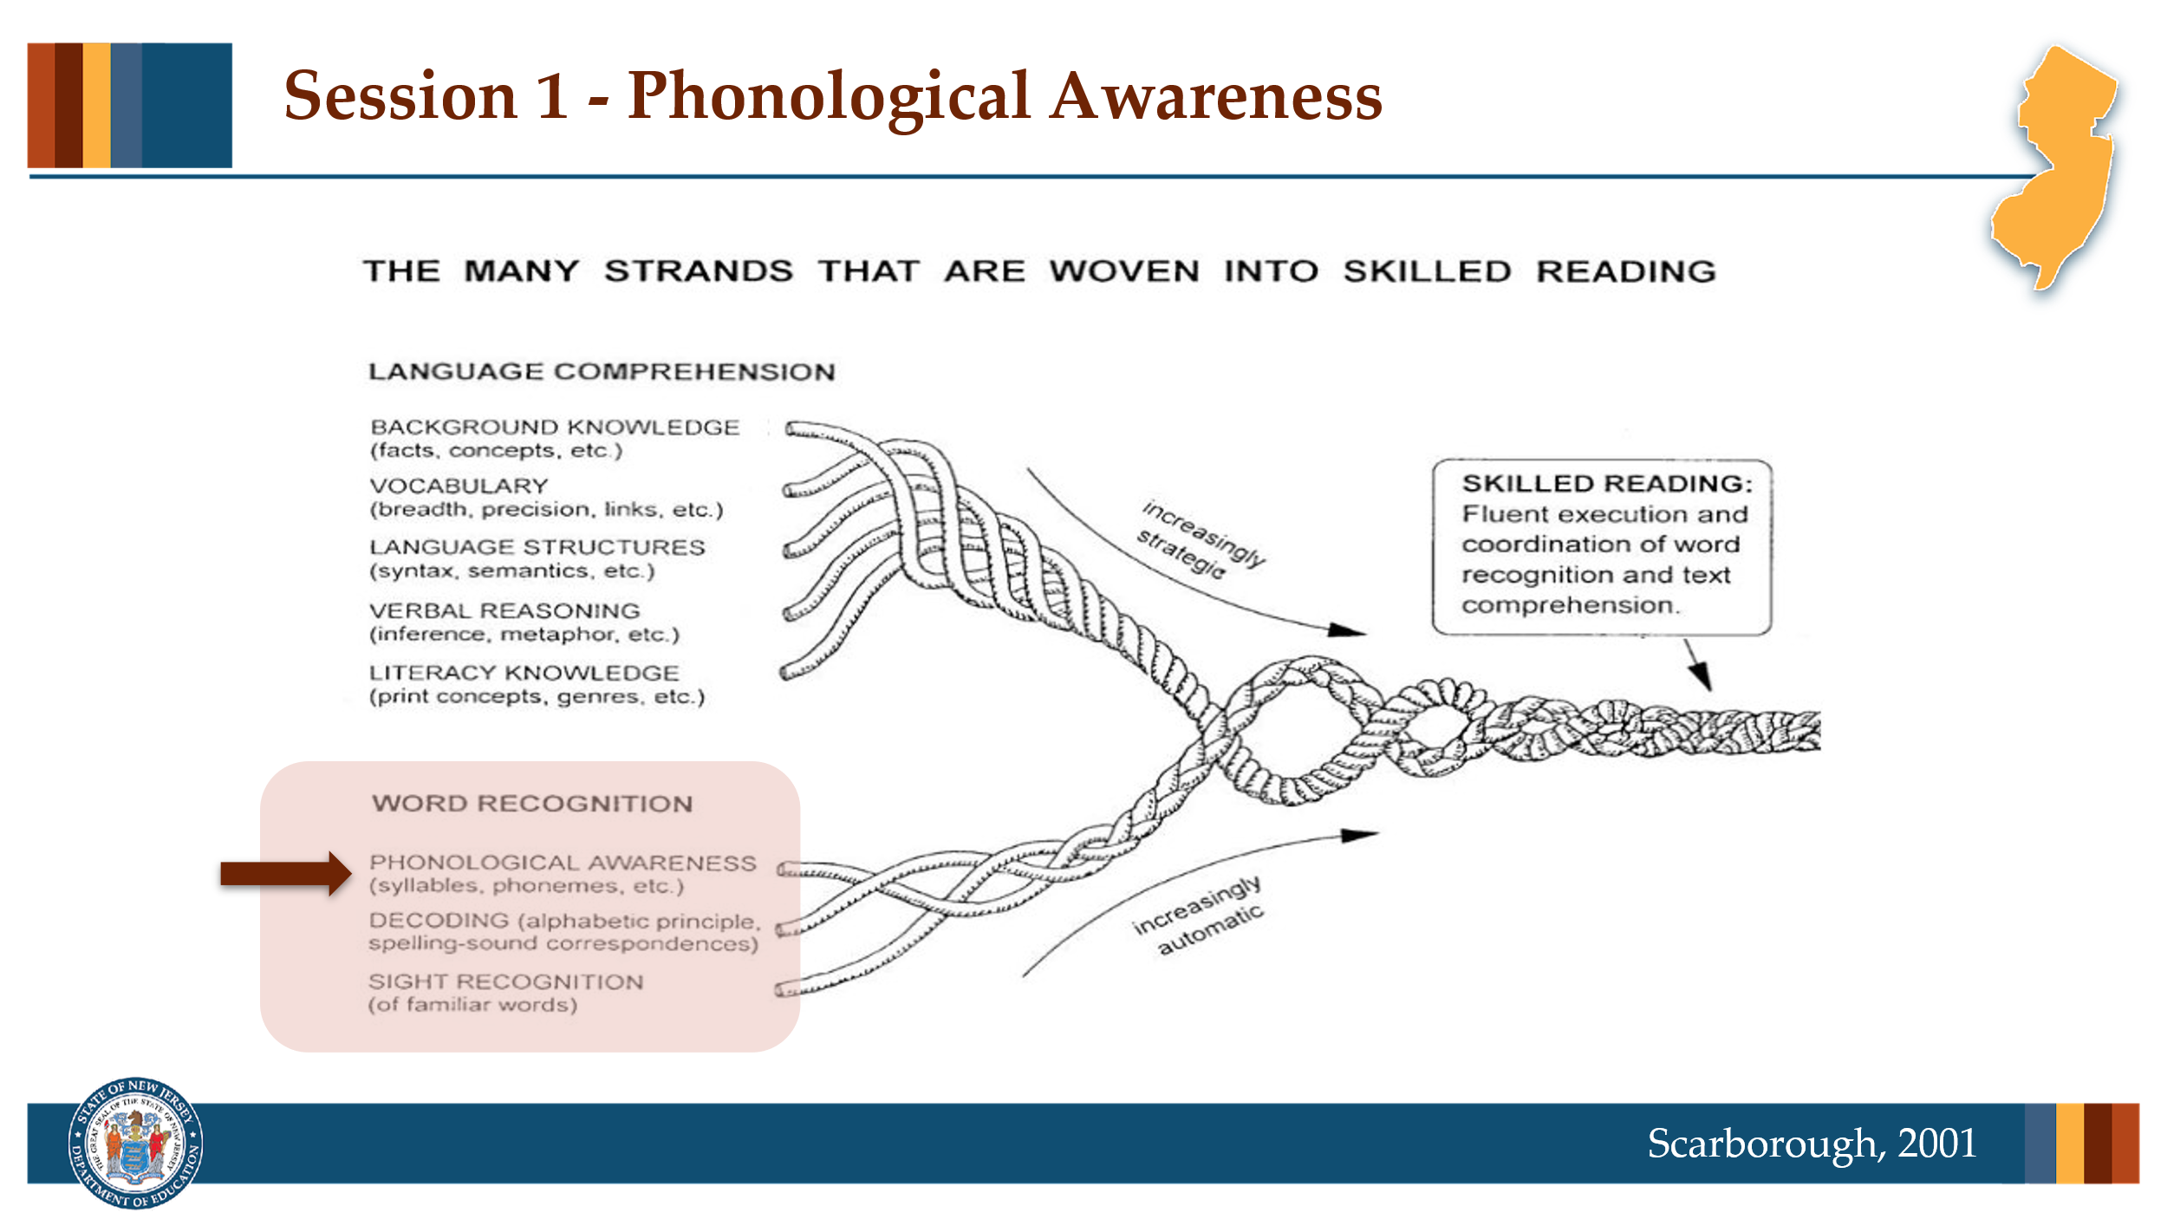

#### Facilitator Narration

Nice discussion! Now, returning to Scarborough’s Reading Rope image, in this session we will be exploring an important word recognition skill, **Decoding** as well as its reciprocal skill, encoding (otherwise known as spelling).

### Slide 4: Text Version of Scarborough’s Rope

The text version is provided for people who cannot access the content in the image (e.g., someone who is blind or has low vision).

### Slide 5: Decoding Skill Simulation

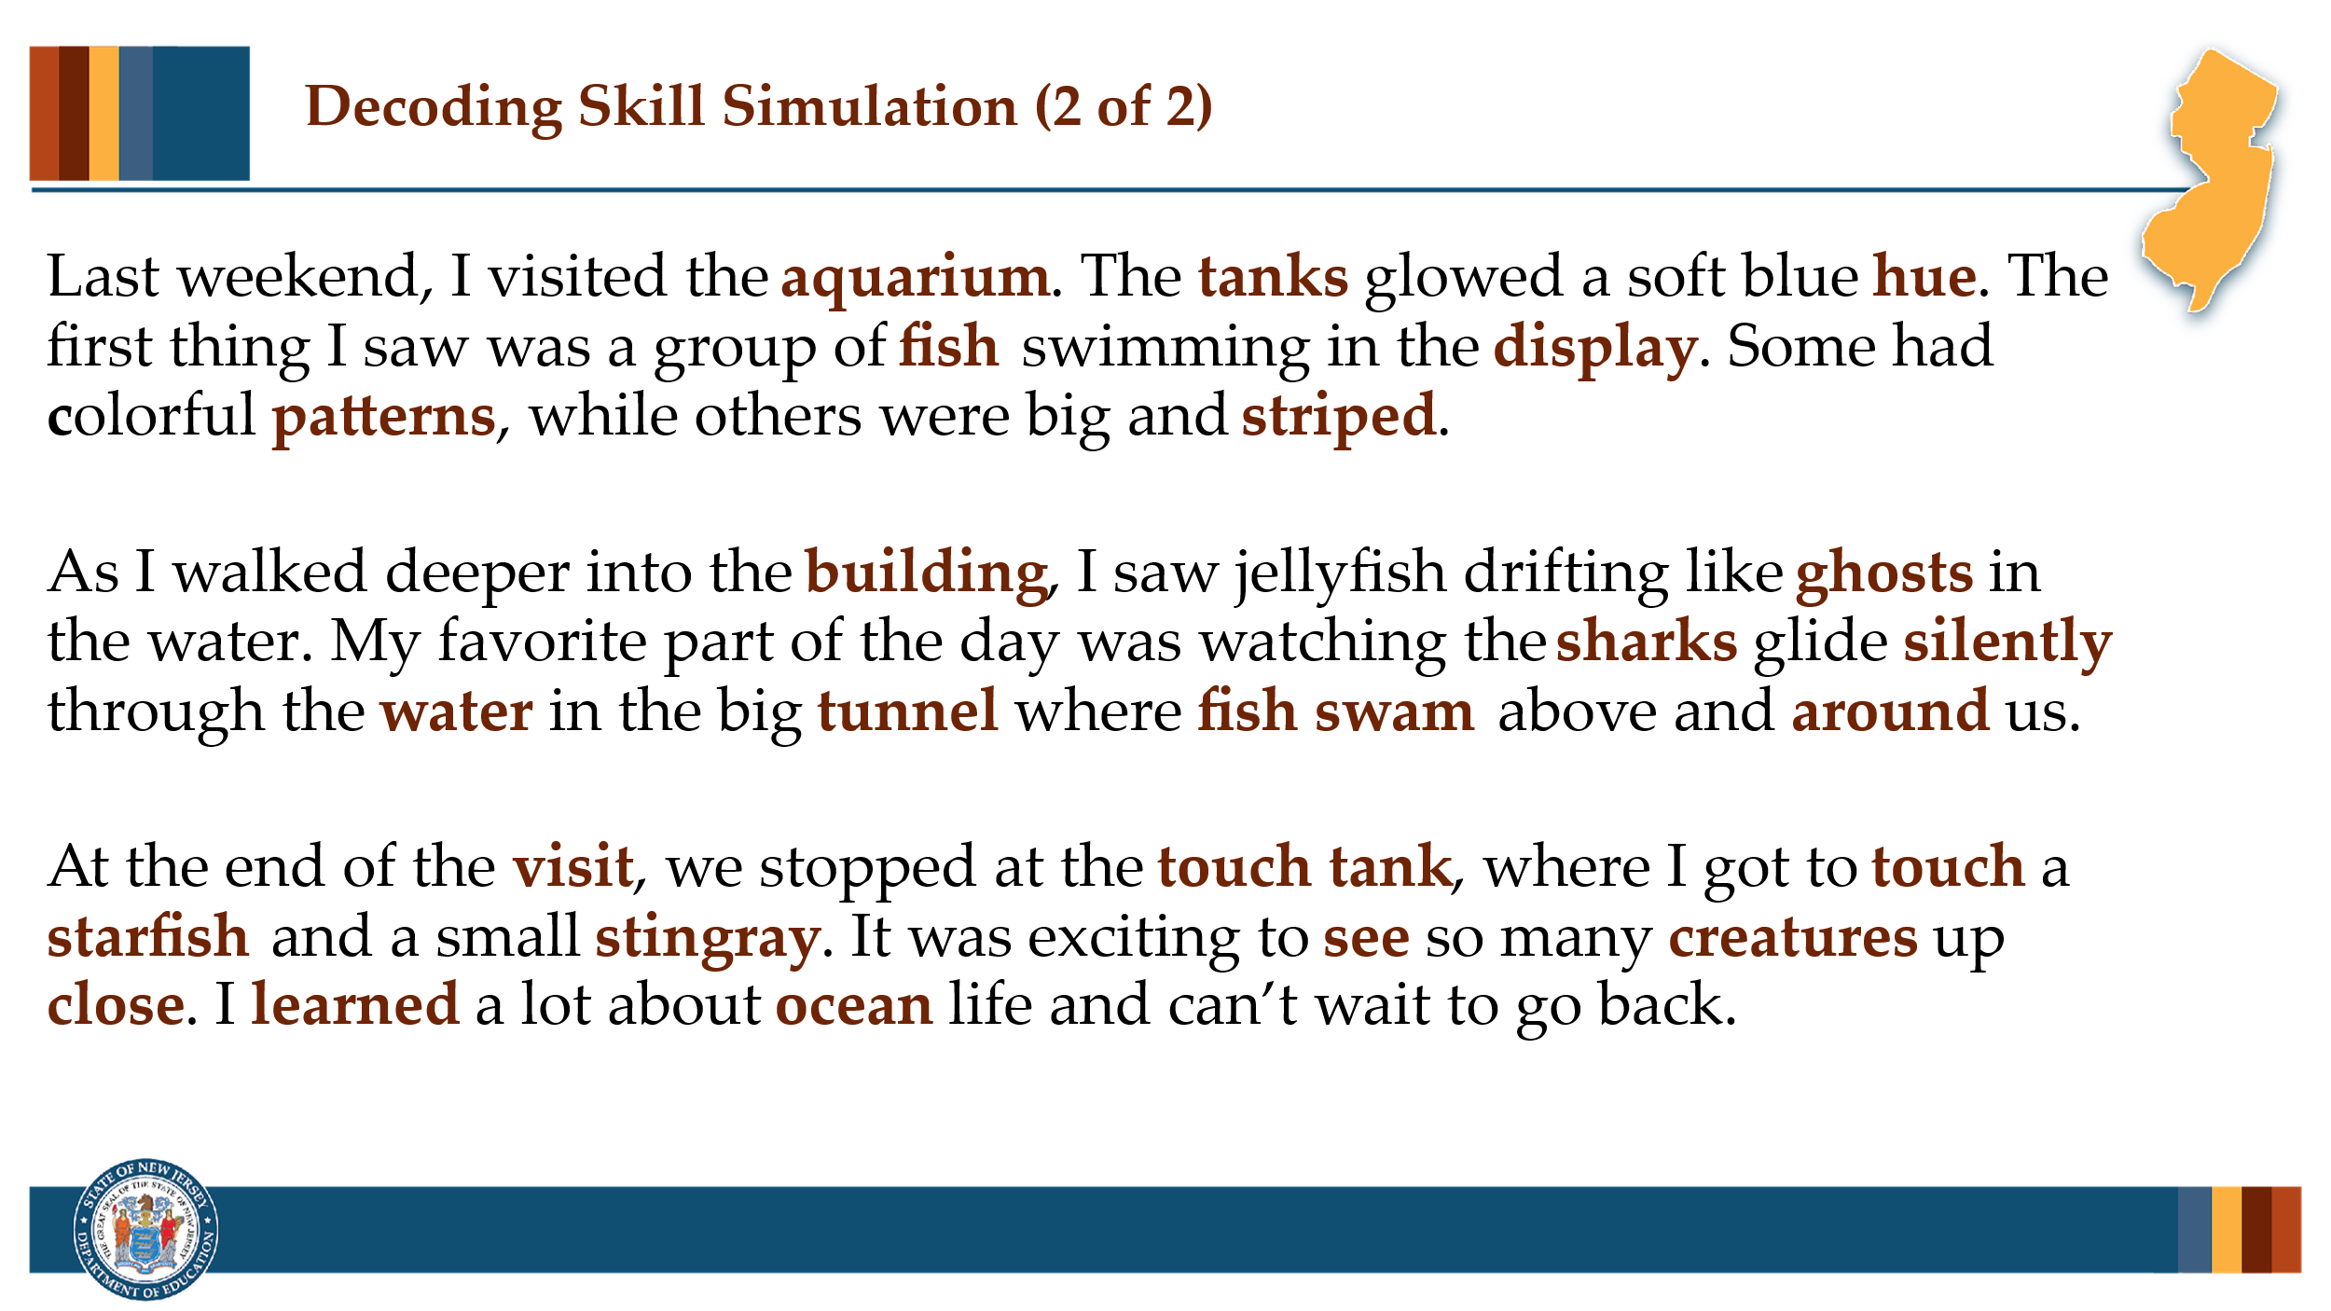

#### Facilitator Narration

In just this brief simulation, we can see how important decoding skills are to make meaning from text; however, we can also see that the skills in the upper strand of Scarborough’s rope are also critically important. It’s important to remember that even when students can accurately decode (pronounce) the words on the page, if they do not already have the meaning of those words in their mental vocabulary it will similarly impact their meaning making abilities. Imagine trying to build a mental model of this passage if you’ve never been to or heard the words *aquarium*, *tank*, or *tunnel*, or if the names of the sea creatures in your home language are different. As we discuss decoding and encoding in this PLC session, we will remember the importance of simultaneously building students’ skills across all strands of the reading rope.

#### Full Passage

Last weekend, I visited the aquarium. The tanks glowed a soft blue hue. The first thing I saw was a group of fish swimming in the display. Some had colorful patterns, while others were big and striped.

As I walked deeper into the building, I saw jellyfish drifting like ghosts in the water. My favorite part of the day was watching the sharks glide silently through the water in the big tunnel where fish swam above and around us.

At the end of the visit, we stopped at the touch tank, where I got to touch a starfish and a small stingray. It was exciting to see so many creatures up close. I learned a lot about ocean life and can’t wait to go back.

### Slide 6: Decoding and Encoding — Reciprocal Skills

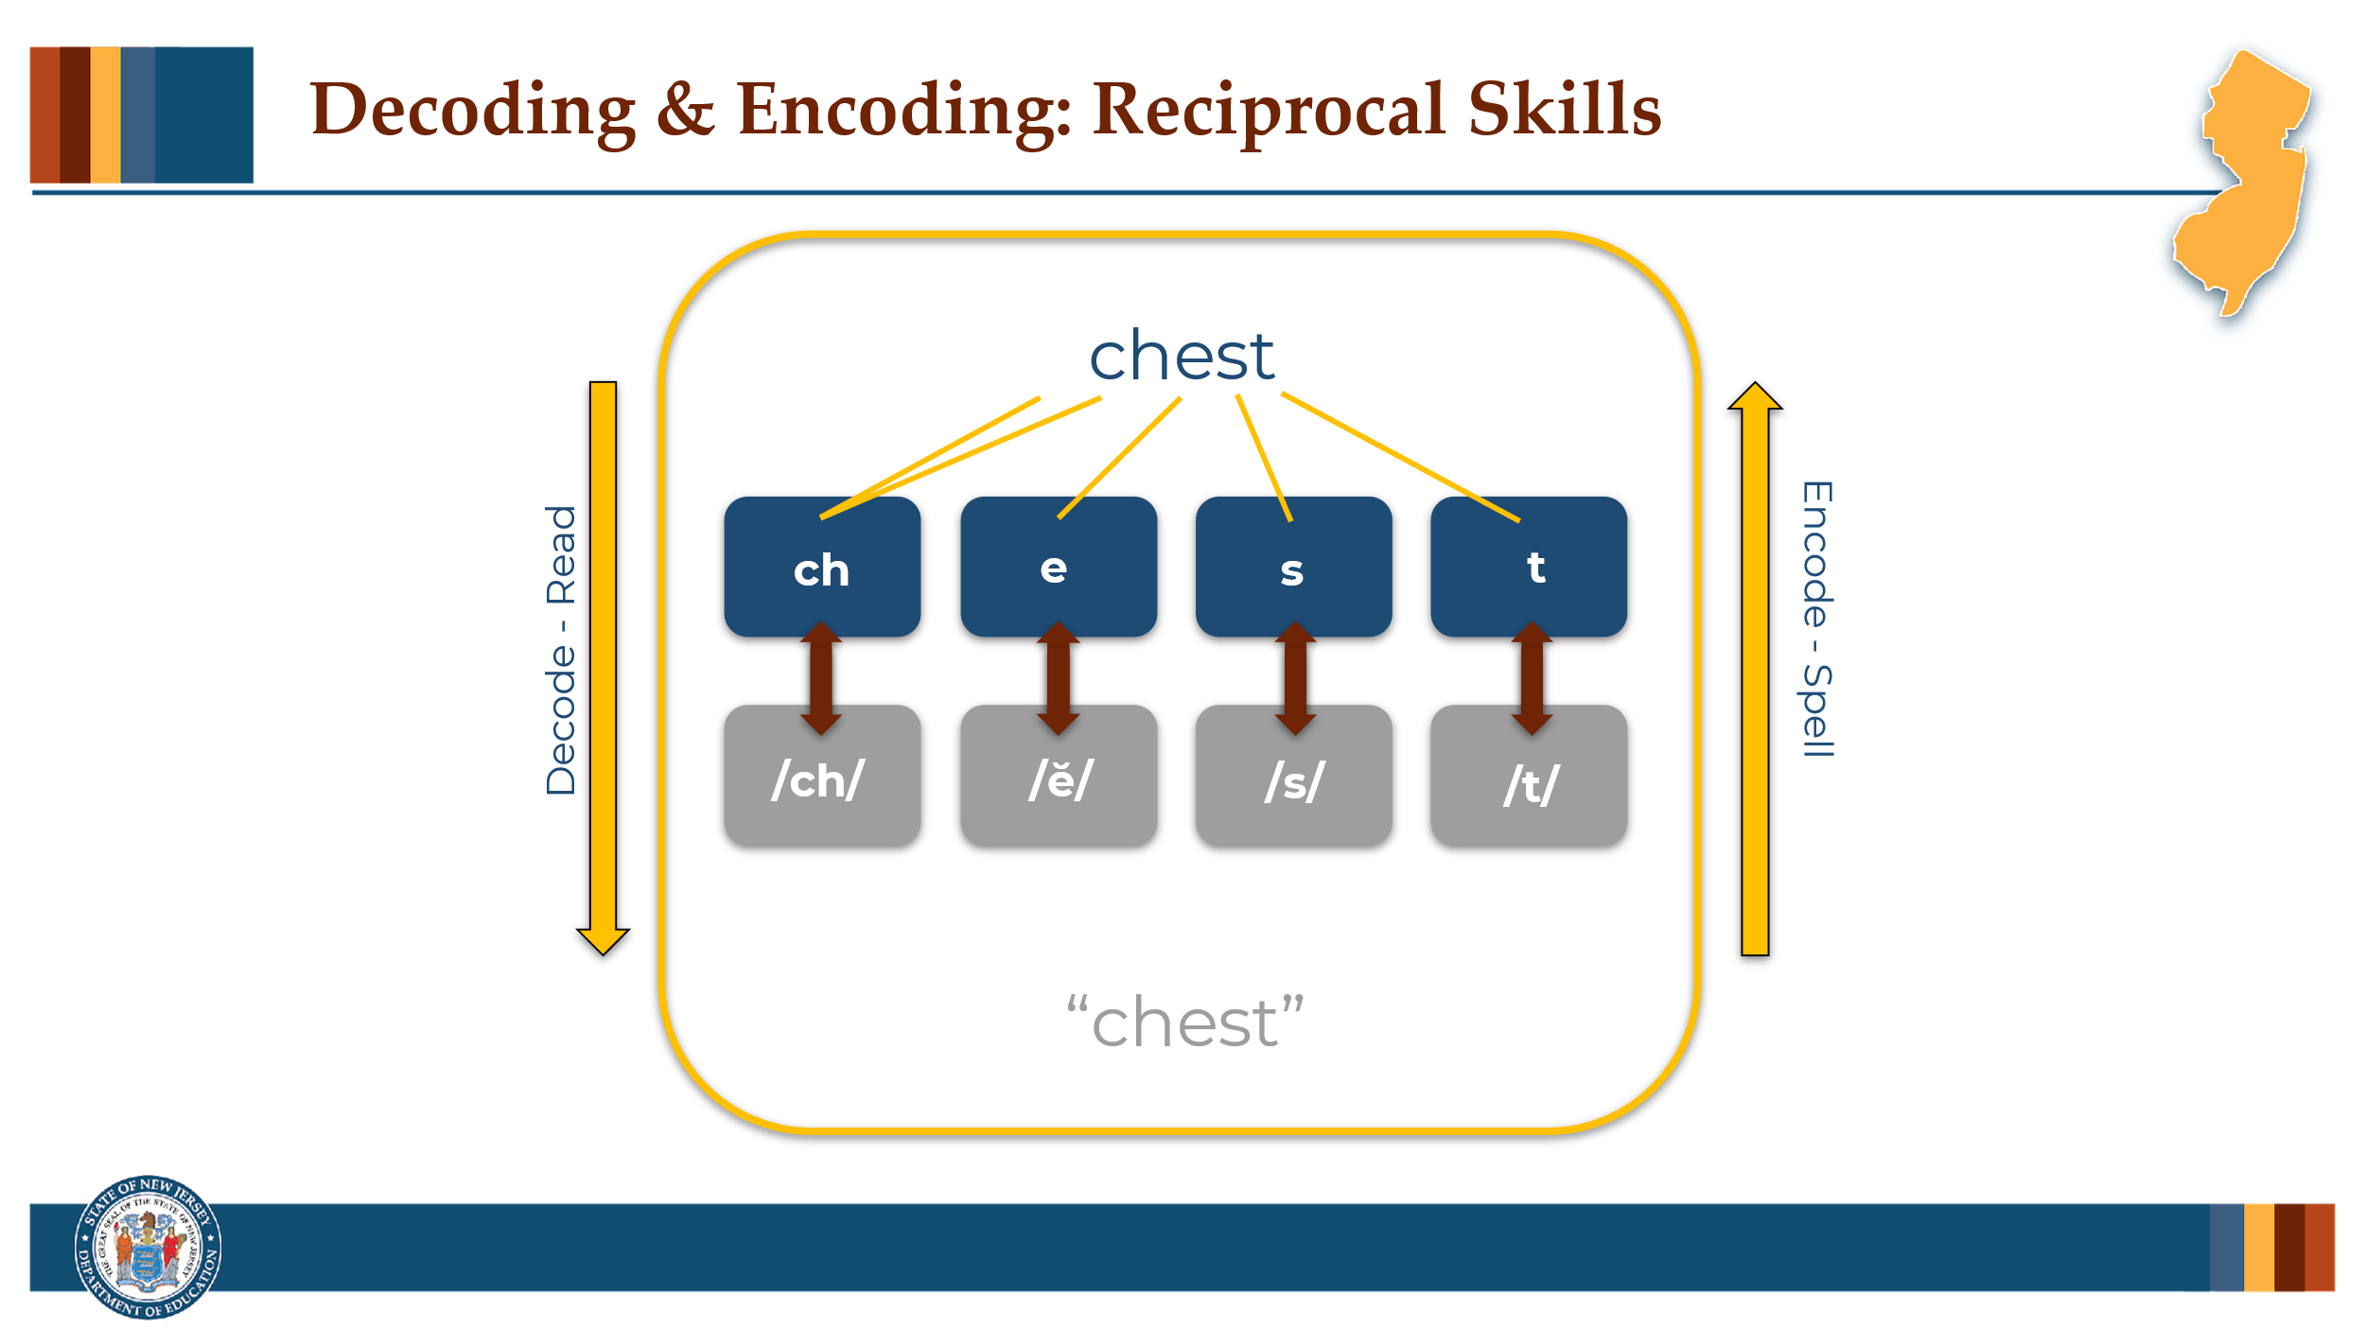

#### Facilitator Narration

As a pre-work activity for this session, we watched the brief video [*Decoding & Encoding: Reciprocal Skills*](https://www.youtube.com/watch?v=QPjxA_dNilc). Reading (decoding) and spelling (encoding) are two sides of the same coin—this is known as the reciprocity between decoding and encoding. Can I get two volunteers, one to describe the decoding process and the other to describe the encoding process?

#### Volunteers Explain

Decoding requires the reader to look at a string of printed letters, identify the graphemes present, and then map those graphemes to the appropriate phonemes in order to pronounce the word and connect to meaning while reading. Encoding requires the writer to segment the word they want to write into its individual phonemes, and then map those sounds to their respective graphemes in order to write the letters that make up the word they are intending to spell.

### Slide 7: The Structured Literacy Plan

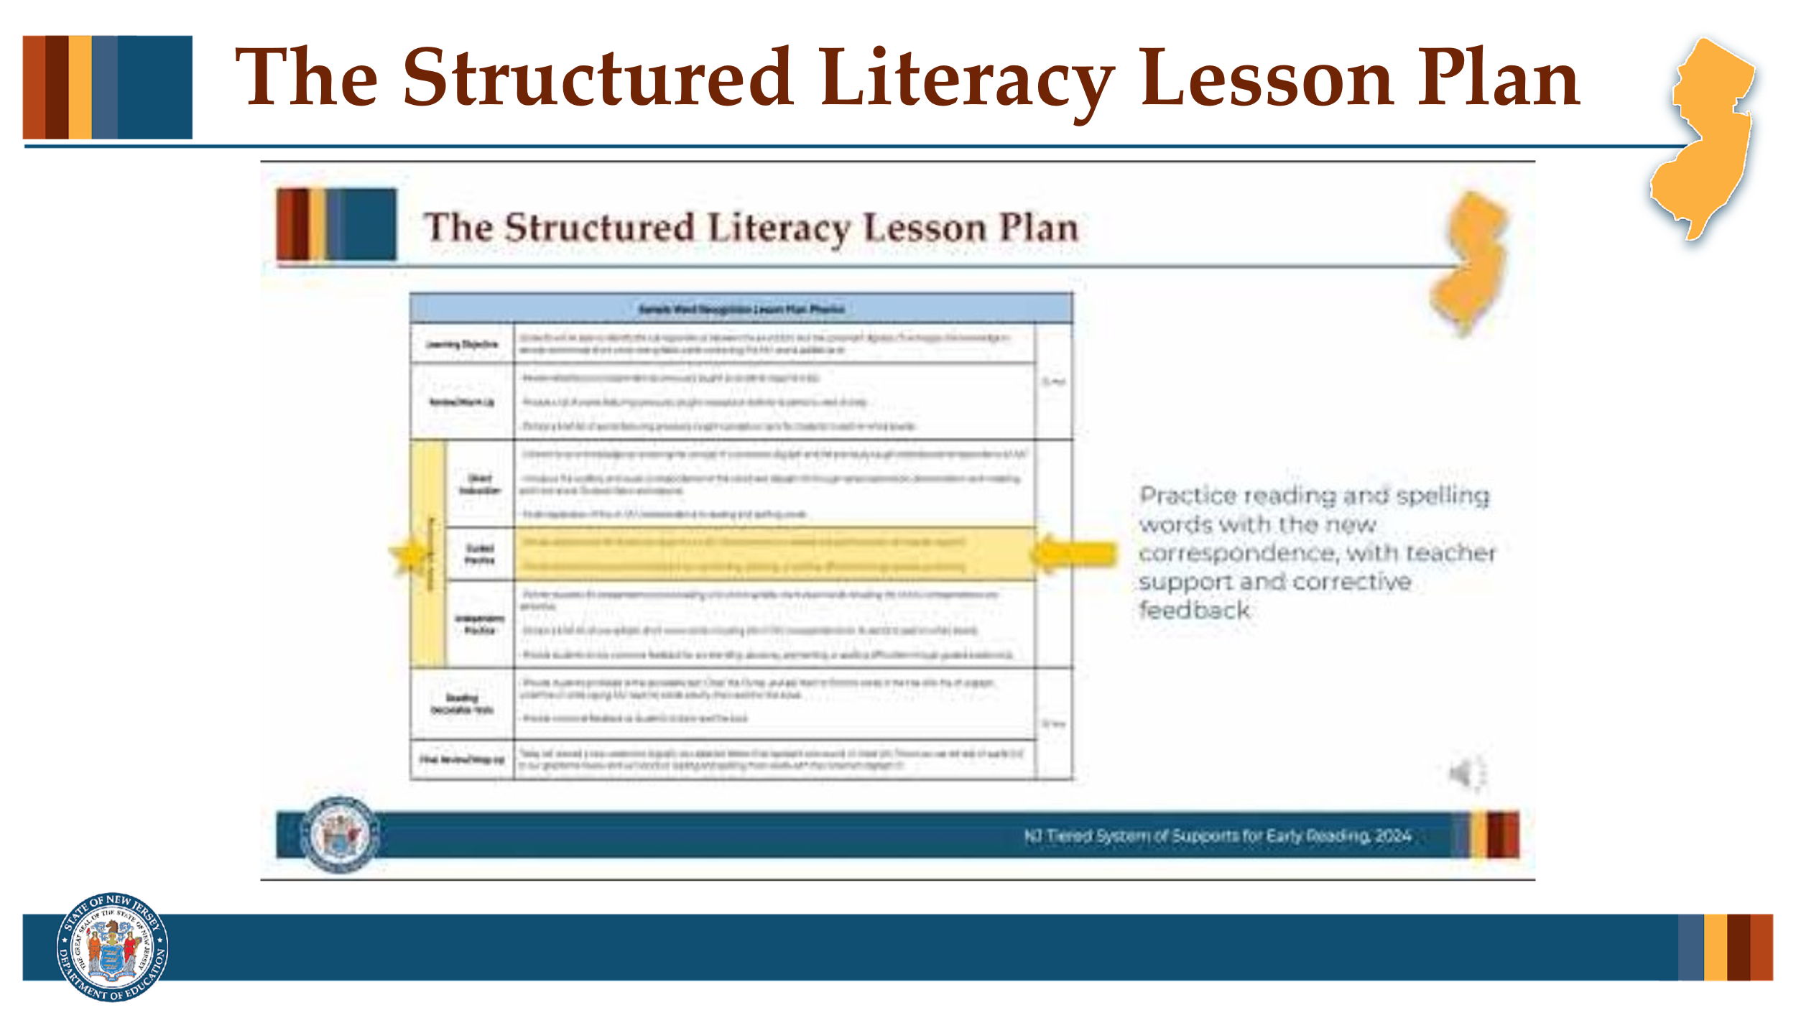

#### Facilitator Narration

Both reading and spelling rely on the same sound-symbol (phoneme-grapheme) correspondences. When students practice one skill, it strengthens their skills in the other. Now let’s take a closer look at how a structured literacy approach to phonics instruction leverages this relationship.

#### Optional Activity

Provide a copy of the current lesson plan being used in your school/district for phonics instruction. Have community members compare it to the sample lesson plan reviewed here. Even though the structure and routines may be a little different, discuss where and how the phoneme awareness and phonics skills are being integrated and identify where the I do, You do, We do routine explicitly addresses decoding and encoding skill development.

### Slide 8: Instructional Routine for Spelling Patterns

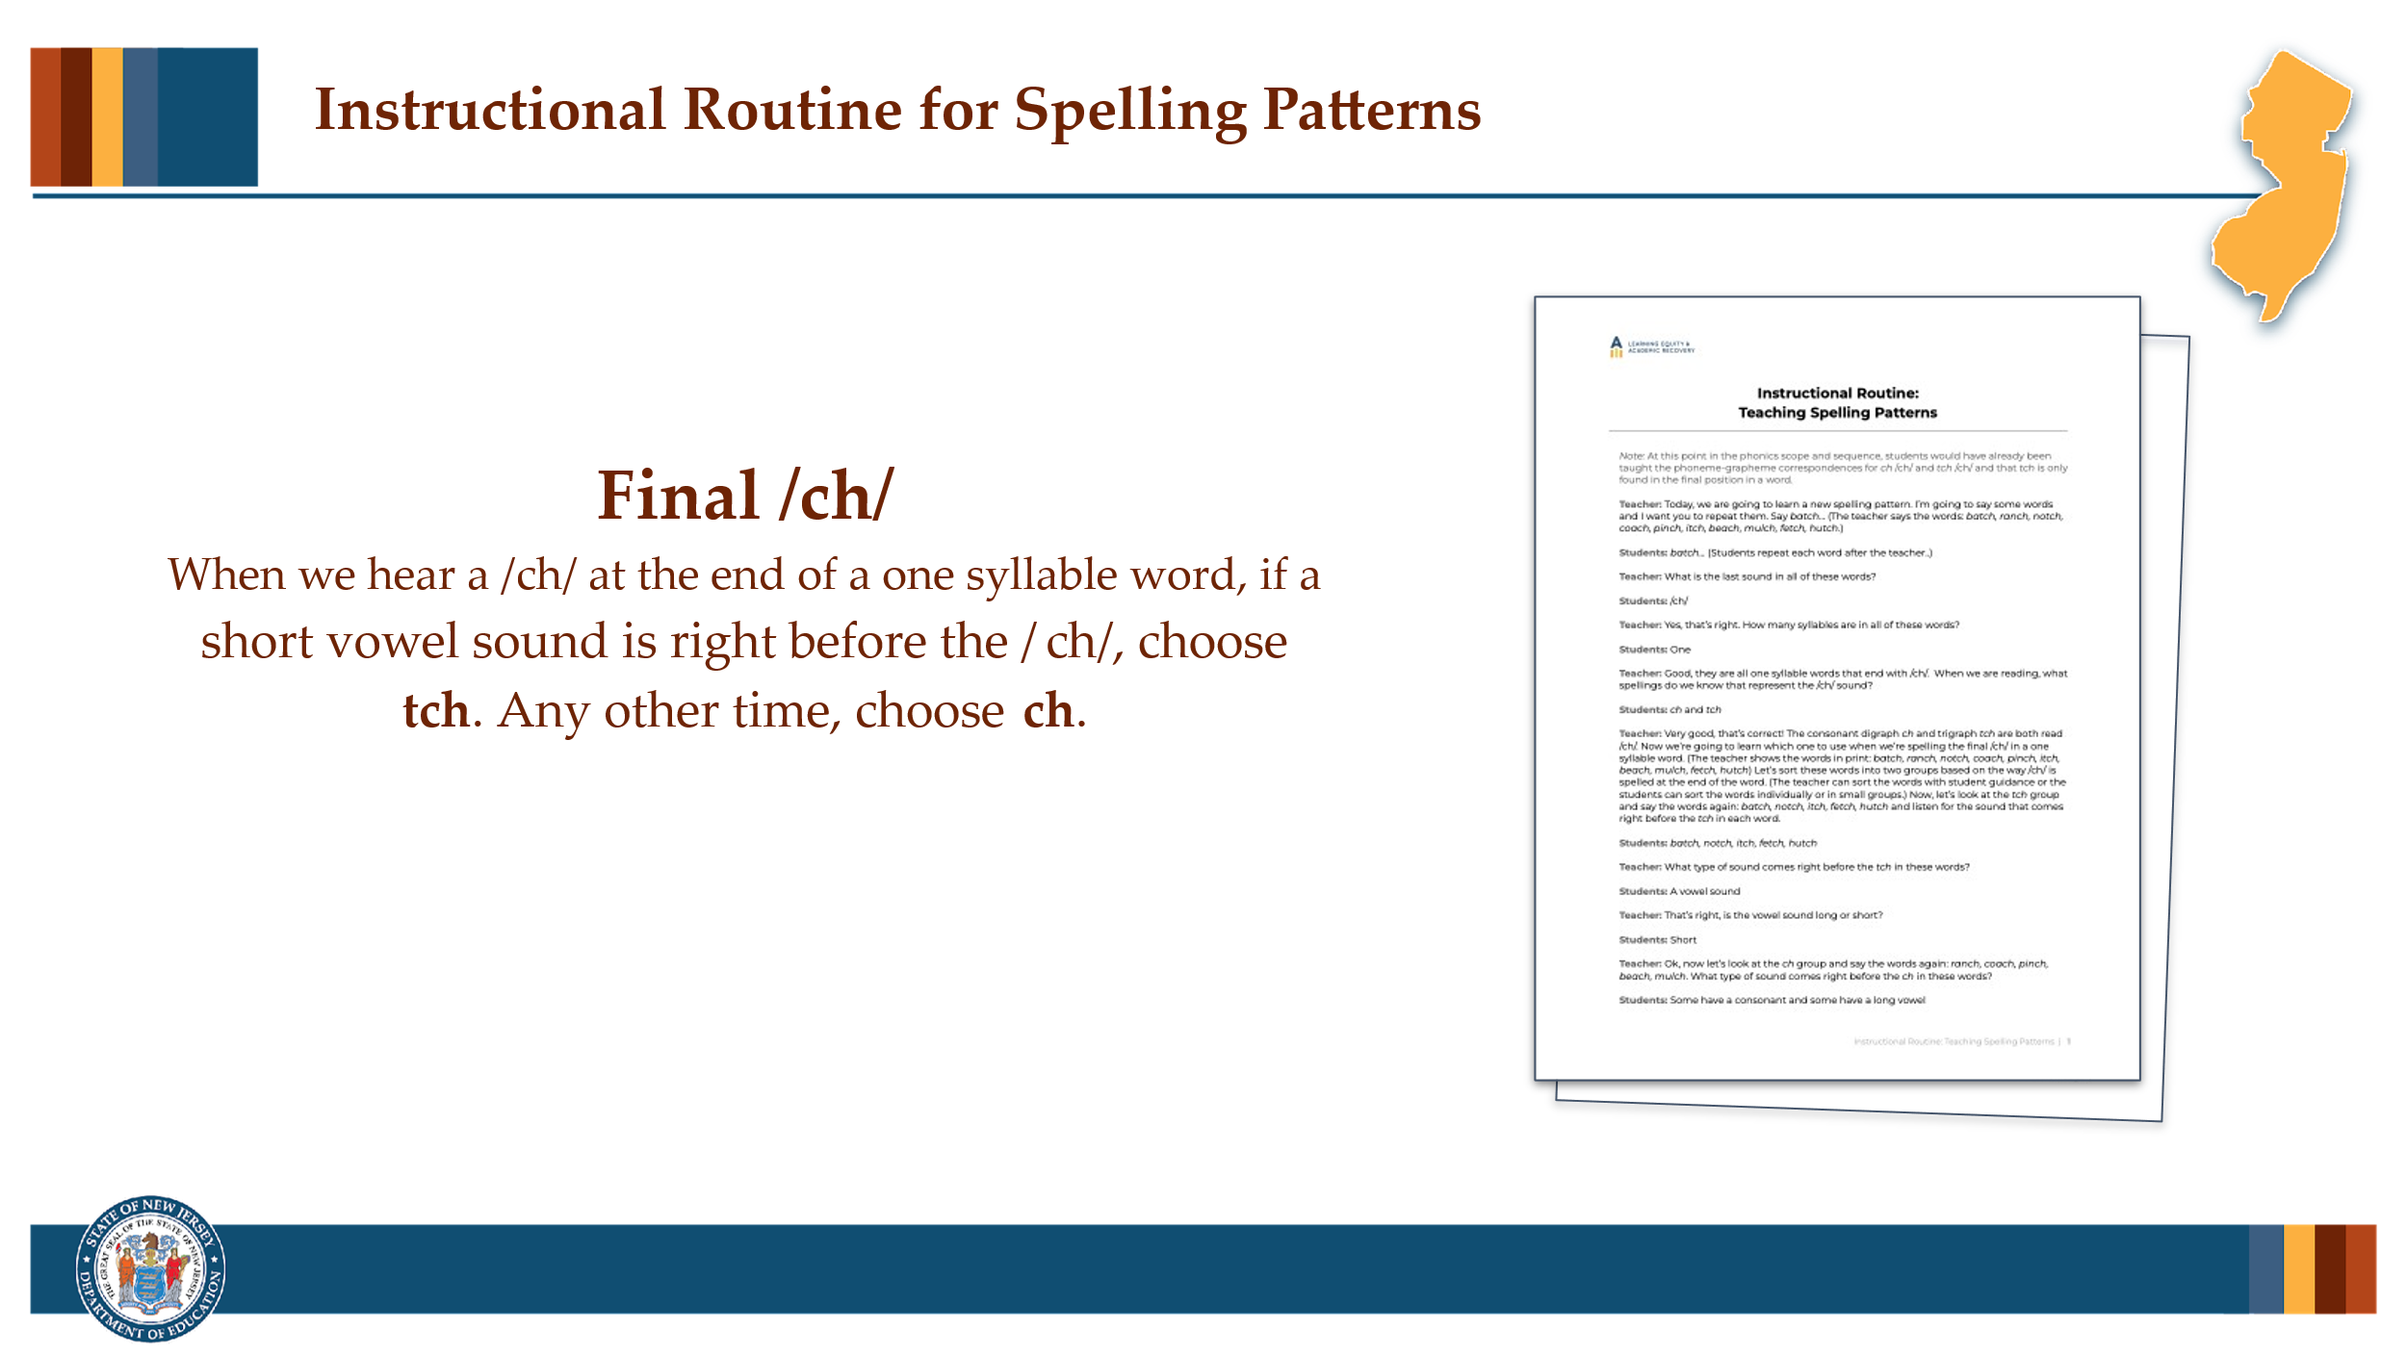

#### Facilitator Narration

In the last PLC session, we explored the 3 step instructional routine for introducing the phoneme-grapheme correspondence - consonant digraph **ch** representing /ch/. Now let’s take a look at the instructional routine that would support students in understanding and analyzing word patterns that inform the options for spelling final /ch/ in words.

#### Activity

(5 –10 minutes)

Distribute copies of the *Instructional Routine: Teaching Spelling Patterns* to all community members. Ask community members to pair off and review the routine. Community members may choose to role play the instructional routine or just review individually in preparation for discussion.

Prompt with questions as needed:

* This routine provides a general framework for helping students understand that they need to think flexibly when spelling words that contain phonemes that can be spelled with different graphemes. Analyzing the position of phonemes and the spelling patterns in words is one way to assist students in making informed choices when spelling. What did you notice about the instructional routine?
* Does our current phonics program have a similar routine for analyzing word patterns to support students’ spelling?
* How can this new routine be implemented to improve our current phonics program or to help better coordinate decoding and encoding instruction?
* For older students, how could a similar type of instructional routine be used to integrate word pronunciations, spellings, and meanings during advanced word study or vocabulary instruction? For example, an adaptation could be used when introducing the different spelling patterns for the final syllable /shən/ in words built with the suffixes *-ion* and *-ian* (e.g., pollution, mansion, discussion, musician).

### Slide 9: Adapting to Student Needs

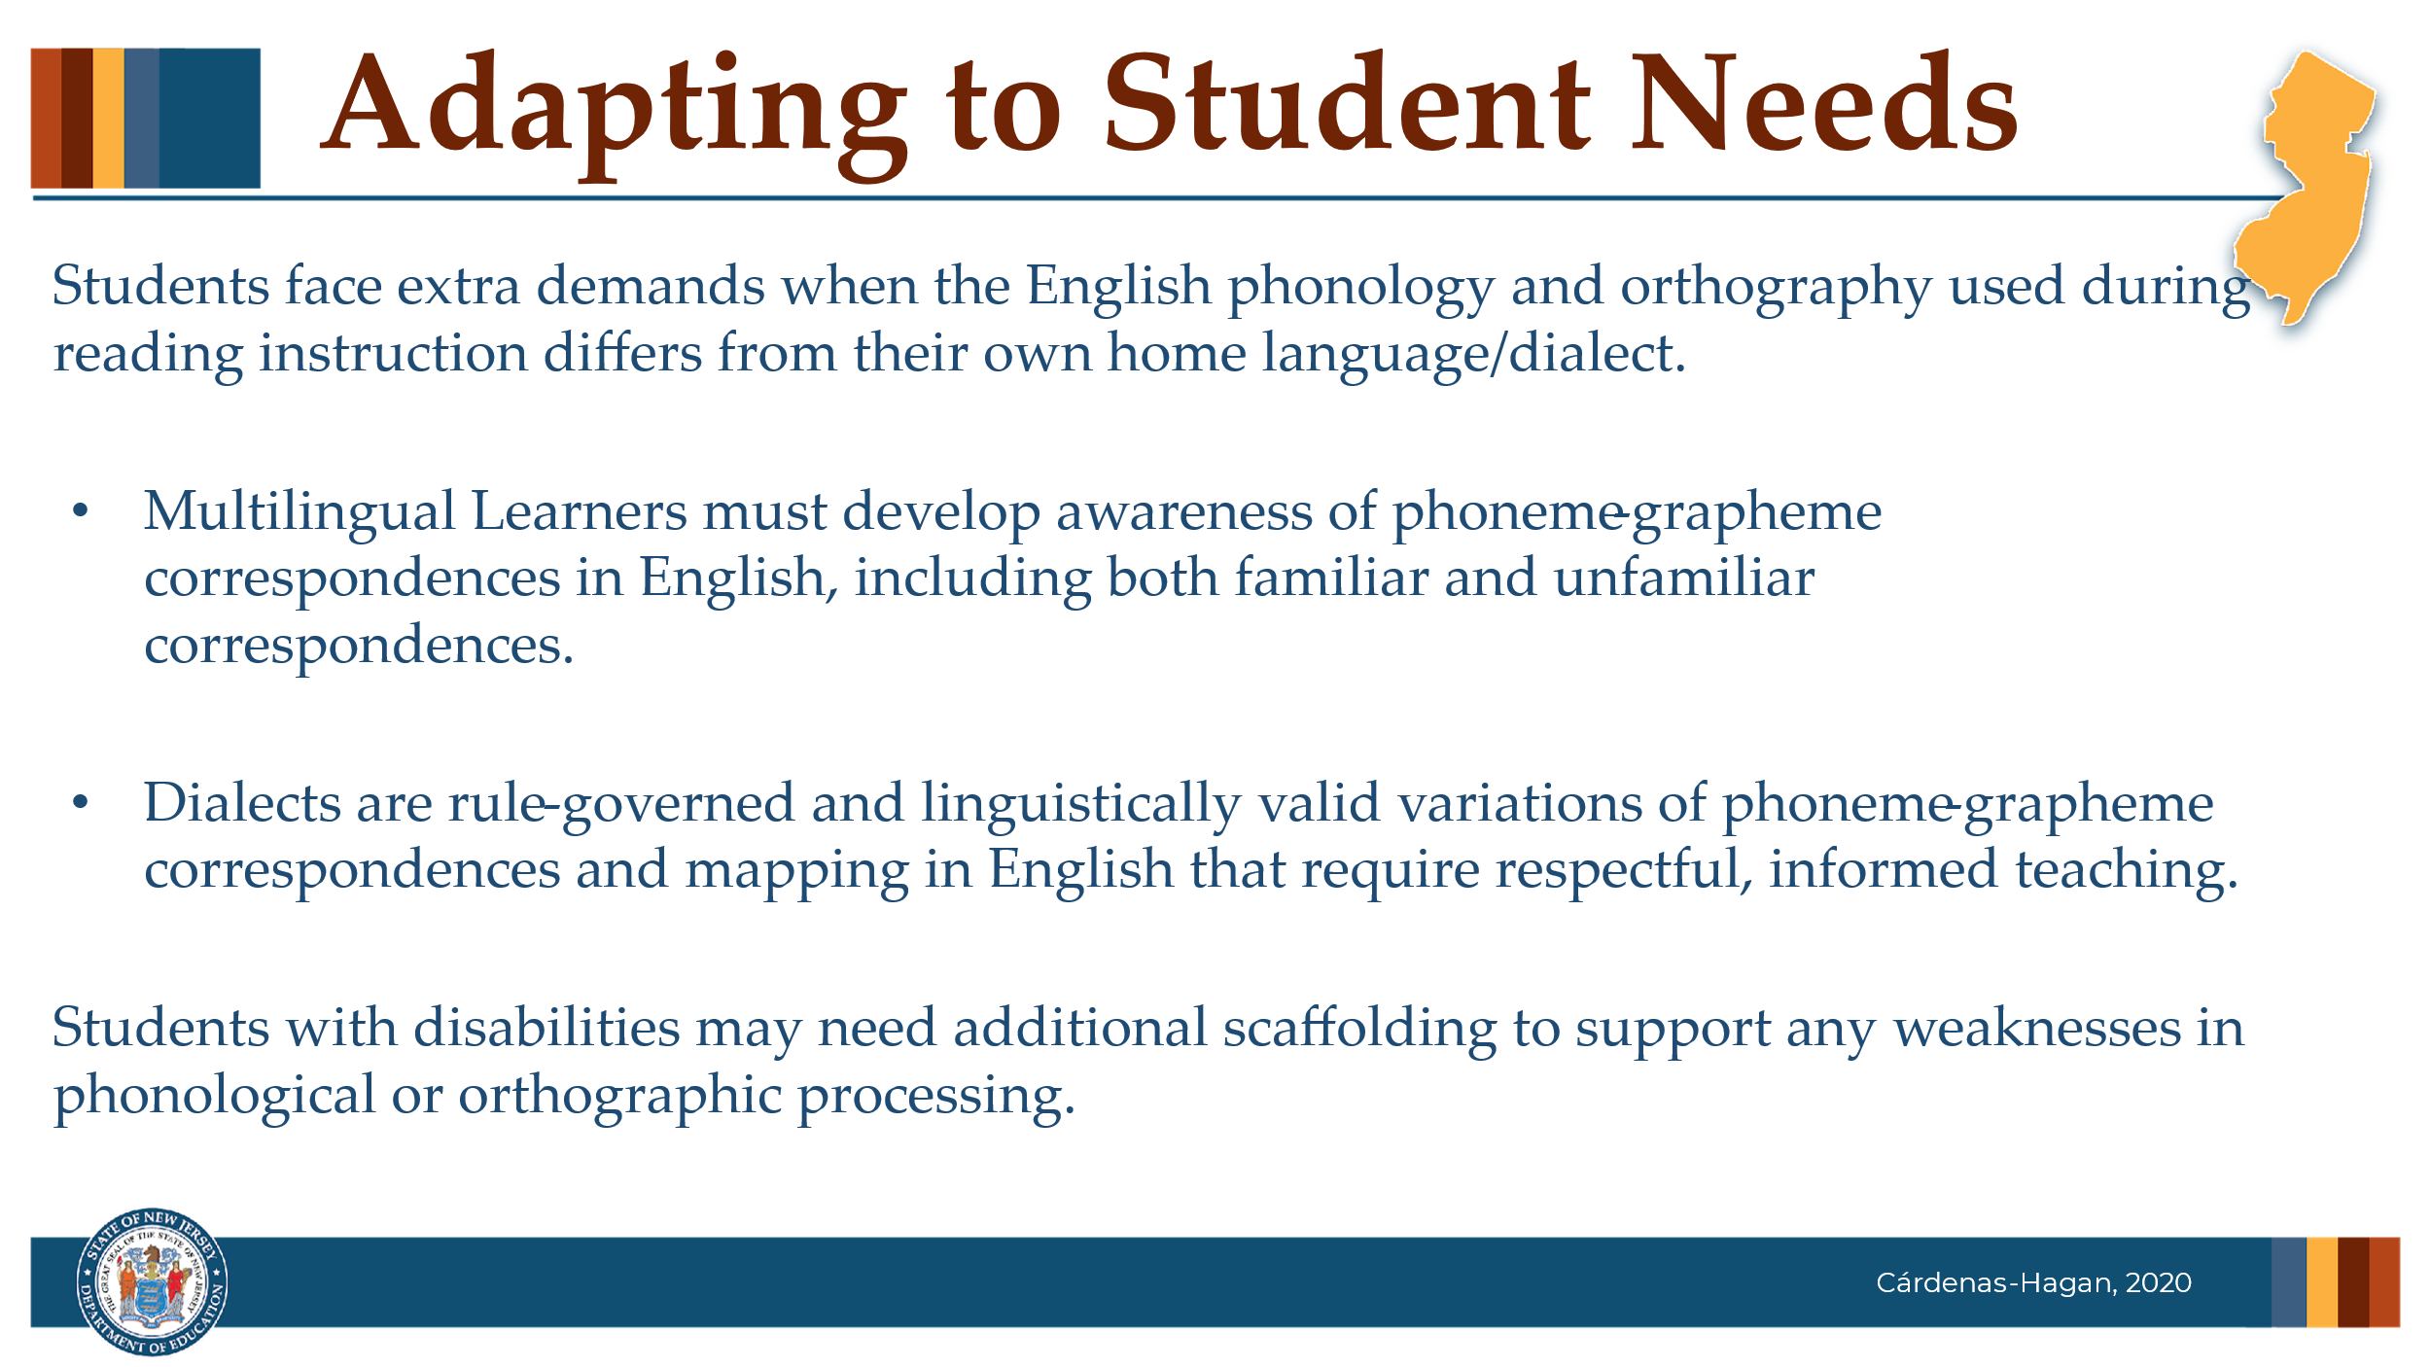

#### Facilitator Narration

As educators, it's important to recognize that when students come to school speaking a different language or dialect than the variation of American English used in the classroom, they face additional language and cognitive demands—especially during reading instruction, which relies heavily on a standardized version of English phonology and orthography.

Multilingual learners, for example, must become consciously aware of the phoneme-grapheme correspondences in English, including those that may be different or not exist in their home language. This process takes time and explicit support. Also, although we know all students need to have the words they decode in their mental vocabularies in order to make meaning, students learning English will need additional supports to build strong vocabulary knowledge in English.

Similarly, students who speak a different English dialect, may use rule-governed phoneme-grapheme correspondences that differ from those used in reading instruction. These are not 'errors,' but features of a valid language variety that need to be explicitly explained during spelling instruction.

Understanding and honoring these differences allows us to tailor instruction in a way that is respectful, effective, and inclusive.

Also, students with disabilities may need additional scaffolding to support any weaknesses in phonological or orthographic processing.

#### Optional Question

How can we prepare ourselves to deliver instruction that supports students whose home language or dialect differs from the phonological or orthographic representations of our school reading instruction?

### Slide 10: Thanks for Participating!

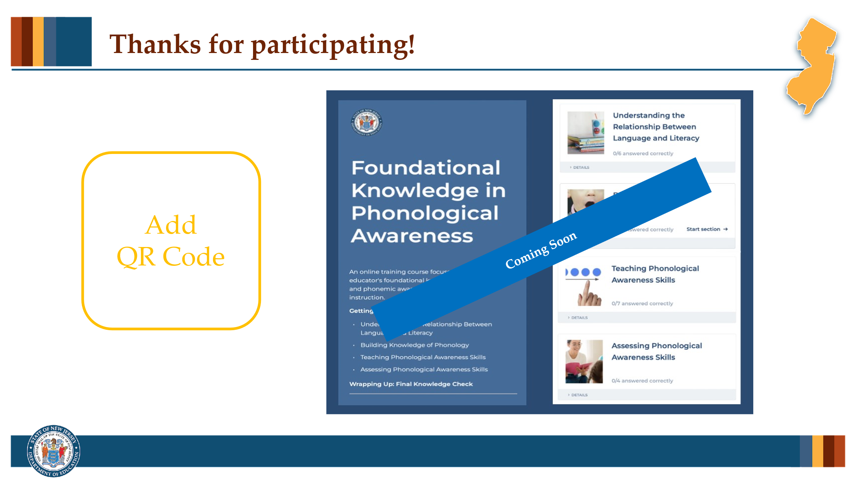

#### Facilitator Narration

This brings us to the end of our session today! If you are interested to learn more about phonics including decoding and encoding instruction and assessment, you can enroll in the NJ Department of Education’s free SISEP online learning module titled Foundational Knowledge in Phonics.

### Slide 11: Next Session in the PLC Series

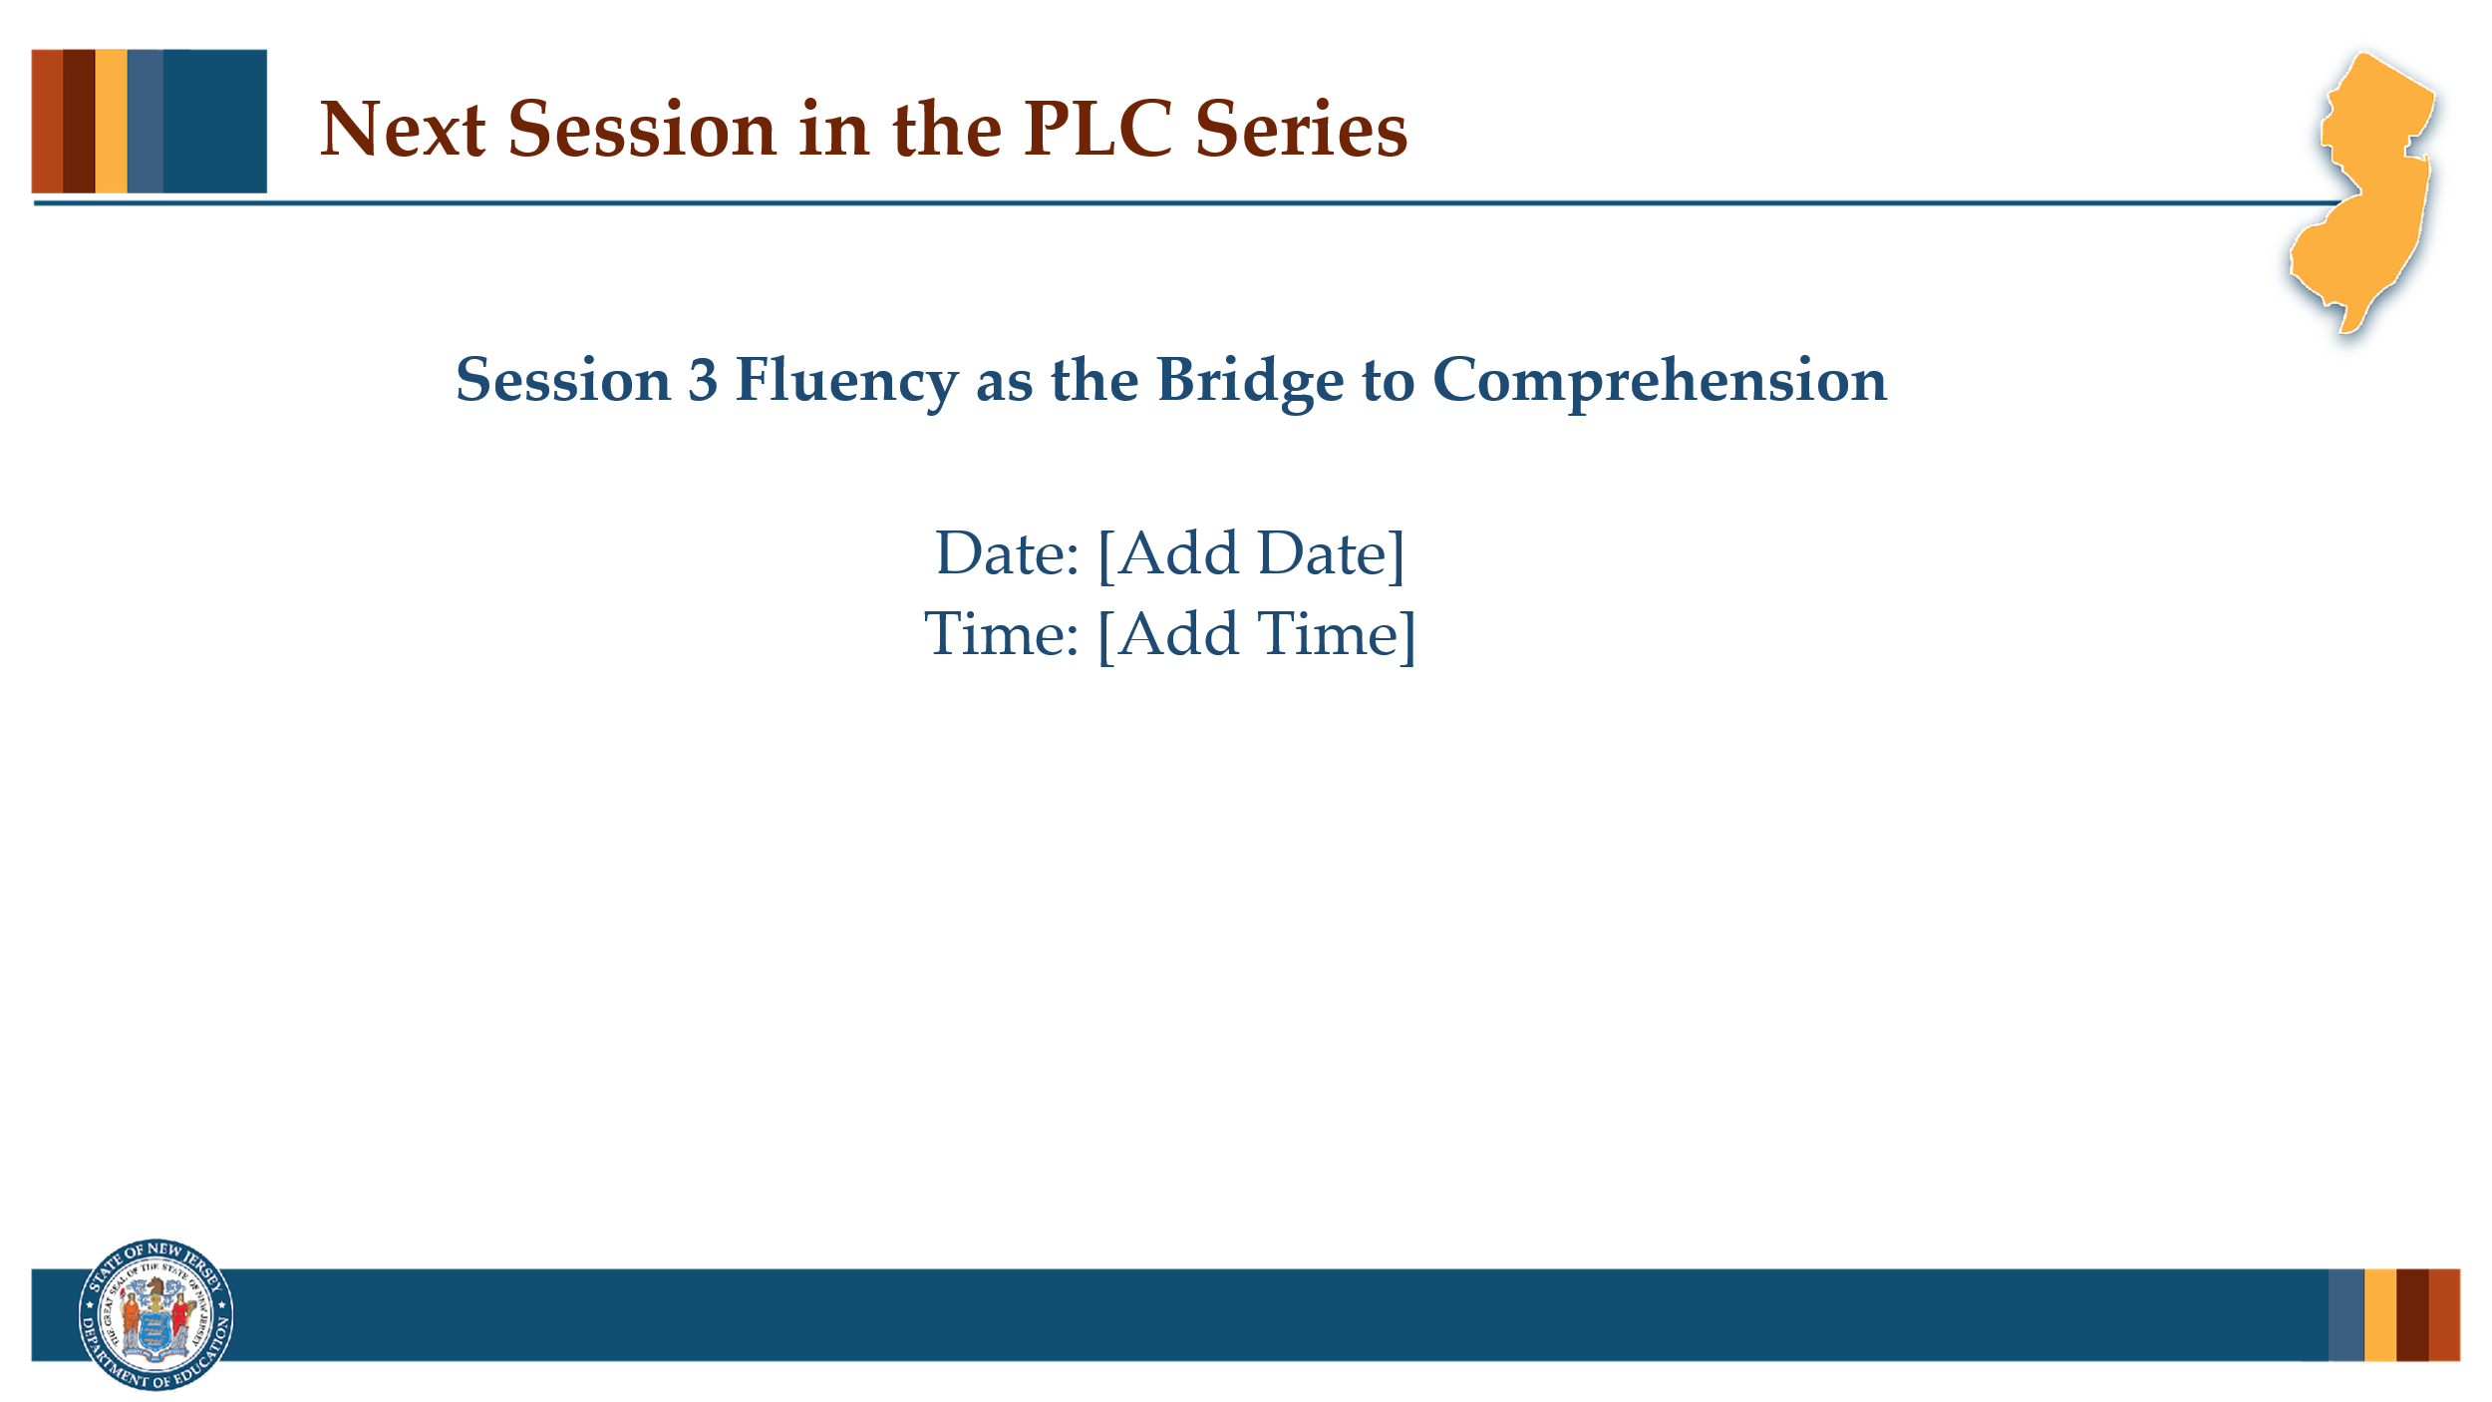

#### Facilitator Narration

Up next is Session 3 Fluency as the Bridge to Comprehension. This PLC session will focus on best practices in building students’ fluency in support of reading comprehension. We will meet on [add date and time]. See you then!

### Slide 12: References

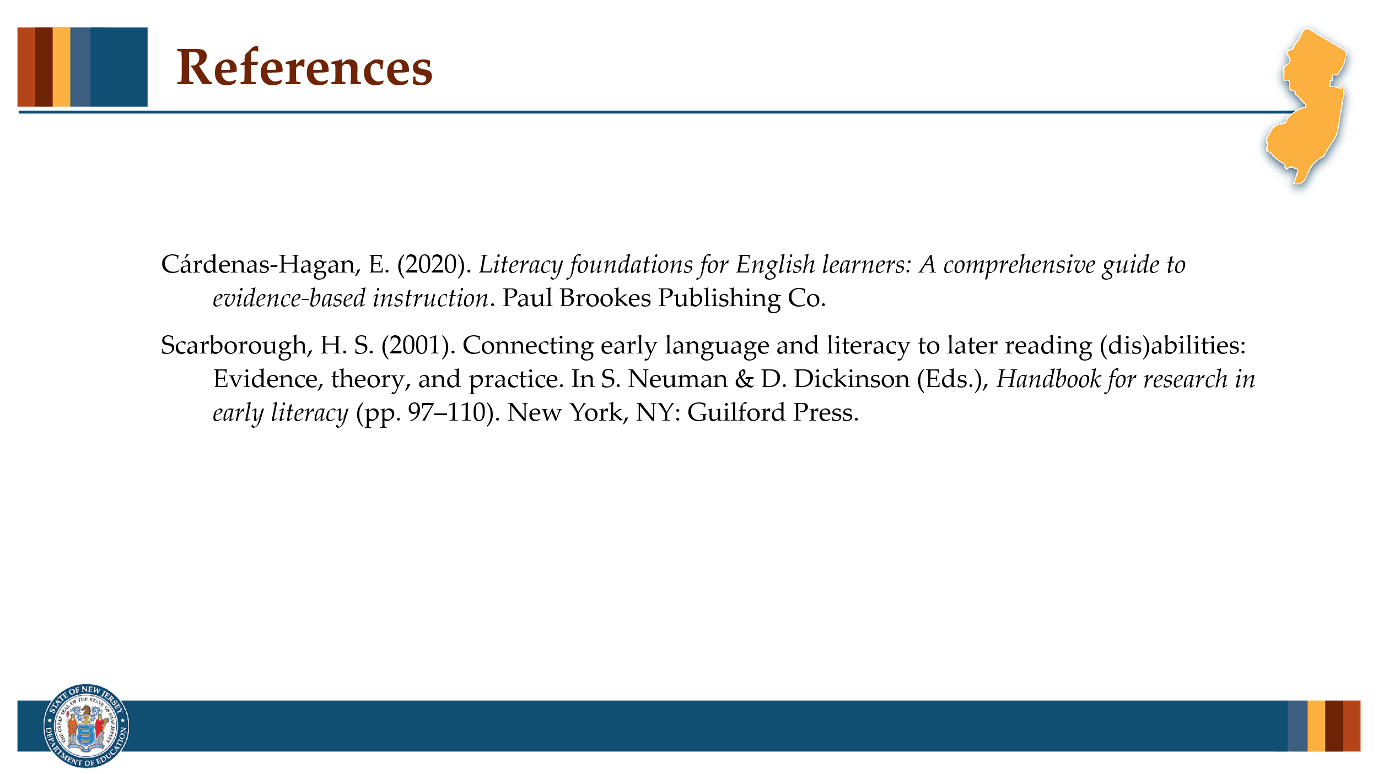

This slide lists references from the presentation.

### Session Materials Needed

* PLC Series Session 2 - Slide Presentation
* Copies of Supplementary Resources for Community Members:
  + Sample Word Recognition Lesson Plan: Phonics (Optional)
  + Current school/district lesson plan for phonics instruction (Optional)
  + Instructional Routine: Teaching Spelling Patterns

If the session is being delivered virtually, use a virtual meeting space that allows for meeting participants to engage via both audio and video.