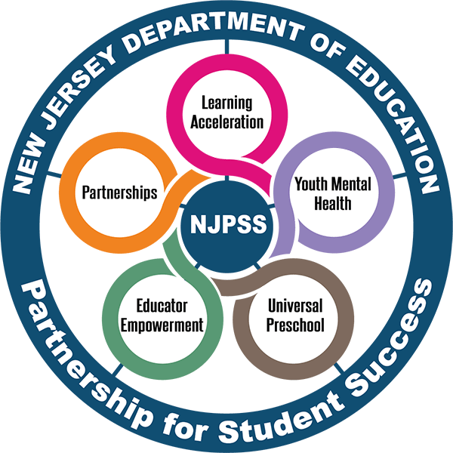
NEW Jersey Partnership For Student Success:
Summer Learning Program Development Resource
A resource for summer program development in New Jersey

Table of Contents
Summer Learning Program Development Resource 1
Purpose 3
How to Use this Resource 3
The Summer Slide 4
Traditional Summer School vs. Enhanced Summer School (Adapted) 4
The Summer Learning Programming Stages 4
Section 1: The Planning Stage 5
Section 2: The Training Stage 5
Section 3: The Assessing Stage 5
Section 4: The Reflection Stage 5
The Summer Learning Program Development Workbook 5
The Categories 5
The Columns 6
Key Terms 6
Familiarizing Teams with Using the Workbook 6
12 Month Overview 7
Appendix A: Sample Summer Schedules 8
Appendix B: Additional Resources 13

Purpose
Summers are for learners, and the development of robust summer learning programs that continuously engage and excite students while preparing them for the upcoming school year is instrumental in curbing the “summer slide,” as well as addressing the need to accelerate learning for those students negatively impacted by the Covid-19 Pandemic. The New Jersey Department of Education (NJDOE) supports local education agencies’ (LEAs) efforts in shifting mindsets about summer by taking a comprehensive approach to planning academic summer programs. The Summer Learning Program Development Resource aims to provide guidance as LEAs design programming that is accessible to all students and maximizes learning opportunities during the summer months.
Utilizing the National Summer Learning Association’s (NSLA) Quality Improvement Cycle, (Figure 1) this resource and accompanying workbook details a comprehensive 12-month approach aimed at assisting a summer program team in strategically planning, training, assessing, and reflecting on summer learning. With purposeful and cyclical planning which starts in September, LEAs can develop a summer program which accelerates learning, while increasing equity in educational opportunities.

How to Use this Resource
The Summer Learning Program Development Resource (the Resource) should be read alongside the NJDOE’s 2022 Summer Learning Guide. The Resource is intended to provide LEAs with a step-by-step outline for summer program development, informed by the information in the Summer Learning Guide.
The Resource begins by providing an overview of why creating impactful summer learning opportunities is imperative. With this introduction, the reader will learn more about the summer slide, as well as goals for enhanced summer learning.
The next section, The Summer Learning Programming Stages will provide an overview of the comprehensive twelve-month approach, by describing suggested tasks to guide LEAs in the construction of quality summer programs. This section should be read as a calendar, as tasks coordinate with a proposed monthly deadline. The calendar is separated into four stages; Planning, Training, Assessing, and Reflection. Each stage includes a rationale and an explanation to provide context for the tasks that follow.
Figure 1. NSLA's Quality Improvement Cycle
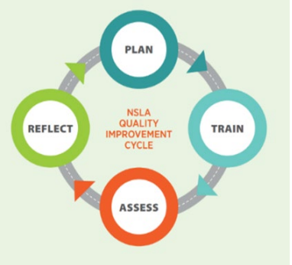
To complement this resource, the NJDOE has provided a Summer Learning Program Development Workbook (the Workbook. The Workbook is designed to help organize team meetings and monitor progress. Directions to use the workbook are explained in this section. Ultimately, the intention behind this work is to help pace summer program development teams as they complete each task.
Finally, the document concludes with appendices containing sample summer schedules and other potential resources.

The Summer Slide
It is well-documented that some students may begin the school year performing at a lower academic level than they did at the close of the previous year; a gap known as the “summer slide.” Put simply, the summer slide occurs due to students having scarce opportunities for learning over the summer break. Our youngest learners, those in kindergarten through second grade, and low-income students are the most vulnerable to the negative impact of summer break.
Students lose the most skills in reading and math, which often causes many educators to prioritize reteaching instead of introducing new content in the earlier months of the school year. School districts can utilize the Resource to design rich summer learning opportunities for students which may in turn assist in combatting the summer slide.

Traditional Summer School vs. Enhanced Summer School (Adapted)
The NJDOE’s 2022 Summer Learning Guide provides a list of qualities of an enhanced summer learning program. See Table 1 below for an adapted list. In aiming to surpass the traditional approach where remediation, credit recovery and remedial interventions were often prioritized, the adoption of these characteristics can aid in the advancement of summer programs which accelerate learning and increase equity in educational opportunities.
Table 1. Qualities of Enhanced Summer Learning Programs
Enhanced Summer Learning Programs
Commit to equity and inclusion for all learners
Frontload anticipated learning for the upcoming school year
Employ the Learning Acceleration Principles to guide curriculum and instruction
Implement intensive, high-dosage tutoring
Focus on depth of instruction rather than the pace; prioritize the content and the learning
Identify and address specific gaps in learning through instruction
Encourage social, emotional, and cultural connectivity and awareness
Provide English Language Learners (ELLs) with supports to address any English language development instruction
Provide dual enrollment, structured learning experiences, and/or advanced coursework opportunities for students to earn credit toward a college degree or industry-valued credential
Provide professional development opportunities for staff
Utilize funds from the Mental Health Services and Supports Grant and the NJTSS Mental Health Support Staffing Grant for additional counseling services during summer programs
Utilize ARP ESSER funds efficiently (See Understanding and Combining ESSER and Federal Funds)

The Summer Learning Programming Stages
To provide students with out-of-school educational opportunities that will accelerate their learning, program planning should begin in September. Below LEAs will be guided through four stages that encompass necessary and extended tasks which provide guidance to planning teams for designing summer learning programming.
Informed by NSLAs Quality Improvement Cycle, the tasks are separated into the following stages:

Section 1: The Planning Stage
The planning stage is where the groundwork for summer programs is developed. Proper planning, though extensive, will ensure the summer programs developed using this calendar are impactful and sustainable. The planning stage begins in September and continues through July, and it is divided into twelve sections. Each section has several correlated tasks which will guide summer programming teams in designing their summer learning opportunities.
The twelve sections are as follows: foundational, budget, facilities, transportation, supplies, meals, schedule, site operations, curriculum, enrichment and partnerships, social emotional learning (SEL) supports and family engagement.

Section 2: The Training Stage
During the training stage, summer program teams will complete tasks which prepare the summer instructional and support staff for summer learning. The purpose of providing training is to ensure consistency in the delivery of content, be preemptive to misunderstandings, and encourage open communication and input during summer learning programs. The NJDOE's Summer Learning Guidance provides a list of guiding questions to support LEAs in preparing teachers to accelerate learning for all students. The training stage begins in October and is forecasted to conclude in May/June.

Section 3: The Assessing Stage
Assessment is an essential step in ensuring the efficacy of summer programs. During the assessing stage, the summer program team will be guided through the process of completing a program evaluation and administering stakeholder feedback surveys to track their impact and progress. Through completion of the tasks, teams will use the logic model, teacher observations, student progress monitoring, and other data inquiries to evaluate and enhance their programs over time. The initial development of assessments will begin in March and conclude in August.

Section 4: The Reflection Stage
The final stage for planning teams is the reflection stage. Within this stage teams will analyze the data collected during the assessing stage and apply its findings to make improvements to the program in preparation for the following year. The team will review the program evaluation, recommit to goals and be encouraged to communicate with families to ensure transparency and accountability to stakeholders. At the conclusion of the reflection stage, planning teams will be able to continue their work annually, starting back at stage one.

The Summer Learning Program Development Workbook
The Workbook is a tool designed to organize and guide summer planning teams through the summer program development process. The workbook itself is based on the research of the Wallace Foundation and the National Summer Learning Association and has been adapted to meet the needs of New Jersey's LEAs. It encompasses various planning categories with associated tasks and a recommended timeline. The flow of the workbook is cyclical and is designed to anchor future summer programming as it starts and ends in September.

The Categories
Each sheet of the Workbook holds several tasks and activities associated with the category title. The categories and associated tasks and activities are as follows:
Planning Stage
- Foundational - Assist teams in laying the groundwork for summer programming
- Budget - Assist teams with creating a program budget
- Facilities - Assist teams in solidifying facilities
- Transportation - Assist teams in coordinating transportation
- Supplies - Assist teams with ordering, distributing, and managing supplies at individual site locations
- Meals - Assist teams with securing meals for students
- Schedule - Assist teams in determining the program, students, and instructional staff's schedules
- Site Operations - Assist teams with confirming that facilities are prepared to support student learning and promote safety during program hours
- Curriculum - Assist teams with developing the curriculum for the summer programs
- Partnerships - Assist teams with utilizing partnerships to enhance instructional programming
- Social and Emotional (SEL) Supports - Assist teams as they construct SEL opportunities for students and summer staff
- Family Engagement - Assist teams in engaging families
Training Stage - Assist in preparing the summer instructional and support staff for summer learning
Assessing Stage - Assist teams with progress monitoring and program evaluation
Reflection Stage - Assist teams with applying lessons learned for program improvement

The Columns
These six columns on each page of the workbook indicate various actions which need to be taken.
The columns read as follows:
- “Key Tasks and Activities” - The key tasks and activities that should be completed
- “Recommended Timeline” - The month in which the tasks or activities should be completed
- “Who's Responsible” - Users will be able to assign their own team member
- “Our Timeline” - Users will be able to set their own deadline
- “Status” - Users will be able to toggle between options to update the status of each task
- “Notes” - Users will have space to add notes around planning dependencies, challenges, or delays

Key Terms
The tasks and activities in each section are categorized by their level of importance:
- Necessary - Tasks that are considered necessary to building a quality summer programming.
- Extended - Tasks that will differ district to district

Familiarizing Teams with Using the Workbook
- Review all directions under the “Getting Started” sheet to maximize the design of the Workbook.
- As a team, review the Workbook and delegate tasks to individuals or smaller groups.
- Utilize the interactive columns to keep track of progress.

12 Month Overview
Figure 2 below provides an overview of the summer program development process.
An accessible version detailing all figure contents can be found in Workbook.
Figure 2. 12-Month Overview
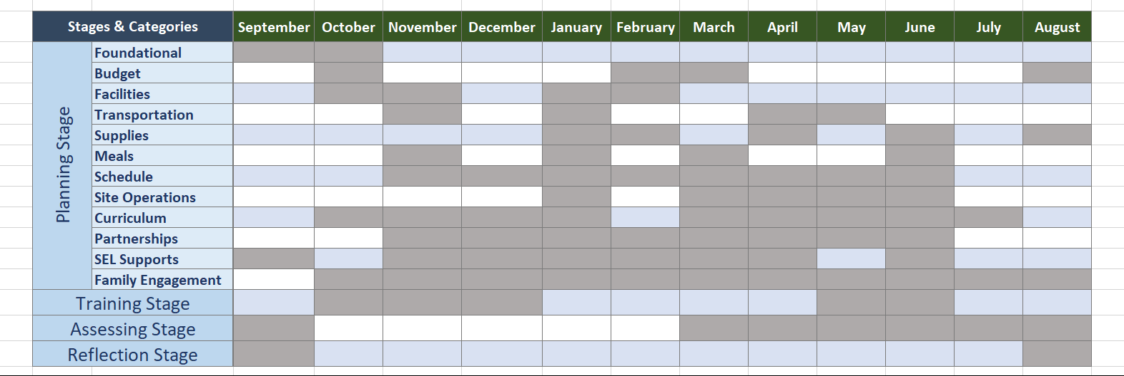

Appendix A: Sample Summer Schedules
Providing students opportunities to deepen their learning is directly correlated to their schedule. Therefore, designing detailed and intentional summer schedules will be imperative to enhancing summer programs. The tables below provide examples of possible summer schedules.
Table 1: Sample Elementary Schedule (grades 3-5)
Time | Activities
7:00 − 7:30 a.m. | Breakfast with literacy activity
7:30 − 8:30 a.m. | ELA Block
8:30 − 9:30 a.m. | Math Block
9:30 − 10:00 a.m. | Play/Physical Activity
10:00 − 11:00 a.m. | Intervention
11:00 − 11:30 a.m. | Lunch
11:30 − 12:30 p.m. | Flexible Content Block
12:30 − 1:30 p.m. | Flexible Content Block
1:30 − 2:00 p.m. | Play/Physical Activity
Source: National Institute for Excellence in Teaching
Table 2: Sample Middle School Schedule (grades 6-8)
Time | Activities
7:00 − 7:30 a.m. | Breakfast
7:30 − 8:30 a.m. | ELA Block
8:30 − 9:30 a.m. | Math Block
9:30 − 10:30 a.m. | Intervention
10:30 − 11:30 a.m. | Play/Physical Activity
11:30 − 12:00 p.m. | Lunch
12:00 − 1:00 p.m. | Flexible Content Block
1:00 − 2:00 p.m. | Flexible Content Block
Source: National Institute for Excellence in Teaching

Table 4: Sample High School Schedule (9-12)
Time | Activities
7:00 −7:30 a.m. | All grades breakfast with literacy activity
7:30 − 9:00 a.m. | Flexible Content Block
9:00 − 9:15 a.m. | Break
9:15 − 10:45 a.m. | Flexible Content Block
10:45 − 11:15 a.m. | 9th and 10th grade lunch
11:30 − 12:00 p.m. | 11th and 12th grade lunch
12:00 − 1:30 p.m. | Flexible Content Block
1:30 − 1:45 p.m. | Break
Source: National Institute for Excellence in Teaching

Appendix B: Additional Resources
Provided below is a list of additional guidance and links to research on designing and implementing a high-quality summer program.
Table 1. High-quality Summer Programming Resources
Stage/ Category | Resources
Planning Stage | - NSLA Summer Starts in September  - Wallace Foundation: Getting to Work on Summer  - NJDOE 2022 Summer Learning Guide
Foundational | - Conducting your Summer Learning Program Needs Assessment  - SMART Goals Template
Facilities | - Planning Guide for Maintaining School Facilities  - NJ.gov-Facilities Checklist Instructions and Guidance
Transportation | - N.J.A.C. 6A:27, Student Transportation  - Understanding the Role of the Student Transportation Department
Meals | - Successfully Incorporating Culturally Appropriate School Meals  - USDA Local School Wellness Policy Outreach Toolkit
Curriculum | - NJDOE Summer Learning Checklist  - NJDOE Young Readers Preventing Summer Slide  - Priorities for Equitable Instruction: 2021 & beyond
Partnerships | - Partnering with Community-Based Organizations for more Broad-Based Public Engagement  - Summer Learning Toolkit-Academics & Enrichment  - Best Practices - Section II: Enrichment Programs
SEL Supports | SEL In New Jersey
Family Engagement | - A Family Engagement Framework for All  - Summer Learning Recruitment Guide
Training Stage | National After School Association (NAA) - Professional Development
Assessing Stage | - Comprehensive Assessment of Summer Programs (CASP)  - NJ Quality Standards for Afterschool (NJSACC)  - Out-of-School Time Program Evaluation: Tools for Action
Reflection Stage | Facilitating Reflections

Endnotes Austrew, Ashley. “How to Prevent Your Kids from Losing What They Learned in School during Summer Vacation.” Www.scholastic.com, 5 June 2019, www.scholastic.com/parents/books-and-reading/raise-a-reader-blog/summer-slide.html.
Cooper, H., Nye, B., Charlton, K., Lindsay, J., & Greathouse, S. (1996). The Effects of Summer Vacation on Achievement Test Scores: A Narrative and Meta-Analytic Review. Review of Educational Research, 66(3), 227–268.
The resources provided are for informational purposes only. All resources must meet the New Jersey Department of Education’s (NJDOE) accessibility guidelines. Currently, the Department aims to conform to Level AA of the Web Content Accessibility Guidelines (WCAG 2.1). However, the Department does not guarantee that linked external sites conform to Level AA of the WCAG 2.1. Neither the Department of Education nor its officers, employees or agents specifically endorse, recommend or favor these resources or the organizations that created them. Please note that the Department of Education has not reviewed or approved the materials related to the programs.

