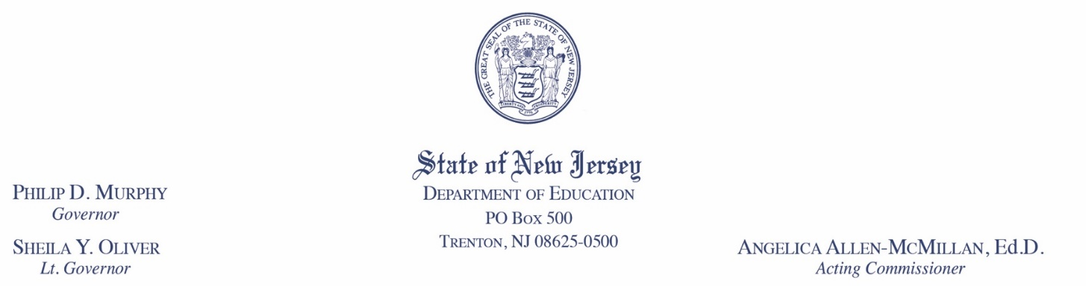

Reimbursements through the Emergency Assistance to Nonpublic Schools (EANS) Program

under the Coronavirus Response and Relief Supplemental Appropriations Act, 2021 (CRRSA Act)

Statement of Assurances for Nonpublic Schools

Assurances, Certification and Agreement
The New Jersey Department of Education (NJDOE) has a limited amount of unobligated funds remaining in the CRRSA EANS program, which may be available to nonpublic schools with approved CRRSA EANS applications. These funds may be used for reimbursement of allowable items that were purchased between March 13, 2020, and August 23, 2021. Nonpublic schools that apply for and meet the assurances presented in this document may be eligible for reimbursement.
Under Section 312(d)(7) of the CRRSA Act of 2021, title to materials, equipment, and property purchased with funds from the EANS Program shall be in a public agency. Accordingly, any equipment, materials, or supplies that are either procured by or on behalf of NJDOE, or for which a nonpublic school is reimbursed by NJDOE using EANS funds, shall become the property of NJDOE.

During the period of operation of the EANS programs, a nonpublic school that receives assets purchased or reimbursed using EANS funds agrees to act as a steward of NJDOE property. This means that the nonpublic school has a fiduciary responsibility to ensure that all assets are utilized only for intended and appropriate purposes and that all items are sufficiently safeguarded throughout the duration of the program. Failure to manage the assets in accordance with established requirements could result in a nonpublic school having to reimburse NJDOE for the items purchased using EANS funds.

A nonpublic school that receives reimbursement for equipment, materials, or supplies must attest prior to receipt of reimbursement for such items that it will comply with all applicable Federal and State requirements and any instructions provided by NJDOE for the management, use, storage, and tracking of any equipment, materials, or supplies for which EANS funding is utilized. The Assurances Letter (see below) must be read and signed by the chief school administrator or equivalent and submitted to EANSreimbursement@doe.nj.gov along with the other documentation required for reimbursement of such items. It is important that you follow the instructions below when submitting this assurances form to NJDOE; failure to follow these instructions may result in delays in approval and reimbursement, or denial of your request.
By signing these assurances, a nonpublic school is ensuring accountability and compliance with applicable laws, regulations, and requirements.

Instructions

- Signed copy of the assurances must be in PDF format. The PDF file must be saved according to these naming conventions: EANS_<SchoolCode>_Assurances.pdf
File name example: EANS_0027_Assurances.pdf

- Submit the signed copy to EANSreimbursement@doe.nj.gov along with the other documentation required for reimbursement.

Programmatic, Fiscal, and Reporting Assurances
As the authorized representative of the nonpublic school, and by signing this List of Assurances, I certify that:
- The nonpublic school has read the CRRSA EANS Reimbursement Program Inventory Management and Monitoring Process and agrees to the requirements therein.
- The nonpublic school did not apply for and receive a loan under the Small Business Administration’s Paycheck Protection Program (PPP) (15 U.S.C. 636(a)(37)) that was made on or after December 27, 2020.
- Funds will be used to address educational disruptions resulting from COVID-19 consistent with Section 312(d) of the Coronavirus Response and Relief Supplemental Appropriations Act, 2021 (CRRSA Act) and all other applicable requirements.
- None of the allowable expenses for which I am requesting reimbursement have already been supported by Federal or State funds.
- All services or assistance provided under the EANS program, including materials, equipment, and any other items will be secular, neutral, and non-ideological.
- The nonpublic school will comply with all reporting requirements at such time and in such manner and containing such information as required.
- A nonpublic school must provide title to materials, equipment, and property purchased/reimbursed with EANS funds to the NJDOE. All non-consumable goods must be labeled: “Property of the State of NJ and purchased with EANS funds SY 20XX.”

- Inventory records must be maintained that include a description of the item, a serial number or other identification number, the acquisition date, the cost, the location, and any ultimate disposition data including the date of disposal.

- A physical inventory of the property must be taken, and the results reconciled with the property records at least once every two years.
- A control system must be developed to ensure adequate safeguards to prevent loss, damage, or theft of the property. Any loss, damage, or theft shall be investigated by the school.
- The school will promptly notify NJDOE if any items reimbursed using EANS funds are lost, damaged, or stolen, using the appropriate disposition form.
- Adequate maintenance procedures must be developed to keep the property in good condition.
- The items for which I am seeking reimbursement are included in the following list of allowable items for reimbursement, were purchased between March 13, 2020, and August 23, 2021, and were purchased to address educational disruptions resulting from COVID-19.
- supplies to sanitize, disinfect, and clean school facilities;
- personal protective equipment (PPE);
- portable air purification systems to ensure healthy air in the nonpublic school;
- physical barriers to facilitate social distancing;
- other materials, supplies, or equipment to implement public health protocols, including guidelines and recommendations from the Centers for Disease Control and Prevention (CDC) for the reopening and operation of school facilities to effectively maintain the health and safety of students, educators, and other staff during the qualifying emergency;
- expanding capacity to administer coronavirus testing to effectively monitor and suppress coronavirus, to conduct surveillance and contact tracing activities, and to support other activities related to coronavirus testing for students, teachers, and staff at the nonpublic school;
- educational technology (including hardware, software, connectivity, assistive technology, and adaptive equipment) to assist students, educators, and other staff with remote or hybrid learning;
- leasing of sites or spaces to ensure safe social distancing to implement public health protocols, including guidelines and recommendations from the CDC; and
- reasonable transportation costs.

I certify to the best of my knowledge and belief, all the information in these assurances is true and correct. I further understand that knowingly making a false statement or misrepresentation on these assurances may subject me to criminal or civil penalties under applicable State and Federal laws. I further certify, to the best of my knowledge, that any ensuing program and activity will be conducted in accordance with all applicable Federal and State laws and regulations, guidelines, and instructions.

______________________________________________________ _________________
Nonpublic School Name Nonpublic School Code

_________________________________________________________
Signature of Chief School Administrator (Electronic signature is accepted)

______________________________________ _____________________________________________
Date Name of Chief School Administrator

See C.F.R. § 200.313 Equipment (a) through (d) and § 200.314 Supplies

