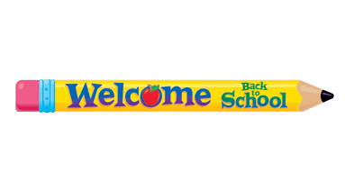

[Your School's Letterhead]

Date: [Insert Date]

Subject: School Attendance

Dear Families/Guardians,

As we begin the school year, I want to take a moment to emphasize a key aspect of our students' success: regular school attendance. We believe that consistent attendance is crucial for your child’s academic and personal growth, and I would like to share with you why this is so important.

## Academic Achievement:

Regular attendance is directly linked to academic success. Students who attend school consistently are more likely to excel academically because they are present for vital instruction, participate in classroom activities, and benefit from continuous learning.

## Routines and Responsibilities:

Consistent school attendance helps students develop important life skills such as punctuality, responsibility, and time management. These skills are valuable not only in their academic life but also in future careers and personal endeavors.

## Sense of Belonging:

Routine and structure provided by regular school attendance can positively impact students' emotional well-being. Being part of a classroom community and having a consistent daily schedule can help students feel secure and supported, which in turn enhances overall mental health and readiness to learn.

## Support for Family and School Partnership:

When students are present in school, it strengthens the partnership between families and educators. We can better support and monitor their progress, address any challenges students may face, and work together to ensure the educational experience is both positive and productive.

We understand that occasional absences due to illness or emergencies are inevitable, and we appreciate your cooperation in keeping us informed of such instances. However, we encourage you to prioritize regular school attendance and work with us to address any concerns that might impact your child's ability to attend consistently. Thank you for your attention to this important matter. If you have any questions or need assistance, please do not hesitate to contact us.

Warm regards,

[Your Full Name]

[Your Position] [School Name] [Contact Information]