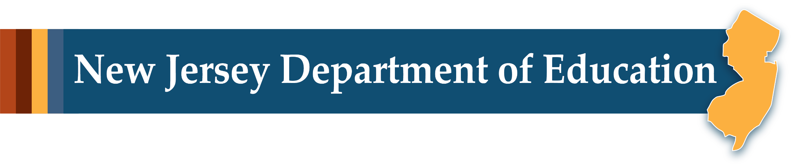

# Overview of the 2023 New Jersey Student Learning Standards for Mathematics

Office of Standards  
Division of Teaching and Learning



## Agenda

* Adoption and Implementation Timeline
* K–5 Structural Revision
* Summary of Revisions and Examples
* Next Steps

## Adoption and Implementation

* NJSLS-Mathematics (NJSLS-M) were adopted by the State Board of Education on October 4, 2023.
* Per SBOE Resolution, NJSLS-Mathematics will be implemented by LEAs in September 2024.
* LEAs will be supported through technical assistance and resources available through the Standards Transparency and Mastery Platform (STAMP).

## K–5 Structural Revision

| **2016 Domains** | **2023 Domains** |
| --- | --- |
| * Measurement and Data (MD) * Geometry (G) * Counting and Cardinality (CC) * Number and Operations in Base Ten (NBT) * Number and Operations – Fractions (NF) * Operations and Algebraic Thinking (OA) | * Measurement (M) * Data Literacy (DL) * Geometry (G) * Counting and Cardinality (CC) * Number and Operations in Base Ten (NBT) * Number and Operations – Fractions (NF) * Operations and Algebraic Thinking (OA) |

## Kindergarten to High School Domain Progression

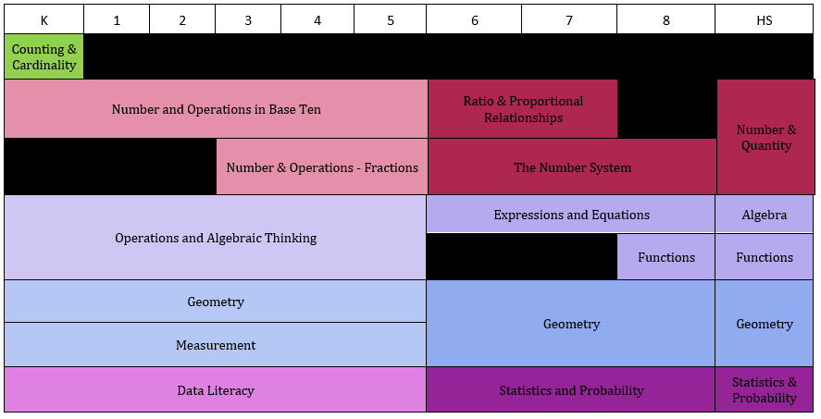

## Text Version: Kindergarten to High School Domain Progressions

Key:

* **A**: Algebra
* **CC**: Counting and Cardinality
* **DL** Data Literacy
* **F**: Functions
* **G**: Geometry
* **M**: Measurement
* **NBT**: Number and Operations in Base Ten
* **NF**: Number and Operations – Fractions
* **OA**: Operations and Algebraic Thinking
* **SP**: Statistics and Probability

| **K** | **1** | **2** | **3** | **4** | **5** | **6** | **7** | **8** | **HS** |
| --- | --- | --- | --- | --- | --- | --- | --- | --- | --- |
| CC | - | - | - | - | - | - | - | - | - |
| NBT | NBT | NBT | NBT | NBT | NBT | RP | RP | - | NQ |
| - | - | - | NF | NF | NF | NS | NS | NS | NQ |
| OA | OA | OA | OA | OA | OA | EE | EE | EE | A |
| OA | OA | OA | OA | OA | OA | - | - | F | F |
| G | G | G | G | G | G | G | G | G | G |
| M | M | M | M | M | M | G | G | G | G |
| DL | DL | DL | DL | DL | DL | SP | SP | SP | SP |

## Summary of Revisions

* K–5 Indicator Revisions
* Elementary Standards involving Money
* Data Literacy Standards (NEW)
* Fractions and Visual Fraction Models
* Perspectives on Accuracy and Efficiency
* Revised Progressions: Grade 8 to High School
* High School Plus Standards

## K–5 Indicator Revision

### Example 1

| **Type** | **2023 NJSLSM** | **2016 NJSLSM** |
| --- | --- | --- |
| Indicator | **K.M.A.1** Describe measurable attributes of objects, such as length or weight. Describe several measurable attributes of a single object. | K.MD.A.1 Describe measurable attributes of objects, such as length or weight. Describe several measurable attributes of a single object. |
| Indicator | **K.M.A.2** Directly compare two objects with a measurable attribute in common, to see which object has “more of”/“less of” the attribute, and describe the difference. For example, directly compare the heights of two children and describe one child as taller/shorter. | K.MD.A.2 Directly compare two objects with a measurable attribute in common, to see which object has “more of”/“less of” the attribute, and describe the difference. For example, directly compare the heights of two children and describe one child as taller/shorter. |

### Example 2

| **Type** | **2023 NJSLSM** | **2016 NJSLSM** |
| --- | --- | --- |
| Indicator | K.DL.A.1 Classify objects into given categories; count the numbers of objects in each category and sort the categories by count. (Clarification: Limit category counts to be less than or equal to 10) | K.MD.B.3 Classify objects into given categories; count the numbers of objects in each category and sort the categories by count. |
| Indicator | 1.DL.A.1 Organize, represent, and interpret data with up to three categories; ask and answer questions about the total number of data points, how many in each category, and how many more or less are in one category than in another. | 1.MD.C.4 Organize, represent, and interpret data with up to three categories; ask and answer questions about the total number of data points, how many in each category, and how many more or less are in one category than in another. |

## New Elementary Standards on Money

Expectations for understanding coins, dollars, and their respective values are proposed.

Examples of new standards addressing money are:

* K.M.B.3 Understand that certain objects are coins and dollars, and that coins and dollars represent money. Identify the values of all U.S. coins and the one-dollar bill.
* 1.M.C.4. Know the comparative values of coins and all dollars (e.g., a dime is of greater value than a nickel). Use appropriate notation (e.g., 69¢, $10).

## Content Emphases in Mathematics

To say that some things have greater emphasis is not to say that anything in the Standards can be neglected or omitted in instruction. Neglecting material will leave gaps in student skill and understanding and may leave students unprepared for the challenges of a later grade.

### Major, Supporting, and Additional Clusters for Grade 1

Emphases are given at the cluster level. Refer to the [New Jersey Student Learning Standards for Mathematics](https://www.nj.gov/education/standards/math/Index.shtml) for the specific standards that fall within each cluster.

Key: **M** — Major Clusters, **S** — Supporting Clusters, **A** — Additional Clusters

| **Indicator** | **Type** | **Cluster Heading** |
| --- | --- | --- |
| 1.OA.A | **M** | Represent and solve problems involving addition and subtraction |
| 1.OA.B | **M** | Understand and apply properties of operations and the relationship between addition and subtraction |
| 1.OA.C | **M** | Add and subtract within 20 |
| 1.OA.D | **M** | Work with addition and subtraction equations |
| 1.NBT.A | **M** | Extend the counting sequence |
| 1.NBT.B | **M** | Understand place value |
| 1.NBT.C | **M** | Use place value understanding and properties of operations to add and subtract |
| 1.M.A | **M** | Describe and compare measurable attributes. |
| 1.M.B | **A** | Tell and write time |
| 1.M.C | **S** | Work with money |
| 1.DL.A | **S** | Represent and interpret data |
| 1.G.A | **A** | Reason with shapes and their attributes |

## STAMP: Content Emphases

Webpage: [K–8 Mathematics Content Emphases: Where to Focus](https://www.nj.gov/education/standards/math/kto8contentemphases.shtml)

K–8 Content Emphases resources will be made available as part of the Standards Transparency and Mastery Platform.

## Money in Grade 2

* 2.M.C.8 Solve word problems involving dollar bills, quarters, dimes, nickels, and pennies, using $ and ¢ symbols appropriately. Example: If you have 2 dimes and 3 pennies, how many cents do you have?
* 2.OA.A.1. Use addition and subtraction within 100 to solve one- and two-step word problems involving situations of adding to, taking from, putting together, taking apart, and comparing, with unknowns in all positions, e.g., by using drawings and equations with a symbol for the unknown number to represent the problem.
* 2.NBT.B.2. Count within 1000; skip-count by 5s, 10s, and 100s.

## Money in Grade 3

3.OA.D.8 Solve two-step word problems, including problems involving money, using the four operations. Represent these problems using equations with a letter standing for the unknown quantity. Assess the reasonableness of answers using mental computation and estimation strategies including rounding. (Clarification: This standard is limited to problems posed with whole numbers and having whole number answers; students should know how to perform operations in the conventional order when there are no parentheses to specify a particular order) (Order of Operations)

## Money in Grade 4

4.M.A.2 Use the four operations to solve word problems involving distances, intervals of time, liquid volumes, masses of objects, and money, including problems involving simple fractions or decimals, and problems that require expressing measurements given in a larger unit in terms of a smaller unit. Represent measurement quantities using diagrams such as number line diagrams that feature a measurement scale.

## Measurement vs. Data Literacy

### Kindergarten

| Measurement | Data Literacy |
| --- | --- |
| * **K.M.A.1** Describe measurable attributes of objects, such as length or weight. Describe several measurable attributes of a single object. * **K.M.A.2** Directly compare two objects with a measurable attribute in common, to see which object has “more of”/“less of” the attribute, and describe the difference. For example, directly compare the heights of two children and describe one child as taller/shorter. | **K.DL.A.1** Classify objects into given categories; count the numbers of objects in each category and sort the categories by count. (Clarification: Limit category counts to be less than or equal to 10) |

### Grade 1

| Measurement | Data Literacy |
| --- | --- |
| * **1.M.A.1** Order three objects by length; compare the lengths of two objects indirectly by using a third object. * **1.M.A.2** Express the length of an object as a whole number of length units, by laying multiple copies of a shorter object (the length unit) end to end; understand that the length measurement of an object is the number of same-size length units that span it with no gaps or overlaps. Limit to contexts where the object being measured is spanned by a whole number of length units with no gaps or overlaps. | **1.DL.A.1** Organize, represent, and interpret data with up to three categories; ask and answer questions about the total number of data points, how many in each category, and how many more or less are in one category than in another. |

## New Grades 2–5 Data Literacy Standards

Data literacy: the ability to reason with and about data—including what data are and where data come from. This includes the ability to make good decisions based on data, to ask questions of data, and to use appropriate reasoning.

### Grades 2 and 3

Examples of new data literacy standards in grades 2 and 3 are:

* 2.DL.A.1 Understand that people collect data to answer questions. Understand that data can vary.
* 3.DL.A.1 Develop data-based questions and decide what data will answer the question. (e.g. “What size shoe does a 3rd grader wear?”, “How many books does a 3rd grader read?”)

### Grades 4 and 5

Examples of new data literacy standards in grades 4 and 5 are:

* 4.DL.A.1 Create data-based questions, generate ideas based on the questions, and then refine the questions.
* 5.DL.A.4 Using appropriate visualizations (i.e. double line plot, double bar graph), analyze data across samples.

New clarification to the new Data Literacy cluster in grades 4 and 5: Analysis of data and visualizations at these grades excludes ratio, rate, proportion and percentages. These concepts are introduced in Grade 6.

## Fractions Revisions—Grade 3

* 3.NF.A.1 Understand a fraction  as the quantity formed by 1 part when a whole is partitioned into *b* equal parts; understand a fraction  as the quantity formed by *a* parts of size. **For example: If a rectangle (i.e. the whole) is partitioned into 3 equal parts, each part is  . Two of those parts would be .**
* 3.NF.A.2a Represent a fraction  on a number line diagram by defining the interval from 0 to 1 as the whole and partitioning it into *b* equal parts. Recognize that each part has size and that the endpoint of the part based at 0 locates the number on the number line. **For example, partition the number line from 0 to 1 into 3 equal parts, represent  on the number line and show that each part has a size  .**

| **2023 NJSLSM** | **2016 NJSLSM** |
| --- | --- |
| 3.NF.A.3b Recognize and generate simple equivalent fractions by reasoning about their size, (e.g., , ). Explain why the fractions are equivalent with the support of a visual fraction model. | 3.NF.A.3b Recognize and generate simple equivalent fractions, (e.g., , ). Explain why the fractions are equivalent, e.g., by using a visual fraction model. |
| 3.NF.A.3d Compare two fractions with the same numerator or the same denominator by reasoning about their size. Recognize that comparisons are valid only when the two fractions refer to the same whole. Record the results of comparisons with the symbols >, =, or <, and justify the conclusions with the support of a visual fraction model | 3.NF.A.3d Compare two fractions with the same numerator or the same denominator by reasoning about their size. Recognize that comparisons are valid only when the two fractions refer to the same whole. Record the results of comparisons with the symbols >, =, or <, and justify the conclusions, e.g., by using a visual fraction model |

## Understanding Fraction Equivalence

### Set Models

**Clarification:** Set models, including those defined as the whole, are excluded at this grade.

4.NF.A.1 Explain why a fraction is equivalent to a fraction  by using visual fraction models, with attention to how the number and size of the parts differ even though the two fractions themselves are the same size. Use this principle to recognize and generate equivalent fractions.

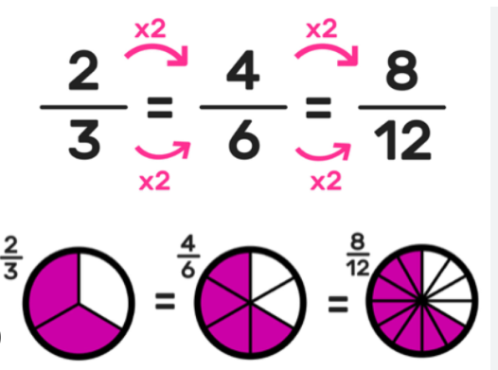 

### Visual Models

Visual fraction models include tape diagrams, number lines, and area models.

3.NF.A.3b Recognize and generate simple equivalent fractions by reasoning about their size, (e.g., , ). Explain why the fractions are equivalent with the support of a visual fraction model.

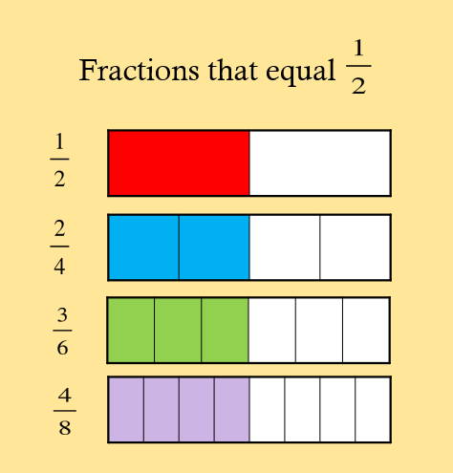 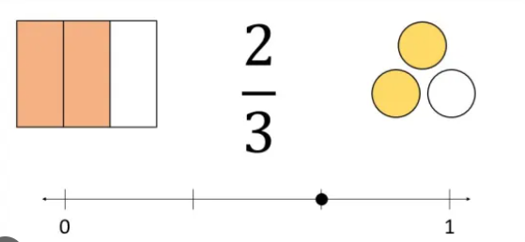

## Accuracy and Efficiency in the NJSLS-M

Accuracy and efficiency, as opposed to speed, are the most essential aspects of fluency.

| **Type** | **2023 NJSLSM** | **2016 NJSLSM** |
| --- | --- | --- |
| Text | K.OA.A.5 Demonstrate accuracy and efficiency for addition and subtraction within 5. | K.OA.A.5 Demonstrate fluency for addition and subtraction within 5. |
| Text | 5.NBT.B.5 With accuracy and efficiency, multiply multi-digit whole numbers using the standard algorithm. | 5.NBT.B.5 Fluently multiply multi-digit whole numbers using the standard algorithm |

## Accuracy and Efficiency Defined

Relevant definitions added to the glossary include:

1. **Accuracy**: The state or quality of being correct.
2. **Efficiency**: The ability to produce answers
   1. flexibly,
   2. easily and
   3. relatively quickly.

It describes methods of calculation that are economical in terms of simplicity of calculation steps, ease, and time.

### Other considerations

**Automaticity:** The ability to complete a task with little or no attention to process. (See second statement in 2.OA.B.2)

## Rational and Irrational Numbers - Grade 8

Foundational work with rational and irrational numbers culminates in grade 8.

| **2023 NJSLSM** | **2016 NJSLSM** |
| --- | --- |
| 8.NS.A.3 Understand that the sum or product of two rational numbers is rational; that the sum of a rational number and an irrational number is irrational; and that the product of a nonzero rational number and an irrational number is irrational. | N.RN.B.3 Understand that the sum or product of two rational numbers is rational; that the sum of a rational number and an irrational number is irrational; and that the product of a nonzero rational number and an irrational number is irrational. |

The middle grades progression on rational and irrational number includes the following cluster headings:

* 6.NS.C Apply and extend previous understandings of numbers to the system of rational numbers (Grade 6)
* 7.NS.A Apply and extend previous understandings of operations with fractions to add, subtract, multiply and divide rational numbers (Grade 7)
* 8.NS.A Know that there are numbers that are not rational, and approximate them by rational numbers (Grade 8)
* 8.NS.A.3 Understand that the sum or product of two rational numbers is rational; that the sum of a rational number and an irrational number is irrational; and that the product of a nonzero rational number and an **irrational** number is irrational.

## Radical Expressions

### Grade 8

Foundational work simplifying numerical radicals is proposed in grade 8.

| **2023 NJSLSM** | **2016 NJSLSM** |
| --- | --- |
| 8.EE.A.2 Use square root and cube root symbols to represent solutions to equations of the form and  where is a positive rational number.   1. Evaluate square roots of small perfect squares and cube roots of small perfect cubes. Know that  is irrational. 2. Simplify numerical radicals, limiting to square roots (i.e. nonperfect squares). For example, simplify  to . | 8.EE.A.2 Use square root and cube root symbols to represent solutions to equations of the form and  where is a positive rational number. Evaluate square roots of small perfect squares and cube roots of small perfect cubes. Know that  is irrational |

### High School

Foundational work simplifying radicals, including algebraic radicals, is explicitly included in high school.

| **2023 NJSLSM** | **2016 NJSLSM** |
| --- | --- |
| Simplify radicals, including algebraic radicals (e.g. , simplify). | n/a |

## Progression on Linear Systems

### Grade 8

| **2023 NJSLSM** | **2016 NJSLSM** |
| --- | --- |
| 8.EE.C.8b Solve systems of two linear equations in two variables using the **substitution method** and estimate solutions by graphing the equations. Solve simple cases by inspection. For example: by inspection, conclude that  and have no solution because  cannot simultaneously be 5 and 6. **Solve  and using the substitution method; Solve  and using the substitution method.** | 8.EE.C.8b Solve systems of two linear equations in two variables algebraically, and estimate solutions by graphing the equations. Solve simple cases by inspection. For example:  and  have no solution because  cannot simultaneously be 5 and 6. |

### High School

| **2023 NJSLSM** | **2016 NJSLSM** |
| --- | --- |
| A.REI.C.6 Solve systems of linear equations algebraically **(include using the elimination method) and graphically**, focusing on pairs of linear equations in two variables. | A.REI.C.6 Solve systems of linear equations exactly and approximately (e.g., with graphs), focusing on pairs of linear equations in two variables. |

## Plus Standards

### Revision and Expansion

Select high school standards have been designated as plus () standards since 2010, which specify the knowledge and skills necessary to take advanced courses.

Designating additional standards as plus standards allows for a more robust treatment of trigonometry and statistics in Precalculus, Statistics, Data Science or other advanced mathematics courses.

### High School Statistics

Select Statistics standards were assigned the plus designation.

| **2023 NJSLSM** | **2016 NJSLSM** |
| --- | --- |
| S.IC.A.1 (plus standard) Understand statistics as a process for making inferences about population parameters based on a random sample from that population | S.IC.A.1 Understand statistics as a process for making inferences about population parameters based on a random sample from that population. |
| S.CP.A.1 (plus standard) Describe events as subsets of a sample space (the set of outcomes) using characteristics (or categories) of the outcomes, or as unions, intersections, or complements of other events (“or,” “and,” “not”). | S.CP.A.1 Describe events as subsets of a sample space (the set of outcomes) using characteristics (or categories) of the outcomes, or as unions, intersections, or complements of other events (“or,” “and,” “not”). |

## High School Revisions

### Statistics

Standard S.IC.B.6 now includes an example to indicate skills students may use in meeting the expectation.

| **2023 NJSLSM** | **2016 NJSLSM** |
| --- | --- |
| S.IC.B.6 (plus standard) Evaluate reports based on data (e.g., interrogate study design, data sources, randomization, the way the data are analyzed and displayed, inferences drawn and methods used; identify and explain misleading uses of data; recognize when arguments based on data are flawed). | S.IC.B.6 Evaluate reports based on data |

### Geometry

Select standards from the Geometry Conceptual Category were assigned the plus designation.

| **2023 NJSLSM** | **2016 NJSLSM** |
| --- | --- |
| G.GPE.A.1 (plus standard) Derive the equation of a circle of given center and radius using the Pythagorean Theorem; complete the square to find the center and radius of a circle given by an equation. | G.GPE.A.1 Derive the equation of a circle of given center and radius using the Pythagorean Theorem; complete the square to find the center and radius of a circle given by an equation. |
| G.GPE.A.2 (plus standard) Derive the equation of a parabola given a focus and directrix. | G.GPE.A.2 Derive the equation of a parabola given a focus and directrix. |

### Algebra

Select standards from the Algebra Conceptual Category were assigned the plus designation.

| **2023 NJSLSM** | **2016 NJSLSM** |
| --- | --- |
| A.REI.C.5 (plus standard) Prove that, given a system of two equations in two variables, replacing one equation by the sum of that equation and a multiple of the other produces a system with the same solutions. | A.REI.C.5 Prove that, given a system of two equations in two variables, replacing one equation by the sum of that equation and a multiple of the other produces a system with the same solutions. |
| A.SSE.B.4 (plus standard) Derive and/or explain the formula for the sum of a finite geometric series (when the common ratio is not 1), and use the formula to solve problems. For example, calculate mortgage payments. | A.SSE.B.4 Derive and/or explain the formula for the sum of a finite geometric series (when the common ratio is not 1), and use the formula to solve problems. For example, calculate mortgage payments. |

### Functions

Select standards from the Functions Conceptual Category were assigned the plus designation.

| **2023 NJSLSM** | **2016 NJSLSM** |
| --- | --- |
| F.TF.A.1 (plus standard) Understand radian measure of an angle as the length of the arc on the unit circle subtended by the angle. | F.TF.A.1 Understand radian measure of an angle as the length of the arc on the unit circle subtended by the angle. |
| F.IF.C.7e Graph exponential and logarithmic functions, showing intercepts and end behavior.  F.IF.C.7f (plus standard) Graph trigonometric functions, showing period, midline, and amplitude. | F.IF.C.7e Graph exponential and logarithmic functions, showing intercepts and end behavior, and trigonometric functions, showing period, midline, and amplitude. |

## Implications of Plus Standards Expansion

High School course redesign (guidance forthcoming!)

* Algebra 1
* Geometry
* Algebra 2
* Advanced Courses

Designating additional standards as plus standards allows for a more robust treatment of trigonometry and statistics in Precalculus, Statistics, Data Science, or other advanced mathematics courses.

## Climate Change in NJSLS-M

Standards accompanied by this icon () represent opportunities to integrate age-appropriate climate change education.

Additional materials designed to support educators in creating interdisciplinary units focused on authentic learning experiences integrating a range of perspectives will be developed.

## Follow Us on Social Media!

* Facebook: @njdeptofed
* Instagram: @newjerseydoe
* LinkedIn: New Jersey Department of Education
* Threads: @NewJerseyDOE
* X: @NewJerseyDOE
* YouTube: @newjerseydepartmentofeduca6565