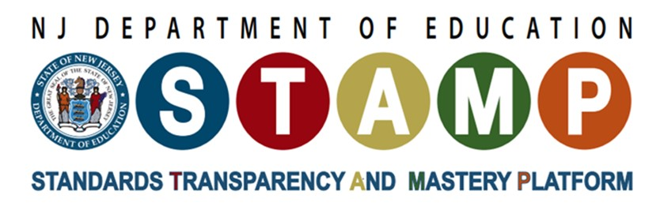

Framework for Grades Six through Eight Engineering, Technology, and Applications of Science
Table of Contents
Introduction 1
Assessment Resources 2
Model Curriculum Framework for Middle School Science 2
Model Scope and Sequence 3
Coherence with English Language Arts 4
Coherence with Mathematics 4
Professional Learning Resources 5
Attributions 5
ETS1: Engineering Design 6

Introduction
The purpose of this Framework is to ensure that New Jersey’s teachers can implement the New Jersey Student Learning Standards for Science (NJSLS-S) with clarity, consistency, and effectiveness. It is designed to support science educators in developing a comprehensive and accurate understanding of the performance expectations.
The performance expectations in ETS1: Engineering, Technology, and Applications of Science help students formulate an answer to the questions, “What is a design for? What are the criteria and constraints of a successful solution?.”
ETS1.A: Defining Engineering Problems with “precision” involves thinking more deeply than is expected in elementary school about the needs a problem is intended to address, or the goals a design is intended to reach. How will the end user decide whether the design is successful? Also, at this level students are expected to consider not only the end user, but also the broader society and the environment. Every technological change is likely to have both intended and unintended effects. It is up to the designer to try to anticipate the effects it may have and to behave responsibly in developing a new or improved technology. These considerations may take the form of either criteria or constraints on possible solutions.
ETS1.B: Developing Possible Solutions does not explicitly address generating design ideas since students were expected to develop the capability in elementary school. The focus in middle school is on a two stage process of evaluating the different ideas that have been proposed: by using a systematic method, such as a tradeoff matrix, to determine which solutions are most promising, and by testing different solutions, and then combining the best ideas into new solution that may be better than any of the preliminary ideas.
ETS1.B: Developing Possible Solutions at the middle school level involves an iterative process in which students test the best design, analyze the results, modify the design accordingly, and then re-test and modify the design again. Students may go through this cycle two, three, or more times in order to reach the optimal (best possible) result.
Connections with other science disciplines help students develop these capabilities in various contexts. For example, in the life sciences, students apply their engineering design capabilities to evaluate plans for maintaining biodiversity and ecosystem services (MS-LS2-5). In the physical sciences, students define and solve problems involving a number of core ideas in physical science, including chemical processes that release or absorb energy (MS-PS1-6), Newton’s third law of motion (MS-PS2-1), and energy transfer (MS-PS3-3). In the Earth and space sciences, students apply their engineering design capabilities to problems related to the impacts of humans on Earth systems (MS-ESS3-3).
By the end of 8th grade, students are expected to achieve all four performance expectations (MS-ETS1-1, MS-ETS1-2, MS-ETS1-3, and MS-ETS1-4) related to a single problem in order to understand the interrelated processes of engineering design. These include defining a problem by precisely specifying criteria and constraints for solutions as well as potential impacts on society and the natural environment, systematically evaluating alternative solutions, analyzing data from tests of different solutions and combining the best ideas into an improved solution, and developing a model and iteratively testing and improving it to reach an optimal solution. While the performance expectations shown in Middle School Engineering Design couple particular practices with specific disciplinary core ideas, instructional decisions should include use of many practices that lead to the performance expectations.

Assessment Resources
Next Generation Science Assessment Task Portal: The tasks are intended to be used to support teaching and learning in classrooms that are striving for NGSS-aligned instruction. They include tasks that are ideal for checking in on student learning at various time points during instruction; some are designed for a mid-point check-in, whereas others are better suited for early formative assessment, and still others encompass more aspects of a performance expectation and thus are a better fit for near the end of instruction.

Model Curriculum Framework for Middle School Science
The model science curriculum framework for middle school is organized around units that each target a bundle of performance expectations. We developed the units so that students’ learning is driven by their questions about intriguing phenomena, rather than grouping ideas by science topic that might be logical to someone who is already an expert in the field.
Unit 6.5: “Where do natural hazards happen, and how do we prepare for them?” includes MS-ETS1-1* and MS-ETS1-2*
Unit 7.2: “How can we use chemical reactions to design a solution to a problem?” includes MS-ETS1-2, MS-ETS1-3* and MS-ETS1-4*
Unit 7.5: “How does changing an ecosystem affect what lives there?” includes MS-ETS1-1*
Unit 7.6 “How do changes in the Earth's system impact our communities, and what can we do about it?” includes MS-ETS1-2*
Unit 8.1: “Why do things sometimes get damaged when they hit each other?” incudes MS-ETS1-2 and MS-ETS1-3
Key: *PE builds across multiple units
The model curriculum framework is sequenced to enable units to build on what students have developed in prior units while supporting the development of the three dimensions of NGSS, Disciplinary Core Ideas (DCIs), Crosscutting Concepts (CCCs), and Science and Engineering Practices (SEPs) coherently across the program. This coherence allows for presenting the concepts in a way that makes sense to students. Materials were designed to motivate student learning and help students see science as more connected to their lives. The tables below show the DCI bundling and the progression summary for the SEPs and CCCs across the units.
Before implementing these instructional materials in your classroom, educators are strongly encouraged to attend professional learning to ensure effective and informed usage. The Liberty Science Center is a certified provider of this professional learning and offers sessions designed to support educators in understanding and applying the material with confidence and fidelity.
For more information on scheduling or registering for professional learning opportunities, please visit Liberty Science Center Professional Development.

Model Scope and Sequence
The Model Scope and Sequence organizes middle school science into units that build on what students have learned before and connect ideas across grades. Each unit bundles performance expectations and develops the three dimensions of the NJSLS-S Disciplinary Core Ideas (DCIs), Crosscutting Concepts (CCCs), and Science and Engineering Practices (SEPs) in a way that feels logical and meaningful to students. See Figure 1 on page 4.
The scope and sequence focuses on two key goals: scaffolding learning so students deepen their understanding step by step, and creating coherence from the student’s perspective, meaning students see how what they’re learning now connects to what they already know. This approach, based on the Framework for K–12 Science Education (NRC, 2012), helps students view science as a tool for making sense of the world. Instead of treating topics as isolated, we help students link ideas from earlier units to new phenomena and problems.
While most units contain PEs from multiple science disciplines Life Science (LS), Physical Science (PS), or Earth and Space Science (ESS), the color shading of the unit indicates which strand is the emphasis. In addition, engineering PEs are integrated across all science disciplines. These are not indicated with colors but are listed using the PE code ETS (Engineering, Technology, and Applications of Science). The arrows show DCI connections between units, indicating that the later unit builds directly on what students figure out about the DCIs in the prior unit. The small dots at the top right of each unit also show connections, indicating the science strands the unit builds upon. For example, Unit 7.3 is shaded to represent that the unit emphasizes Life Science DCIs, and the dots on its top right indicate that this unit builds on both Life Science and Physical Science ideas from earlier units (6.6., 7.1, 7.2).
Figure 1: Disciplinary Core Idea Bundling and Connections
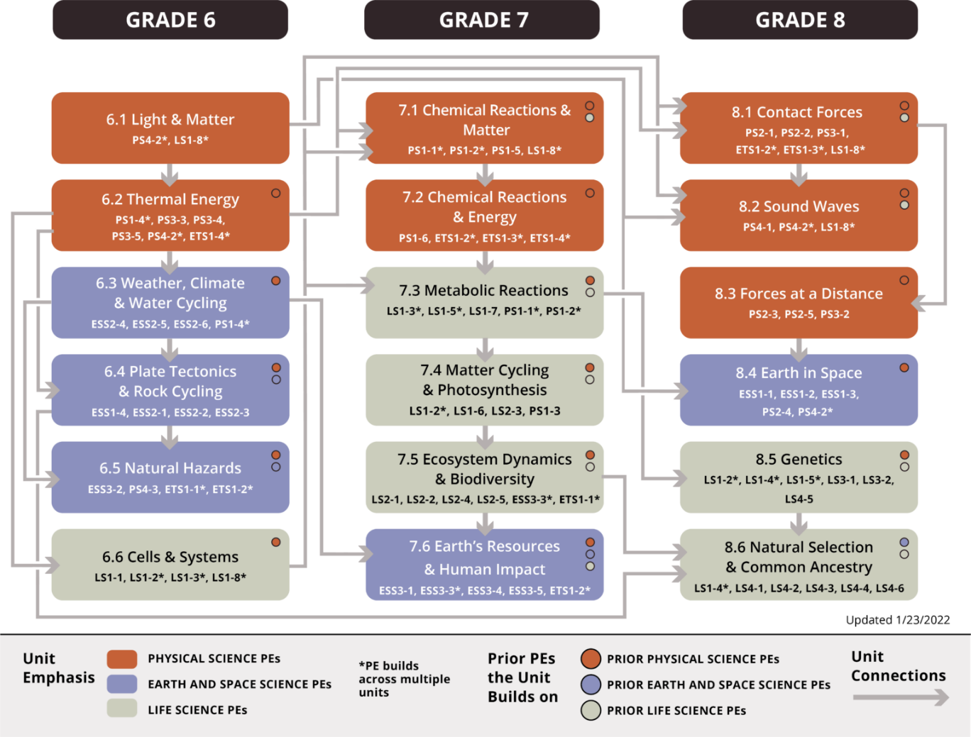
Accessible Version of Figure 1: Grades 6 - 8 Unit Map

Coherence with English Language Arts
Literacy skills are essential to how students build and deepen their understanding of science. Integrating English Language Arts (ELA) into science instruction allows students to use reading, writing, speaking, and listening to engage in the core practices of scientists and engineers—“actively trying to figure out how the world works or how to design solutions to problems” (NSTA, 2025). As middle school learners continue to develop their ability to comprehend and communicate through text, they become increasingly capable of reading about phenomena, writing explanations, recording observations, and participating in meaningful scientific discussions.
This Framework identifies the Grade 6 NJSLS - ELA skills that directly support the science and engineering practices. These literacy skills extend beyond the ELA classroom and can be used across content areas to enhance science learning and strengthen students’ disciplinary literacy (NASEM, 2023). References to Connections with English Language Arts throughout this document focus specifically on Grade 6 standards; Grade 7 and 8 teachers should refer to the 2023 NJSLS‑ELA for the skills aligned to their respective grade levels.

Coherence with Mathematics
Science is a quantitative discipline, which means it is important for educators to ensure that students’ learning in science coheres well with their learning in mathematics. Beginning in middle school, students develop a number of powerful quantitative tools, from rates and proportional relationships to basic algebra and functions, to basic statistics and probability. Their applicability extends far beyond the mathematics classroom. These tools can also become better understood, and more securely mastered, by applying them in a variety of contexts. The NRC Framework makes clear in its Science and Engineering Practices (Analyzing and Interpreting Data, Using Mathematics and Computational Thinking) that statistics and mathematics have a prominent role in science. NJSLS -S also aim to give middle school and high school science educators a clear road map for how they can prepare their students for the quantitative demands of college and careers, where students need to apply quantitative tools in an applied or scientific context. Grade 7 and 8 teachers should refer to the 2023 NJSLS‑M for the skills aligned to their respective grade levels.

Professional Learning Resources
- National Academies of Sciences, Engineering, and Medicine. 2019. Science and Engineering for Grades 6-12: Investigation and Design at the Center. Washington, DC: The National Academies Press. DOI: https://doi.org/10.17226/25216
  - Interactive Infographic: Teacher Guidance During Science Investigation and Engineering Design
  - Interactive Infographic: How Students Engage with Science Investigation and Engineering Design
- STEM Teaching Tools Website: Each tool is focused on a specific issue and leverages the best knowledge from research and practice. STEM Teaching Tools have also been used to support extended professional learning sessions. Open educational resource (OER) versions of professional learning sessions include slides, speaker notes, facilitator guide, and embedded resources.
- NextGenScience works alongside educators to support the design of quality, coherent K–12 programs that align science standards, instructional materials, professional learning, and assessments to support meaningful science experiences for all students.

Attributions
The performance expectations referenced are based on the Next Generation Science Standards: For States, By States. (NGSS), developed by the National Research Council, the National Science Teachers Association, the American Association for the Advancement of Science, and Achieve. © 2013 Achieve, Inc. on behalf of the 26 states and partners that collaborated on the NGSS. Available at https://nap.nationalacademies.org/catalog/18290/next-generation-science-standards-for-states-by-states
The science and engineering practices, disciplinary core ideas, and crosscutting concepts referenced are based on the Framework for K–12 Science Education: Practices, Crosscutting Concepts, and Core Ideas, developed by the National Research Council. © 2012 National Academy of Sciences. Published by the National Academies Press. Available at: https://nap.nationalacademies.org/catalog/13165/a-framework-for-k-12-science-education-practices-crosscutting-concepts
Examples referencing mathematics connections are adapted from Appendix L: Connections to the Common Core State Standards for Mathematics, originally published by Achieve, Inc. as part of the Next Generation Science Standards (NGSS).
© 2013 Achieve, Inc. Used with permission. Available at www.nextgenscience.org.
The Model Science Curriculum Framework and the Model Scope and Sequence are adapted from OpenSciEd Middle School Curriculum originally developed by The OpenSciEd Project of the National Center for Civic Innovation. © 2023 National Center for Civic Innovation Licensed under the Creative Commons Attribution Non-Commercial 4.0 International License (CC-BY-NC). Available at www.openscied.org.

ETS1: Engineering Design
MS-ETS1-1. Define the criteria and constraints of a design problem with sufficient precision to ensure a successful solution, taking into account relevant scientific principles and potential impacts on people and the natural environment that may limit possible solutions.
Dimension | Descriptions of the Developmentally Appropriate Elements
Science and Engineering Practices | Asking Questions and Defining Problems  - Asking questions and defining problems includes specifying relationships between variables and clarifying arguments and models.  - Define a design problem that can be solved through the development of an object, tool, process, or system and includes multiple criteria and constraints, including scientific knowledge that may limit possible solutions.
Disciplinary Core Ideas | ETS1.A: Defining and Delimiting Engineering Problems  The more precisely a design task’s criteria and constraints can be defined, the more likely it is that the designed solution will be successful. Specification of constraints includes consideration of scientific principles and other relevant knowledge that are likely to limit possible solutions (e.g., familiarity with the local climate may rule out certain plants for the school garden).
Crosscutting Concepts | Influence of Science, Engineering, and Technology on Society and the Natural World  All human activity draws on natural resources and has both short- and long-term consequences, positive as well as negative, for the health of both people and the natural environment. The uses of technologies and any limitations on their use are driven by individual or societal needs, desires, and values; by the findings of scientific research; and by differences in such factors as climate, natural resources, and economic conditions. Thus, technology use varies from region to region and over time. Technologies that are beneficial for a certain purpose may later be seen to have impacts (e.g., health-related, environmental) that were not foreseen. In such cases, new regulations on use or new technologies (to mitigate the impacts or eliminate them) may be required.
Connections to other DCIs in Grades 6-8:
Connections to MS-ETS1.A: Defining and Delimiting Engineering Problems include:
Physical Science: MS-PS3-3
Articulation of DCIs across grade-levels: 3-5.ETS1.A, 3-5.ETS1.C, HS.ETS1.A, HS.ETS1.B

Connections to English Language Arts:
RI.CR.6.1. Cite textual evidence and make relevant connections to support analysis of what an informational text says explicitly as well as inferences drawn from the text.
RI.CR.7.1. Cite several pieces of textual evidence and make relevant connections to support analysis of what an informational text says explicitly as well as inferences drawn from the text.
W.SE.6.6. Gather relevant information from multiple print and digital sources; assess the credibility of each source; and quote or paraphrase the data and conclusions of others while avoiding plagiarism and providing basic bibliographic information for sources.
W.SE.7.6. Gather relevant information from multiple print and digital sources, using search terms effectively; assess the credibility and accuracy of each source; and quote or paraphrase the data and conclusions of others while avoiding plagiarism and following a standard format for citation.
Connections to Mathematics:
MP.2. Reason abstractly and quantitatively.
6.EE.C.9. Use variables to represent two quantities in a real-world problem that change in relationship to one another; write an equation to express one quantity, thought of as the dependent variable, in terms of the other quantity, thought of as the independent variable. Analyze the relationship between the dependent and independent variables using graphs and tables, and relate these to the equation.
7.EE.B.3. Solve multi-step real-life and mathematical problems posed with positive and negative rational numbers in any form (whole numbers, fractions, and decimals), using tools strategically. Apply properties of operations to calculate with numbers in any form; convert between forms as appropriate; and assess the reasonableness of answers using mental computation and estimation strategies.
Rubric:
- Identifying the problem to be solved
- Students describe a problem that can be solved through the development of an object, tool, process, or system.
- Defining the process or system boundaries and the components of the process or system
- Students identify the system in which the problem is embedded, including the major components and relationships in the system and its boundaries, to clarify what is and is not part of the problem. In their definition of the system, students include:
- Which individuals or groups need this problem to be solved.
- The needs that must be met by solving the problem.
- Scientific issues that are relevant to the problem.
- Potential societal and environmental impacts of solutions.
- The relative importance of the various issues and components of the process or system.
- Defining criteria and constraints
- Students define criteria that must be taken into account in the solution that:
- Meet the needs of the individuals or groups who may be affected by the problem (including defining who will be the target of the solution).
- Enable comparisons among different solutions, including quantitative considerations when appropriate.
- Students define constraints that must be taken into account in the solution, including:
- Time, materials, and costs.
- Scientific or other issues that are relevant to the problem.
- Needs and desires of the individuals or groups involved that may limit acceptable solutions.
- Safety considerations.
- Potential effect(s) on other individuals or groups.
- Potential negative environmental effects of possible solutions or failure to solve the problem.

MS-ETS1-2. Evaluate competing design solutions using a systematic process to determine how well they meet the criteria and constraints of the problem.
Dimension | Descriptions of the Developmentally Appropriate Elements
Science and Engineering Practices | Engaging in Argument from Evidence  - Engaging in argument from evidence includes constructing a convincing argument that supports or refutes claims for either explanations or solutions about the natural and designed worlds.  - Evaluate competing design solutions based on jointly developed and agreed-upon design criteria.
Disciplinary Core Ideas | ETS1.B: Developing Possible Solutions  A solution needs to be tested and then modified on the basis of the test results, in order to improve it. There are systematic processes for evaluating solutions with respect to how well they meet the criteria and constraints of a problem. Sometimes parts of different solutions can be combined to create a solution that is better than any of its predecessors. In any case, it is important to be able to communicate and explain solutions to others.
Crosscutting Concepts | Intentionally left blank
Connections to other DCIs in Grades 6-9:
Connections to MS-ETS1.B: Developing Possible Solutions Problems include:
Physical Science: MS-PS1-6, MS-PS3-3
Life Science: MS-LS2-5
Articulation of DCIs across grade-levels: 3-5.ETS1.A, 3-5.ETS1.B, 3-5.ETS1.C, HS.ETS1.A, HS.ETS1.B
Connections to English Language Arts:
W.SE.6.6. Gather relevant information from multiple print and digital sources; assess the credibility of each source; and quote or paraphrase the data and conclusions of others while avoiding plagiarism and providing basic bibliographic information for sources.
W.SE.7.6. Gather relevant information from multiple print and digital sources, using search terms effectively; assess the credibility and accuracy of each source; and quote or paraphrase the data and conclusions of others while avoiding plagiarism and following a standard format for citation
RI.CT.6.8. Compare and contrast informational texts in different forms, by different authors, or from different genres (e.g., a memoir written by and a biography on the same person, historical novels and primary source documents, infographics and scientific journals) in terms of their approaches to similar themes and topics.
RI.CT.7.8. Analyze and reflect on (e.g., practical knowledge, historical/cultural context, and background knowledge) how two or more authors writing informational texts about the same topic shape their presentations of key information by emphasizing different evidence or advancing different interpretations of facts
Connections to Mathematics:
6.EE.C.9. Use variables to represent two quantities in a real-world problem that change in relationship to one another; write an equation to express one quantity, thought of as the dependent variable, in terms of the other quantity, thought of as the independent variable. Analyze the relationship between the dependent and independent variables using graphs and tables, and relate these to the equation.
7.EE.B.3 Solve multi-step real-life and mathematical problems posed with positive and negative rational numbers in any form (whole numbers, fractions, and decimals), using tools strategically. Apply properties of operations to calculate with numbers in any form; convert between forms as appropriate; and assess the reasonableness of answers using mental computation and estimation strategies.
Rubric:
- Identifying the given design solution and associated claims and evidence
- Students identify the given supported design solution.
- Students identify scientific knowledge related to the problem and each proposed solution.
- Students identify how each solution would solve the problem.
- Identifying additional evidence
- Students identify and describe* additional evidence necessary for their evaluation, including:
- Knowledge of how similar problems have been solved in the past.
- Evidence of possible societal and environmental impacts of each proposed solution.
- Students collaboratively define and describe* criteria and constraints for the evaluation of the design solution.
- Evaluating and critiquing evidence
- Students use a systematic method (e.g., a decision matrix) to identify the strengths and weaknesses of each solution. In their evaluation, students:
- Evaluate each solution against each criterion and constraint.
- Compare solutions based on the results of their performance against the defined criteria and constraints.
- Students use the evidence and reasoning to make a claim about the relative effectiveness of each proposed solution based on the strengths and weaknesses of each.

MS-ETS1-3. Analyze data from tests to determine similarities and differences among several design solutions to identify the best characteristics of each that can be combined into a new solution to better meet the criteria for success.
Dimension | Descriptions of the Developmentally Appropriate Elements
Science and Engineering Practices | Analyzing and Interpreting Data  - Analyzing data includes quantitative analysis to investigations, distinguishing between correlation and causation, and basic statistical techniques of data and error analysis.  - Analyze and interpret data to determine similarities and differences in findings.
Disciplinary Core Ideas | ETS1.B: Developing Possible Solutions  A solution needs to be tested and then modified on the basis of the test results, in order to improve it. There are systematic processes for evaluating solutions with respect to how well they meet the criteria and constraints of a problem. Sometimes parts of different solutions can be combined to create a solution that is better than any of its predecessors. In any case, it is important to be able to communicate and explain solutions to others.  ETS1.C: Optimizing the Design Solution  There are systematic processes for evaluating solutions with respect to how well they meet the criteria and constraints of a problem. Comparing different designs could involve running them through the same kinds of tests and systematically recording the results to determine which design performs best. Although one design may not perform the best across all tests, identifying the characteristics of the design that performed the best in each test can provide useful information for the redesign process—that is, some of those characteristics may be incorporated into the new design. This iterative process of testing the most promising solutions and modifying what is proposed on the basis of the test results leads to greater refinement and ultimately to an optimal solution. Once such a suitable solution is determined, it is important to describe that solution, explain how it was developed, and describe the features that make it successful.
Crosscutting Concepts | Intentionally left blank
Connections to other DCIs in Grades 6-8:
Connections to MS-ETS1.B: Developing Possible Solutions Problems include:
Physical Science: MS-PS1-6, MS-PS3-3
Life Science: MS-LS2-5
Connections to MS-ETS1.C: Optimizing the Design Solution include:
Physical Science: MS-PS1-6
Connections to English Language Arts:
RI.CR.6.1. Cite textual evidence and make relevant connections to support analysis of what an informational text says explicitly as well as inferences drawn from the text.
RI.CR.7.1. Cite several pieces of textual evidence and make relevant connections to support analysis of what an informational text says explicitly as well as inferences drawn from the text.
W.WR.6.5. Conduct short research projects to answer a question, drawing on several sources and refocusing the inquiry when appropriate.
W.WR.7.5. Conduct short research projects to answer a question, drawing on several sources and generating additional related, focused questions for further research and investigation.
Connections to Mathematics:
6.EE.C.9. Use variables to represent two quantities in a real-world problem that change in relationship to one another; write an equation to express one quantity, thought of as the dependent variable, in terms of the other quantity, thought of as the independent variable. Analyze the relationship between the dependent and independent variables using graphs and tables, and relate these to the equation.
7.EE.B.3. Solve multi-step real-life and mathematical problems posed with positive and negative rational numbers in any form (whole numbers, fractions, and decimals), using tools strategically. Apply properties of operations to calculate with numbers in any form; convert between forms as appropriate; and assess the reasonableness of answers using mental computation and estimation strategies.
Articulation of DCIs across grade-levels: 3-5.ETS1.A, 3-5.ETS1.C, HS.ETS1.C
Rubric:
- Organizing data
- Students organize given data (e.g., via tables, charts, graphs) from tests intended to determine the effectiveness of three or more alternative solutions to a problem.
- Identifying relationships
- Students use appropriate analysis techniques (e.g., qualitative or quantitative analysis; basic statistical techniques of data and error analysis) to analyze the data and identify relationships within the datasets, including relationships between the design solutions and the given criteria and constraints.
- Interpreting data
- Students use the analyzed data to identify evidence of similarities and differences in features of the solutions.
- Based on the analyzed data, students make a claim for which characteristics of each design best meet the given criteria and constraints.
- Students use the analyzed data to identify the best features in each design that can be compiled into a new (improved) redesigned solution.

MS-ETS1-4. Develop a model to generate data for iterative testing and modification of a proposed object, tool, or process such that an optimal design can be achieved.
Dimension | Descriptions of the Developmentally Appropriate Elements
Science and Engineering Practices | Developing and Using Models  - Modeling includes developing, using, and revising models to describe, test, and predict more abstract phenomena and design systems.  - Develop a model to generate data to test ideas about designed systems, including those representing inputs and outputs.
Disciplinary Core Ideas | ETS1.B: Developing Possible Solutions  A solution needs to be tested and then modified on the basis of the test results, in order to improve it. There are systematic processes for evaluating solutions with respect to how well they meet the criteria and constraints of a problem. Sometimes parts of different solutions can be combined to create a solution that is better than any of its predecessors. In any case, it is important to be able to communicate and explain solutions to others.  Models of all kinds are important for testing solutions, and computers are a valuable tool for simulating systems. Simulations are useful for predicting what would happen if various parameters of the model were changed, as well as for making improvements to the model based on peer and leader (e.g., teacher) feedback.  ETS1.C: Optimizing the Design Solution  There are systematic processes for evaluating solutions with respect to how well they meet the criteria and constraints of a problem. Comparing different designs could involve running them through the same kinds of tests and systematically recording the results to determine which design performs best. Although one design may not perform the best across all tests, identifying the characteristics of the design that performed the best in each test can provide useful information for the redesign process—that is, some of those characteristics may be incorporated into the new design. This iterative process of testing the most promising solutions and modifying what is proposed on the basis of the test results leads to greater refinement and ultimately to an optimal solution. Once such a suitable solution is determined, it is important to describe that solution, explain how it was developed, and describe the features that make it successful.
Crosscutting Concepts | Intentionally left blank
Connections to other DCIs in Grades 6-8:
Connections to MS-ETS1.B: Developing Possible Solutions Problems include:
Physical Science: MS-PS1-6, MS-PS3-3
Life Science: MS-LS2-5
Connections to MS-ETS1.C: Optimizing the Design Solution include:
Physical Science: MS-PS1-6
Articulation of DCIs across grade levels: https://nap.nationalacademies.org/read/13165/chapter/93-5.ETS1.B, 3-5.ETS1.C, HS.ETS1.B, HS.ETS1.C
Connections to English Language Arts:
SL.UM.6.5. Include multimedia components (e.g., graphics, images, music, sound) and visual displays in presentations to clarify information.
SL.UM.7.5. Include multimedia components and visual displays in presentations to clarify claims and findings and emphasize salient points.
Connections to Mathematics:
6.SP.A.2. Understand that a set of data collected to answer a statistical question has a distribution which can be described by its center, spread, and overall shape.
6.SP.A.3. Recognize that a measure of center for a numerical data set summarizes all of its values with a single number, while a measure of variation describes how its values vary with a single number.
7.SP.C.7. Develop a probability model and use it to find probabilities of events. Compare probabilities from a model to observed frequencies; if the agreement is not good, explain possible sources of the discrepancy.
a. Develop a uniform probability model by assigning equal probability to all outcomes and use the model to determine probabilities of events.
b. Develop a probability model (which may not be uniform) by observing frequencies in data generated from a chance process.
Rubric:
- Components of the model
- Students develop a model in which they identify the components relevant to testing ideas about the designed system, including:
- The given problem being solved, including criteria and constraints.
- The components of the given proposed solution (e.g., object, tools, or process), including inputs and outputs of the designed system.
- Relationships
- Students identify and describe* the relationships between components, including:
- The relationships between each component of the proposed solution and the functionality of the solution.
- The relationship between the problem being solved and the proposed solution.
- The relationship between each of the components of the given proposed solution and the problem being solved.
- The relationship between the data generated by the model and the functioning of the proposed solution.
- Connections
- Students use the model to generate data representing the functioning of the given proposed solution and each of its iterations as components of the model are modified.
- Students identify the limitations of the model with regards to representing the proposed solution.
- Students describe* how the data generated by the model, along with criteria and constraints that the proposed solution must meet, can be used to optimize the design solution through iterative testing and modification.

