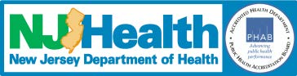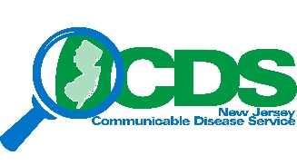
Sample Social Media Posts:

- A #COVID19 vaccine will help protect you from getting COVID-19, especially severe illness and death.

- COVID-19 vaccination is recommended for people who are pregnant, breastfeeding, trying to get pregnant now, or might become pregnant in the future. https://bit.ly/3GYnL4y

- Some people may need a third dose of a COVID-19 vaccine AND a booster. Learn the difference, by visiting https://bit.ly/3J5NAkL

- Your best protection from #COVID19 will be a combination of getting a COVID-19 #vaccine, wearing a mask, staying at least 6 feet away from others, avoiding crowds, and washing your hands often. #CDC

- FACT: #COVID19 vaccination helps to protect you from serious COVID-19 illness.
Let’s help stop the pandemic #publichealth #CDC

- Did you know that there are many benefits of getting your #COVID19 vaccine? Get the #facts #njdoh
https://bit.ly/3mkpTvD

- Stopping a pandemic requires using all the tools we have available. Get your #COVID-19 vaccine.

- COVID-19 vaccine is free regardless of insurance or immigration status. Make your vaccine appointment today covid19.nj.gov/finder

- We are connected by our faith. Let’s stand together and fight against COVID-19. #SleeveUp

- Getting a COVID-19 vaccine will help protect you without having to be sick. Learn about the benefits of COVID-19 vaccination so you’ll be ready when a vaccine is recommended for you: https://www.cdc.gov/coronavirus/2019-ncov/vaccines/about-vaccines/vaccine-benefits.html

- Getting your COVID-19 vaccine can help us fight this pandemic. #CDC #njdoh

- Getting a COVID-19 vaccine is a way to show love to your neighbors and community and bring us all one step closer to returning to our way of life. covid19.nj.gov/finder

- Getting a COVID-19 vaccine gives most people a high level of protection against COVID-19, even in people who have already been sick with COVID-19.

For more sample posts, visit https://www.cdc.gov/coronavirus/2019-ncov/communication/vaccination-toolkit.html
Updated 12/22/2021

