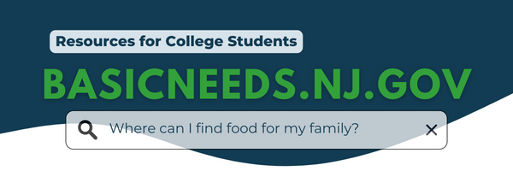
Fellow [Knights],

The New Jersey Office of the Secretary of Higher Education has initiated the beta launch of their new statewide BasicNeeds.nj.gov website.

A free, one-stop-shop resource, the website offers a comprehensive collection of information about programs and services available to students across New Jersey. This includes resources that deal with housing, hunger, financial aid, transportation, childcare, health care support, and more.

To improve the site and make it as user-friendly as possible, the State needs your assistance! Can you help by taking a couple minutes to visit the website and share it with your friends and in your campus clubs or organizations?

More website traffic will inform website improvements, so that programs can reach as many students in need as possible. Have feedback on the site? Share your thoughts here!

Thank you,
_____________________
