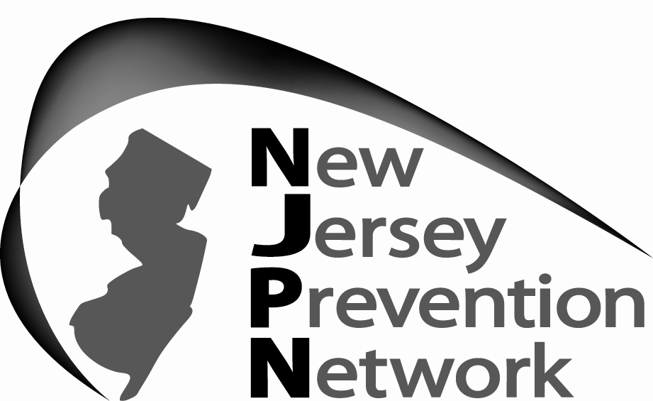

ADDICTION TRAINING & WORKFORCE DEVELOPMENT PROGRAM
$2000 Scholarship
Reimbursement for Completion of Alcohol and Drug Counseling Course

The Addiction Training and Workforce Development Initiative was developed to enhance and diversify the addiction counseling workforce in New Jersey. In support of this goal, NJPN is offering scholarships for individuals currently enrolled in a college or university degree program related to addiction education, treatment, counseling, social work, healthcare, prevention (or closely related field).

The goal of the scholarship program is to increase the number of addiction and behavioral health care professionals providing effective, culturally competent alcohol and drug counseling, education, treatment, healthcare, and prevention services.

The maximum amount of each scholarship is $2,000.

Eligibility requirements for these scholarships include the following:

- Individuals employed at a substance abuse, behavioral health, or co-occurring treatment facility
- Individuals enrolled in an associate’s, bachelor’s, or master’s degree program
- Individuals enrolled in an addictions, alcohol and drug counseling, education, treatment, or prevention course (or closely related course)
- Academic program is in counseling or a closely-related field (e.g., social work, psychology, human services, sociology, nursing, public health) or;
- Individual is working towards a LCADC, CADC, LPC, LCSW, LMFT, RN, APN, CCS, CPS, etc.

Although priority is given to individuals working at a DHS-licensed/DMHAS funded substance abuse or co-occurring treatment facility, scholarships for individuals who are not currently working in the field but who are pursuing a master’s degree in counseling or a closely-related field and have a plan to pursue licensure in clinical specializations where addiction counseling is permitted through scope of practice will also be considered if funding is available.

(State of New Jersey employees and individuals currently participating in DMHAS funded Rutgers University academic addiction training programs are not eligible for this opportunity.)

Required Documentation: Applicants will be required to submit the following documentation:

- An updated resume
- Two professional letters of recommendation on letterhead from an agency and/or college/university (e.g., supervisor/clinical director, professor)
- Course description/syllabus
- Verification of registration

Form Must be Submitted to NJPN by April 24, 2015

APPLICATION FOR PARTIAL REIMBURSEMENT FOR A COLLEGE COURSE
RELATED TO ADDICTION OR ADDICTION COUNSELING
Form Must be Submitted to NJPN by April 24, 2015
Submit to: Diane Liga at diane@njpn.org or 732-367-9985.

Section 1: Personal Information
Name: |  |  |  | Date:
Home Address:
City: |  |  |  | State: |  |  | Zip Code:
What COUNTY do you live in? |  | Home Phone: |  |  |  | Cell Phone:
Employer:
Program:
Position/Title: | FT/PT (circle one) # of years w/agency:
Work Address:
City: |  |  |  | State: |  |  | Zip Code:
Work Phone: | Ext. |  |  | Work Fax:
E-mail address: (Required) | All communication with scholarship recipients is conducted via e-mail.  Work:  Personal:

Are you employed at a DHS-licensed substance abuse treatment agency? YES NO

Are you employed at a DMHAS-funded substance abuse agency? YES NO

Are you a state employee? YES NO

Are you a state contractor? YES NO

Does your employer offer tuition reimbursement? YES NO

Demographic Information: Demographic information is requested, but not required, to monitor workforce development initiatives that promote a diversified workforce.

Age: ____ Gender: ___________ Ethnicity: __________________

Section 2: Education & Experience

Do you have a (circle one)… | GED High School Diploma
Highest level of education you have obtained beyond high school? (circle one if applicable) | AA BA MA
If you have an AA or BA, what was your field of study?

Do you currently possess any certifications and/or licenses?  If so, please list type of license/certificate. | YES NO
Do you currently have your CADC?  If no, how many experience hours towards the 3,000 required hours for the CADC/LCADC have you completed? | YES NO

Information about the degree you are currently pursuing:

What university/college are you currently attending?
What level of education are you currently pursuing? | AA BA MA
What is the specific degree you are pursuing, including your field of study?

How many credits have you completed towards this degree?

Section 3: Consent and Confirmation

In order to receive the scholarship reimbursement, I agree to furnish NJPN with the required documentation verifying I have completed the course for which I am requesting reimbursement, including:

- Course description
- Verification of final, official grade for the course. I understand that I must receive at least a B in the course in order to be reimbursed.
- Proof of payment for the course (i.e., cancelled check, credit card receipt), and written confirmation that I did not receive a scholarship or grant covering the course.
- Any other documents verifying reimbursement.

I also agree to allow NJPN to follow up with me to track my progress toward obtaining my degree.

_____________________________ _______
Signature Date

Section 4: How did you learn about the Addiction Training and Workforce Development Program College Scholarship Program?
_________________________________________________________________________

_________________________________________________________________________
Section 5: Student Questionnaire
Please type your answers separately and submit with this application. Please carefully consider your answers as they will be scored and will be taken into consideration when reviewing your application.

- Please tell the Scholarship Review Committee why you should be selected for the Addiction Training and Workforce Development College Course Reimbursement Program.

- Describe what influenced your decision to pursue alcohol and drug counseling as a career?

- How will this degree help to enhance your counseling skills and better serve your clients?

- How will you contribute to the addiction field?

- How will you address potential challenges in pursuing your education and career goals?

Section 6: Student Statement of Need
Please type your answer separately and submit with this application. Please carefully consider your answers as it will be scored and will be taken into consideration when reviewing your application.

- Please provide the following information:
  - Total household income:
  - Total individuals living in household:

- Describe your financial need for this scholarship and how the scholarship will impact your ability to obtain your desired degree.

Applicant: | Print Name: ____________________________________________________
 | Signature: ______________________________________ Date: ________
 | My signature attests that the information I have supplied is true and to the best of my knowledge.
The Addiction Training and Workforce Development Program is made possible by a grant from the State of New Jersey Department of Human Services, Division of Mental Health and Addiction Services.

