DEPARTMENT OF HUMAN SERVICES

Hearings

Proposed Readoption without Amendment: N.J.A.C. 10:6
Authorized By: Jennifer Velez, Commissioner, Department of Human Services
Authority: N.J.S.A. 30:1-12 and 52:14B-12

Proposal Number: PRN

Submit Comments by to:

Frederick Cohen
Assistant Commissioner
Office of Legal, Regulatory and Guardianship Services
Department of Human Services
P.O. Box 700
Trenton, New Jersey 08625

The Agency proposal follows:

Summary

Pursuant to Executive Order No. 66 (1978), the Department's Rules on Hearings (N.J.A.C. 10:6) were due to expire on March 15, 2010. Pursuant to Governor Chris Christie’s Executive Order #1, all regulations that were set to expire during the course of a 90 day regulatory freeze that commenced on January 19, 2010, were themselves frozen. The Department of Human Services (Department), which has maintained these general rules applicable to administrative reviews and hearing procedures regarding matters under its jurisdiction to accomplish the indicated purposes, now proposes to readopt same without amendment. In so doing, he Department has reviewed the rules proposed for readoption and has determined them to be necessary, adequate, reasonable, proper and responsive for the purposes for which they were originally promulgated and is, therefore, proposing them for readoption at this time without change.

These rules are intended to clarify that "contested cases", as well as "non-contested cases" at the discretion of the agency head and with the concurrence of the Director of the Office of Administrative Law, shall be transmitted to the Office of Administrative Law for initial hearing before an Administrative Law Judge. This is in accord with the Administrative Procedure Act, N.J.S.A. 52:14B-1, et seq.; 52:14F-1, et seq. and Uniform Administrative Rules, N.J.A.C. 1:1.

It should be noted that the various divisions within the Department have promulgated specific rules governing administrative reviews and hearing procedures. Thus, these rules require that division-specific informal conferences shall be conducted in accord with division-specific rules and the minimum requirements of the rules for Department level informal conferences also set forth in these rules.

The rules, as they address Department level informal conferences, are intended to provide procedures applicable to appeals from agency actions, excluding employee and contract-related appeals. These appeals must relate to programs administered by the Department or Department action not assignable to a particular division. The department level informal conferences address non-employee and non-contract related appeals from agency action or inaction in programs administered directly by the Department and not within the jurisdiction of a specific division and not readily assignable to a particular division or particular program. The rules are not to be interpreted as supplanting division-specific rules governing hearing procedures. In situations where an aggrieved person wishes to appeal the action of one of the several divisions of the Department, appeal is to be made directly to that division. These rules are supplemental to the Uniform Administrative Procedure Rules (N.J.A.C. 1:1) promulgated by the Office of Administrative Law, which has exclusive authority over the development of procedural rules for the conduct of administrative hearings (N.J.S.A. 52:14F-l, et seq.).

Social Impact

The proposed readoption without amendment will have a positive social impact in that the rules will benefit the public by providing clear steps that may be taken in the interests of preserving the rights of persons wishing to appeal an administrative action taken by the Department of Human Services.

These rules also set minimum standards in terms of procedural safeguards that all divisions of the Department must provide to persons wishing to appeal agency action or inaction.

Economic Impact

The readoption of these rules will have no economic impact on the Department or on the public.

Federal Standards Statement

A Federal standards analysis is not required because these rules proposed for readoption do not implicate or exceed established Federal requirements or standards.

Jobs Impact

The proposed readoption will have no impact on jobs to be generated or lost as a result of the rule promulgation.

Agriculture Industry Impact

The proposed readoption will have no impact on agriculture in the State of New Jersey.

Regulatory Flexibility Statement

While some service providers under contract with the Department may qualify as small businesses, as the term is defined in the Regulatory Flexibility Act, N.J.S.A. 52:14B-16 et seq., the rules proposed for readoption do not impose recordkeeping, reporting or compliance requirements on such providers, and therefore a regulatory analysis is not required.

Housing Affordability Impact Statement

The proposed readoption will not have any impact on the development of affordable housing.

Smart Growth Impact

The proposed readoption with amendment will have no impact on the achievement of smart growth and implementation of the State Developmental and Redevelopment Plan.

Full text of the rules proposed for readoption may be found in the New Jersey Administrative Code at N.J.A.C. 10:6.
5/6/10 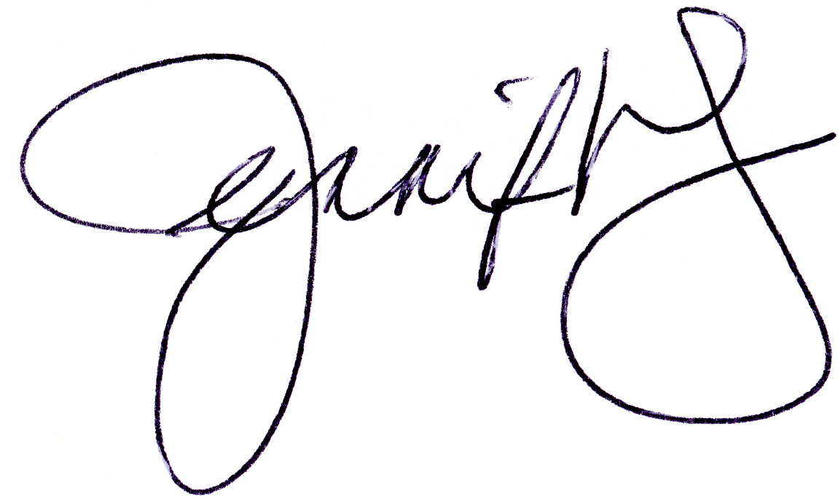
Date Jennifer Velez, Commissioner

