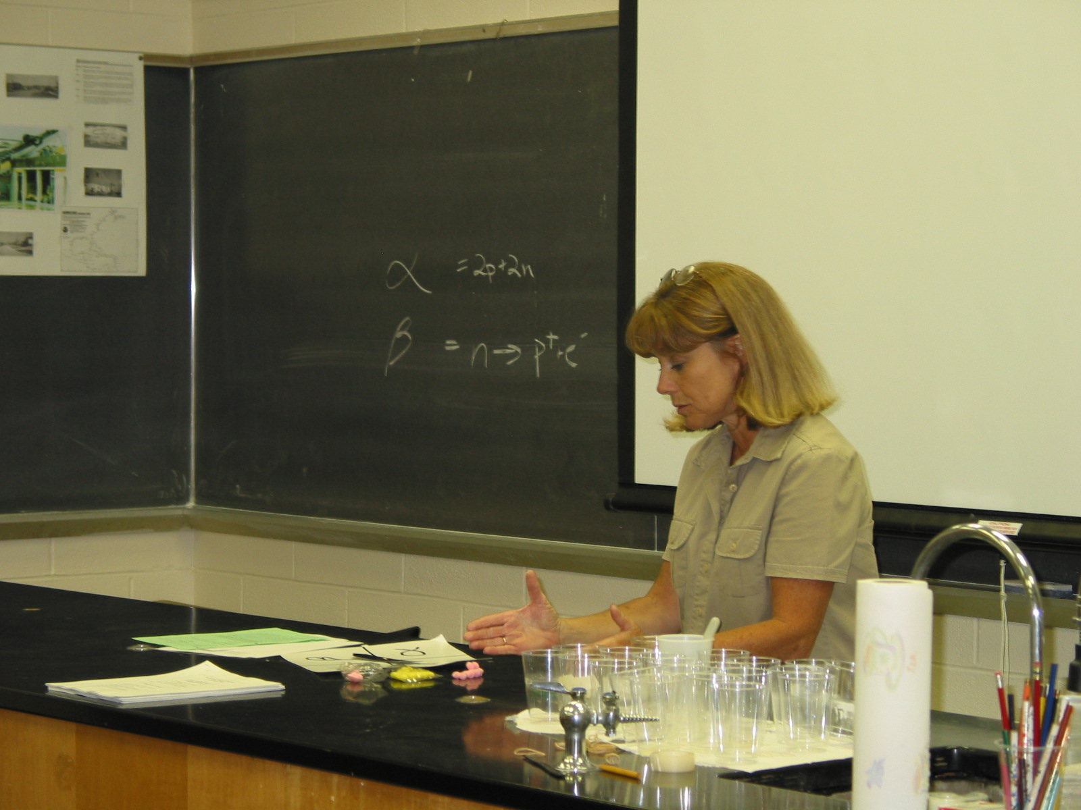

Instructor: (2002 Science Teacher Workshop participant)

Lesson Title: Radiation Particles
Type: Teacher guided activity/ worksheet
Intent: Extension
Grades: 7-8
Estimated time: one 30-40 minute class period.
Objectives: The students will be able to illustrate what happens to the nucleus of an atom when it releases alpha or beta particles using a model and be able to identify the resulting atom. They will illustrate the decay series of their atom.
Materials:
Spinner (one per group)
Pink pom-poms- (Protons)
Yellow pom-poms- (Neutrons)
Small plastic dish or lid – one per student
Periodic Table- one per student
Worksheet

Background Information:
Prior to the lesson the instructor must explain that when an alpha particle (2p and 2n) is released from the atom, it reduces the atomic number by 2 and the mass number by 4. A beta particle is formed when a neutron falls apart and produces a proton, which stays in the nucleus and an electron, which leaves the atom. This results in an increase in the atomic number by 1 but the mass number remains constant. An alpha particle is represented ( α ) and beta ( β ). A nuclear formula is written as shown on worksheet.

Procedure:
- Divide the students into groups of 3-6.
- Each student is to choose an atom, preferably one with a low atomic number.
- In a plastic lid, the student should place a pink pom-pom for each of the protons in his/her chosen atom.
- Next, place a yellow pom-pom representing each of the neutrons in his/her chosen atom into the lid. (Use the average number of neutrons.)
- The lid now represents the nucleus of the chosen atom. Record the type of atom and its parts onto the worksheet.
- One at a time, the students in the group spin the spinner to determine what type of particle his/her atom is to release. If it is to release an alpha particle then the student should remove 2” Protons” and 2 “Neutrons” from their nucleus and record they remaining nuclear parts on the worksheet. Using the periodic table they are to determine what type of atom the new nucleus represents and record it on the worksheet. If it is to release a beta particle the student should remove a neutron from the nucleus and replace it with an extra proton (the resulting electron leaves the atom as a beta particle). Again, the student should use the periodic table to determine the type of atom resulting and record the information of the worksheet.
- Continue in this manner until each student has had at least four turns.
- Each student should fill in the “decay series” of their atom at the bottom of the worksheet, indicating how the atomic number and mass changed as the particles were given off (see example on the worksheet).

Student’s name ________________________________ Period__________________

Worksheet: Radiation Particles

Starting atom

First Turn Second Turn

Particle given off = ________ Particle given off = ____________
Type of atom=________ Type of atom=_________
#p=_________________ #p=__________________
#n=_________________ #n=__________________
atomic#=_____________ atomic#=_____________
mass#=______________ mass#=_______________

Third Turn Fourth Turn
Particle given off= ____________ Particle given off=____________
Type of atom=__________ Type of atom= __________
#p=___________________ #p=___________________
#n=___________________ #n=___________________
atomic#=______________ atomic#=_______________
mass#=________________ mass#=________________

Use the example below to fill in the decay series for your atom.

Mass# 238 _{U} 234 _{Th} 234 _{Pa}
Atomic# 92 90 91

Your Atom: Decay Series

