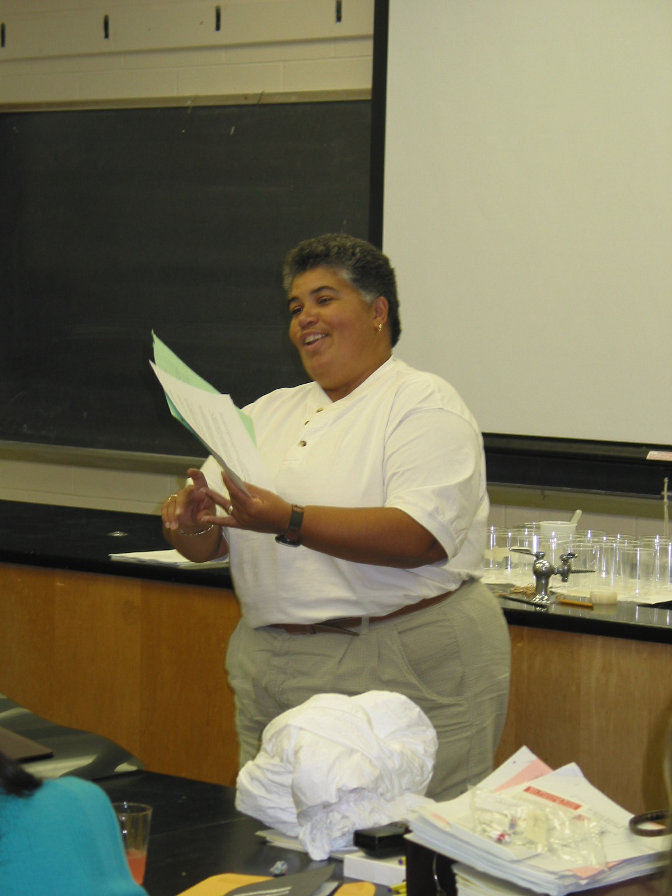

Instructor: Denise Boyer
School District: Upper Saddle River, NJ
Lesson Title: Wanted: A Good Home
Grade: 8
Subject: Environmental Studies
Overview: Students will present information at a town meeting
Objectives: Students will research and learn about what is involved in a town’s decision to host a disposal facility.

Wanted: A Good Home

PROBLEM:
For a time our low-level radioactive waste was sent to Barnwell, SC for disposal. Due to changing politics, SC has decided to close their facility to out-of-state waste. We now need to find a location where we can dispose of our own low-level radioactive waste.

YOUR TASK:
You are members of the State Siting Board. As part of your job you will visit a town meeting in a community that is considering becoming a host for a disposal site. You will present information at the meeting so that the community members can make an informed decision about hosting a disposal site. Each group will prepare a multimedia presentation for the town meeting. Use the attached rubric to monitor your work.

Group One: Basic Information
You will be first up at the meeting to provide general information. You should explain the basic structure of the atom, definitions of the different types of radiation (ionizing, non-ionizing), properties of the different types of particles & waves (alpha, beta, gamma) and methods of measurement (rems, rads).

Group Two: What is it?
You will inform the public of the sources of low-level radioactive waste. Your presentation should include examples of the “everyday” activities that produce low-level radioactive waste (manufacturing, research, medical). You should also include actual items that could be low-level radioactive waste.

Group Three: What’s needed?
You will present the physical requirements for the site. Be sure to include how much land is needed, water table concerns, topography & geology concerns and construction plans.

Group Four: Benefits of being a host community
You will outline the benefits that the town will receive as a host community. You should include financial incentives, job opportunities and tax relief. Stories of other host communities can be used.

Group Five: The “Nay-Sayers”
You are not part of the Siting Board but you will represent a group of concerned citizens who do not think a disposal site is right for the town. Be ready to present opposing views.

Resources:

- Rutgers University Fact Sheets
- www.state.nj.us/llrwsb
- Siting Board Video
- The web site for the rubric is
- http://www.ncsu.edu:80/midlink/rub.mmproj.htm
- Health Physics Society PowerPoint presentations

This project is designed to be part of our Interdisciplinary Environmental Unit. The problem will be posed to the entire class at a “town meeting.” A small group of students (perhaps a G/T class) will role-play a group from the state Siting Board. They will have researched and will be ready to present information to the townspeople. Citizens will be able to ask questions of the Siting Board members. There will be some citizens who will be opposed to the disposal site and will be allowed to voice their concerns. At the end, students would meet in “neighborhoods” to discuss hosting a site then the town will vote on the proposed disposal site.

