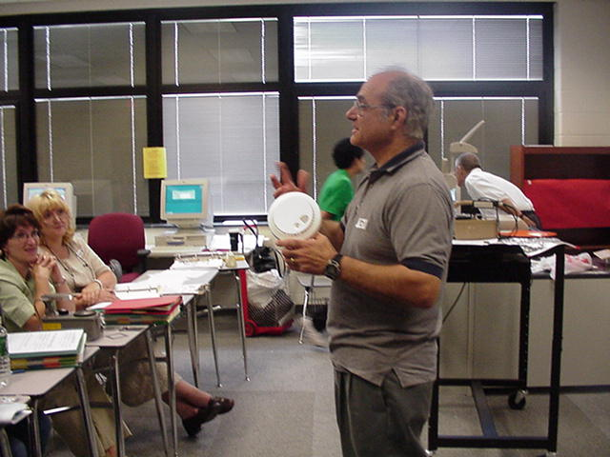
Created by:
Tony Brancato (2000 Science Teacher Workshop presenter)
Dr. Brimm Medical Arts High School
1626 Coperwood Ave., Camden, NJ 08104
May 21, 2000

DAY 1
Topic: Radiation- What? Where From? What Formed?
Type: Teacher Demonstration
Intent: Introductory
Performance Assessment: worksheet and oral response
Standards Addressed: 5.1,5.2,5.3,5.4,5.5,5.8,5.9,5.10
Cross Curriculum Areas:
General Information: Proposed Grade 3rd to 8th; Estimated Time 40 minutes
Content Knowledge: Parts of an atom; Origin of radioactivity; Reading a Periodic Table; balancing a nuclear equation; Types of Radiation (Radioactivity); Stable and Unstable
Process Skills:
Language /Vocabulary:
Concepts:
Radioactivity originates in the nucleus of an atom
Three examples of radioactivity (alpha, beta and gamma)
The properties of each example of radioactivity
When an atom releases radioactivity a change takes place in the nucleus of the atom.
Identify products of an emission of radiation, using a periodic table.
Use of worksheets for student practice and assessment.

Materials:
Styrofoam models of alpha and beta radiation.
Flashlight (gamma)
Work sheets for nuclear reaction equations (practice and assessment)
Periodic Table

DAY 2 Morning
Topic: Half-life and Radioactive Decay
Type: Teacher Directed Simulation
Intent: Introductory
Standards Addressed: 5.1,5.2,5.3,5.4,5.5,5.8,5.9,5.10
Cross Curriculum Areas: Graphing, techniques; division by 2’s
General Info: Proposed Grade 6-8; Estimated Time 40 minutes
Content knowledge:
Radioactive decay follows a pattern that can be analyzed
Finding the half-life from a graph
Calculating time for low level of activity
Process Skills: Graphing;
Vocabulary: half-life, decay, and activity
Concepts: There is an overall order to the decay of a sample
Assessment: Worksheet with pre-made graph to find half-life of unknown sample
Worksheet for finding low level of radioactivity of known half-life
Activities: Use of dice to simulate half-life. Game played to demonstrate various half-lives as well. Analysis: Practice worksheets on determining length of time to low level of activity
Materials: Geiger counter
Dice, one pair for each participant
Graph paper
Rulers
Sample radioactive graphs of various activities
Worksheet for half-life practice to low level activity

DAY 2 Afternoon
Topic: Shielding
Type: Teacher Directed Experimentation and Student Analysis
Intent: Introductory
Standards Addressed: 5.1,5.2,5.3,5.4,5.5,5.8,5.9,5.10
Cross Curriculum Areas: Graphing
General Info: Proposed Grade 6-8; Estimated Time 30 minutes
Content knowledge:
Penetration of radiation depends on type of radiation and its energy
Shielding requirements are based on type of radioactivity
Effectiveness of radiation depends on distance from source (an exponential relationship)
Process Skills: Graphing;
Vocabulary: shielding
Concepts: alpha easiest to stop, beta next, gamma needs heavy shielding
Assessment: Worksheet with scenario of a radioactive source and precautions taken
Activities: students have Geiger counter and radioactive sources, investigate cpm at various measured distances and graph: discussion of shape of graph.
Students use a beta source and find which materials successfully block radioactivity: use a gamma source and repeat: discussion of results from the group. Overall discussion on protection from a radioactive source.
Materials:
Geiger counter
Sources of radioactivity
Graph paper
Rulers
Worksheet for class discussion of findings with scenario

CLASS EXERCISES:

- Radioactive Simulation Game

- Each person receives a die. If upon rolling a "3" you gave up radiation and became stable.

Throws (simulates time) | Persons that have not rolled a three (simulates radioactive atoms remaining)
0
1
2
3
4
5
6
7

2. Each person receives a die. If upon rolling a "3" or a "6" you give up radiation and become stable.

Throws (simulates time) | Persons that have not rolled a 3 or 6 (simulates radioactive atoms remaining)
0
1
2
3
4
5
6
7

3. Each person receives a die. If upon rolling a "1", "3" or a "6" you give up radiation and become stable.

Throws (simulates time) | Persons that have not rolled a 1, 3 or 6 (simulates radioactive atoms remaining)
0
1
2
3
4
5
6
7

- Graph remaining radioactive atoms (activity) vs. throws of the die (time) on the same graph for the above three examples .

Summary questions:

- In which situation was there the greatest chance of dropping out of the game?
1 2 3

- In Which situation showed a radioactive atom losing its radioactivity the fastest?
1 2 3

- Which situation represented an example of the most unstable radioactive isotope?
1 2 3

- Was it possible to tell which person (radioactive atom) would drop out next from the game?
Yes No

- Does the graphed data indicate similar patterns for different isotopes?
Yes No

B. Calculating length of activity with half-life (t1/2 ) Complete the following chart by entering a time in years and calculating the resultant cpm for that additional time. Repeat until the cpm is down to 20 and add up the time in the first column.

1. half life = 100 years. Sample now measures 2000 counts per minute (cpm). How many years until cpm approaches background of 20cpm?

Time(y) cpm

2. half life = 5 days. Sample now measures 2000 counts per minute (cpm). How many days until cpm approaches background of 20cpm?
Time(dy) cpm

- Identifying Elements (Isotopes)

Complete the following chart using the periodic chart. Note that examples 1, 2, 3, 7, 8, 9, and 11are for stable isotopes, and that each of these isotopes have a net charge of 0, i.e. they are not ions.

Example # | Element | Atomic # | Atomic weight | # of protons | # of neutrons | # of electrons
1 | Al | 13
2 | Zn | 30
3 | Ne | 10
4 | He |  | 4
5 | Bi |  | 210
6 | P |  | 32
7 | Sb
8 | Hg
9 | Ba
10 | U |  |  |  | 143
11 |  |  |  | 79
12 |  |  |  |  | 8 | 6

Radioactivity and Transmutation

Complete the following equations and state the type of radiation emitted. Note that the location of the atomic weight is not location that is commonly accepted because of formatting constraints.

Radioactive Isotope Type of Radiation

1. 56Ba142  ______ + -1e0

2. 58Ce 139  ______ + 

3. 99Εs252  ______ + 2He4

4. 48Cd117  ______ + -1e0

5. 2He6  ______ + -1e0

6. 86Rn209  ______ + -1He4

7. 88Ra226  ______ + 

8. 90Τh231  ______ + -1e0 + 

9. 91Pa230  ______ + -1e0 + 

10. ____  8Ο17 + -1e0

A Glossary of Terms Related to Radiation Dose

DOSE: Technically, a measure of the energy deposited in material by ionizing radiation. The traditional unit of dose is the “rad” which is equivalent to 100 ergs of energy deposited per gram of material.

DOSE EQUIVALENT: A measure of the biological effect (related to risk of cancer or leukemia) of a given DOSE of radiation. All regulatory limits are set in terms of DOSE EQUIVALENT. The traditional unit of DOSE EQUIVALENT is the “rem”. A more useful unit is the “millirem” which is 1/1000th of a rem. For example a typical chest X-ray gives a DOSE EQUIVALENT of from 10 to 20 millirem to the torso.

DOSE RATE: The rate at which DOSE (or DOSE EQUIVALENT) is received. Typically expressed in terms of “millirem per hour”. Often used as a measure of the intensity of a RADIATION field. for example “the DOSE RATE at one meter from that X-ray machine is 5,000 millirem per hour. If you stood in this RADIATION field for 2 hours, you would receive a total DOSE of 10,000 millirem.”

BACKGROUND
RADIATION: Sources of radiation exposure which are naturally occurring, such as cosmic rays, RADON decay products in the air, uranium in rocks and soils, and potassium - 40 in our bodies.

RADON: RADON is an odorless, colorless radioactive gas which is a product of the RADIOACTIVE DECAY of uranium-238. RADON itself undergoes RADIOACTIVE DECAY, and these RADON decay products (which are also RADIOACTIVE) can be inhaled, resulting in an INTERNAL DOSE to the lungs.

INTERNAL
CONTAMINATION: RADIONUCLIDES or RADIOACTIVE materials taken inside the body via inhalation, ingestion, or through wounds.

INTERNAL DOSE: A DOSE, or DOSE-EQUIVALENT, received from radioactive materials deposited inside the body.

COMMITTED DOSE
EQUIVALENT: RADIONUCLIDES deposited inside the body may take weeks, months, or years to be totally eliminated from the body. During this time, the body is being irradiated. The COMMITTED DOSE EQUIVALENT is the total DOSE EQUIVALENT received over a period of time, typically 50 years.

