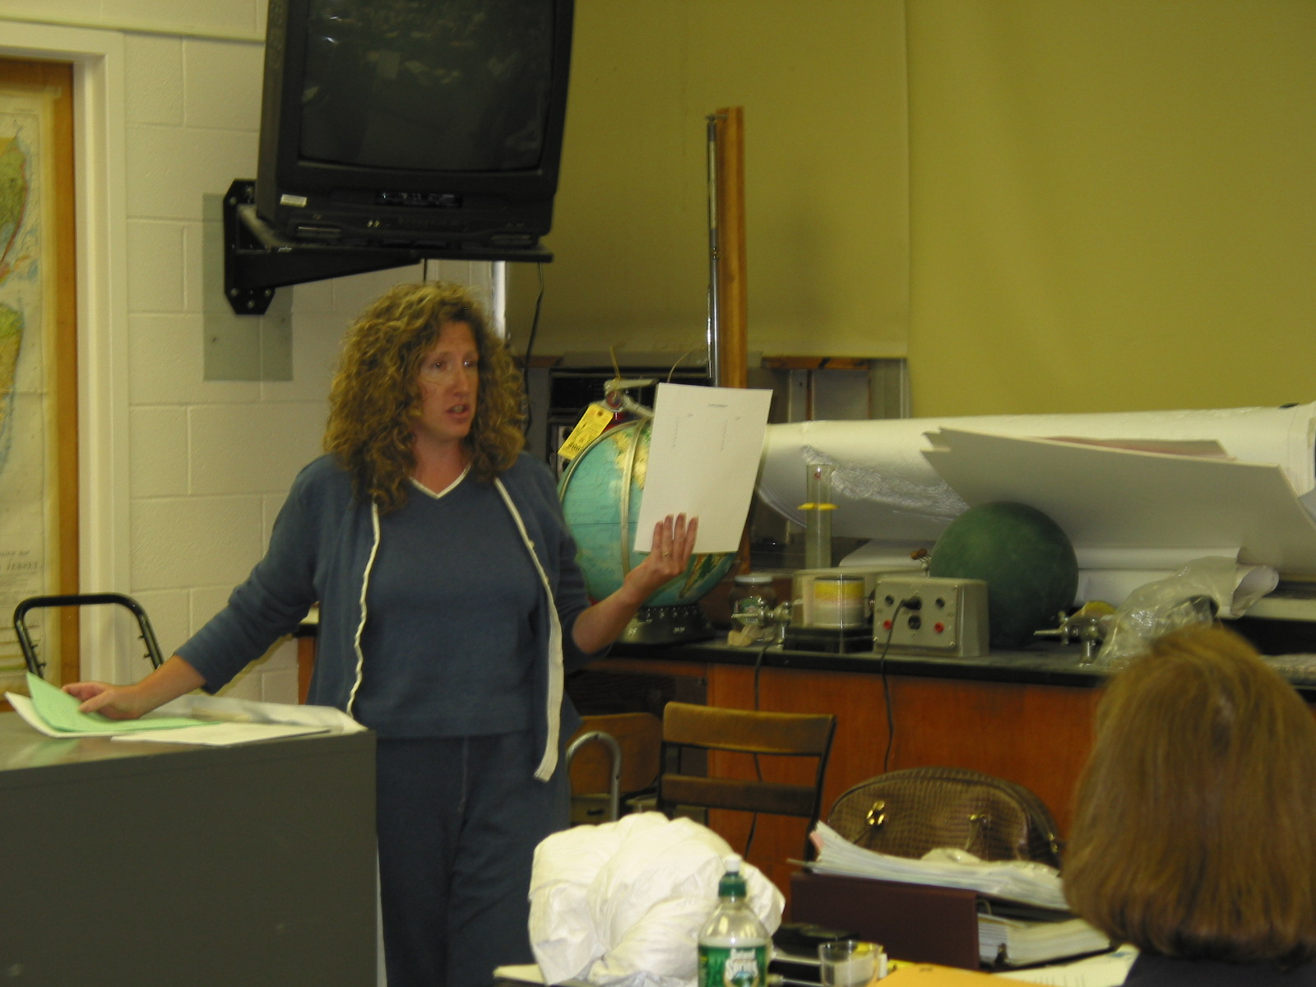
Instructor: (2002 Science Teacher Workshop participant)
School District: Vernon Township
Lesson Title: Food Irradiation: The Good, The Bad and The Ugly.
Grades: 7-12
Subjects: Language Arts and Science
Overview: Students will research and develop a five-paragraph essay stating their position on food irradiation.
Objectives:
- Students will conduct research using a variety of materials.
- Students will recognize how the prejudice of the author influences the content of the material.
- Students will take a position on a controversial topic.
- Students will write a five-paragraph essay supporting a given position on a controversial science topic. (GEPA skill)
Materials and Resources: Science journals, web sites and writing organizers.
- Students will research a given topic, such as food irradiation. Library time will be available.
- Students will find 3 articles giving both the positive and negative aspects of the given topic.
- Class discussion will take place about how the position of the author and the propaganda used in the writing affect the overall quality and accuracy of the information stated.
- After reading the articles, the student must fill out the attached organizer to determine the position the student will be taking. Eight facts per side must be listed.
- The essay will be written in the given five-paragraph format.
- Revision and editing will then take place.
- Final essay will be submitted for evaluation.
- Examples of prop and con references:
- http://www.organicconsumers.org/irrad/irradfact.cfm “What’s Wrong with Food Irradiation”
- http://www.cdc.gov/ncidod/dbmd/diseaseinfo/foodirradiation.htm#whatis “Frequently asked questions on food irradiation”, Center for Disease Control

ORGANIZER

Topic: Food Irradiation

Pro: Con:

1. ___ 1. ___
2. ___ 2. ___
3. ___ 3. ___
4. ___ 4. ___
5. ___ 5. ___
6. ___ 6. ___
7. ___ 7. ___
8. ___ 8. ___

ESSAY FORMAT

Introduction: WHO _____________
WHAT _____________
WHERE _____________
WHEN _____________
WHY IS THIS AN ISSUE? ____

- Be clear what your position is!!!!!!!!!!!!!!!!!

FIRST REASON
1 supporting detail
2 supporting detail
3 supporting detail

- Include transition words

SECOND REASON
1 supporting detail
2 supporting detail
3 supporting detail

- Include transition words

THIRD REASON

1 supporting detail
2 supporting detail
3 supporting detail

Conclusion: Restate your position on the topic. Highlight your most impressive arguments. Leave the reader believing your opinion!!!

