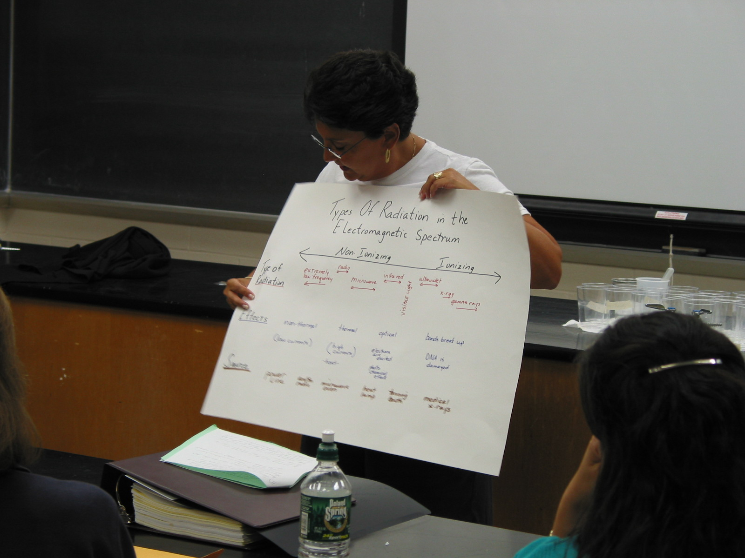

Instructor: Jane E. Brienza (2002 Science Teacher Workshop participant)
School District: Paramus, NJ
Lesson Title: Radiation
Grades: 6 and 7
Subject: Science
Overview: Ionizing and non-ionizing radiation
Objectives: understanding the difference between ionizing and non-ionizing radiation.
Materials & Resources: Poster, textbook, notes, felt, magazine pictures. Students use their own imagination for more resources.
Evaluation: Students will be evaluated on poster and how they explain the poster to the class.

Content:
At the conclusion of a two-day lesson on ionizing and non-ionizing radiation, the students will create a poster showing types of radiation in the electromagnetic spectrum, and the effects and the sources of this radiation.

The lesson will be introduced by explaining the differences between ionizing and non-ionizing radiation as well as how energy from radiation forms the electromagnetic spectrum. Teacher will point out the areas of ionizing and non-ionizing radiation.

- Non-ionizing Radiation: Energy causes atoms in a molecule to vibrate. They are not changed chemically. On the electromagnetic spectrum the range is from extremely low into the ultraviolet range. Low-frequency radiation has very long wavelengths and [low] frequencies. Wavelengths are measured in meters and frequencies in hertz.

Examples if non-ionizing radiation are microwave radiation (used in telcommunications and heating food), infared radiation (infared lamps, keeping food warm in restaurants, for example, Burger King fries under lamp) and radiowaves (broadcasting)

- Ionizing Radiation: Energy is able to break down chemical bonds. Very high frequency, extremely high energy causing electrons to break off or the nucleus to break up [the nucleus breaks with neutron irradiation in a nuclear reactor].

There are three main kinds of ionizing radiation
- Alpha particles – have 2 protons of positive charge and two neutrons of no charge.
- Beta particles – these are [free] electrons, and
- Gamma rays – also x-rays. These are pure energy.

Students can do either a poster or bulletin board using a variety of materials. For example, felt, magazine picture cut outs, or a 3-D spectrum using wood or styrofoam.

