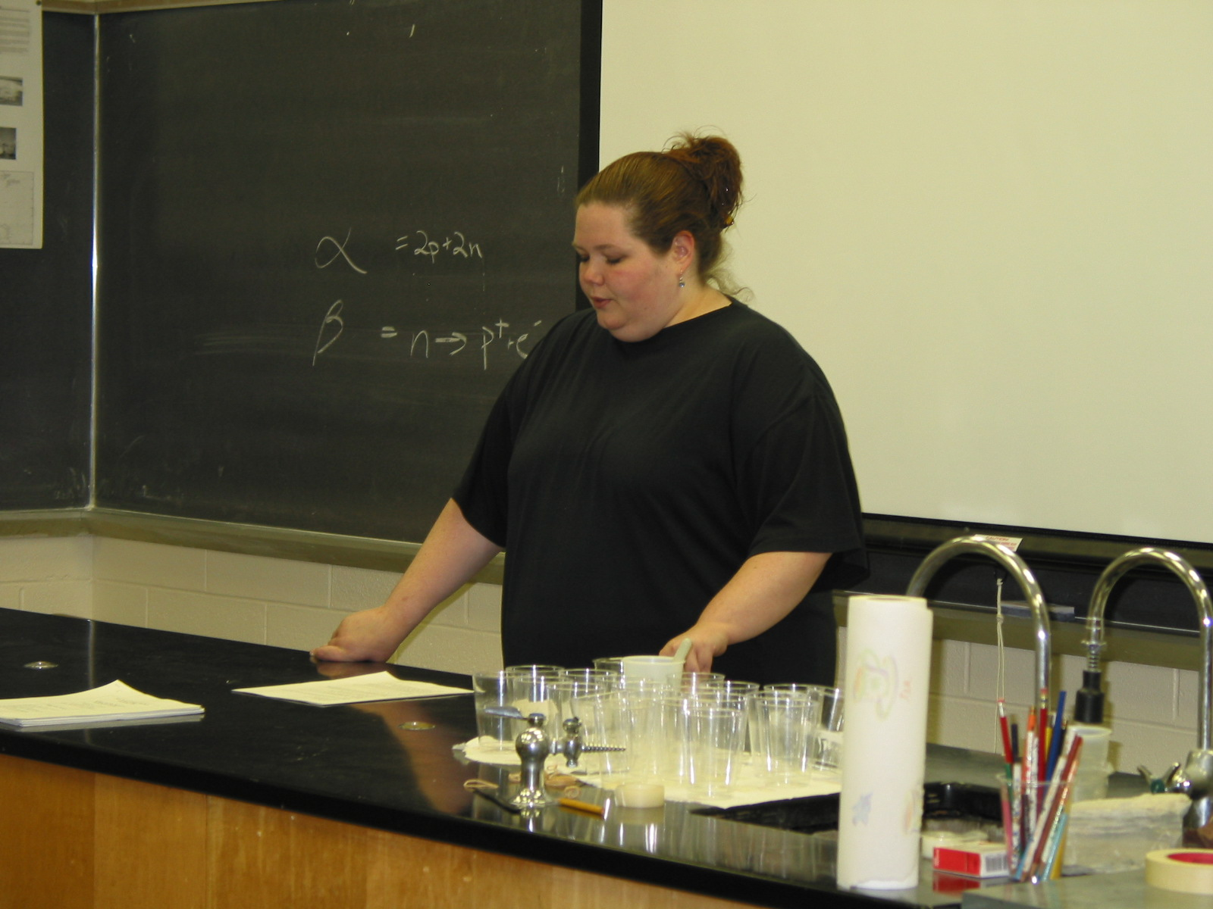
Instructor: MaryEllen Cleary (2002 Science Teacher Workshop participant)
School District: Vernon Township
Lesson Title: “You Say Potato, I Say Pota-NO!”
Subtitle: Food Irradiation Debate
Grade: 8
Overview: Students will be given the opportunity to stretch their debating muscles as they research and argue the positives and negatives of food irradiation.
Objectives: After their review of ionic radiation energy sources (alpha, beta, gamma, x-rays), students will be able to
- illustrate their understanding of the ionic radiation used in food irradiation
- research evidence to prove their side of a debate
- generate informational hand-outs and visual aides
- present their positions in a classroom debate.
Materials and Resources: Internet site sheet, note taking graphic organizer, computers with Internet access, Microsoft Publisher and Power Point software, writing utensils, paper (printer and poster), 3x5 index cards, art tools (pencils, markers, etc)
Time: five eighty- minute class periods
Procedure:
1. Present the following scenario to the class as an introduction to the debate:
Our school’s cafeteria is considering purchasing irradiated meat, fish, fruits, and vegetables for use in your meal preparation. Food irradiation is a process in which food products are exposed to a controlled amount of radiant energy to kill harmful bacteria such as E. coli O157:H7, Campylo-bacter, and Salmonella. The process also can control insects and parasites, reduce spoilage, and inhibit ripening and sprouting.
Despite what we know about radiation, food irradiation is a very controversial subject. You are challenged to argue this issue in a class debate.

2. Divide the class in half. One half will be in favor of food irradiation, the other side will be against the process.

3. Each side will then divide itself in half again. One group will serve as researchers and note takers and the other group will generate a visual aid, such as a poster, video, or Power Point presentation, and a handout, such as a brochure or flyer.

4. Students will work in class and at home on their projects. By Day Three, each side should meet to discuss the structure of the debate as well as determine who will be speaking about each topic. Each side is required to introduce their viewpoint, present at least three strong supportive reasons with evidence, and conclude their debate with their strongest, most persuasive points. EVERY STUDENT MUST PARTICIPATE IN THE ORAL DEBATE.

5. On Day Five, students will present their debate on food irradiation to a panel of students visiting from another class. After each side is heard, each group will also be given an opportunity to rebut the opposing argument or restate their most persuasive reason. Then the student panel will determine the “winner” of the debate (with teacher guidance).

6. Students will conclude the activity with a journal reflection:
“Based all the information presented on both sides, how do you personally feel about food irradiation?” Discuss the students’ entries as a culminating activity.

Evaluation: Students will be evaluated on their debate preparation (30%).
visual aides and handouts (30%) and their debating skills (40%).

Food Irradiation Websites

Positive Sites:

1. www.cdc.gov/ncidod/dbmd/diseaseinfo/foodirradiation.htm

2. www.fda.gov/opacom/catalog/irradbro.html

3. www.eatright.org/adap0200.html

Opposing Views:

4.www.consumersinternational.org/campaigns/irradiation/irrad. html

- www.citizen.org/cmep/rad-food/radfoodindex.htm

- www.organicconsumers.org/irrad/FDArebuttal.cfm

"You Say Potato, I Say Pota-NO!"
Graphic Organizer
Our Postion: Pro or Con?_______________
What is food irradiation?
How does irradiation work?

Reason # 1

Reason # 2

Reason #3

