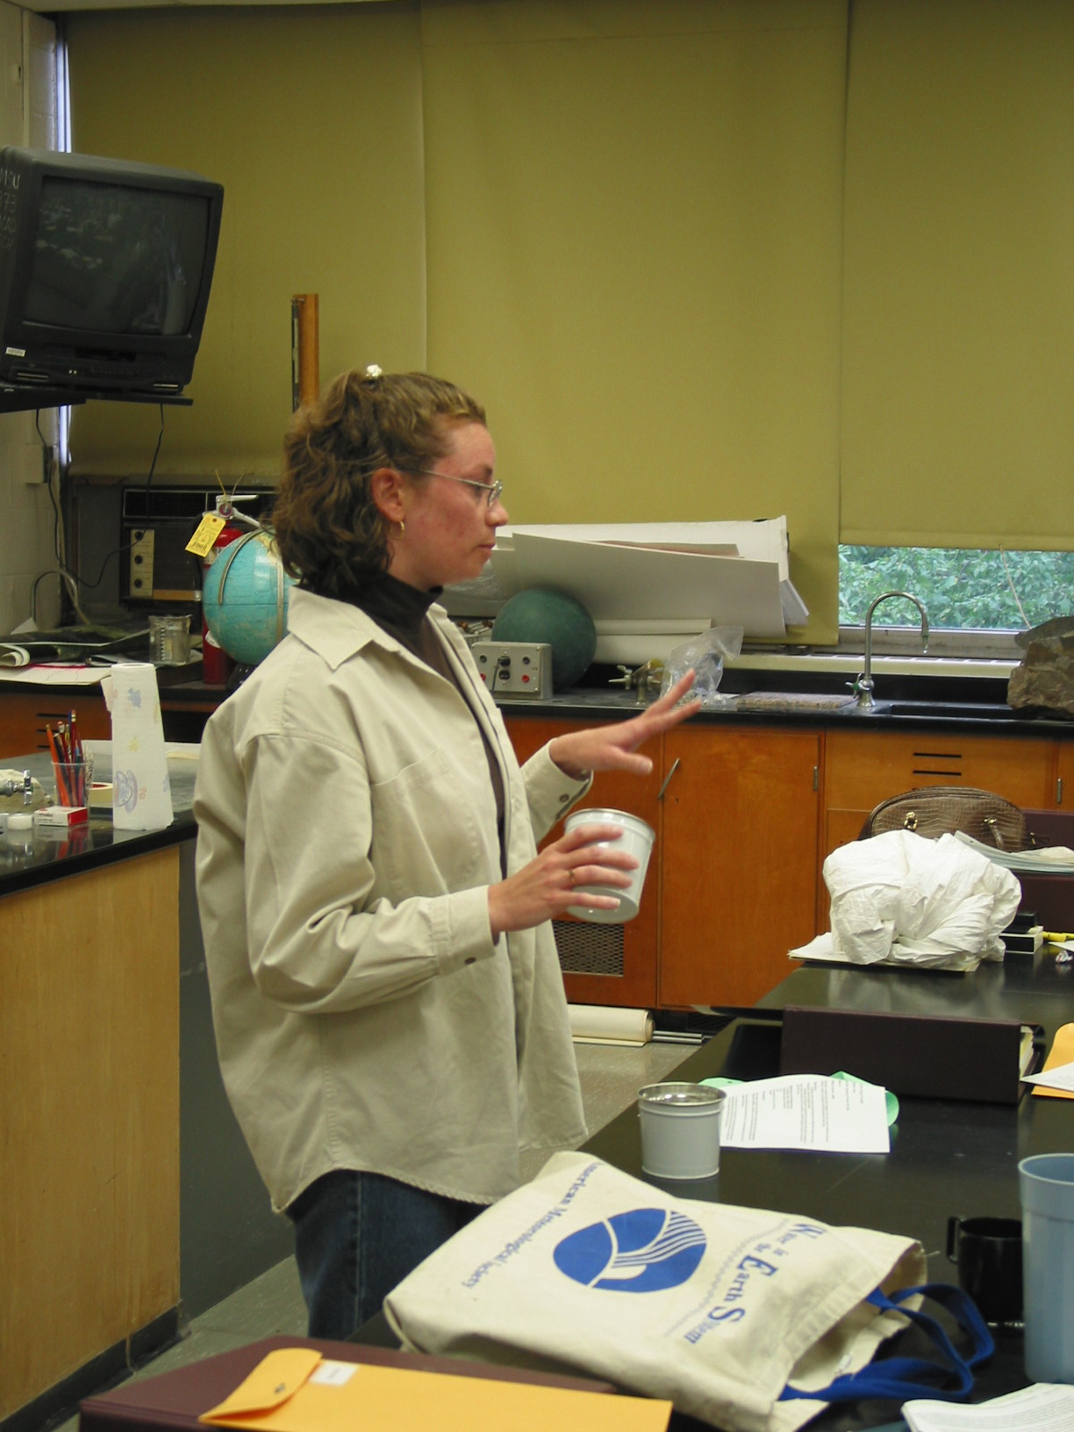

Instructor: Jennifer Coppock-Huegel
School District: Clifton
Lesson Title: Radioactive Waste Storage
Grades: 6-8
Subjects: Science, Health

Overview: Students will build models of old and modern radioactive waste storage facilities in order to compare the effectiveness of each type.

Objectives:
Students will be able to demonstrate the differences between an old and modern radioactive waste storage facility.
Students will be able to describe the possible health effects of waste disposed of in each type of facility and the pollution controls designed to protect human health and the environment.

Materials and Resources:
* 2 planters with water trays
* sealable plastic container
*clay
*soil
*powdered food coloring
*water

Procedure:
After learning about the effects of radioactive waste and the history of radioactive waste disposal facilities, students will use the above-listed materials to make a model of each.

Have students line each planter with soil. The planters will represent the ground site for the waste disposals.

To construct the "old" type of facility, instruct students to sprinkle some radioactive waste (represented by the powdered food coloring) into the first planter. Then students should cover the waste with another layer of soil and set it aside.

To construct the "modern" type of facility, instruct students to sprinkle some radioactive waste into the plastic container. Have students seal the container. Next, students should completely surround the container with clay. Once the container is sealed in clay, have students place the container inside the second planter. Then students should cover the waste with another layer of soil and set it aside.

Lastly, students should simulate rainfall by pouring water into each planter. If food coloring is apparent in the water, the facility leaked. If the water comes through without color, the facility is safe!

Follow up activity with a discussion of why one facility is safe and the other is not, as well as consequences of a poorly designed facility.

