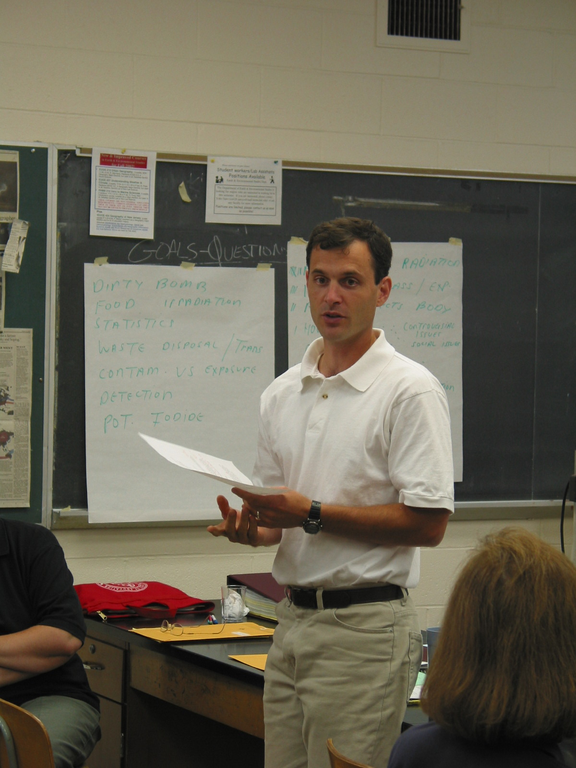

Instructor: Robert DeJulia (2002 Science Teacher Workshop participant)
School District: Vernon Township, NJ
Lesson Title: Radon
Grade: 9
Subject: Earth Science

Overview: General definitions of radon, half-life, and radioactivity. Describe the existence, risks and remediation of radon.

Objectives: To identify the “Tier 1” existence level of radon in Vernon as well as health risks and removal of radon in the home.

Materials:
- Internet research (library or home)
- Radon kits
- Overheads and notes

Lesson Duration: 3 days

Lesson:

Topics to be Covered:
- What is radon?
- Is it in your home? How do you test for it?
- What are the health risks? How can radon be removed?

- What is radon?
Radon is a naturally occurring gas. It forms from the nuclear decay of Uranium-238 that is naturally found in soil or bedrock. It’s half-life is 3.8 days. Students will have previously researched and defined: half-life, nuclear decay, and radioactivity.

- Is it in your home? How do you test for it?
The radon gas enters a house by seeping in from ground via foundation cracks, drains, sump pumps, exposed soil, construction joints, loose fitting points, or occasionally, by well water. Students will research radon levels in their home area on the internet and also radon test devices, both active and passive. These will include:
- Passive detectors: Charcoal canister and liquid scintillation devices, alpha track detectors and electret ion detectors.
- Active detectors: Professional monitoring devices.

- What are the health risks? How can radon be removed?
Home radon levels average 1.25 pCi/L. If a test reveals levels of 4pCi/L or greater, some action is necessary to reduce levels. It is removed easily and professionally by proper ventilation. Health risks include lung cancer from long term exposure. Radon atoms can further decay to lead (Pb-210) which can cause problems in the lungs.

Conclusion: Students will report any radon testing or remediation in their own homes.

