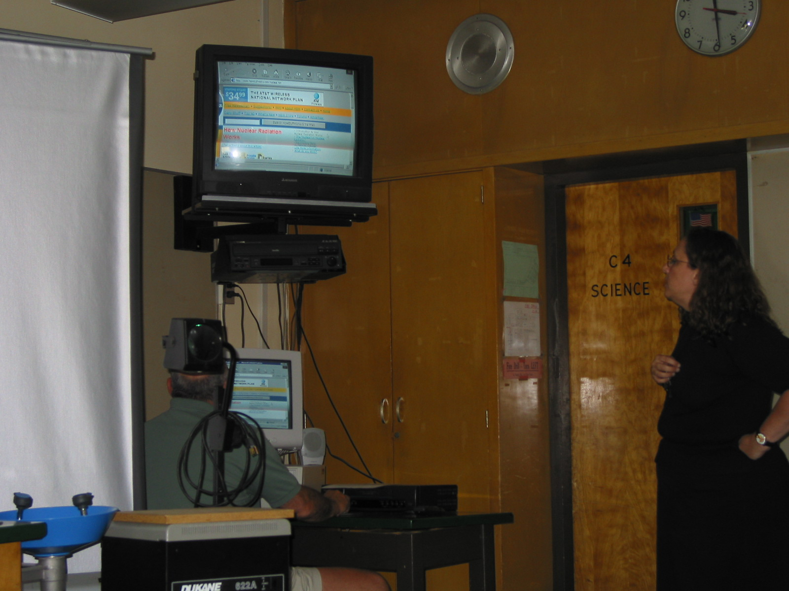

Instructor: Karen Delgado (2002 Science Teacher Workshop participant)
School District: Union Township, NJ (Hunterdon County)
Lesson Title: Nuclear Power Plant
Subtitle: Internet Activity
Grades: 7,8

Subject: Science

Overview: Students will use an Internet source to locate the website: Marshall Brain’s HowStuffWorks. (http://www.howstuffworks.com) Using a teacher-created worksheet as a guide, the student will read portions of the article, view animations and photographs, and answer questions.

Objectives: To understand the relationship between nuclear reactions and their role in generating electricity.
- Students will use technology for research purposes.
- Students will use previous knowledge to make inferences about how a power plant might work and the concerns of the general public regarding the operation of these power plants.
- Students will read for content.
- Students will use study skills--skimming, following directions, notetaking, etc.
- Students will formulate conclusions based on their research and compare and contrast them to inferences made prior to research.
- Students will use vocabulary and concepts from previous lessons.
- Students will gain knowledge of the process of generating electricity, especially as related to the unit on nuclear energy.
- Students will have a better understanding of the positive contributions made by our nuclear power plants.
- Students will be able to recognize the risk vs. advantages of using nuclear power to generate electricity.
- Students will be able to distinguish between fact and myth regarding fears and misconceptions about nuclear power plants.
Evaluation:
- Review of worksheet for accuracy. (May be done as an oral group activity, with students correcting their answers, as needed.)
- Teacher evaluation of student writing.
- Diagrams of Oyster Creek Nuclear Reactor (from: Nuclear Energy: Brought to You by GPU, located in the Teacher Workshop CD)
Materials and Resources:
- www.howstuffworks.com Provides articles such as: How Power Distribution Grids Work; How Nuclear Power Works; How Hydropower Plants Work; How Nuclear Radiation Works; Question of the Day--#481; etc. Many of these articles include photographs, animations, and/or charts/tables/graphs. http://www.howstuffworks.com/nuclear.htm
- 2002 Workshop Binder: Understanding Radiation--Grade 5/Chem-Nuclear Systems, Inc. And North Carolina Low-Level Radioactive Waste Management Authority, Activity 5-3, page 16.
- 2002 Workshop CD: GPU Lesson, pages 5-9
- 1998 Edition of The Complete Reference Collection, from Compton’s Home Library collection: article, Electric Power; diagrams, Principal Parts of a Nuclear Reactor, and Electric Power from the Atom with a Pressurized-Water Reactor (c. 1997, The Learning Company, Inc.); and a multi-media presentation, Nuclear Reactor--an animation.

Lesson Plan for: Internet Activity/Nuclear Power Plants

Prior to this lesson, students will have completed the unit on nuclear physics (found in text and supplemental sources.) They should have an understanding of the vocabulary words: atom; nucleus; neutron, proton, electron, ion, isotope, fission, radiation, and radioactivity.

Objective:

In addition to the student objectives stated; this lesson will act as a bridge between the unit on nuclear physics and the unit on electricity. Students will have an understanding of how we obtain electricity before they are introduced to it, while investigating how nuclear energy plays a part in their daily lives.

Introduction:

State the objective. (We have completed our unit on nuclear physics. We have learned what an atom is, and how it can be used to create nuclear energy. We have looked at radiation, its effects, etc........our next unit of study will be on electricity. Before we begin to experiment with electricity I would like you to understand the relationship between nuclear reactions and their role in generating electricity.....)

Review classroom procedures for Internet use. (Teacher should review classroom procedures, school policy, assign groups, etc., as needed.)

Lesson:

- Distribute an Internet Activity worksheet to each student
- Read (or restate) the first paragraph...review vocabulary words, as needed
- Review the word, inference. Students should read and complete the first section independently.
- When students have completed the inference section, direct them to the computers. Students should access the website and follow the directions on the activity sheet.
- Interact with students: assist them in finding the correct site; the correct place in the article; as well as viewing the animations and photographs.

Evaluation:

- Worksheet should be checked for accuracy. Teacher may collect and read through the students’ sheets or do this as a group activity. Allow students to correct their work, as needed.
- Conclusion paragraph should be collected and assessed for content understanding. Student should understand the role that the fission of an atom plays in the process of generating electricity, as well as understanding the safe and environment-friendly operation of well-maintained nuclear reactors.
- Diagram activity can be used to reinforce concepts or as a quiz.

Follow-Up/Extending the Lesson:

- Use the Internet to find the locations and number of reactors in the state.
- Assign further research on other energy sources for power plants. Compare and contrast the advantages/disadvantages of each.
- Use the background materials to expand this topic--what is happening inside the fission reactor?
- Research the work being done on fusion reactors. (Princeton Plasma)
- Discuss the issues of the disposal of radioactive waste, based on prior lessons on radiation. Compare low-level disposal with disposal of the spent fuel rods, etc.
- Build a model of a steam-powered turbine using boiled water in a flask with a one-hole stopper, tubing, and a pinwheel. Expand it by making a “turbine” that turns a “generator” and discuss the transfer of energy. (Modified K’nex pieces and Gearapolis pieces work well) A hair dryer can be use to represent the “steam”.
- Discuss the concept of “transfer of energy”. Use one of the diagrams to mark where the various energy conversions take place.

Name:___________________
Section:__________________
Date:____________________
Internet Activity: Nuclear Power Plants

You have done a great job learning the concepts of: atom; nucleus; neutron, proton; electron; ion; isotope; fission; radiation; and radioactivity. You will be using the Internet to investigate how these concepts are used to create electricity.

Before we begin....What can you infer?

Using the knowledge you have of the atom and of radioactivity, how do you think nuclear energy is used to create electricity? (...in other words how does “splitting an atom” get “changed into” electricity? _______________________________________________ ______________________________________________________________________
______________________________________________________________________
______________________________________________________________________
______________________________________________________________________
List several concerns you or others may have about nuclear power plants. (...in other words... What concerns would you have, if your parent told you that your family may be moving to the new development that was just built next to the local nuclear plant?)
________________________________________________________________________________________________________________________________________________________________________________________________________________________________________________________________________________________________

Let’s begin our research. . .

You will be reading the article, How Nuclear Power Plants Work, on the Marshall Brain’s HowStuffWorks website: http://www.howstuffworks.com/nuclear.htm. Use your computer to access this website. When you have found it...proceed....

1. Scroll down to (or click on) the section, Inside a Nuclear Power Plant.
2. Scroll down until you reach the animation. Using the key, follow the path that
indicates the processes that take place in the nuclear reactor.
3. Read the paragraph below the diagram. Answer the following questions:
a. What element is used in the fission reaction?_______________________
b. For what purpose are the atoms fissioned?________________________
c. The steam that is created is used to turn a t__________________.
d. This turns the g_______________________________________.
e. The g________________________produces electricity.

4. How does a nuclear power plant compare to a coal-fired or oil-fired power plant?__________________________________________________________________

5. Return to the beginning of the article.
6. Skim the first paragraph. What percent of the electricity in the United States is supplied by nuclear power plants? _______% How many power plants are located in the United States?_______ (The article does not give information on our state. Do you think we have nuclear power plants in our state? ______ If yes, how many?_______.)

7. Scroll down, again, to the section: Inside a Nuclear Power Plant.
8. Read through the first two paragraphs in this section....answer these questions:
a. How large are the Uranium pellets?________________________
b. How are these pellets arranged?__________________________
c. What is the purpose of the water?_________________________
d. What is a control rod?_________________________________
e. What is the job of the control rod?_________________________________
_____________________________________________________________

9. Scroll down to the photos below the animation-- “Electricity for homes and....”
and “Pipes carry steam...”.

10. Read the paragraph below this picture. What precautions are taken to prevent radiation from accidentally “leaking” out of the facility?___________________________
________________________________________________________________________________________________________________________________________________

11. Scroll down to the section, What Can Go Wrong?
12. Skim the paragraph to find a benefit of using nuclear power plants to produce electricity. State one way that a nuclear power plant is better than a coal-firing plant for the environment:______________________________________________________

Conclusions: Now that you have done some research, will your conclusions be different than your inferences? Will your opinions change? Write a paragraph summarizing what you have learned from this activity.

