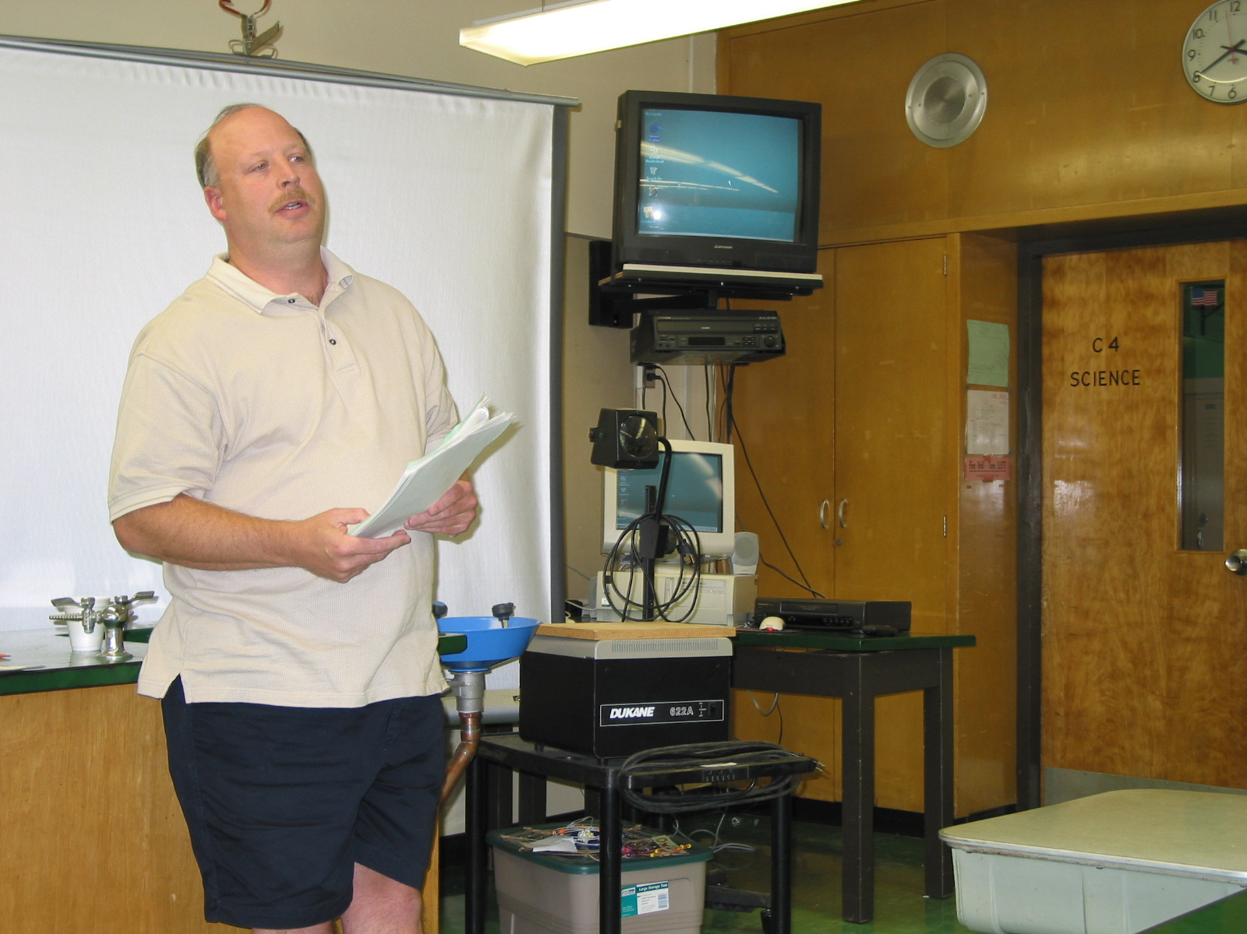

Instructor: Don Foley (2002 workshop participant)
Hamilton Township, NJ School District
Grades 6-12

Lesson Title: Benefits of Radioactivity for Some Medical Diagnostic Procedures

Overview: Chronicle of a disease from onset of symptoms to cure.

Objectives: The learner will gain knowledge of two medical diagnostics procedures that use radioactivity to cure disease.

Materials and Resources:

Internet:
- Gale Encyclopedia of Medicine
- http://www.howstuffworks.com
- http://www.tummyhealth.com
- http://www.cdc.gov

Content: In a unit devoted to “radiology” I would include not just the problems but also the many benefits of radioactivity on our lives. Following the lecture a worksheet would be given out to check for understanding. A discussion could take place to let the learner add a possible event that also benefited him/her or a close family member.

