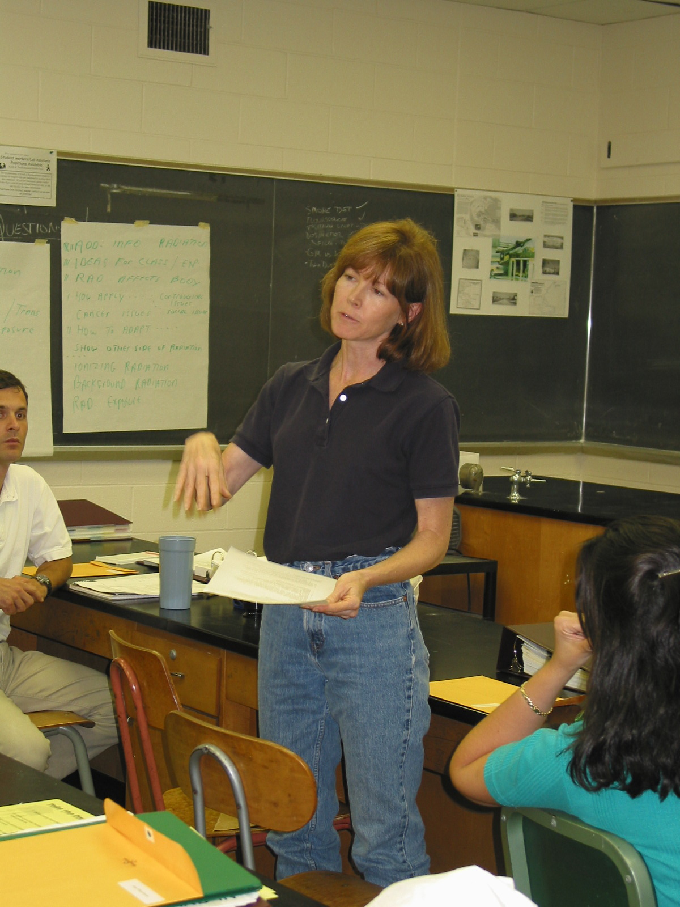

Instructor: Alison Frawley (2002 Science Teacher Workshop participant)
School District: Springfield, NJ
Lesson Title: Radiation Is Here To Stay
Grades: 7,8
Overview: Students are shown a Geiger Counter and its ability to detect ionizing radiation. After it is turned on and students realize that ionizing radiation is in the room, they are divided into research groups to determine sources of background radiation.
Objectives:
- Describe several sources of ionizing radiation
- Explain sources of background radiation
Material and Resources:
- Geiger Counter
- Internet
- Resource material
Evaluation: Ask each student to develop a poster, a poem or a song that explains the sources of background radiation.

Lesson:
- Students should be aware of energies of the electromagnetic spectrum and should be able to distinguish between non-ionizing and ionizing radiation.
- Ask the student if they know of any devices that can detect ionizing radiation. Show them the Geiger counter and explain that it can detect ionizing radiation.
- Ask them to write down what will happen if the Geiger counter is turned on in the classroom.
- Survey the class for responses, you can even see if they have the idea that any amount of radiation is harmful.
- Turn on the Geiger counter and listen for beeps.
- Explain that the Geiger counter is picking up background radiation.
- Explain how the research groups are going to look for sources of background radiation.
- Each group will have three areas to explore:
- Use the internet to download sources. Each group will try to find as many examples as possible for each category.
- At the end of the allotted time, have each group write their findings on the board.
- Final discussion:
- What are some common sources of ionizing radiation?
- What surprised you from your research?

Natural Sources | Everyday Products | Voluntary Sources

