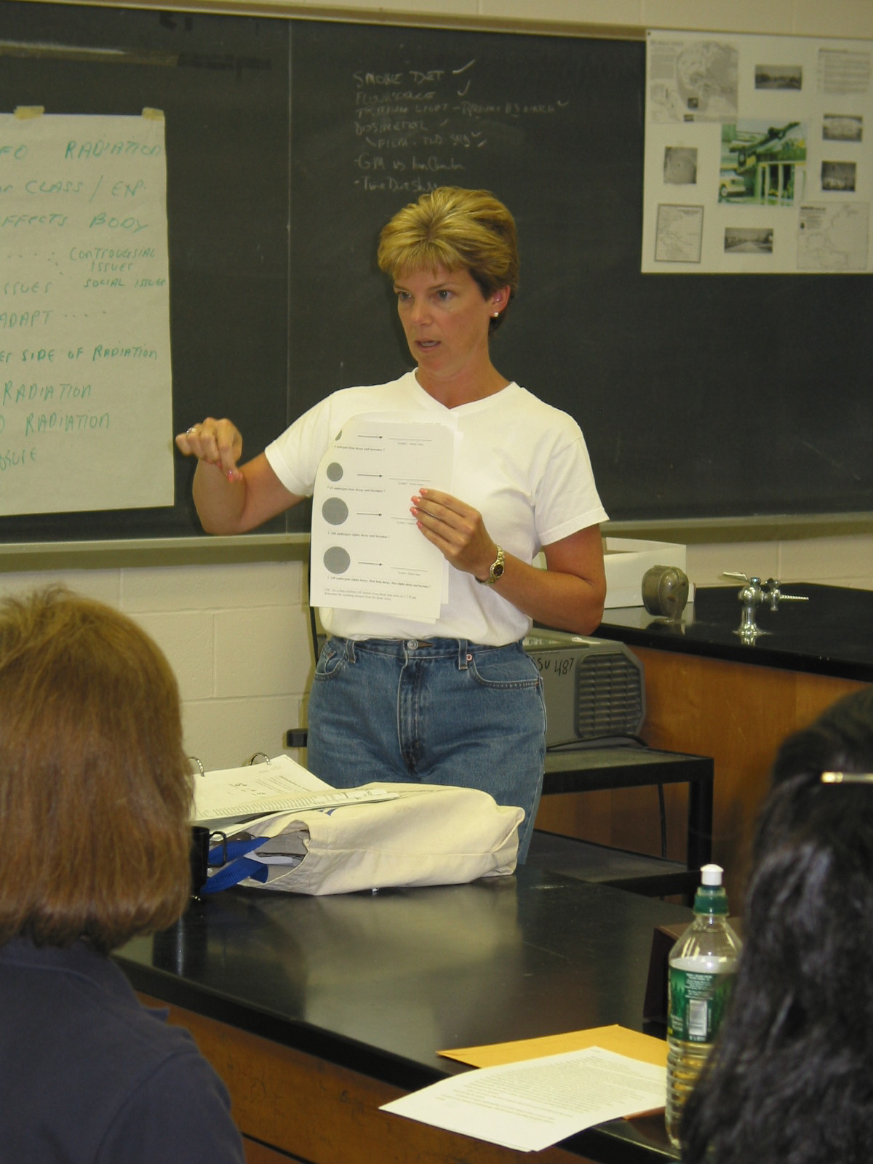

Instructor: Karen M. Ganssle (2002 Science Teacher Workshop participant)
School District: Vernon Township, NJ

Lesson Title: Isotopes & Radioactive Elements

Subtitle: Recognizing isotopes and predicting resulting elements after nuclear decay

Grades: 7-8

Objectives: Students will know how to determine what isotope is represented by various nuclear diagrams and be able to determine the resulting element formed after nuclear decay.
Materials and Resources: Comprehensive notes on the parts of the nucleus, how to determine atomic number and atomic weight, understanding of isotopes, comprehension of the three forms of nuclear decay and the resulting effect on the nucleus after decay. Students will need a periodic chart and nuclear diagrams supplied by the instructor.

Lesson: Students must first have a full understanding of the parts of an atom, their characteristics and location. Students must also be able to explain what the atomic number and atomic weight represent and how those numbers can be used to determine the number of protons and neutrons in any atom. Emphasis on counting the number of protons in the nucleus to determine which atom is represented and counting the number of protons and neutrons to determine the mass of that atom should be stressed. Students are next introduced to the concept of isotopes, which are atoms of the same element (meaning they have the same number of protons) with a different number of neutrons. This difference in neutron number solely affects the element’s weight. This variance does not affect the element’s characteristics as that is determined by the number of protons, which in isotopes of the same element remains the same. Remind students that all chemical interactions occur because the majority of the elements are not inherently stable. This fact can then be tied in to the reality that not all nuclei are stable either.

Explanations of the three forms of decay, their characteristics, and their resulting effect on the nucleus can next be discussed.

After a full review of the above concepts which will ensure comprehension the activity sheets can then be utilized.

Evaluation of student understanding is two-fold, students ability to answer direct questions is one measure of understanding, while accurately completing the activity sheets is another.

