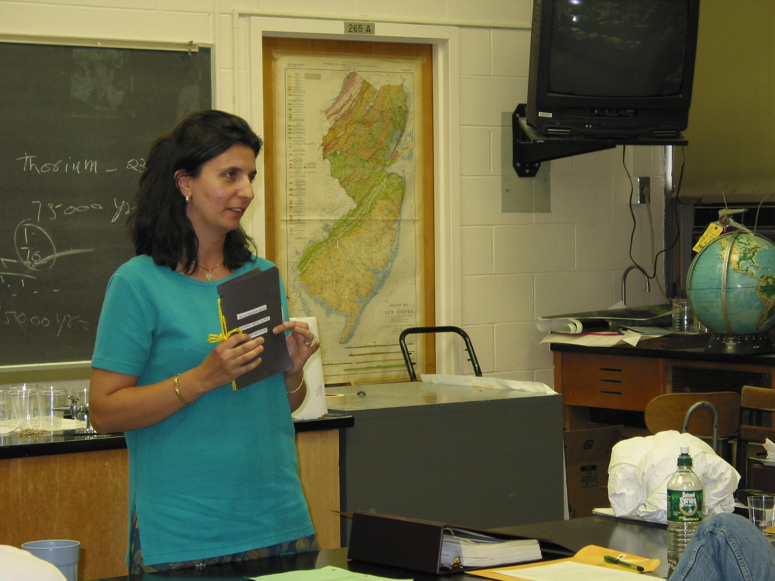

Instructor: Angela Harrigan (2002 Science Teacher Workshop participant)
School: Our Lady of Mercy, Jersey City, NJ

Lesson Title: Ionizing Facts

Grades: 6,7,8

Subject: Science

Objectives: To create a book which will identify the various types of ionizing particles. Students should be able to list a few facts for each type.

Materials & Resources:
- Construction paper
- Yarn or fasteners
- Scissors
- Glue
- Pencil
- Pen
- Markers or crayons

Sample book:
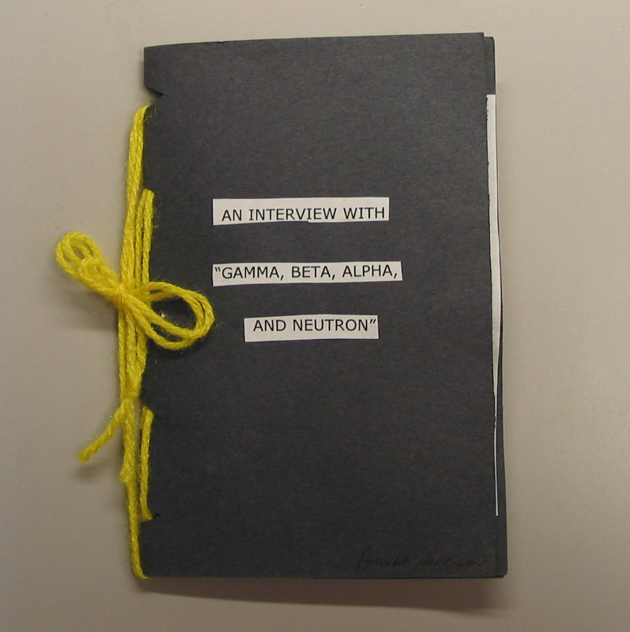 | 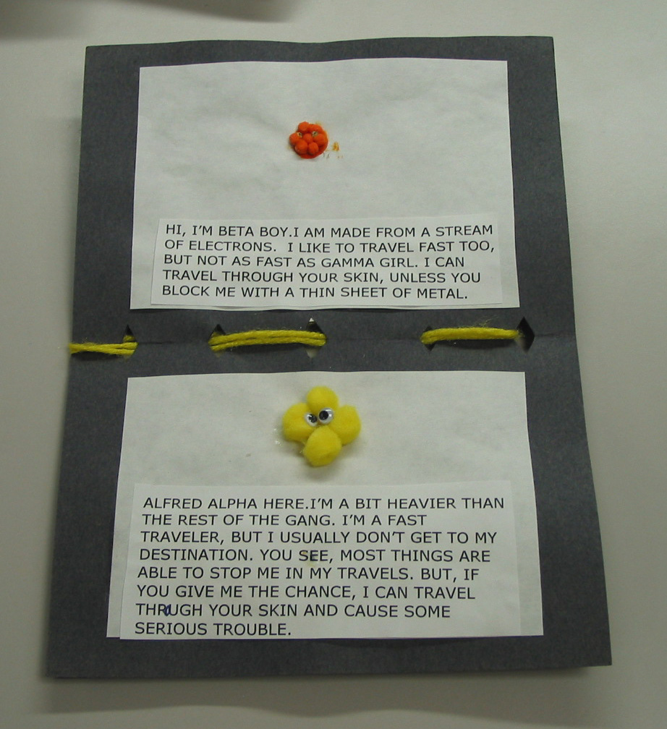
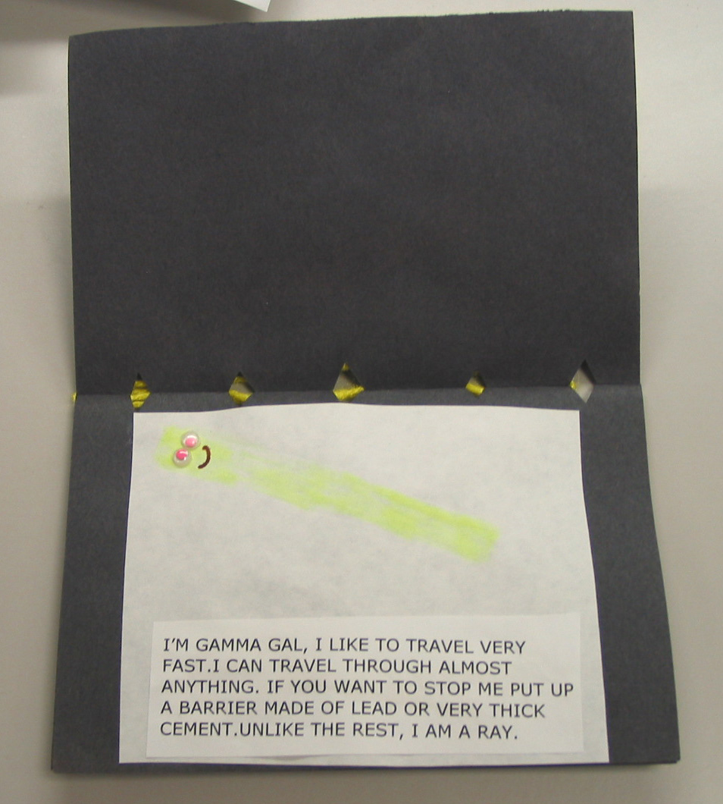 | 