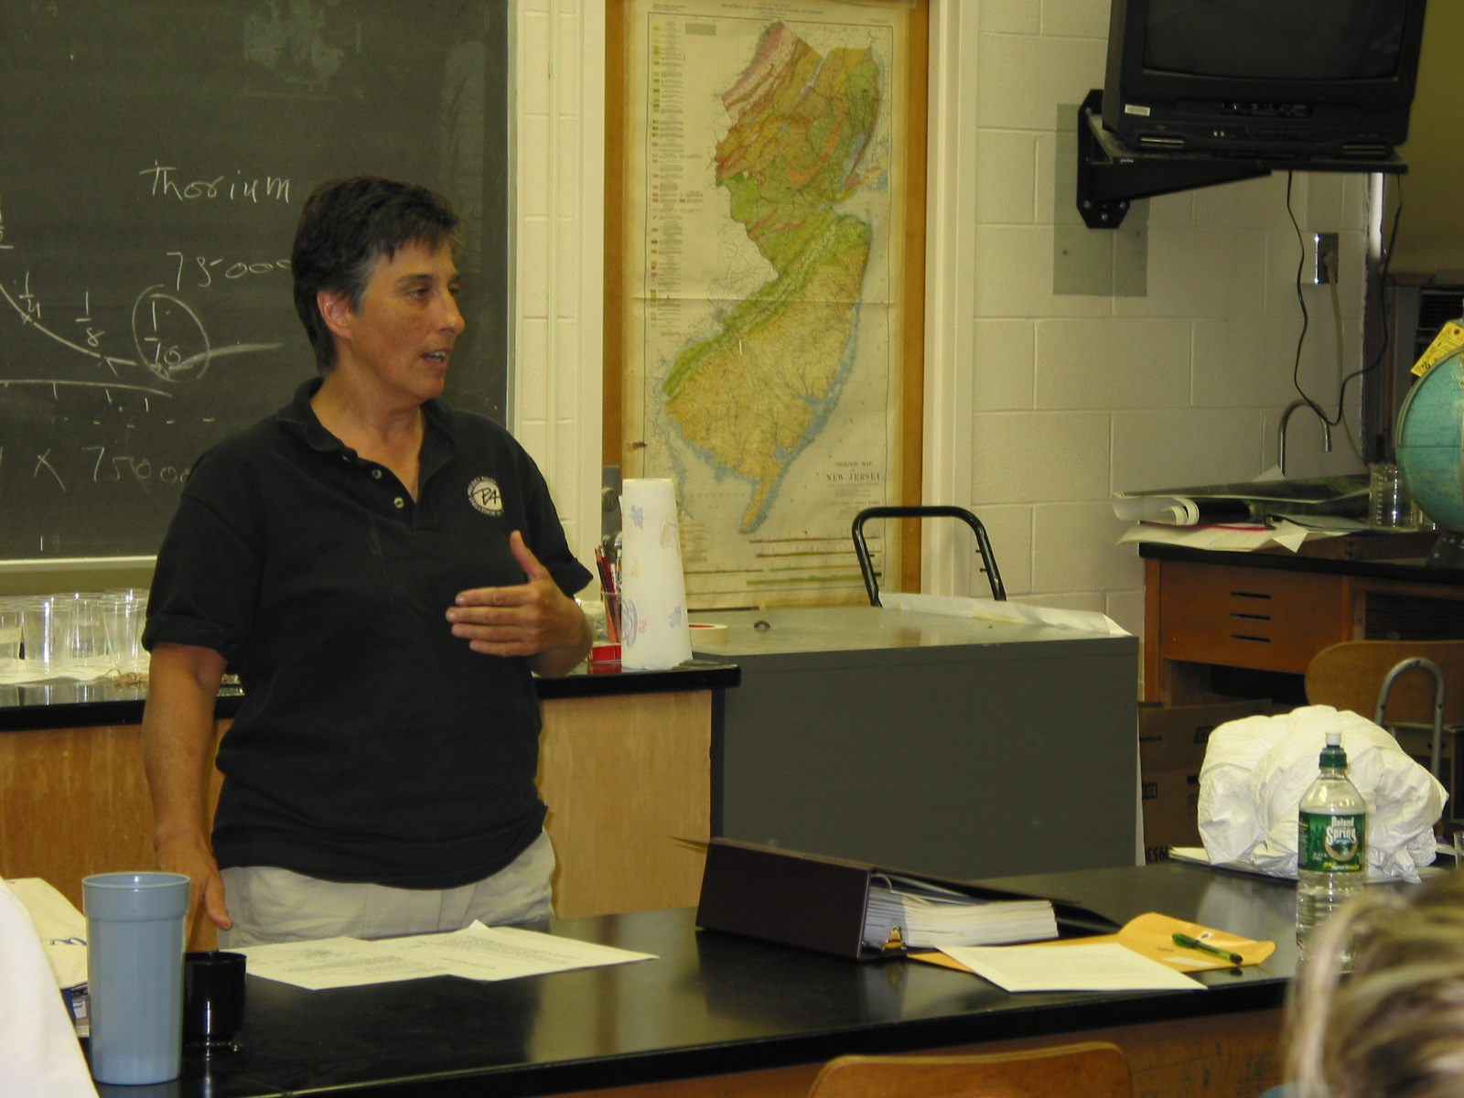
Instructor: Sandra Jordan (2002 Science Teacher Workshop participant)
School District: Vernon Township Schools
Lesson Title: Timeline - The People Behind Ionization Radiation
Grade: 8
Subject: Science
Overview: Students research information and create a timeline.
Objective: To investigate the early discoveries of ionization radiation; to organize events in chronological order
Materials: Internet access or other informational text; scissors; paste
Procedure:
Each student reviews the information on the student instruction sheet. Using the research process, the student will match the events with the appropriate scientist and identify and approximate year of discovery. Then the student will cut out the printed information from the instruction sheet and organize it on a timeline on a piece of 12x18 drawing paper. The final product should look something like this:

TITLE

1890 1895 1900 1905 1910 1915 1920
l______l_____ l______l______l______l______l

event
event scientist event
event scientist scientist
scientist

event
scientist event
scientist
event
scientist

Student Instructions:
- Using the website: http://lal.cs.byu.edu/ketay/issue-2.8/atomic-theory.html#exper or other suitable source, match the events below with the scientist credited with the discovery and determine the approximate year in which it occurred.
- Cut out the title and paste at the center of the top of the timeline.
- Cut out each of the years and paste them in the appropriate position above the timeline.
- Cut out each of the bits of information and paste them in the appropriate position below the timeline. Use the arrows, pasted perpendicular to the timeline, to keep the events orderly and easy to read.
- Under each event paste the name of the scientist credited with the discovery.

Example:
1490 1495 1500
l________l________l

Discovery of
America
C.Columbus

Title: THE PEOPLE BEHIND IONIZATION RADIATION

1895 1900 1905 1910 1915 1920

Isolate plutonium and extract radium from ore | Discovers an unknown radiation; calls it X-rays | Describe 3 types of emitted radiation: alpha, beta, and gamma
Received Nobel Prize for work with radium | Receives first Nobel Prize in Physics | Discovers that Uranium emits radiation
First to artificially transmute one element to another |  | Marie and Pierre Curie
Henri Becquerel | Ernest Rutherford | Wilhelm Roentgen
P.V. Villard and E. Rutherford | Wilhelm Roentgen | Marie and Pierre Curie

