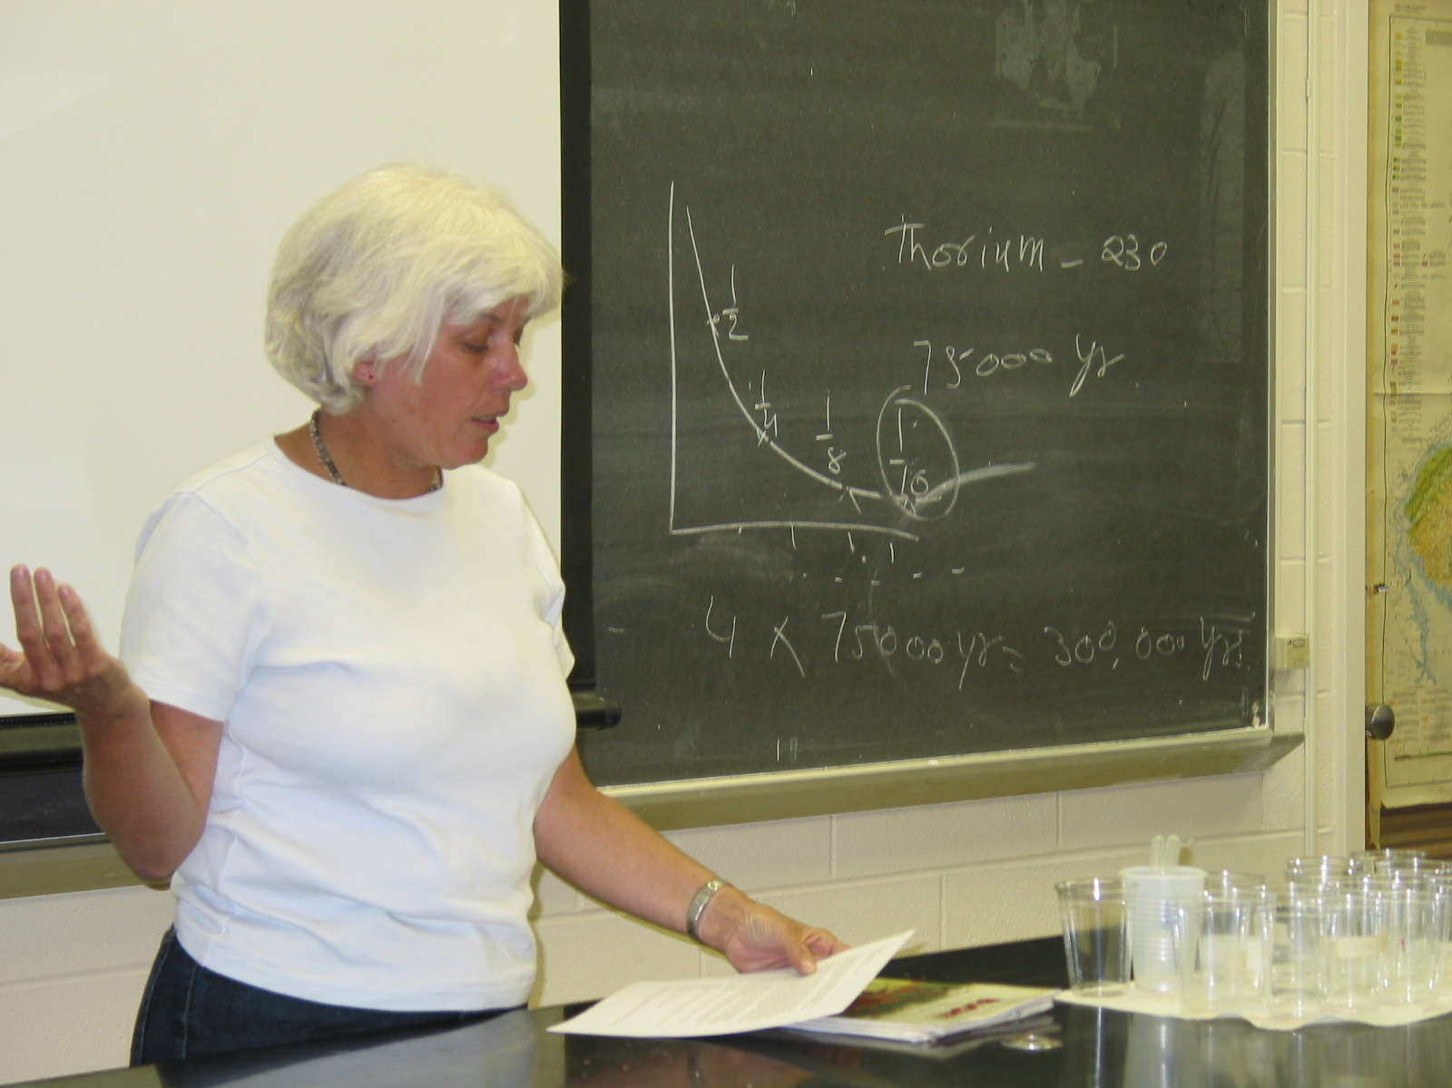

Instructor: Ann Kinney (2002 Science Teacher Workshop participant)
School District: Hawthorn, NJ
Lesson Title: Food Irradiation
Grade: 7
Subject: Science, Math

Lesson:

Prior Knowledge:
Students will have prior knowledge that will include an event-based science module “Blight” by Russell G. Wright, published by Dale-Seymour. They will also be familiar with atoms, molecules, ions, isotope, and the properties of alpha particles, beta particles, and gamma rays.

Introduction:
Students will learn the uses of ionizing radiation in the food industry. Radiation can be defined as energy moving through space in invisible waves. Non-ionizing radiation comes to us as light, infared heat, microwaves, radio and television broadcasts. Ionizing radiation, with shorter wavelengths, is capable of creating a chemical reaction and making changes in an organism. In food preservation, irradiation is used to kill insects and microorganisms, reduce spoilage, and increase shelf life of fresh foods and meats. Not all foods are suitable for irradiation and although it is considered safe and is compared to pasteurization, it is still controversial and not widely available. In 1964, The FDA and USDA approved irradiation of white potatoes with the dose of 0.05-0.15 kGy (1), in an effort to inhibit sprouting and prolong shelf life.

In this lesson, students will test potatoes to determine how they were processed.

Method:
Begin with vocabulary.

Students will compare three white potatoes of similar size that are bought from a local supermarket chain (A), irradiated (B), and organic (C). They will be labeled so the students will not know their identity. They will measure the circumference and weigh each potato. They will also count potato “eyes” for sprout potential. All measurements will be recorded on the data sheet.

Students will then attempt to sprout the potatoes in beakers of water. Students will check for sprouting, measure and weigh potatoes at three-day intervals and record data.

Safety:
- Goggles
- Students will understand that the irradiated potato is not radioactive and they will not need gloves.

Materials:
- Potatoes – store bought, irradiated, organic (enough for groups of two or three students per station.
- Covered beakers
- Labels – A,B,C
- Metric scale (one per group)
- Tape measure (one per group)
- Data sheet
- Colored pencils

Conclusion:
Based on the results, students will determine the identities on the potatoes and graph data.

Ongoing:
Students will research the pros and cons of food irradiation using books (minimum 1), magazines/newspaper articles (minimum 2) and internet resources (minimum 2). They will be given an outline and be prepared to debate the issue.

Data Collection:

Original Size

Potato | Mass [g] | Circumference [cm] | # of Eyes
A
B
C

Data collection frequency to be determined based on growing conditions:

 | A |  | B |  | C
Date | Mass [g] | Circ. [cm] | Mass [g] | Circ. [cm] | Mass [g] | Circ. [cm]

Vocabulary:
- Ionizing radiation
- Non-ionizing radiation
- Irradiated food

Evaluation:
- Written and illustrated lab report

