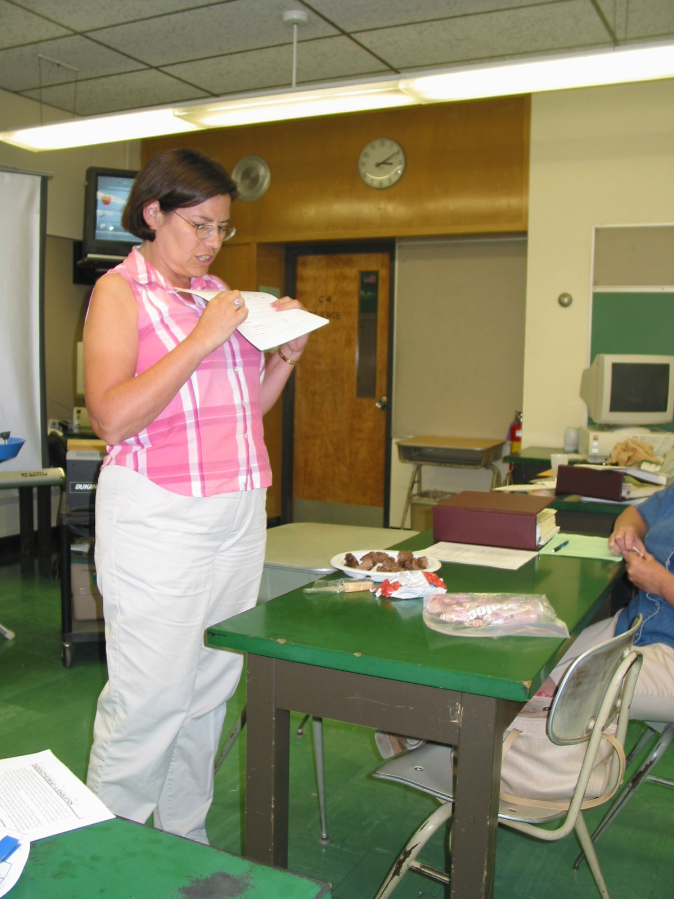
Instructor: Mary Laudenberger (2002 Science Teacher Workshop participant)
School District: Trenton, NJ
Lesson Title: Irradiated Foods
Grade: 6
Subject: Science
Overview: Students will do a project on irradiated foods that includes a lab, written report and presentation.
Objectives: To use student’s observation skills to determine differences in regular ground beef and irradiated beef; to research the pros and cons of irradiated foods; to synthesize their understanding of irradiatied foods by designing a skit, song, TV show, letter to the editor of a newspaper, TV commercial, poster, or bumper sticker.
Materials: Lab – irradiated ground beef vs. regular ground beef (teacher made)
Project outline (teacher made)
Web sites included in project
NAME:_______________________ HR:_____________
DATE:________________________ Science Lab

Scenario: Mrs. Laudenberger had a family picnic this past weekend. I was barbecuing hamburgers and hot dogs, and I didn’t have enough hamburgers. I sent Mr. Laudenberger to the store to buy some more hamburgers. He came back with ground beef that was labeled irradiated. I told Mr. Laudenberger that his ground beef was not the same that I bought. Mr. Laudenberger likes to think that he is always right, so he went through the garbage and found my label of ground beef. He said,”Look your label says 80/20 ground beef and my label says 80/20 ground beef—so they are the same.” Who is right?

DIRECTIONS: Write your observations in the table. Do not mix up sample 1 with sample 2.

HAMBURGER TASTE TEST

 |  | SAMPLE 1  (___________________BEEF) |  | SAMPLE 2  (__________________BEEF)
APPEARANCE

TEXTURE

SMELL

TASTE

HOMEWORK:

Find the unit price (price per pound)
Regular ground beef: $3.30 for 1.66 pounds . ANSWER:________________

Irradiated ground beef: $2.29 for 1 pound. ANSWER:_______________

What is food irradiation?
__________________________________________________________________________________________________________________________________________________________________________________________________________________________________________________________________

Mrs. Laudenberger
Project Due:__________

PROJECT: Irradiated Foods-- Pros and Cons

Project will include:
- Lab: Comparing irradiated and non-irradiated hamburgers
- Research paper
- Presentation to the class

Tools:
Information seeking strategies
What are the possible sources to find this information?
Research internet sources
Encyclopedia sources
Journal sources
Magazine articles
Interview people

Location and Access
Where will I find these sources?
Library, computer room , classroom
Who can help me find what I need?
Teacher, librarian, parent, friend, relative
How will I record the information?
Keep a notebook that contains all the information that you found.
How will I give credit to my sources?
As you research information, keep track of your sources and write a bibliography. You must use
a minimum of four references.

Synthesis
What product or performance will I make to finish my assignment?
Written research paper, including a bibliography
Lab
Presentation: TV commercial, skit, song, poster, bumper sticker, letter to the editor of a
local newspaper for or against irradiation of foods, or a TV news show about food irradiation.
How will I know that I have done my best?
The quality of the project will be graded not only on what is presented but also on the presenters ability to discuss the work intelligently. Each project will be graded based on the following criteria.

GRADING RUBRIC

LAB—10 points total
Must be complete and neat

PAPER—60 points total
Format—20 points
10 points—Paper has a neat cover and is typed or written neatly.
10 points—Contains a bibliography , which lists at least four sources.
Content—40 points
15 points –paper contains information that is scientific, interesting , and accurate.
15 points—ideas flow logically from one to another, and are strengthened by supporting statements.
10 points—paper is free of grammar and spelling errors.

PRESENTATION—30 points total
Visual Aid—20 points
10 points—presented in a neat , easy to read/easy to understand fashion.
10 points—presents the important facts from the paper.
Speaker—10 points
10 points—presents him/herself in a professional manner, speaking clearly, making eye contact with audience, and displaying knowledge of the topic.

.

