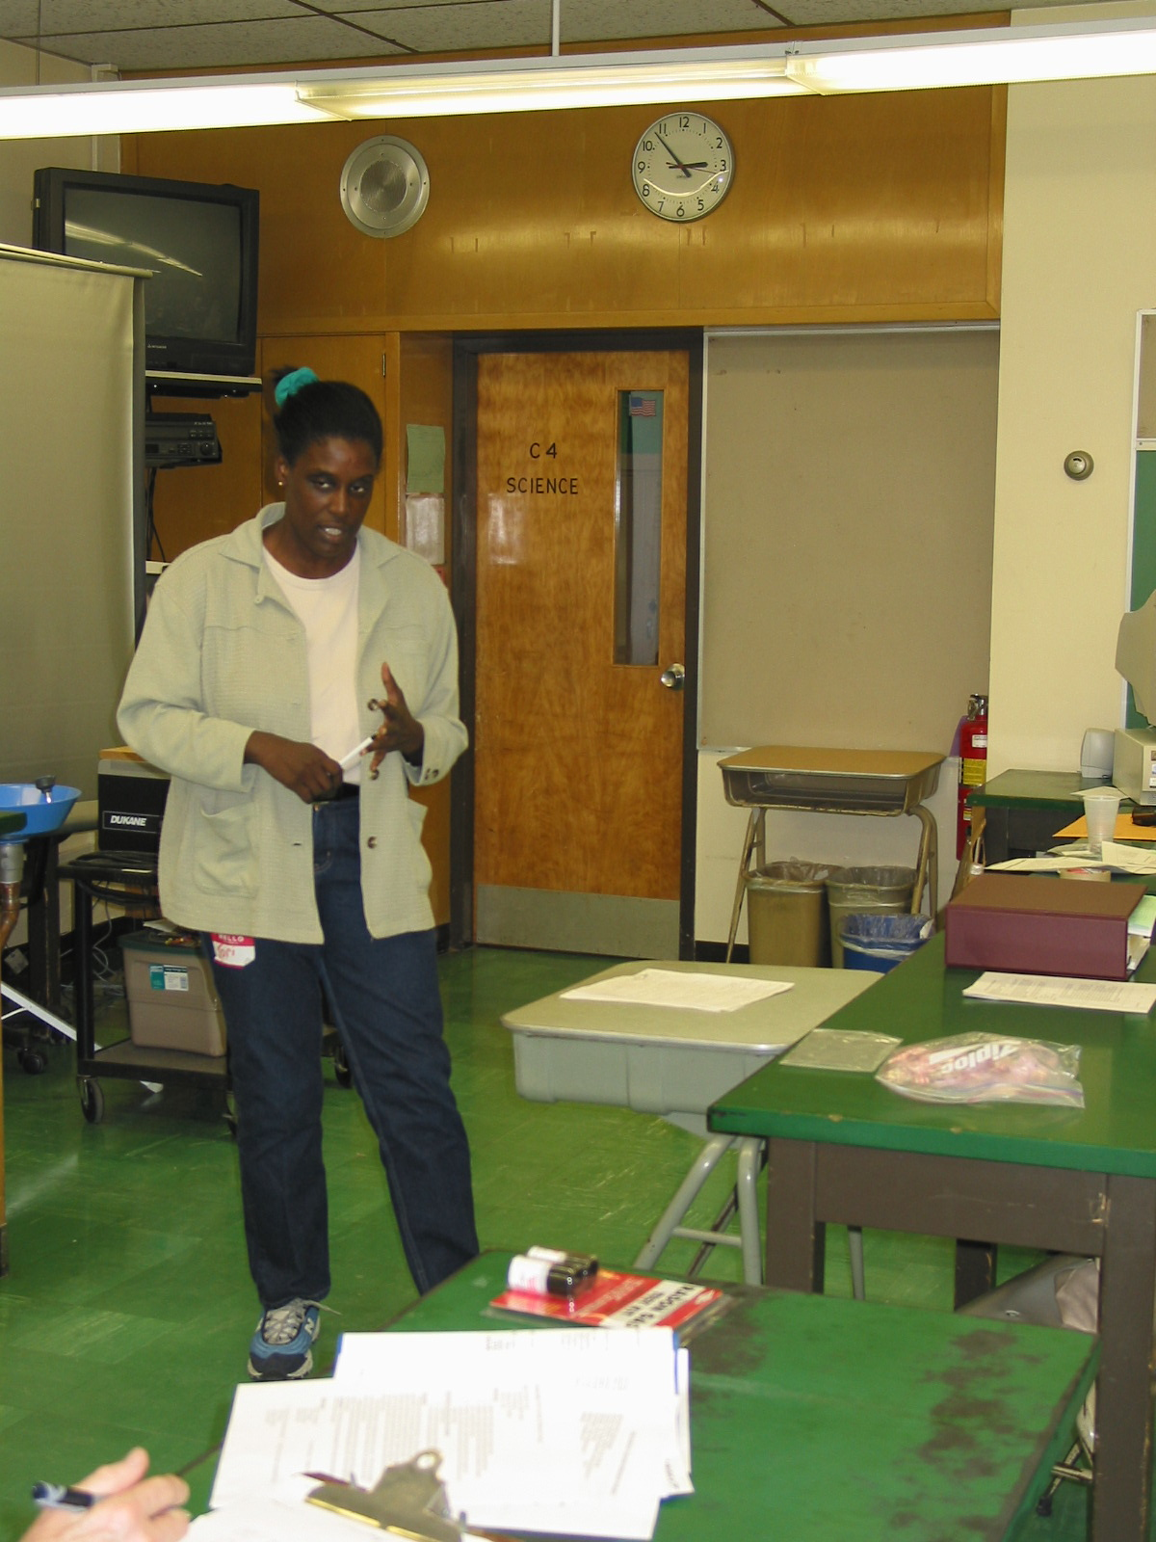

Instructor: Tori Lynn Lee (2002 Science Teacher Workshop participant)
School District: Hamilton Township, NJ

Lesson Title: The different uses of radiation

Grade: 6

Overview: Students will gain an understanding of the basic terms of radiation, the basic rays and its uses in everyday life.

Objectives:
- To identify key terms for the uses of radiation
- Discuss the basic knowledge of radiation
- Learn the uses of radiation
- To view different x-rays

Materials:
- Overhead Projector
- X-Ray pictures

Key terms:
- Radiation
- Ionization
- Gamma rays
- Beta rays
- Alpha rays
- Neutrons
- X-rays

Evaluation:
- Students understanding of key terms for this lesson for radiation with a discussion as a class.

