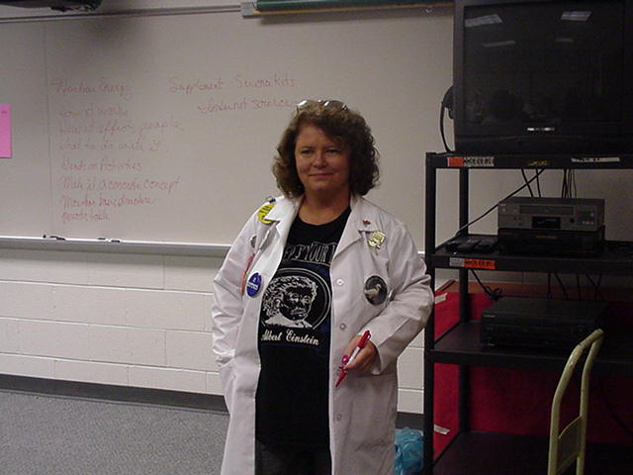
Created by:
Linda Smith, (2000 Science Teacher Workshop presenter)
Billingsport and Loudenslager Elementary Schools,
Paulsboro, NJ 08066
May 12, 2000

Topic: Detecting Radiation
Type: Teacher demonstration
Intent: Introductory
Standards Addressed: 5.4; 5.8; 5.9; 5.10
General Info: Proposed Grade K-6 Age 6-12; Estimated Time 40 min.

Content Knowledge:
- Define Dose as the energy lost by ionizing radiation and absorbed by living or non-living material
  - It is sometimes called Equivalent Dose or Radiation Dose
- Define Exposure Rate as the amount of radiation energy that reaches an object’s surface in a given time period
- Define Absorbed Dose as the amount of radiation energy that is actually absorbed by the material through which it passes
- Define Equivalent Dose as the absorbed dose multiplied by a number that represents how a certain kind of radiation affects a certain kind of material.
  - The “factor “ number is different for each kind of radiation and material that absorbs it
  - Scientist do lots of calculations to come up with the factors
- Identify rem as one dose
- Identify millirem as 1/1000 of a rem
- Identify Sievert as 100 rem
- Identify Lethal Dose of radiation as 400,000 – 600,000 millirem
- Identify three most common radiation measuring devices and their uses
  - Personal dosimeters
  - Hand held detectors
  - Continuous Sampling Monitor
General Sketch (Procedure)
- Before start of lesson teacher sprinkles sparkles on both hands
- Teacher defines radiation dose as she walks through the room touching things, making sure that there are several areas she touches more than once.
- When students start to notice the sparkles, teacher tells them they represent radiation absorbed into the materials they touch. Ask for ideas to measure the “sparkles”.
  - Note that places that were touched more than once have more sparkles on them – relate that to the Exposure Rate
  - Note that some sparkles didn’t stick. Relate that to radioactive particles that passed though without interacting with any atoms in the material
  - Note that scientists only count the radioactive material that is absorbed – relate that to Absorbed Rate
  - Note how small the individual sparkles are. Tell them the particles are so small they had to come up with a measure for them called rem.
  - Note that even a rem was too big to measure some types of radiation, so they came up with a measure called the millirem
  - Note that some scientist use a measure called Sievert to measure larger amounts of radiation
  - Give students charts that show average radiation doses. Discuss. When they have a working concept of how much radiation absorption is normal, tell them how much radiation has to be absorbed to become a lethal dose.
  - Identify three kinds of detectors,
  - Talk about their purpose and use.
Assessment/Evaluation
- Have students identify different sources of radiation doses
- Identify which kind of detector should be uses for each kind of dose

Topic: Shielding Radiation
Type: Teacher demonstration
Intent: Introductory
Standards Addressed: 5.4; 5.8; 5.9; 5.10
General Info: Proposed Grade K-6 Age 6-12; Estimated Time 40 min.

Content Knowledge:
- Define Factors that affect Radiation Dose as time, distance and shielding
- Define Time as how long the person is near the radiation source. The longer you are exposed, the larger the dose of radiation you will receive.
- Define Distance as how far away the person is from the source of radiation. The farther away you are, the less dose you will receive.
- Define Shielding as material placed between the person and the source of radiation
  - Different materials absorb different kinds of radiation
- Identify Alpha Particles as atoms that have 2 neutrons, 2 protons, and 0 electrons
  - They travel through solid materials and react with many atoms in a short period of time
  - They spend their energy very quickly
  - They can be shielded by a single piece of notebook paper
  - They are a problem when ingested or inhaled because they affect the internal tissues such as the lungs
- Identify Beta Particles as an electron not attached to an atom
  - It is 7000 times smaller than alpha particles
  - It travels farther through solid material than alpha particles
  - They can travel through a half inch of plastic before spending all their energy
  - They are a problem when they are ingested or inhaled because they affect the internal tissue such as lungs
- Identify Gamma Radiation as fast moving rays of energy
  - They can pass completely through the human body
  - They can be absorbed through the skin
  - They can affect any organ in the body
  - 3 feet of soil, 3 feet of concrete, or six inches of lead will be enough shielding to use up gamma radiation before it gets to you
- Identify Lethal Dose of radiation as 400,000 – 600,000 millirem
General Sketch (Procedure)
- Refer to the Sparkles as how radiation moves through the environment
- Teacher uses models made of Styrofoam balls to demonstrate how alpha, beta and gamma rays loose energy as they go through other atoms
  - Note that radiation looses its effect on matter as it looses its energy
  - Note that different kinds of radiation loose their energy differently in different materials
  - Give students charts that show average radiation doses. Discuss. When they have a working concept of how much radiation absorption is normal, tell them how much radiation has to be absorbed to become a lethal dose.
  - Identify what kind of shielding would prevent a lethal dose of radiation
  - Identify the natural shielding that occurs in the environment
  - Talk about their purpose and use.
Assessment/Evaluation
- Have students identify different sources of radiation and the materials that shield them
- Identify which kind of shielding should be used for different doses of radiation

LESSON PLAN
Topic: Detection of Radioactivity
Objective: The student will be able to use the Geiger counter to detect the presence radiation in various items
found in their home.

Materials:
- Geiger counter
- Miscellaneous Items – (from bedroom, kitchen, living room and bathroom)

Procedure:
- This lesson may be done as a whole class or in small groups of 4, depending on class size.
- Give students a few random objects from home. Do NOT explain the use of the Geiger counter. Simply ask students to come to the front of the class and use the Geiger counter on the given object.
- Ask students what they think is happening. What do they think the purpose of the Geiger counter is?
- Create a list on the board.
- After the children have used the Geiger counter on each object, explain that it is used to detect the presence of radioactivity.
- Students should make a chart depicting their predictions of other objects they may have at home that may also contain radioactivity.

Follow up: Ask students to bring in an object from home they feel may have some type of radioactivity.

Next Day:
- Ask students to use the Geiger counter to properly detect radioactive presence, and record their findings.
- Students should compare results with predictions and create a conclusion regarding their experiment.
- Discuss findings as a class.
- Briefly review what radioactivity is.

OBJECTS THAT CONTAIN RADIOACTIVE MATERIAL

Computer Or Video Monitors (NORM [Naturally Occurring Radioactive Material] In Screen)
Breakers (Arc Chutes Contain NORM)
Camera (Some Lenses And Camera Batteries Contain NORM)

Welding Rod (NORM )

Batteries (NORM )
Charcoal (Cs-137 As Background)

Grinding Disks (NORM )
Timepieces (Tritium Promethium-147, Radium-226)
Balances Of Precision (Tritium)
Marine Compasses, Self- Luminous Dials And Instrumentation (Tritium Gas; Promethium Gas 147; Kr-85)
Thermostat Dials & Pointers (Tritium)
Electron Tubes (Tritium In The Microwave Receiver Protector; Co-60; Nickel-63; Krypton-85; Cesium-137; Promethium-147)
Spark Gap Irradiators (Cobalt-60)

Synthetic Plastic Resins Containing Scandium-46 Which Are Designed For Sand Consolidation In Wells
Ice Detection Devices (Sr-90)

“Black Beauty” Sand Blasting Grit
Rock Wool (Thorium) Used For Oven Insulation And In Fire Doors.

