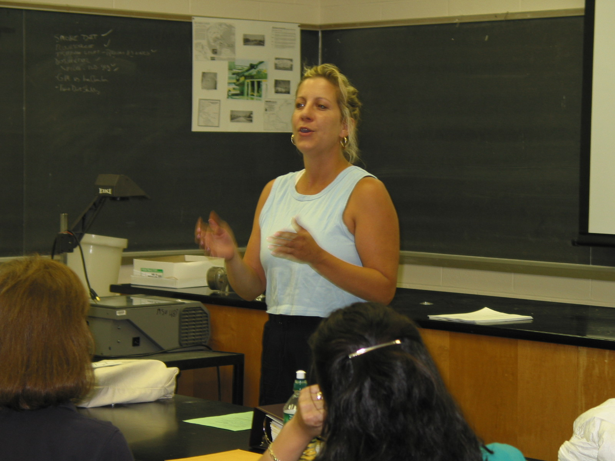

Instructor: Linda McGovern (2002 Science Teacher Workshop participant)

School District: Bloomfield, NJ

Lesson Title: Experiencing the Electromagnetic Spectrum

Grade: 7

Subject: Science

Overview: Integrating everyday experiences into learning the electromagnetic spectrum. This lesson could be introduced while discussion heat transfer through the atmosphere: conduction, convection, radiation (Bloomfield 7th grade curriculum). The lesson would take 2 ½ class periods: vocabulary, lecture, class discussion.

Objectives: Students will be able to apply real life situations as they apply to the electromagnetic spectrum, focusing on gamma rays.

Materials & Resources: Copy of the electromagnetic spectrum and description of each section.
http://imagine.gsfc.nasa.gov/docs/science/know_l1/emspectrum.html
http://www.lbl.gov/MicroWorlds/ALSTool/EMSpec/EMSpec2.html
http://csep10.phys.utk.edu/astr162/lect/light/spectrum.html
http://www.state.nj.us/llrwsb/fact02.pdf
Vocabulary as it applies to the discussion.

Evaluation: Students will be evaluated on the vocabulary and concepts taught in the form of a poster, complete with examples.

Content:

Day 1:
After discussing conduction and convection, radiation would be introduced and definitions provided: 1) radiation, 2) non-ionizing radiation, 3) ionizing radiation.

A copy of the spectrum would be provided after definitions. Have students label ionizing and non-ionizing areas of the spectrum.

Determining the fact that the electromagnetic spectrum can be referred to as electromagnetic radiation and that definition provided would be the next step.
- Photon – define
- Non-ionizing radiation – have photons with lower energy levels than ionizing radiation.
- Wavelength – define
- Frequency – define
- Non-ionizing radiation – long wavelengths and low frequency.
- Ionizing area of the spectrum – increases to short wavelengths and high frequency

Homework: review definitions.

Day 2:
Review terms

Use the spectrum to apply to everyday life. How are we exposed to electromagnetic radiation everyday?
- Radio and television – AM & FM: different wavelengths and frequency
- Radar – doppler radar, radar guns from police
- Microwave – cooking, reheating foods
- Infared radiation – restaurants, heat lamps, McDonalds and Burger King. Heat re-radiated back into the atmosphere. Compare summer temperatures in the city vs. suburbs due to pavement (black top).
- Visible light – ROYGBIV, rainbows. Demonstration with a prism and a flashlight.
- Ultraviolet radiation – suntans, sunburns. May ask students if they know people who have had skin cancer, a direct result of UV radiation.
- X-rays – Hopefully all students have had dental x-rays by now. Anyone with broken bones could explain what safety measures were taken before being exposed.
- Gamma rays – Using the web site: http://www.howstuffworks.com/nuclear-medicine.htm , teacher could print out different types of medical tests or treatments that student’s family may have experienced. This print out would be taken home so students could survey family member’s experiences with nuclear medicine.

Homework: nuclear medicine survey.

Day 3:
Discuss student’s results. May also want to end lesson by mentioning that ionizing radiation is harmful when it is not controlled. Example: some nuclear waste and dirty bomb.

Extension: Students could research harmful uncontrolled radioactive substances on their own and report finding to the class.

